Optimal Capacities in
Discrete Facility Location Design Problem

Mohammad Reza Yadollahpour, Soheila Kavosh, Ali Shahandeh Nookabadi
Industrial Engineering Department, Isfahan University of Technology, Isfahan, Iran

Abstract
Network location models comprise one of the main categories of location models. These models have various applications in regional and urban planning as well as in transportation, distribution, and energy management. In a network location problem, nodes represent demand points and candidate locations to locate the facilities. If the links network is unchangeably determined, the problem will be an FLP (Facility Location Problem). However, if links can be added to the network at a reasonable cost, the problem will then be a combination of facility location and NDP (Network Design Problem); hence, called FLNDP (Facility Location Network Design Problem), a more general variant of FLP. In previous studies of this problem, capacity of facilities was considered to be a constraint while capacity of links was not considered at all. The proposed MIP model considers capacity of facilities and links as decision variables. This approach increases the utilization of facilities and links, and prevents the construction of links and location of facilities with low utilization. Furthermore, facility location cost (link construction cost) in the proposed model is supposed to be a function of the associated facility (link) capacity. Computational experiments as well as sensitivity analyses performed indicate the efficiency of the model.

Keywords: Network Location, Network Design Problem, Mixed Integer Programming, Facility Location, Link, Capacity.

1. Introduction
Network location models comprise a main category of location models. In the network location problem, nodes represent demand points and candidate locations to locate the facilities. The objective of the problem is to determine the optimum number and locations of the required facilities. Facility location problem (FLP) and capacitated facility location problem (CFLP) are two basic and generic problems that can be formulated as network location problems. In FLP, capacity of facilities is considered to be unlimited, while in CFLP facilities have a limited capacity. Most research on the FLP and CFLP has focused on the development of efficient solution algorithms. These include branch and bound approach (Akinc and Khumawala [1]), Lagrangian relaxation (Christofides and Beasley [3]), Decomposition (Davis and Ray [6]), Dual-based methods (Guignard and Spielberg [7]), and heuristic methods (Jacobsen [9]). Magnanti and Wong [11] provide an overview of solution techniques for the CFLP. However, variants of the model are generally sparse. Simchi-levi [16] investigated the capacitated traveling salesman location problem. Laporte et al. [10] developed a model for CFLP in which customer demands are stochastic.
Uncapacitated facility location/network design problem (UFLNDP) was first introduced by Daskin et al. [4]. This was motivated by the simple observation that in a network, it may be more economical to add some links instead of locating new facilities to improve service levels. In other words, Daskin omitted the assumption of unchangeable links network from the location problem. Generally, UFLNDP is applicable to and useful in modeling a number of situations in which tradeoffs must be made between facility location costs, network design costs, and operating costs. Such situations arise in urban planning problems, distribution systems, supply chain, communication networks, airlines networks, pipeline systems, and power transmission networks. Melkote and Daskin solved this combined model for instances with up to 40 nodes and 160 candidate links in polynomial time (Melkote [14]; Melkote and Daskin [12]).
In UFLNDP, it is assumed that facilities may serve an infinite amount of demand and that the facilities will operate significantly below their capacity. However, such an assumption is not valid as in many situations facilities have a constraining upper limit on the amount of demand they can satisfy. For example, in power transmission and telecommunication networks, there are strict constraints on capacities of switches and transformers, so an upper limit on demands that a facility can handle should be considered. Some warehouses and production plants in supply chain and public facilities such as hospitals, schools, or fire stations in urban areas also operate close to their capacity. Melkote and Daskin [13] formulated the capacitated facility location/network design problem. This problem was a general variant of facility location problem, so they named it CFLNDP.
In CFLNDP model, the capacity of facilities is known and taken as the input parameter. The capacity of links is assumed to be unlimited. In the model proposed in this paper, the capacities of links and facilities are considered not as constraints but as decision variables. Here, the value of capacities are not continuous and depend on the special application cases, can be optimally selected among several candidate discrete values. So the problem becomes more flexible and facilities and links utilization can be improved. The objective function is to minimize the sum of facility location costs, link construction costs, and operating costs (transportation costs). Link construction costs and facility location costs are considered as functions of the associated link or facility capacity in order for them to conform to real conditions.
The rest of this paper is organized as follows. In section 2, we present a mixed integer programming formulation for the problem at hand. In section 3, numerical examples are investigated and the behavior of the model will be explored via sensitivity analysis. Finally in Section 4, we draw conclusions and suggested areas for future study.
2. Formulation
Prior to formulating the problem, the following assumptions regarding the underlying network must be made. The network includes$N$nodes each of which represents a demand point. Facilities may be located only on the nodes of the network. Only one facility can be located per node. The network is a customer-to-server system, in which demands themselves travel to facilities to be served. The demand is only for a single service or commodity. The capacity of links and facilities are considered as decision variables. Some links which are candidates to be constructed connect nodes of the network to each other. For each node, the demand and travel cost per unit flow on the link$(i,j)$ are known. Links can be constructed in different “ranks”. The simplest interpretation of the “rank” is its width such that if increased, the link capacity will increase correspondingly. For example, a four-lane road can be considered as a link with rank 4. We assume the construction cost of a unit length link with rank 1 to be known and the same for all links. Construction cost of each link is a linear function of its length and rank. The link rank is an integer variable with an upper bound. When link rank increases by one unit, the link capacity will be increased by a specific amount. Facility location cost contains tow components: (1) the initial cost for locating a basic facility (a facility with minimum capacity), and (2) a variable cost that is related to the capacity of that facility. As the capacity of the facility increases (or its rank increases), the variable facility location cost also increases as a linear function of facility rank. A facility rank is also an integer variable with an upper bound. When the rank of a facility is increased by one unit, its capacity increases by a specified quantity.
To formulate the problem we define the following notations:
$$N$$ | Set of nodes in the network
$$L$$ | Set of candidate links in the network
$$D_{i}$$ | Demand at node $i$
$$M=\sum_{i∈N}{D_{i}}$$ | Total network demand
$$W_{i}$$ | Total demand served by a facility at node $i$
$$Y_{\text{ij}}^{k}$$ | Fraction of demand of node k that flows on link $(i,j)$
$$W_{i}^{k}$$ | Fraction of demand of node k served by a facility at node i
$$d_{\text{ij}}$$ | Distance between nodes $i$ and $j$
$$e_{\text{ij}}^{k}$$ | Travel cost per unit of demand of node $k$from node $i$ to $j$
$$p^{k}$$ | Travel cost per unit of demand of node $k$ in unit of length $(e_{\text{ij}}^{k}=p^{k}d_{\text{ij}})$
$$u$$ | Construction cost of link per unit of length with rank $1$
$$v$$ | Cost of increasing capacity of a facility up to $n$(increasing rank of facility by one unit)
$${\text{Capl}}_{\text{ij}}$$ | Rank for link $(i,j)$
$$S$$ | Link capacity with rank $1$
$$m$$ | Initial facility capacity (capacity of basic facility)
$$n$$ | The amount of facility capacity increase when its rank is increased by one unit
$${\text{IC}}_{i}$$ | Location cost with capacity m (basic facility)
$${\text{Capf}}_{i}$$ | Rank of facility that is located at node $i$
$$b_{1}$$ | Upper bound for ${\text{Capl}}_{\text{ij}}$
$$b_{2}$$ | Upper bound for ${\text{Capf}}_{i}$
$$E_{i}$$ | Equals 1 if a facility with basic capacity is located at node$i$, otherwise it is $0$
According to the above assumptions, the problem can be formulated as follows:
$$\text{min} \sum_{(i,j)∈L}{\sum_{k∈N}{e_{\text{ij}}^{k}}}D_{k}Y_{\text{ij}}^{k}+\sum_{(i,j)∈L}{[(u d_{\text{ij}}}) {\text{Capl}}_{\text{ij}}]+\sum_{i∈N}{({\text{IC}}_{i}} E_{i}+v {\text{Capf}}_{i})$$ | (1)
The objective function is the sum of transportation, link construction, and facility location costs. Eq. (2) is a conservation of flow Equation, stating that input flow to a node must be equal to the output flow from that node. Eq. (3) guarantees that each demand entering node i is either shipped out or served at i. And finally, (4) states that all demands on each node must be served completely.
$$\sum_{j∈N}{Y_{\text{ji}}^{k}}=\sum_{j∈N}{Y_{\text{ij}}^{k}}+W_{i}^{k},i,k∈N,i≠k$$ | (2)
$$W_{i}^{i} +\sum_{j∈N}{Y_{\text{ij}}^{i}} =1,i∈N , D_{i}>0$$ | (3)
$$\sum_{i∈N}{W_{i}^{k}}=1,k∈N,D_{k}>0$$ | (4)
Eq. (5) states that the rank of the facility at node $i$ can be positive, only if an initial facility is located at this node. It also takes into account the upper bound of the facility rank.
$${\text{Capf}}_{i} ≤b_{2} E_{i},i∈N$$ | (5)
Eqs. (6) and (7), respectively, imply facility and link capacity constraints.
$$\sum_{k∈N}{D_{k}} W_{i}^{k} ≤(m E_{i} +n {\text{Capf}}_{i}),i∈N$$ | (6)
$$\sum_{k∈N}{Y_{\text{ij}}^{k}} D_{k} ≤ S\text{.} {\text{Capl}}_{\text{ij}},(i,j)∈L$$ | (7)
Eq. (8) states that commodities will be moved from node $i$ to node$j$only if the link$(i,j)$is constructed at least with rank 1.
$$Y_{\text{ij}}^{k} ≤{\text{capl}}_{\text{ij}} ,(i,j)∈L ,k∈N$$ | (8)
Eq. (9) states that demand on node $k$can be served at node $i$only if a facility is located at this node.
$$W_{i}^{k} ≤E_{i}, i∈N, k∈N$$ | (9)
If it is desirable to control the number of facilities, the following constraint can be applied:
$$\sum_{i=1}^{N}{E_{i}≤p}$$ | (10)
If the budget for locating facilities and constructing links is limited (B), the following constraint will be used:
$$\begin{aligned} \\ \sum_{(i,j)∈L}{[(u d_{\text{ij}}}) {\text{Capl}}_{\text{ij}}]+\sum_{i∈N}{({\text{IC}}_{i}} E_{i}+v {\text{Capf}}_{i})≤B \end{aligned}$$ | (11)
(12) and (13) are standard nonnegativity and integrality constraints:
$${\text{capl}}_{i} ∈\left\{1,2,\text{.}\text{.}\text{.},b_{1}\right\} , {\text{Capf}}_{i} ∈\left\{1,2,\text{.}\text{.}\text{.},b_{2}\right\},∀i∈N$$ | (12)
$$\begin{aligned}E_{i}∈\left\{0,1\right\} , W_{i}≥0 ,∀i∈N \\ Y_{\text{ij}}^{k}≥0 ,∀(i,j)∈L\end{aligned}$$ | (13)
The above formulation is regarded to be ‘strong’ in the sense that constraints including big M are avoided (Meltoke and Daskin [12]). The presence of constraints including big M in the formulation would require longer CPU time (Nemhauser and Wolsey [15]).
3. Numerical results
Numerical results are organized in three separate sections. In section one, the structure of the solutions are investigated and compared to the solutions of CFLNDP (Melkote and Daskin [13]) using a benchmark problem. Comparisons indicate that the proposed model suggests more efficient facilities and links with less costs. In the next section, sensitivity analyses will be conducted with respect to link construction and facility location cost. The results show that the model solutions are clearly sensitive to changes in input parameters. Finally, in the third section, the efficiency of the model with respect to CPU time is investigated. Results show that CPU time almost exponentially increases as the node number increases and that problems with up to 200 nodes can be solved within a reasonable time. The effect of the parameter u on CPU time will also be investigated in the same section. A CPLEX solver in GAMS software on a Pentium IV computer with a 3.4 GHz processor and 512 MB of memory has been used to solve numerical examples.
3.1. Solution configuration and comparison of results
To examine the structure of the solutions and to make comparisons and sensitivity analyses, a 21-node network has been used. This test problem is a well-known one commonly employed in several papers (Daskin [5]; Hodgson and Rosing [8]; Simchi-Levi and Berman [17]; Melkote and Daskin [12]). In the present paper, a number of changes have been made in the problem due to differences in assumptions. Locations of nodes and their distances as well as demands on each node are the same as in the original problem. Initial facility location costs are generated randomly from a Uniform [2000, 6000] distribution and are normalized so that their average is 4000 (according to Balakrishnan et al. [2]). In Figure 1, quantity of demands, initial facilities location cost, and distances between nodes have been shown. Table 1 shows the values for other parameters used in the model.

 |  |  |  |  | Table 1. Input Parameters
$$b_{2}$$ | $$b_{1}$$ | $$m$$ | $$n$$ | $$S$$ | $$v$$ | $$u$$ | $$p^{k},∀k∈N$$
5 | 4 | 100 | 20 | 20 | 200 | 30 | 1
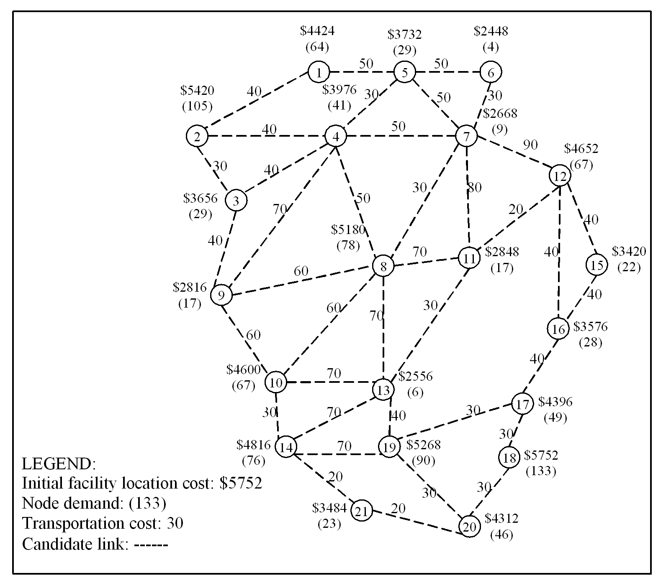
Figure 1. Network with 21 nodes

Figure 2 shows the optimal solution to the problem. The located facilities have been shown with squares. The facilities located at nodes 2, 12, 18, and 21 have gained ranks of 2, 2, 5, and 3, respectively. However, the other facilities have no increase in their capacity. This Figure also shows constructed links. Line thicknesses imply link ranks. For example, the rank of links (7, 8), (12, 16) and (14, 21) are 1, 2, and 4, respectively. The optimum total cost obtained for this problem was $70736. In Figure 2, costs are shown separately.
To investigate the effect of considering facilities and links capacities as decision variables, the results are compared with those of CFLNDP (Melkote and Daskin [13]). To do such comparisons, some customizations are needed. In CFLNDP, link capacities are supposed to be infinite but links are capacitated in our model. Therefore, Eq. (14) is added to CFLNDP. In this equation, $X_{\text{ij}}$ is equal to 1 if the link $(i,j)$ is constructed; otherwise, it equals 0.
$${\sum_{k∈N}{Y_{\text{ij}}^{k}} D_{k} ≤ S\text{.} \text{Cap \{}l}_{\text{ij}}^{'}\text{.}X_{\text{ij}},(i,j)∈L$$ | (14)
Based on this observation in the example, $b_{1}$ is equal to 4, a number from the set {1, 2, 3, 4} is randomly selected for${\text{Cap \{}l}_{\text{ij}}^{'}$. For example, if 2 is selected for the link$(i,j)$, this link will not be constructed, or in case of construction, its capacity will be$2∗\text{20}=\text{40}$. This is while in the proposed model, each link can select its capacity from the set {20, 40, 60, 80}. To determine the capacity of facilities for each node (given that$b_{2}=5$,$n=\text{20}$,$m=\text{100}$), a number from the set {100, 120, 140, 160, 180, 200} is randomly selected. These values are proportional to the values of variables $E_{i}$and ${\text{Capf}}_{i}$ in our proposed model. In CFLNDP, for example, if 140 is selected for node 5, no facility or a facility with capacity 140 will be located in this node, while in our model the capacity of each facility in each node can be each of the above values. Using this method, 20 random problems will be generated whose solutions obtained from both CFLNDP and the proposed model can be compared as shown in Table 2. The results show that our model simultaneously decreases the total cost and clearly increases utilization of facilities and links. In fact, by optimum use of facilities and links capacity, the link construction and facility location costs are decreased. Although this observation can be expected due to the flexibility of the solution space in our proposed model compared to that in CLENDP, this example reveals that the improved values (average values of 63% and 27%, respectively, for increases in facility and link utilizations and 18% for total cost reduction) are quite considerable.
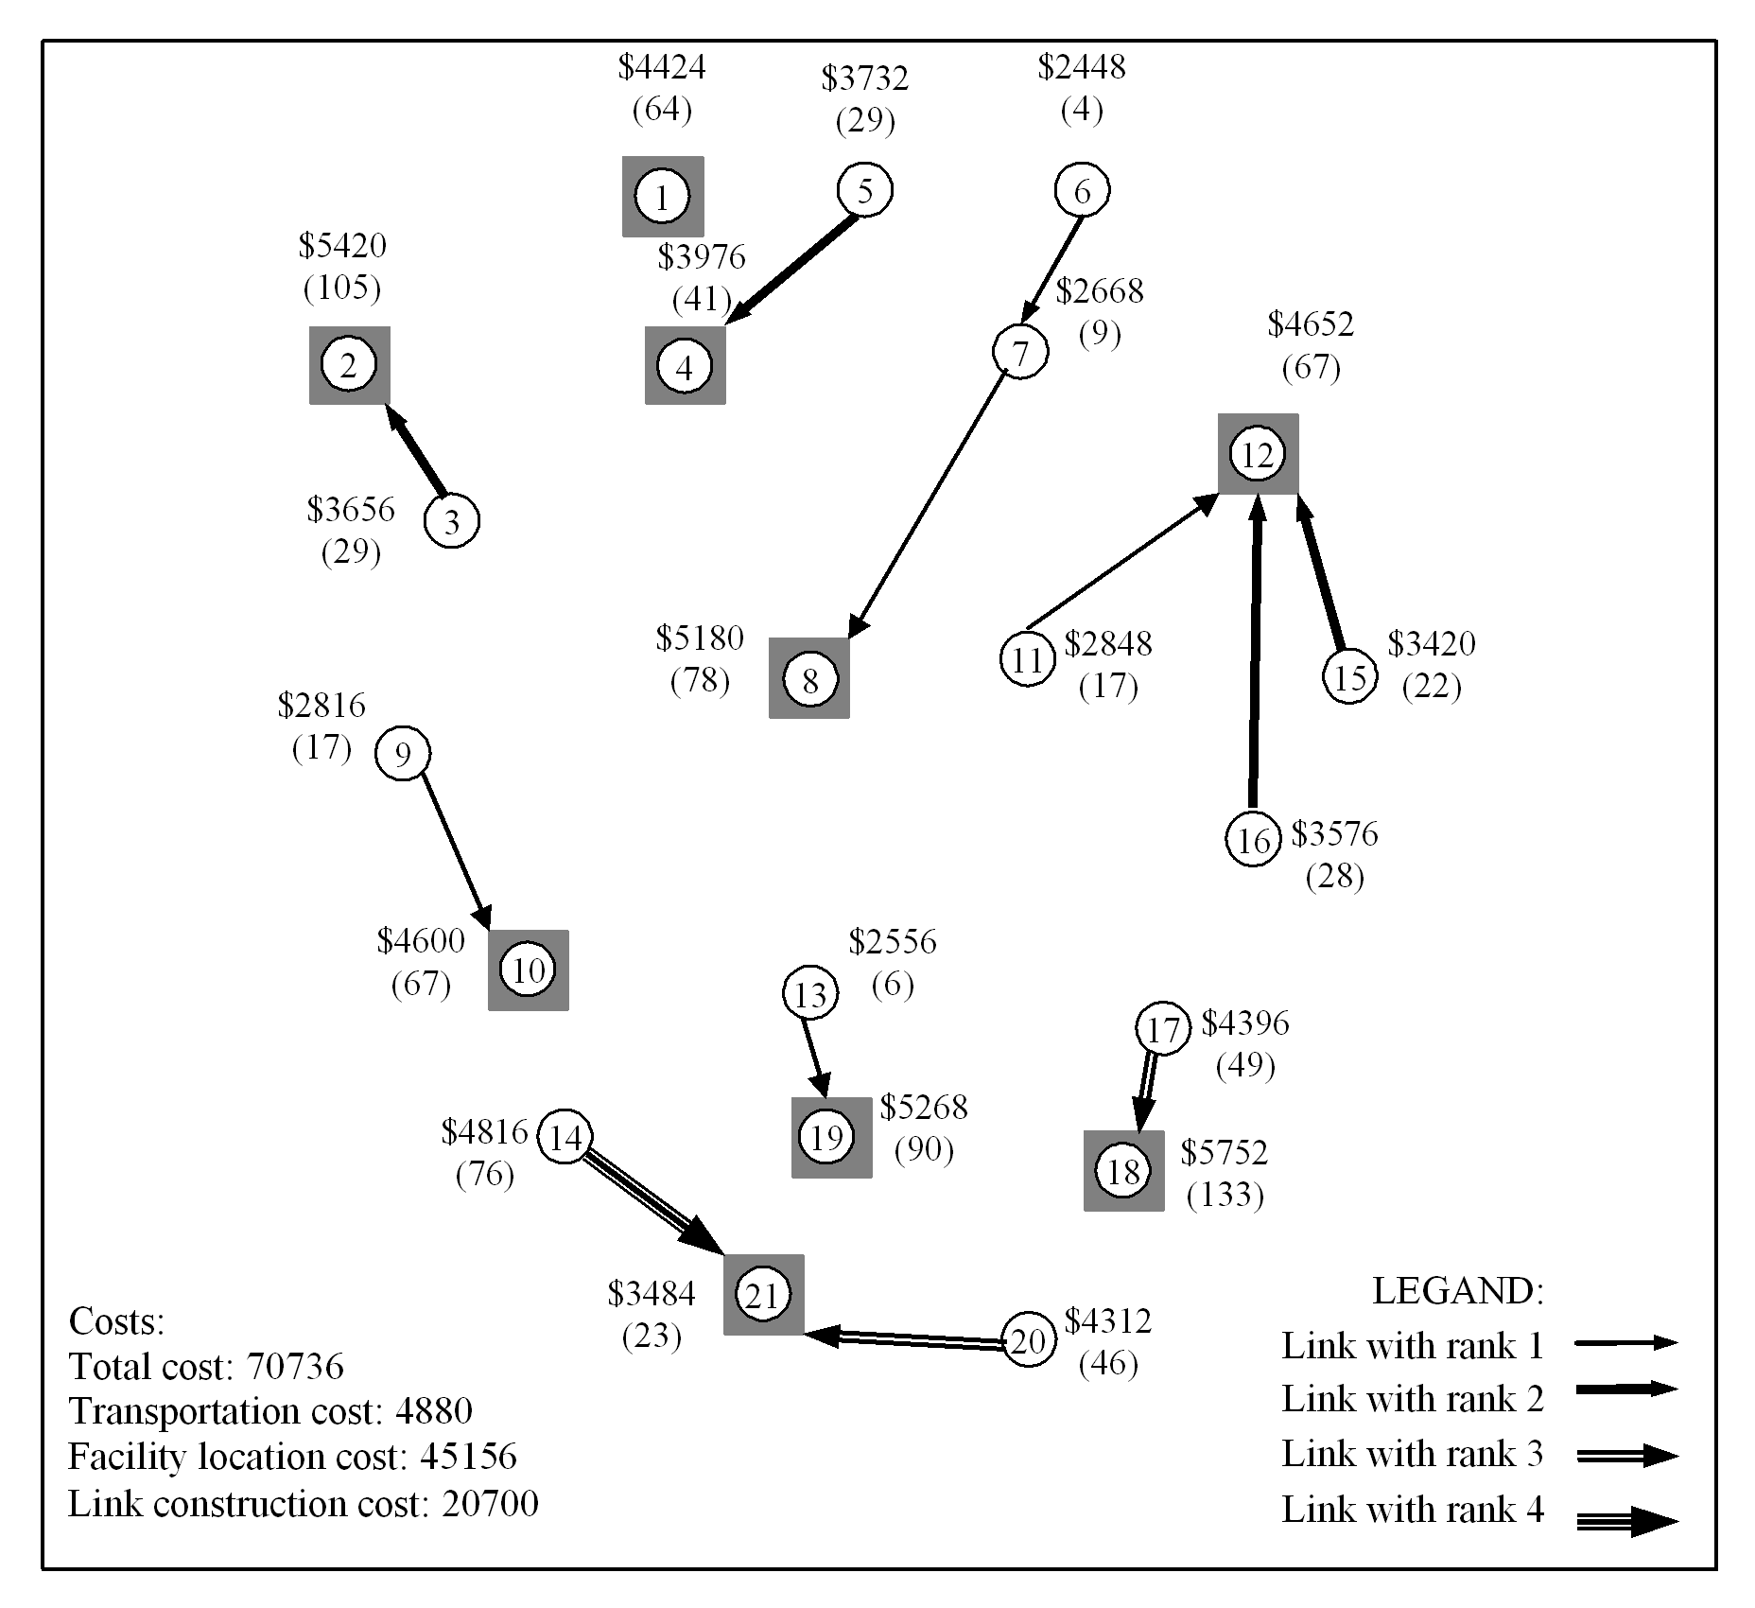
Figure 2. Optimal solution

 | Prob. | Number of candidate |  |  |  |  |  |  | Number of located |  |  |  |  |  | Avg. facilities | Number of candidate |  |  |  |  | Number of constructed |  |  |  | Avg. links | Total
 | Num. | facilities with capacity: |  |  |  |  |  |  | facilities with capacity: |  |  |  |  |  | utilization (%) | links with capacity: |  |  |  |  | links with capacity: |  |  |  | utilization (%) | cost
 |  | 100 | 120 | 140 | 160 | 180 | 200 |  | 100 | 120 | 140 | 160 | 180 | 200 |  | 20 | 40 | 60 | 80 |  | 20 | 40 | 60 | 80
CFLNDP | 1 | 0 | 4 | 5 | 4 | 6 | 2 |  | 0 | 2 | 5 | 1 | 4 | 0 | 55.15 | 8 | 12 | 13 | 5 |  | 4 | 5 | 1 | 0 | 57.42 | 84246
CFLNDP | 2 | 1 | 4 | 8 | 1 | 6 | 1 |  | 1 | 3 | 5 | 1 | 2 | 0 | 61.46 | 5 | 11 | 14 | 8 |  | 2 | 5 | 3 | 0 | 51.42 | 86914
CFLNDP | 3 | 2 | 2 | 3 | 5 | 6 | 3 |  | 1 | 2 | 3 | 2 | 5 | 1 | 50.27 | 5 | 13 | 16 | 4 |  | 1 | 5 | 3 | 0 | 39.17 | 92678
CFLNDP | 4 | 5 | 2 | 6 | 3 | 3 | 2 |  | 3 | 2 | 5 | 1 | 1 | 1 | 56.89 | 12 | 10 | 12 | 4 |  | 3 | 4 | 3 | 0 | 51.50 | 86258
CFLNDP | 5 | 2 | 5 | 4 | 6 | 1 | 3 |  | 2 | 2 | 3 | 5 | 1 | 1 | 48.48 | 4 | 13 | 13 | 8 |  | 0 | 6 | 1 | 0 | 50.48 | 85174
CFLNDP | 6 | 0 | 5 | 1 | 5 | 6 | 4 |  | 0 | 2 | 0 | 2 | 6 | 3 | 44.68 | 7 | 10 | 15 | 6 |  | 4 | 3 | 2 | 1 | 54.96 | 92266
CFLNDP | 7 | 0 | 6 | 6 | 2 | 3 | 4 |  | 0 | 1 | 4 | 2 | 1 | 3 | 56.12 | 8 | 13 | 11 | 6 |  | 4 | 4 | 3 | 0 | 58.79 | 85110
CFLNDP | 8 | 3 | 6 | 2 | 0 | 7 | 3 |  | 2 | 5 | 2 | 0 | 6 | 2 | 42.02 | 6 | 17 | 10 | 5 |  | 2 | 3 | 0 | 0 | 58.00 | 88568
CFLNDP | 9 | 5 | 1 | 2 | 4 | 6 | 3 |  | 4 | 1 | 1 | 2 | 3 | 2 | 53.42 | 8 | 11 | 15 | 4 |  | 2 | 4 | 2 | 0 | 57.81 | 83564
CFLNDP | 10 | 3 | 1 | 2 | 5 | 8 | 2 |  | 2 | 1 | 2 | 0 | 6 | 2 | 49.58 | 9 | 10 | 16 | 3 |  | 5 | 4 | 1 | 0 | 66.00 | 89920
CFLNDP | 11 | 0 | 3 | 4 | 6 | 5 | 3 |  | 0 | 3 | 4 | 2 | 3 | 1 | 52.64 | 6 | 12 | 13 | 7 |  | 4 | 5 | 1 | 0 | 46.83 | 89064
CFLNDP | 12 | 2 | 4 | 4 | 4 | 7 | 0 |  | 2 | 4 | 3 | 1 | 3 | 0 | 57.22 | 6 | 12 | 14 | 6 |  | 4 | 4 | 0 | 1 | 58.33 | 84890
CFLNDP | 13 | 1 | 5 | 3 | 7 | 3 | 2 |  | 0 | 4 | 1 | 6 | 1 | 0 | 57.85 | 8 | 11 | 14 | 5 |  | 4 | 4 | 2 | 0 | 56.92 | 83566
CFLNDP | 14 | 3 | 1 | 7 | 5 | 4 | 1 |  | 2 | 1 | 4 | 3 | 3 | 0 | 53.42 | 5 | 14 | 13 | 6 |  | 4 | 4 | 1 | 0 | 56.76 | 82418
CFLNDP | 15 | 5 | 3 | 8 | 3 | 2 | 0 |  | 1 | 2 | 6 | 2 | 2 | 0 | 56.92 | 6 | 14 | 13 | 5 |  | 1 | 6 | 2 | 0 | 43.06 | 86558
CFLNDP | 16 | 1 | 5 | 7 | 4 | 3 | 1 |  | 0 | 4 | 4 | 4 | 1 | 0 | 55.30 | 3 | 12 | 15 | 8 |  | 0 | 5 | 3 | 0 | 41.35 | 86732
CFLNDP | 17 | 1 | 4 | 2 | 5 | 7 | 2 |  | 0 | 2 | 2 | 4 | 3 | 1 | 52.42 | 3 | 13 | 15 | 7 |  | 1 | 4 | 3 | 1 | 52.04 | 86344
CFLNDP | 18 | 3 | 6 | 3 | 4 | 3 | 2 |  | 3 | 4 | 3 | 1 | 2 | 2 | 50.51 | 5 | 19 | 9 | 5 |  | 1 | 6 | 0 | 0 | 55.71 | 87444
CFLNDP | 19 | 0 | 5 | 6 | 6 | 2 | 2 |  | 0 | 4 | 3 | 4 | 1 | 1 | 52.50 | 9 | 11 | 13 | 5 |  | 4 | 3 | 3 | 0 | 54.08 | 86924
CFLNDP | 20 | 2 | 4 | 5 | 6 | 2 | 2 |  | 2 | 3 | 3 | 4 | 1 | 0 | 55.72 | 9 | 11 | 14 | 4 |  | 2 | 5 | 2 | 0 | 46.94 | 84998
CFLNDP | avg. | 2 | 3.8 | 4.4 | 4.3 | 4.5 | 2.1 |  | 1.3 | 2.6 | 3.2 | 2.4 | 2.8 | 1 | 53.13 | 6.6 | 12 | 13 | 5.6 |  | 2.6 | 4.5 | 1.8 | 0.2 | 52.88 | 86681.8
Proposed Model |  | - | - | - | - | - | - |  | 5 | 0 | 2 | 1 | 0 | 1 | 86.45 | - | - | - | - |  | 5 | 4 | 2 | 1 | 67.36 | 70736
Table 2. Comparison of results obtained from proposed model and CFLNDP

3.2. Sensitivity analyses
In this section, we will investigate the behavior of the model with respect to link construction and facility location costs.
3.2.1. Sensitivity analysis with respect to link construction cost (parameter u)
If u is increased, transportation cost will decrease (Figure 3.b). In fact, with higher link construction costs, the model locates more facilities and most of the demands will be served at relevant nodes. This increases the number of facilities and, consequently, facility location costs (Figures 3.c & 3.f). By increasing u to a specific value, the model still suggests construction of some previous links or their equivalents at a higher cost; this causes total link construction cost to increase. But, if $u$is increased to higher value, the model will select less links to be constructed (Figure 3.d). When unit link construction cost u increases, we observe most of the facilities located in their own nodes as basic facility; therefore, the sum of number of ranks decreases correspondingly (Figure 3.a). Finally, the total cost will be increased evidently as a result of increasing u (Figure 3.e).

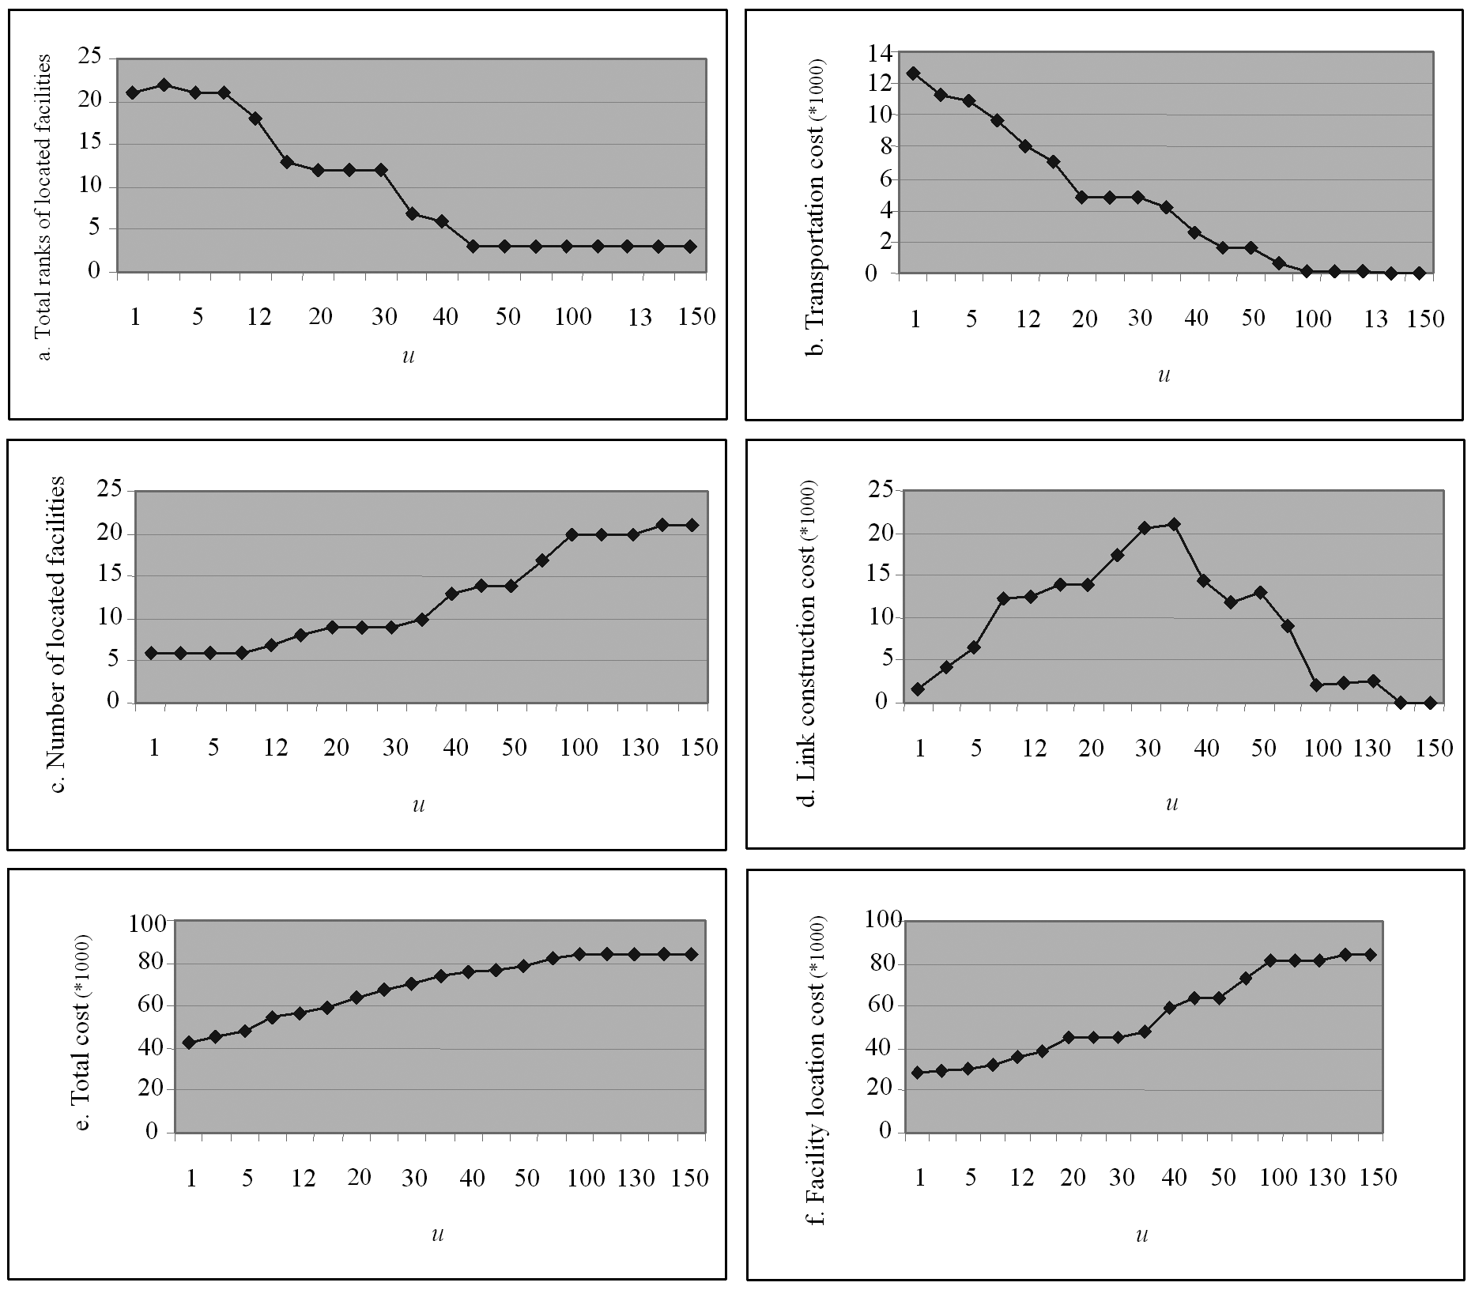
Figure 3. Sensitivity analysis with respect to u

3.2.2. Sensitivity analysis with respect to facilities location cost $(\text{IC},ν)$
To study the effect of increasing facilities location cost,$(\text{IC},ν)$in the above example is multiplied by various coefficients (horizontal axes in the charts). By increasing$(\text{IC},ν)$, more links are constructed and demands are shipped out to other nodes. So, link construction and transportation costs are increased (Figures 4.d & 4.b). By increasing$(\text{IC},ν)$, the total facility location costs will increase with relevant fluctuations. When $(\text{IC},ν)$is increased, the model initially suggests previous facilities or their equivalents to be located. If this trend continues, locating some facilities may no longer be economical (Figure 4.f). Figures 4.a and 4.c show that increasing$(\text{IC},ν)$ decreases the number of located facilities and the sum of facilities rank enhancements increases. Figure 4.e shows that by increasing$(\text{IC},ν)$, the total cost is increased.

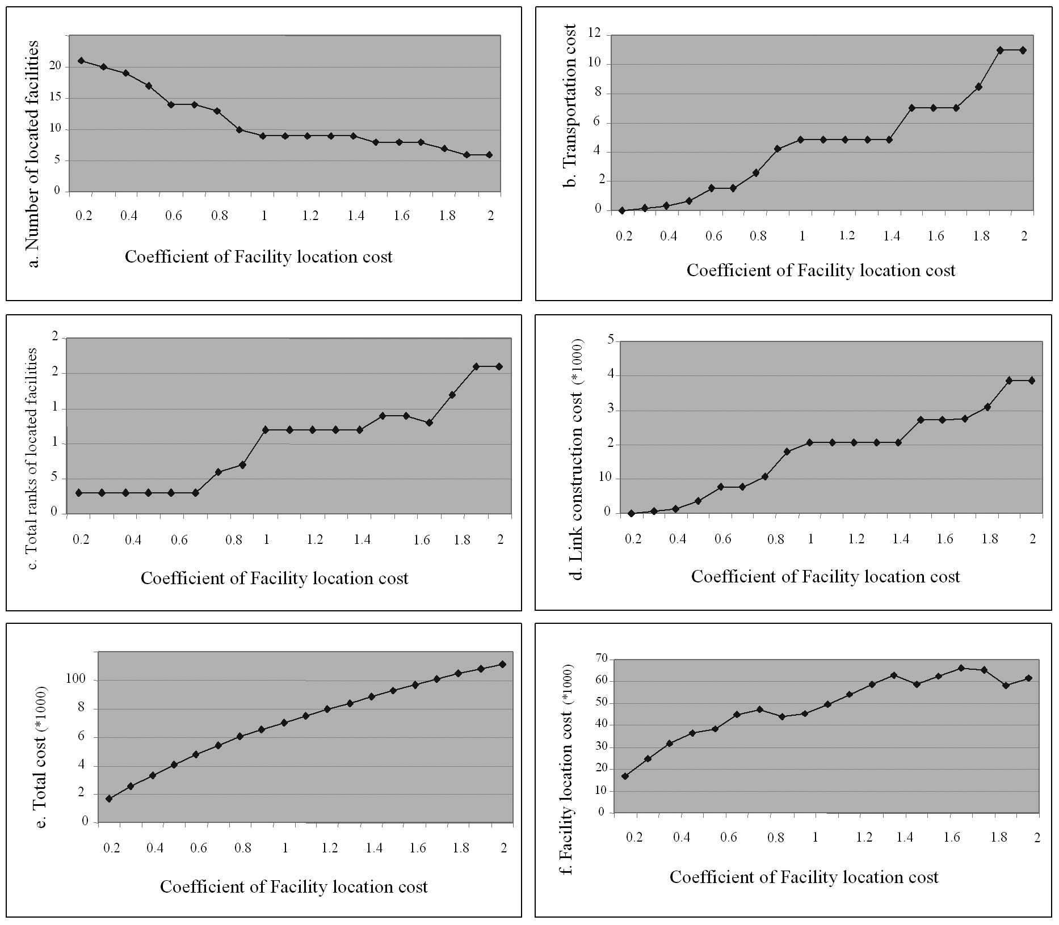
Figure 4. Sensitivity analysis with respect to $(\text{IC},ν)$

3.3. Investigation of model efficiency with respect to computational solution time
In this part, we will employ almost the same approach to test problems as used by Balakrishnan et al. [2] for the UFLNDP problem. This approach can be explained as follows. At first, the location of each node is randomly determined in a network of the size 500*500 (For each node, x and y are randomly generated in the range [1,500]). Then, node distances are calculated as Euclidean distances and the number of candidate links that are connectable to other nodes is generated from a Uniform $[\text{2, 5}]$distribution. In other words, for each node an integer random number is generated which represents the number of candidate links connectable from that node to others in the network. Also, the demand on each node is generated randomly from a Uniform [50, 200] distribution. Basic facilities location cost is generated and normalized using a Uniform [2000, 6000] distribution so that their average is 4000. Other parameters are used as described in Table 1. Figure 5 shows the CPU time versus the number of nodes and the value of u. For node numbers less than 40, the CPU time is less than 1 second. For a fixed value of u, as we can see, CPU time is almost exponentially increased with increasing number of nodes. Sensitivity analysis of the CPU time with respect to the value of u as an important parameter was also performed since the ratio of link construction cost to facility location cost can be controlled by changing the value of u. Numerical results show that CPU time generally decreases when the value of u increases.

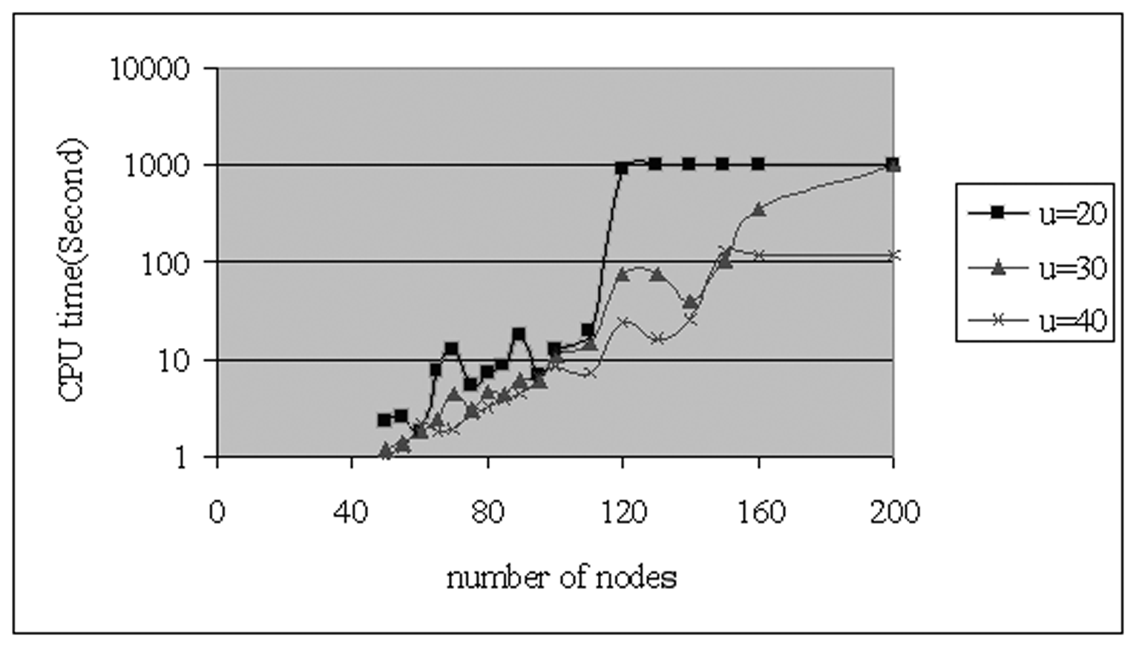
Figure 5. CPU time versus number of nodes and values of u

4. Conclusion
In this paper, we proposed a MIP model to determine discrete optimal facilities and links capacities in FLNDP. The major difference between the present model and previous studies of FLNDP is that facilities and links capacity are here considered as decision variables, not as constraints. This approach increases the utilization of facilities and links, and prevents construction of links and location of facilities with low utilization. Also to conform to real conditions, link construction (facility location) cost was considered as function of that link (facility) capacity.
The proposed model was exhaustively investigated via numerical examples. Compared to CFLNDP, computational results showed that the proposed model would locate facilities and construct links of higher utilization, so that the total cost would decrease. The model is well sensitive to changes in parameter values. The numerical results also show that the CPU time varies almost exponentially with the number of nodes and, further, that problems up to 200 nodes are solvable in less than 17 minutes. With regard to the kind and nature of this model and its applications, it can be said that a problem with 200 nodes is a rather large one and the CPU time used is reasonable.
Several extensions of the model are possible to enhance its applicability to a variety of real life transportation and distribution network planning scenarios. Some suggestions are: (1) the consideration of multi-commodity networks, and (2) the consideration of two directional links.

References
[1] U. Akinc and B.M. Khumawala, An efficient branch and bound algorithm for the capacitated warehouse location problem, Manag Sci 23 (1977) 585-594.
[2] A. Balakrishnan, T.L. Magnanti, and R.T. Wong, A dual ascent procedure for large-scale uncapacitated network Design, Oper Res 37 (1989) 716-740.
[3] N. Christofides and J.E. Beasley, Extensions to a Lagrangian relaxation approach for the capacitated warehouse location problem, Eur J Ope Res 12 (1983) 19-28.
[4] M.S. Daskin, A.P. Hurter, and M.G. Van Buer, Toward an integrated model of facility location and transportation network design, Working Paper, The Transportation Center, Northwestern University, Evanston, IL, USA (1993).
[5] M.S. Daskin, Location, dispatching, and routing models for emergency services with stochastic travel times, In: A. Ghosh and G. Rushton, Spatial Analysis and Location-Allocation Models, Van Nostrand Reinhold, New York, 1987 224-265.
[6] P.S. Davis and T.L. Ray, A branch-bound algorithm for capacitated facilities location problem, Naval Res. Logistics Q. 16 (1969) 331-344.
[7] M. Guignard, K. Spielberg, A direct dual method for the mixed plant location problem with some side constraints, Math Program 17 (1979) 198-228.
[8] M.J. Hodgson and K.E. Rosing, A network location-allocation model trading off. flow capturing and p-nedian objectives, Ann of Oper Res 40 (1992) 247-260.
[9] S.K. Jacobsen, Heuristics for the capacitated plant location model, Eur J Ope Res 12 (1983), 253-261.
[10] G. Laporte, F.V. Louveaux, and L. Hamme, Exact solution of a stochastic location problem by an integer L-shaped algorithm, Transp Sci 28 (1994) 95-103.
[11] T.L. Magnanti and R.T. Wong, Network design and transportation planning: Models and algorithms, Transp Sci 18 (1984) 1-55.
[12] S. Melkote and M.S. Daskin, An integrated model of facility location and transportation network design, Transp Res 35 (2001) 515-538.
[13] S. Melkote and M.S. Daskin, Capacitated facility location/network design problems, Eur J Ope Res 129 (2001) 481-495.
[14] S. Melkote, Integrated models of facility location and network design, PhD Dissertation, Department of Industrial Engineering and Management Science, Northwestern University, Evanston, IL, 1996.
[15] G.L. Nemhauser and L.A. Wolsey, Integer and Combinational Optimization, Wiely, New York, 1988.
[16] D. Simchi-Levi, The capacitated traveling salesmen location problem, Transp Sci 25 (1991) 9-18.
[17] D. Simchi-Levi and O. Berman, A heuristic algorithm for the traveling salesman location problem on networks, Oper Res 36 (1988) 478-484.

Corresponding author email: ali-nook@cc.iut.ac.ir
Average facilities utilization in CFLNDP model is obtained from ${\sum_{i}{\sum_{k}{[D_{k}}{W_{i}^{k}}/{K_{i}}]}}/{\sum_{i}{Z_{i}}}$( where $K_{i}$ is capacity of facility that is located at node $i$,$Z_{i}$ is equal to 1 if a facility is located at node $i$and otherwise equal to 0) and in proposed model from ${\sum_{i∈\left\{N:E_{i}≠0\right\}}{\sum_{k}{[D_{k}} {W_{i}^{k}}/ (m E_{i} +n {\text{Capf}}_{i})]}}/{\sum_{i}{E_{i}}}$.
Average links utilization in CFLNDP model is calculated from${\sum_{(i,j)∈L}{{\sum_{k∈N}{[Y_{\text{ij}}^{k}} D_{k} /S\text{.} \text{Cap \{}l}_{\text{ij}}^{'}}]}/{\sum_{(i,j)∈L}{X_{\text{ij}}}}$(where$X_{\text{ij}}$is equal to 1 if link$(i,j)$is constructed and $i<j$, otherwise equal to 0 ) and in proposed model from${\sum_{(i,j)∈\left\{L:{\text{Capl}}_{\text{ij}}≠0\right\}}{\sum_{k∈N}{[Y_{\text{ij}}^{k}} D_{k} /S\text{.} {\text{Capl}}_{\text{ij}}]}}/{\sum_{(i,j)∈L}{\text{min}}}$.

