**SYSTEM DYNAMICS APPROACH FOR QUANTITATIVE RISK ALLOCATION**

**Mostafa Khanzadi, Assistant Professor,** [**khanzadi@iust.ac.ir**](mailto:a_khanzadi@st.ac.ir)

Dept. of Civil Engineering - Iran University of Science and Technology - Tehran – Iran-

Cellphone: 09123121025

**Farnad Nasirzadeh, Assistant Professor,** [**f.nasirzadeh@gmail.com**](mailto:f.nasirzadeh@gmail.com)

Dept. of Project Management - Faculty of Engineering - Payame Noor University (PNU) –Karaj – Iran

**Mahdi Rezaie, M.Sc. Student, mahdirezaie@gmail.com**

Dept. of Civil Engineering - Iran University of Science and Technology - Tehran - Iran

**Abstract:**

Allocation of construction risks between clients and their contractors has a significant impact on the total construction costs. This paper presents a system dynamics (SD)-based approach for quantitative risk allocation. Using the proposed SD based approach, all the factors affecting the risk allocation process are modeled. The contractor’s defensive strategies against the one-sided risk allocation are simulated using governing feedback loops. The full-impact of different risk allocation strategies may efficiently be modeled, simulated and quantified in terms of time and cost by the proposed object-oriented simulation methodology. The project cost is simulated at different percentages of risk allocation and the optimum percentage of risk allocation is determined as a point in which the project cost is minimized. To evaluate the performance of the proposed method, it has been implemented in a pipe-line project. The optimal risk allocation strategy is determined for the inflation risk as one of the most important identified risks.

**Keywords**: Modeling, risk allocation, simulation, system dynamics.

**1-Introduction:**

Risk allocation is the process of identifying project risks and determining how they may be equitably and realistically shared by all of the parties in a construction project [1]. Allocation of construction risks between clients and their contractors has a significant impact on the total construction costs [2].

Traditionally, in construction projects, client seeks to pass most of all risk to the contractor. However, one sided attitude regarding risk allocation, which one party tries to dispatch all risk to other parties, probably result in unfavorable effect to both transferees and transferrers [2], [3]. Due to one-sided attitude to the risk allocation and unfair transfer of risks, the parties that these risks are imposed to are forced to adopt defensive strategies such as lowering the work quality, imposing extensive contingency charges, conservative design and finally claim, dispute and litigation. These defensive strategies may lead to project delay, project cost overrun and poor quality (Fig.1). Risk allocation strategies should be determined at the inception of the project by the client organization [4]. The risk allocation should be done appropriately in order to prevent defensive strategies leading to project delay, project cost overrun and poor quality.

Risk allocation can be categorized into qualitative and quantitative approaches. The qualitative approach is considered as standardized form of contract specifying the obligation of contractual parties. The qualitative approach leads to the development of the risk allocation matrix, which identifies what type of risk is allocated to whom [5]. The quantitative approaches of risk allocation have been developed to overcome the limitation of qualitative approaches especially the issue of how much risk should be borne by each party. Most of the quantitative approaches discussed their risk allocation model based on the optimality of allocating the risk [3].

Almost all of the previous researches perform the risk allocation qualitatively. Lam et al [6] presented a decision model to qualitative risk allocation using the fuzzy logic. Seven risk allocation criteria and a set of knowledge-based fuzzy inference rules were established and the corresponding risk allocation decisions between the client and contractor were suggested. Li bing et al [7] explored risk allocation in PPP/PFI construction projects in the UK. A questionnaire survey was conducted to explore preferences in risk allocation. El sayegh [8] identiﬁed and assessed the signiﬁcant risks in the UAE construction industry and addressed their proper allocations qualitatively. Kangari [9] discussed the attitude of large U.S. construction firms toward risks and determined how these contractors conduct construction risk management based on a survey of the top 100 large U.S. contractors. Loosmore [10] analyzed the rationale behind decision about risk distributions between public and private sectors and their consequences. Loosemore and McCarthy [11] explored differences in perceptions of risk allocation within the traditional construction supply chain and a simple risk/role matrix was developed to indicate who was the best party to manage each risk.

Although there are several works in the area of qualitative risk allocation, there exists only one work in the area of quantitative risk allocation. Levitt and Ashley [2] described a methodology which allocated construction projects risks quantitatively by a decision analysis model. This research, however, faced some major defects. The various factors affecting the risk allocation process and the defensive strategies which may be implemented by the contractor against one sided risk allocation were not taken into accounted. Moreover, the dynamic nature of risks throughout the project life cycle was not considered.

This research presents a system dynamics (SD) based approach to perform the risk allocation both qualitatively and quantitatively. The proposed approach resolves the shortcomings of the previous works. In order to perform the risk allocation using proposed SD based approach, all the factors affecting the risk allocation process are modeled using cause and effect feedback loops. The contractor’s defensive strategies are also simulated. The developed SD model determines the optimum risk allocation strategy both qualitatively and quantitatively. In order to determine the optimum risk allocation quantitatively, the project cost is simulated at different percentages of risk allocation and the optimal risk allocation is determined as a point in which the project cost is minimized. To evaluate the performance of the proposed method, it has been implemented in a pipe-line project. . The optimal risk allocation is determined for the inflation risk as one of the most important identified risks.

**2-system dynamics methodology:**

System dynamics was created during the mid-1950s by [Jay Forrester](http://en.wikipedia.org/wiki/Jay_Forrester) [12].System dynamics is adequate for the modeling and simulation of systems which are extremely complex, consisting of multiple interdependent components, are highly dynamic, involve multiple feedback processes, and nonlinear relationships with both “hard” (quantitative) and “soft” (qualitative) data [13]. Considering the complex inter-related structure of different factors affecting the risk allocation process, SD is well suited to perform the risk allocation process.

SD has been applied in different areas of construction project management [14]. SD approach describes cause-effect relationships with stocks, ﬂows and feedback loops [15]. Stocks represent stored quantities and ﬂows represent control quantities ﬂowing into and out of stocks [16]. Causal loop diagrams (CLDs) are an important tool for representing the feedback structure of systems. CLDs are excellent for quickly capturing hypotheses about the causes of dynamics, eliciting and capturing the mental models of individuals or teams, communicating the important feedbacks believed to be responsible for a problem [12]. All dynamics arise from the interaction of just two types of feedback loops, i.e., positive (or self-reinforcing) and negative (or self-correcting) loops. Positive loops tend to reinforce or amplify whatever is happening and negative loops counteract and oppose change [12].

**3- Risk allocation process simulation model**

The proposed SD based approach performs the risk allocation both qualitatively and quantitatively. In the qualitative risk allocation, the responsibility of a risk is totally allocated to the contractor or client. In the quantitative risk allocation, however, the consequences of a risk are shared by all parties involved in a project and an optimum percentage of risk allocation is determined in which the project cost is minimized.

To quantify the consequences of different risk allocation strategies on project objectives first a qualitative model of the risk allocation process was developed. The qualitative model of risk allocation process for the inflation risk, as one of the most important identified risks, is presented in fig. 2. As it can be seen in this figure, the project cost is consisted of workforce cost, equipment cost and material cost. In the case of occurrence of inflation risk, the workforce, equipment and material costs will increase leading to an increase in project cost.

As shown in fig. 2, the amount of cost overrun arising from inflation is shared by the contractor and client based on the achieved risk allocation percentage. This cost overrun results in deficiency in contractor’s financial sources (Fig. 2). The amount of deficiency in financial sources depends on the amount of cost overrun due to the inflation as well as the percentage of risk allocated to the contractor. Taking account of the amount of cost overrun imposed due to the occurrence of inflation risk, the contractor may implement alternative defensive strategies such as lowering work quality, claim, dispute and litigation (Fig. 2). Moreover, due to deficiency in financial sources, the contractor has to lower the amount of resources implemented in the work. Therefore, the actual completion rate is decreased and the project duration is increased accordingly.

Having constructed the qualitative model of the risk allocation process, the mathematical relationships (model equations) existed between different factors were determined. So that, the full-impact of different risk allocation strategies may efficiently be modeled, simulated and quantified using the proposed SD modeling approach. The model can simulate the project objectives in terms of project cost and time taking account of all factors influencing the risk allocation process as well as the contractor’s defensive strategies. The following section explains the qualitative model shown in Fig.2 in more detail. Some conceptual diagrams have been derived from the model to explain the model behavior considering the existing reinforcing and balancing feedback loops.

**4- Conceptual model of deficit in financial sources due to inflation**

The conceptual diagram of deficit in financial sources due to inflation and its impact on implemented resources has been presented in fig.3. As shown in this figure the occurrence of inflation risk will increase the equipment, material and workforce cost. Therefore, the contractor expenses increases accordingly which may result in deficiency in financial sources.

In the case of deficit in financial sources, the contractor will decrease the number of equipment and workforce as well as the amount of supplied material. Therefore, the actual completion rate is decreased and the project duration is increased which may lead in client loss. On the other side, having decreased the actual completion rate means that the work will be executed later and the contractor expenses will increase due to inflation. These cost overruns may result in more pronounced deficiency in financial sources (DFS) and hence exacerbate the degree to which the DFS will affect the performance of the project and a reinforcing loop is constructed (Fig. 3).

Traditionally, the inflation risk is totally allocated to the contractor in fixed price contracts. In the case the responsibility against inflation risk is shared by the client and contractor, the amount of payment to the contractor is increased and the deficit in financial sources is decreased accordingly. Therefore, the negative impacts of inflation risks on the project duration are decreased.

To evaluate the impacts of different risk allocation strategies on project objectives, a factor namely “risk allocation percentage” has been defined in the model.

**5- Conceptual model of defensive strategies**

The conceptual model of defensive strategies which may be implemented by the contractor against the one-sided risk allocation is shown in fig 4. These defensive strategies include lowering work quality, and claim, dispute and litigation. As shown in fig 3, the occurrence of inflation risk will increase the contractor expenses which may result in deficit in financial sources. As a defensive strategy, the contractor may lower the work quality in order to decrease his expenses (Fig. 4). This defensive strategy may reduce contractor expenses. However, lowering the work quality will increase the flawed tasks. These flawed tasks may be discovered by the client or may be undiscovered. The discovered flaws should be corrected by the contractor and increases the contractor expenses and the project duration. Increase in project duration, may in turn lead in client losses due to delay in project start-up which increase the project cost. The undiscovered flaws are not found during the project construction period and are discovered later during project operation. The undiscovered flaws should be corrected by the client and increases the project cost similarly.

**6-Model validation and application**

System dynamics modelers have developed a wide variety of specific tests to uncover flaws and improve models [12]. To evaluate and validate the SD model four validation tests have been implemented. These tests are boundary adequacy, structural assessment, dimensional consistency and extreme conditions.

To evaluate the performance of the proposed risk allocation model, it was implemented in a 150 km pipe-line project. The contract is on unit price basis equals to 650000 dollars per kilometer. According to the preliminary estimations, the project will be executed within 939 days. The inflation is one of the most important risks identified in this project. The monthly inflation rate has been predicted as 2 percent. The proposed SD approach was implemented to determine the optimum percentage of risk allocation.

**7-Results and discussion:**

In order to simulate the impact of different risk allocation strategies on project objectives, the mathematical relationships existed between different variables were determined and the quantitative model of risk allocation was built. So that, the full-impact of different risk allocation strategies may efficiently be modeled, simulated and quantified on project cost and time.

The actual completion rate of work at different percentages of risk allocation is depicted in fig.5. As can be seen in this figure, the actual completion rate is equal to 127 and 160 meter per day at 0 and 100 percent of risk allocation, respectively. As the amount of risk allocated to the client is increased, the actual completion rate will increase accordingly. The following section explains the reason briefly. As explained before, the occurrence of inflation risk, will lead to deficit in financial sources. Therefore, the contractor may decrease the amount of implemented resources which in turn decrease the actual completion rate. If a higher percentage of inflation risk is allocated to the client, deficit in financial sources will be decreased and the actual completion rate will increase accordingly.

In fig.6, the project duration variation at different percentages of risk allocation is presented. The project duration is varied between 938 to 1032 days, corresponding to 100 and 0 percent of risk allocation, respectively. As shown in this figure, the project duration is increased as the percentage of risk allocated to the client is decreased. The reason is that the actual completion rate is decreased due to the inflation risk as explained before. The total client losses due to delay in project start-up at different percentages of risk allocation is presented in fig.7. As explained for fig.6, the project duration is decreased as the percentage of risk allocated to the client is increased. The total client losses arising from delay in project start-up is therefore decreased. The client losses due to inflation risk is varied between US$0 million to US$25 million corresponding to 100 and 0 percent of risk allocation, respectively (Fig. 7).

The rework cost due to undiscovered flaws is presented in fig.8. As can be seen in this figure, the rework cost is maximized when the responsibility of risk is totally allocated to the contractor. The reason is that in this case the contractor is faced with losses and deficit in financial sources. Therefore, the contractor implements the defensive strategy of lowering work quality in order to mitigate these unfavorable effects. The rework cost is varied between US$0 million to US$490000 corresponding to 100 and 0 percents of risk allocation, respectively (Fig. 8).

Finally, the project cost at different percentages of risk allocation is presented in fig.9. As can be seen in this figure, there is an optimum percentage of risk allocation in which the project cost is minimized. In the case the percentage of risk allocated to the client is chosen low, the extra costs imposed due to inflation are mainly born by the contractor. However, some other indirect costs are imposed to the client due to the one sided attitude to the risk allocation. These indirect costs include (1) increase in project duration which consequently lead in the employer’s loss due to delay in project start-up, (2) rework costs due to lowering of work quality by the contractor and (3) the costs related to the claims lodged by the contractor.

In the other extreme of the diagram where a higher percentage of risk is allocated to the client, the extra indirect costs imposed due to the one sided risk allocation are decreased. However, in this case the costs induced from the inflation risk are mainly born by the client resulting in an increased project cost. Therefore, there exists an optimum percentage of risk allocation between these two extremes in which the project cost is minimized. The optimum percentage of risk allocation to the client is 45%. The project cost is minimized at this percentage of risk allocation which is equal to US$116071000 million (Fig. 9).

To appreciate the performance of the proposed model which fully considers all the influencing factors as well as the contractor's defensive strategies against one sided risk allocation, another version of the model was also developed that disregards the contractor's defensive strategies (Fig. 9). In the case the contractor's defensive strategies are disregarded, the optimum percentage of risk allocated to the client is chosen incorrectly as 0 and the significant indirect costs imposed to the client are not taken into account.

It should be mentioned that the achieved concave shape of the project cost diagram is not general and may vary depending on the nature of the selected risk as well as the specific project data used for the modeling and simulation of the risk allocation process.

**8- Conclusions and remarks**

Allocation of construction risks between clients and their contractors has a significant impact on the project cost. Traditionally, in construction projects, client seeks to pass most of all risk to the contractor. Due to One-sided attitude to the risk allocation and unfair transfer of risks, the parties that these risks are imposed to are forced to adopt defensive strategies such as lowering the work quality and claims, dispute and litigation. These defensive strategies may lead to project delay, project cost overrun and poor quality. The previous researches carried out in the area of quantitative risk allocation did not account for defensive strategies which may be implemented against one sided risk allocation. Moreover, the various factors affecting the risk allocation process were not considered. This research presented a system Dynamic (SD) based approach for quantitative risk allocation, which resolves the major shortcoming of the previous works.

In order to perform the quantitative risk allocation, first a qualitative model of risk allocation process was built. All the factors affecting the risk allocation process as well as the contractor’s defensive strategies were modeled using cause and effect feedback loops. Then, the mathematical relationships existed between different factors were determined and the quantitative model of risk allocation process was built. Having constructed the quantitative model of the risk allocation process, the full-impact of different risk allocation strategies (different percentages of risk allocation) can be modeled, simulated and quantified on project cost and time.

The applicability and performance of the proposed method was evaluated by its implementation in a pipe-line project. The optimum risk allocation strategy was determined for the inflation risk as one of the most important identified risks. The project cost was simulated at different percentages of risk allocation and the optimum risk allocation strategy was determined as a point in which the project cost is minimized.

It is traditionally believed that the project cost is minimized when the responsibility of risks is totally allocated to the contractor. However, the results achieved by the proposed SD model revealed that the project cost is minimized at 45 percentages of risk allocation. The reason is that when the responsibility of risk is totally allocated to the contractor, this party may implement defensive strategies such as lowering the work quality and lodging claims, which are not taken into account in the traditional approaches. These defensive strategies lead in project cost overrun, project delay and poor quality, which increases the project cost accordingly. To appreciate the performance of the proposed model which fully considers all the influencing factors as well as the contractor's defensive strategies against one sided risk allocation, another version of the model was also developed that disregards the contractor's defensive strategies.

Using the proposed SD approach, the optimum risk allocation strategy could be determined for each of the identified risk. It is believed that the proposed SD approach can determine the optimum risk allocation strategy efficiently since all the factors affecting the risk allocation process as well as the contractor's defensive strategies against one sided risk allocation is taken into account.

**References**

[1] Enlightened Risk Allocation, 2005, the American Council of Engineering Companies and the associated general contractors of America (ACEC).

[2] Levitt, R. E., Ashley, D. B., 1980. Allocating Risk and Incentive in Construction. Journal of the Construction Division, 106(3), 297-305.

[3] Pipattanapiwong, J., 2004. Development of Multi-party Risk and Uncertainty Management Process for an Infrastructure Project. Doctoral dissertation. Kochi University of Technology, Cochi, Japan.

[4] Zaghloul, R .S, 2005. Risk Allocation In Contracts-How To Improve Process. Doctoral dissertation .department of civil engineering, Calagary, Alberta.

[5] Yamaguchi, H., Uher, T. E. and Runeson, G, 2001. Risk Allocation in PFI Projects. Proceedings of the 17th Association of Researchers in Construction Management (ARCOM) annual conference, UK. 885-894.

[6] Lam,K.C, Wang,D, Lee, Patricia T.K. , Tsang, Y.T, 2007. Modeling risk allocation decision in construction contracts. International Journal of Project Management, 25, 485–493.

[7] Li Bing, Akintoye, A., Edwards, P.J, and Hardcastle, C., 2005. The allocation of risk in PPP/PFI construction projects in the UK. International Journal of Project Management, 23, 25–35.

[8] El-Sayegh, S.M, 2008. Risk assessment and allocation in the UAE construction industry. International Journal of Project Management, 26, 431–438.

[9] Kangari,R, 1995. Risk Management Perceptions and Trends of U.S Construction. International Journal of Construction Engineering and Management, 121(4), 422-429.

[10] Loosmore, M., 2007. Risk allocation in the private provision of public infrastructure., International Journal of Project Management, 25, 66-76.

[11] Loosemore, M. and Mc Carthy, C.S, 2008, Perceptions of Contractual Risk Allocation in Construction Supply Chains. Journal of Professional Issues in Engineering Education and Practice, 134(1), 95-105.

[12] Sterman, J., 2000. Business Dynamics, McGraw-Hill.

[13] Sterman, J.D. System dynamics modeling for project management, 1992. [online], Available from web.mit.edu/jsterman/www/sdg/project.html

[14] Nasirzadeh, F., Afshar, A., Khanzadi, M., and Howick, S., 2008., Integrating system dynamics and fuzzy logic modeling for construction risk management. International Journal of Construction Management and Economics. 26, 1197–1212.

[15] Stephen ,O., Ogunlana, Heng Li, and Fayyaz A. Sukhera, 2003. System Dynamics Approach to Exploring Performance Enhancement in a Construction Organization. ASCE Journal of Construction Engineering and Management, 129(5), 528-536.

[16] Pena-Mora, F. and Park, M., 2001. Dynamic Planning For Fast-Tracking Building Construction Projects .ASCE Journal of Construction Engineering and Management, 127(6), 445-456.

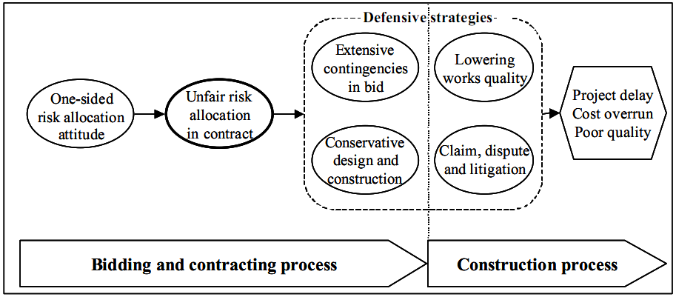

Fig.1. Contractor’s defensive strategies against one-sided risk allocation [adopted from (Pipattanapiwong, 2004)].



Fig.2. Qualitative model of risk allocation



Fig.3. Conceptual model of deficit in financial sources



Fig.4. Conceptual model of the defensive strategies

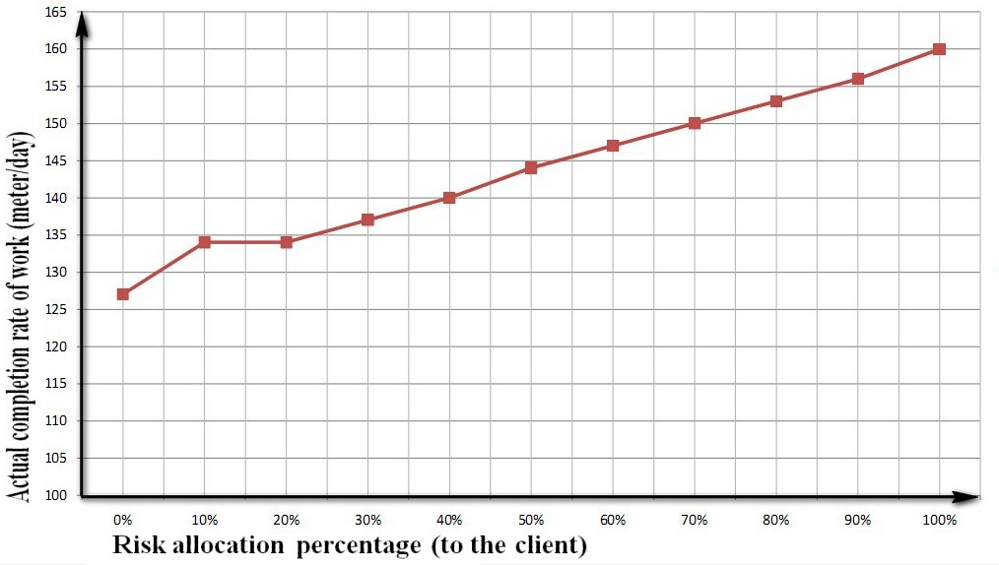

Fig.5. Actual completion rate of work at different percentages of risk allocation

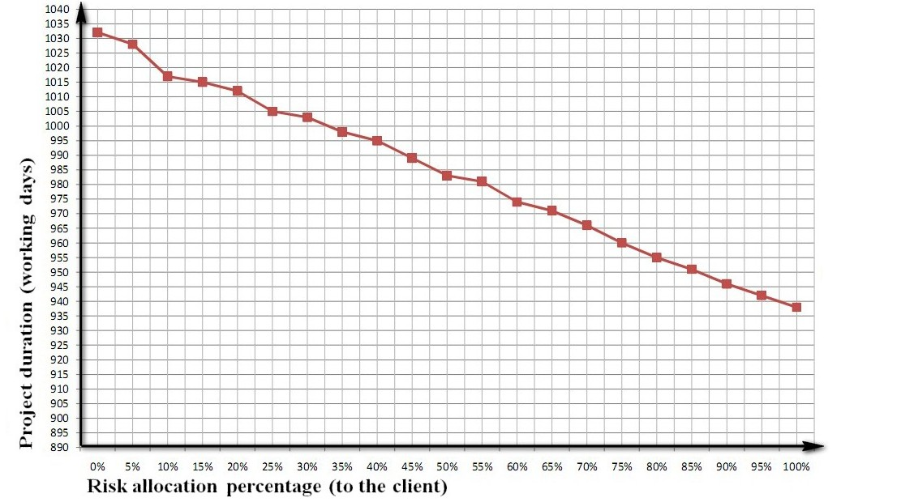

Fig.6. Project duration at different percentages of risk allocation

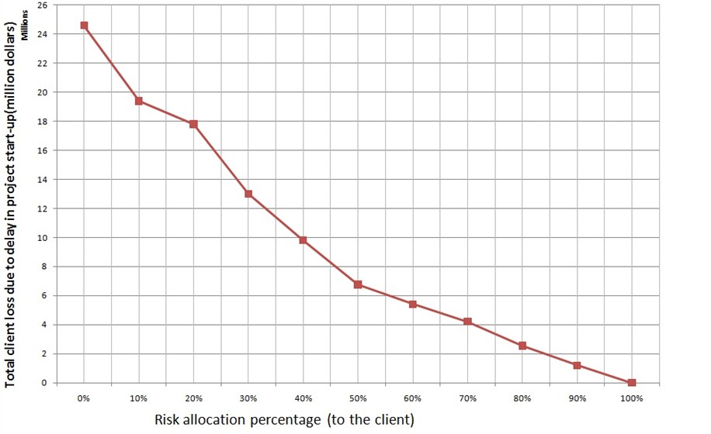

Fig.7. Total client loss due to delay in project start-up at different percentages of risk allocation

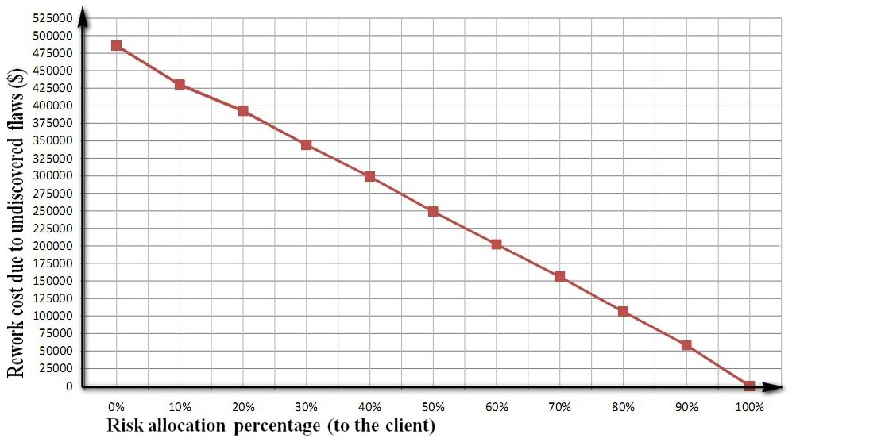

Fig.8. Rework cost due to undiscovered flaws at different percentages of risk allocation

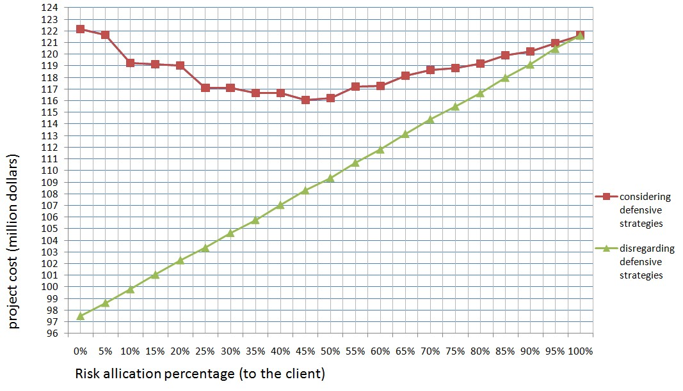

Fig 9. Project cost at different percentages of risk allocation