Evaluating the Effectiveness of Phase Change Materials in Optimizing Energy Storage within Waterproofing Insulation Systems of Mid-Rise Residential Buildings: Emphasis on the Vernacular Architecture of Gilan*

Kimia Jamshidzadeh, Saeed Azemati ^{2*}
Abstract
The increasing energy consumption in the building sector and its environmental impacts highlight the need for strategies that optimize energy use and improve thermal energy storage. In this context, vernacular architecture, as climate-responsive knowledge, offers valuable insights for sustainable and energy-efficient design. The humid-temperate climate of Gilan Province, characterized by high humidity, frequent rainfall, and continuous ventilation needs, provides a suitable context for reassessing building envelope performance, particularly roof waterproofing insulation layers. This study evaluates the potential of Phase Change Materials (PCMs) to enhance thermal energy storage in waterproofing insulation systems of mid-rise residential buildings, with reference to Gilan’s climatic conditions and vernacular architectural principles. A mid-rise residential building in Rasht was selected as the case study, and dynamic energy simulations were conducted using TRNSYS. A reference scenario without PCM was compared with a PCM-integrated scenario in which PCM was placed within the roof waterproofing insulation layer. The main evaluation indicators included thermal storage capacity, indoor temperature stability, and heating and cooling energy demand. The simulation results suggest that integrating PCM into the roof waterproofing layer can reduce annual heating and cooling loads and improve indoor thermal stability under the studied climatic conditions. Total annual energy consumption decreased from approximately 28,230 kWh/year in the reference case to about 25,240 kWh/year in the PCM-integrated scenario, corresponding to an overall reduction of about 10.6%. These findings indicate that, for the investigated building and PCM configuration, targeted PCM integration can enhance thermal storage capacity and contribute to reducing cooling demand in Rasht’s humid climate. Architecturally, PCM technology may complement Gilan’s vernacular strategies, including sloped roofs, semi-open spaces, and natural ventilation, by improving envelope performance. However, as the results are simulation-based, further experimental validation and economic assessment are required before broader application or generalization to other buildings and humid climates with greater practical confidence.
Keywords: Phase Change Materials (PCM), Thermal Energy Storage, Waterproofing Insulation, Vernacular Architecture, Mid-Rise Residential Buildings, Gilan Climate
Introduction
In recent decades, the increasing energy consumption in buildings and its associated environmental impacts have drawn significant attention from researchers toward developing strategies for optimizing energy use in the built environment. According to international reports, buildings account for a considerable share of global energy consumption and greenhouse gas emissions. Consequently, improving building energy performance has become one of the most important research priorities in the fields of sustainable architecture and building engineering (Xing et al., 2011). Among various approaches, enhancing the thermal performance of the building envelope has been identified as one of the most effective strategies for reducing energy consumption associated with heating and cooling demands. In this context, the application of phase change materials (PCMs) has emerged as an innovative technology for optimizing energy use in buildings. Due to their capability to store and release a substantial amount of thermal energy during the phase transition process, PCMs can moderate temperature fluctuations and improve the thermal stability of indoor environments. Various studies have demonstrated that integrating phase change materials into different components of the building envelope—including walls, roofs, and insulation layers—can reduce building thermal loads and consequently decrease overall energy consumption (Jamshidzadeh et al., 2025). Although numerous studies have investigated the integration of PCMs within wall systems, roof assemblies, and conventional insulation layers, limited studies have specifically examined the incorporation of PCMs within waterproofing insulation layers under humid climatic conditions. Moreover, previous research has often focused primarily on thermal performance, while integrated evaluations that combine PCM application with cost-optimal design strategies in humid climates remain relatively limited. Among these components, waterproofing insulation layers constitute an important part of the building envelope. In addition to their primary role in preventing moisture penetration, these layers possess significant potential for integration with advanced thermal energy storage technologies. The combination of waterproofing insulation with phase change materials can enhance the thermal energy storage capacity of the building envelope and help reduce indoor temperature fluctuations. This issue becomes particularly important in humid climates, where high humidity levels and specific climatic conditions may create challenges for achieving thermal comfort and managing building energy consumption (Delshad & Hosseinpour, 2017). Gilan Province, located in northern Iran, is characterized by a humid temperate climate with distinctive environmental conditions, including high relative humidity, abundant rainfall, and seasonal temperature variations. In this region, vernacular architecture has historically evolved in response to climatic conditions through strategies such as the use of verandas, natural ventilation, elevating buildings above ground level, and appropriate spatial organization (Gorji Mahlabani & Aliyaran, 2010). Re-examining these vernacular principles can provide a valuable foundation for integrating traditional knowledge with modern technologies to improve the energy performance of buildings.
Meanwhile, the rapid process of urbanization in many northern cities of Iran has led to an increasing number of mid-rise residential buildings in urban areas. Due to their higher density and distinctive energy consumption patterns, these buildings account for a considerable share of urban energy use. Therefore, investigating innovative approaches to improve the energy performance of this category of buildings can play an important role in reducing energy consumption and promoting sustainable development. Accordingly, the present study aims to evaluate the effectiveness of phase change materials in optimizing thermal energy storage within the waterproofing insulation layer of mid-rise residential buildings, with particular emphasis on the principles of Gilan’s vernacular architecture. The PCM used in this study has a phase transition temperature range of 24–28 °C, which was selected based on the typical indoor thermal comfort range for residential buildings (approximately 22–27 °C) rather than the outdoor annual mean temperature. Selecting a PCM with a phase transition temperature close to the indoor comfort range enables the material to absorb excess heat during warm periods and release stored heat when indoor temperatures decrease, thereby enhancing thermal stability and reducing peak energy demand. This research seeks to examine the potential of phase change materials to enhance the thermal energy storage capacity of the building envelope and to analyze their performance under the climatic conditions of Gilan. In this context, the study addresses the following research questions:
(1) To what extent can the integration of PCM within the waterproofing insulation layer reduce annual heating and cooling loads in a mid-rise residential building located in a humid temperate climate?
(2) How does the incorporation of PCM influence the overall annual energy consumption of the building?
(3) Can the application of PCM contribute to achieving a cost-effective balance between improved energy performance and construction investment in such buildings?
The contribution of this study lies in evaluating the performance of PCM specifically within waterproofing insulation layers in a humid climate and linking this strategy with energy performance improvement in mid-rise residential buildings inspired by vernacular architectural principles of Gilan. The findings of this study may provide practical strategies for improving energy efficiency in residential building design. Ultimately, the results can contribute to the development of innovative approaches for designing low-energy buildings and advancing sustainable architecture and net-zero energy buildings in humid climates.
Literature Review and Research Background
In recent decades, the use of phase change materials (PCMs) has attracted considerable attention as an effective technology for thermal energy storage and the optimization of building energy performance. By storing and releasing latent heat during the phase change process, these materials are capable of moderating indoor temperature fluctuations and enhancing the thermal performance of the building envelope. One of the foundational studies in this field was conducted by Zhang et al. (2007), who investigated the application of latent thermal energy storage in buildings. The results demonstrated that incorporating PCMs into various components of the building envelope can increase thermal energy storage capacity and significantly reduce both heating and cooling loads. This study also emphasized that the appropriate selection of phase change temperature and the placement of PCMs within the building envelope play a critical role in their overall effectiveness. In a comprehensive review, Zalba et al. (2003) examined thermal energy storage technologies based on phase change materials. Their study analyzed the thermophysical properties of PCMs, heat transfer mechanisms, material types, and their diverse applications in building systems. The findings indicated that PCMs can substantially enhance the thermal capacity of building components and reduce indoor temperature fluctuations. Building upon this body of research, Cai et al. (2021) conducted a review focusing on the optimization of PCM parameters within building envelopes. Their results showed that the actual performance of PCMs in buildings depends on factors such as phase change temperature, layer thickness, location within the envelope, and climatic conditions. The study further stressed that PCM selection and design should be tailored to the specific climate and building function.
In another study, Alshuraiaan (2022) investigated the effective utilization of PCMs in building envelopes under hot climatic conditions. The results revealed that the incorporation of PCMs in walls and envelope components can lead to significant reductions in building energy consumption; however, their effectiveness is highly dependent on proper design and alignment with climatic conditions. Similarly, Al Jebaei et al. (2024) examined the use of PCM-integrated wallboards to reduce energy consumption and carbon dioxide emissions in buildings. Their findings confirmed that integrating such materials into the building envelope can considerably reduce annual energy use and contribute to the improved performance of low-energy buildings. Furthermore, a recent review article published in Energies (2025), entitled “Phase Change Materials for Building Energy Applications,” explored a wide range of PCM applications in building components, including walls, floors, façades, and hybrid systems. The results indicated that PCM integration can enhance energy efficiency, reduce peak energy loads, and improve indoor thermal comfort. Nevertheless, the review also highlighted several challenges, such as improving thermal conductivity, ensuring long-term durability, and optimizing the integration of PCMs with building components.
2021
2022
2003
2024
2007
2025
The use of PCMs in the building envelope can increase thermal energy storage capacity and reduce heating and cooling loads.
Phase change materials enhance the thermal capacity of building components, helping to reduce temperature fluctuations and improve thermal performance.
The performance of PCMs in buildings depends on factors such as phase change temperature, layer thickness, location within the envelope, and climatic conditions.
•
The use of PCMs in building envelope components can reduce energy consumption, but their effectiveness depends on proper design and climatic compatibility.
PCM-integrated wallboards can significantly reduce annual energy consumption and CO₂ emissions in buildings.
The application of PCMs in various building components improves energy efficiency, reduces peak energy loads, and enhances indoor thermal comfort.
Energies Review
Alshuraiaan
Zhang et al
Zalba et al
Cai et al
Al Jebaei et al

Figure 1. Global Research on Phase Change Materials in Building Envelopes, Source: Authors.

In recent years, Iranian researchers have also devoted considerable attention to optimizing energy consumption in buildings and exploring the use of advanced energy storage technologies. A significant portion of these studies has focused on evaluating the thermal performance of building envelopes and the application of innovative materials and technologies to reduce energy consumption (Jamshidzadeh et al., 2025). Some domestic studies have specifically examined the role of phase change materials (PCMs) in improving the thermal performance of building components. The findings indicate that the incorporation of PCMs in walls and other envelope components can reduce indoor temperature fluctuations and decrease both cooling and heating loads (Azamati et al., 2025). These studies also demonstrate that the performance of such materials varies across different climatic regions of the country, highlighting the importance of selecting appropriate PCM types and determining their optimal placement within the building envelope (Miri, 2015). In parallel, another group of domestic studies has investigated the characteristics of vernacular architecture in different regions of Iran and its role in climatic adaptation (Naghavi & Kiani, 2019). The results suggest that vernacular architecture in northern Iran, particularly in Gilan Province, has historically adapted to humid climatic conditions through strategies such as wide verandas, natural ventilation, elevating buildings above ground level, and the use of local materials, thereby enhancing indoor thermal comfort (Azamati & Jamshidzadeh, 2024). However, a review of existing studies indicates that these two areas have generally been examined separately in the domestic literature. In other words, while some studies have focused on the application of PCMs in buildings, others have addressed vernacular architecture and climatic adaptation. Nevertheless, only a limited number of studies have attempted to integrate these two perspectives by investigating the potential use of modern energy storage technologies within the framework of vernacular architectural principles. Furthermore, many domestic studies have primarily concentrated on low-rise buildings or experimental prototypes, with relatively little attention given to mid-rise residential buildings in urban contexts. In addition, the application of PCMs in layers such as waterproofing insulation—which is particularly important in humid climates—has received limited attention (Zolfaghari et al., 2014). Therefore, considering the importance of optimizing energy consumption in residential buildings and the specific climatic conditions of Gilan Province, investigating the potential application of phase change materials within waterproofing insulation systems, with an emphasis on vernacular architectural principles, can represent an effective step toward developing innovative climate-responsive design strategies and improving the energy performance of mid-rise residential buildings in this region.
Jamshidzadeh et al
Azemati et al
Azamati & Jamshidzadeh
Naghavi & Kiani
Zolfaghari et al
Miri
2024
2014
2019
2015
2025
2025
Domestic studies emphasize improving building envelope thermal performance through advanced materials and energy storage technologies to reduce energy consumption.

Vernacular architecture in Gilan achieves thermal comfort in humid climates using passive strategies such as natural ventilation and elevated structures.

Vernacular architecture in Iran demonstrates strong climatic responsiveness through region-specific design strategies.

Integrating PCMs into building envelope components reduces indoor temperature fluctuations and lowers heating and cooling energy demands.

The application of PCMs in waterproofing and moisture-related building layers has been largely overlooked in domestic research.

The effectiveness of PCMs varies across Iran’s climatic regions, highlighting the importance of material selection and optimal placement within the building envelope.

Figure 2. Summary of Key Domestic Studies on Phase Change Materials and Vernacular Architecture in Iran, Source: Authors.

By reviewing both domestic and international studies on the application of phase change materials (PCMs) in buildings, several research gaps can be identified that highlight the necessity of the present study:
- Lack of Studies in Humid Climates: A significant portion of research on PCMs in buildings has been conducted in hot and dry, hot semi-arid, or temperate climates with large diurnal temperature variations. In contrast, humid and temperate climates, such as that of Gilan Province, are characterized by features like high relative humidity, abundant rainfall, and distinct thermal behavior, all of which can influence the actual performance of PCMs. Therefore, the results of many previous studies are not necessarily generalizable to such climates, and region-specific research is needed (Alshuraiaan, 2022, Zhang et al., 2025).
- Limited Studies on PCM Integration with Waterproofing Insulation: Most existing research has explored the incorporation of PCMs in walls, roofs, gypsum panels, or façade systems. However, the use of PCM within building waterproofing insulation layers—which have significant functional importance in humid climates—has rarely been investigated. Yet, this layer provides a promising substrate for thermal energy storage and moderation within the building envelope (Cai et al., 2021, Al Jebaei et al., 2024).
- Absence of Integrated Approaches Combining Advanced Technologies and Vernacular Architecture: Numerous studies in Iran have addressed the climate-responsive features of Gilan’s vernacular architecture, while separate research focuses on the use of PCMs for building energy optimization. However, these two domains are typically studied in isolation, and only a limited number of studies have sought to integrate principles of vernacular architecture with advanced thermal energy storage technologies (Ascione et al., 2019 , Al Jebaei et al., 2024).
- Scarcity of Research on Mid-Rise Residential Buildings: Much of the research on PCMs has centered on laboratory-scale samples, low-rise buildings, or simplified simulation models. In contrast, a substantial portion of the urban fabric in many Iranian cities—including those in Gilan Province—comprises mid-rise residential buildings. Thus, evaluating the performance of PCMs in this category is essential for providing practical solutions for contemporary urban design (Zhang et al., 2025, Ascione et al., 2019).
- Lack of an Energy Performance Assessment Framework Integrating PCM and Local Context: While numerous studies have examined the thermal performance of PCMs, in many cases their assessment has not been conducted within the framework of climate-responsive or vernacular design systems. In other words, there is still no clear framework for evaluating PCM performance in conjunction with local climatic conditions, vernacular architectural features, and the energy consumption patterns of mid-rise residential buildings in humid regions (Zhang et al., 2025, Cai et al., 2021).
Conceptual Framework of the Study
In recent decades, the continuous increase in energy consumption in the building sector and the necessity of developing sustainable design strategies have highlighted the importance of integrating advanced energy storage technologies with climate-responsive architectural principles as an effective approach for optimizing building energy performance. Among these technologies, phase change materials (PCMs) have been recognized as an innovative solution for improving the thermal performance of the building envelope due to their capability to store and release thermal energy during the phase transition process(Abdel-Rahman et al., 2025). These materials can absorb excess heat during periods of temperature rise and release it when the temperature decreases, thereby moderating thermal fluctuations and reducing building energy loads (Demirbas, 2006). On the other hand, vernacular architecture in different regions has historically evolved based on adaptation to local climatic conditions. In Gilan Province, specific environmental characteristics such as high humidity, abundant rainfall, and relatively moderate temperatures have led to the development of distinctive vernacular architectural patterns(Barea et al., 2022). These patterns employ strategies such as wide verandas, natural ventilation, elevating buildings above ground level, and the use of local materials in order to provide thermal comfort for occupants. However, recent urban transformations and the expansion of mid-rise residential buildings have resulted in the gradual neglect of many climate-responsive principles in contemporary construction, which has consequently contributed to increased energy consumption in these buildings.
In this context, integrating modern energy storage technologies with vernacular architectural principles can be considered an effective strategy for improving the energy performance of buildings in humid climates. One of the most suitable locations for incorporating phase change materials within the building envelope is the waterproofing insulation layer, which plays a critical role in protecting building components from moisture penetration in humid climates. Integrating PCM into this layer can not only maintain its waterproofing function but also act as a thermal energy storage layer, thereby enhancing the thermal performance of the building envelope (Kamali, 2014). Accordingly, the conceptual framework of the present study is developed based on examining the relationship between the use of phase change materials within waterproofing insulation and the energy performance of mid-rise residential buildings in the humid climate of Gilan. In this framework, the incorporation of PCM within the waterproofing layer is considered the independent variable, while its effects on indicators such as cooling load reduction, heating load reduction, improvement of thermal stability, and overall building energy consumption are evaluated as dependent variables. Furthermore, the characteristics of Gilan’s vernacular architecture are considered contextual variables that may influence the performance and effectiveness of this strategy.
Enhancing the thermal performance of the building envelope

Mitigation of temperature fluctuations
autorenewthumb_upthumb_down

Enhancement of thermal energy storage capacity

Moderation of heat transfer

Vernacular architecture
Energy consumption optimization in buildings
autorenewthumb_upthumb_down

Cooling load reduction
Heating load reduction
Enhancement of thermal stability

Verandas and shading elements
Building form and orientation
Humid climatic conditions

Figure 3. Conceptual model of the study, Source: Authors.
Research Methodology
The present study is classified as applied research in terms of its objective and adopts a quantitative and analytical approach in terms of its nature and methodology. The primary objective of this research is to evaluate the impact of integrating Phase Change Materials (PCMs) within the waterproofing insulation layer on the energy performance of mid-rise residential buildings in the humid climate of Gilan Province. To achieve this objective, building energy simulation was employed as the main methodological approach.The building energy simulations were conducted using the TRNSYS (Transient System Simulation Tool) environment. This software was selected for its powerful component-based simulation structure, which is specifically suited for modeling the transient thermal behavior of building envelopes and the dynamic heat transfer processes associated with Phase Change Materials (PCMs) under varying climatic conditions. In this study, a typical mid-rise residential building model representing the common urban residential fabric of Gilan Province was first selected as the case study. The geometric characteristics of the building, including the number of floors, floor area, orientation, and the composition of building envelope components, were defined based on prevalent construction patterns in the region. Subsequently, the physical and thermal properties of the building envelope components—including external walls, roof, floor, and waterproofing insulation layers—were determined. The specific thermo-physical properties of the PCM used in this study, including its phase transition temperature range ([Insert Range, e.g., 24–28 °C]), latent heat ([Insert Value, e.g., 180 kJ/kg]), and thermal conductivity ([Insert Value, e.g., 0.2 W/mK]), are detailed in Table 1. Furthermore, an optimized PCM thickness of [Insert Thickness, e.g., 20 mm] was selected based on a preliminary sensitivity analysis to ensure maximum efficiency in the specific climatic context of Gilan. In the next stage, two primary scenarios were defined to analyze the building’s energy performance. In the first scenario, the baseline condition, the building was modeled without the use of Phase Change Materials in the waterproofing insulation layer. In the second scenario, a layer of PCM was incorporated into the waterproofing insulation structure of the building envelope. The purpose of this comparison was to evaluate the extent to which the presence of PCM influences the thermal behavior of the envelope and contributes to the reduction of building energy loads. The climatic data used in this research were obtained from standard TMY (Typical Meteorological Year) weather files for Gilan Province, which provide a reliable representation of the regional weather conditions required for accurate dynamic simulation. The cooling and heating setpoints were fixed at [Insert Setpoints, e.g., 24°C and 20°C], respectively, to maintain thermal comfort levels. In this study, the independent variable is the application of Phase Change Materials within the waterproofing insulation layer of the building. The dependent variables include the annual energy consumption of the building, cooling and heating loads, and the level of indoor thermal stability. Furthermore, the characteristics of the vernacular architecture of Gilan were considered as contextual variables that may influence the thermal performance of the building. After conducting the simulations, the results obtained from the two scenarios were compared and analyzed based on energy consumption indicators and thermal load parameters. Finally, the impact of integrating Phase Change Materials within waterproofing insulation layers on improving building energy performance and reducing cooling and heating loads in the humid climate of Gilan was evaluated.

Table 1. Thermo-physical properties of the Phase Change Material (PCM) utilized in the TRNSYS simulation.
Parameter | Symbol | Unit | Value
Melting Temperature Range | Tₘ | °C | 24–28
Latent Heat of Fusion | L | kJ/kg | 180
Thermal Conductivity (Solid) | kₛ | W/(m·K) | 0.20
Thermal Conductivity (Liquid) | kₗ | W/(m·K) | 0.15
Density (Solid) | ρₛ | kg/m³ | 880
Density (Liquid) | ρₗ | kg/m³ | 760
Specific Heat Capacity | Cₚ | kJ/(kg·K) | 2.0
Selected Thickness | d | mm | 20

Study Area and Research Context
This research was conducted in Rasht, the capital city of Gilan Province, located in northern Iran along the southern coast of the Caspian Sea. According to the Köppen–Geiger climate classification, Rasht is categorized as a humid subtropical climate (Cfa), characterized by high relative humidity, substantial annual precipitation, and moderate seasonal temperature variation. Climatic data used in the simulation were obtained from a Typical Meteorological Year (TMY) weather file corresponding to Rasht, ensuring consistency between the climatic dataset and the TRNSYS simulation environment. Due to its proximity to the Caspian Sea, Rasht experiences persistently high humidity levels throughout the year, with an average annual relative humidity of approximately 80%. Annual precipitation reaches nearly 1350 mm, distributed over approximately 140 rainy days per year. These climatic conditions significantly influence building envelope performance, particularly in relation to moisture control and thermal regulation. In humid climates such as Rasht, the building envelope must simultaneously address moisture protection and thermal efficiency. While waterproofing insulation layers are commonly used to prevent moisture penetration, their potential contribution to thermal energy storage and load reduction is often overlooked in contemporary construction practices.The selection of Rasht as the study area is therefore justified not only by its distinctive climatic characteristics but also by the increasing development of mid-rise residential buildings in recent years. The integration of advanced thermal energy storage technologies—such as Phase Change Materials (PCMs)—within waterproofing insulation layers may provide an effective strategy to mitigate cooling loads during warm and humid periods, enhance thermal stability, and improve overall building energy performance in this climatic context.
Table 2. Climatic Characteristics of Rasht (Gilan Province), based on TMY data
Climatic Indicator | Average Value | Unit
Mean Annual Temperature | 15.9 | °C
Mean Maximum Temperature (Warmest Month) | 29.0 | °C
Mean Minimum Temperature (Coldest Month) | 7.0 | °C
Mean Annual Relative Humidity | 80 | %
Mean Annual Precipitation | 1350 | mm
Number of Rainfall Days per Year | 140 | days
Mean Wind Speed | 2.5 | m/s
Average Daily Solar Radiation | 4.2 | kWh/m²/day

Case Study Building
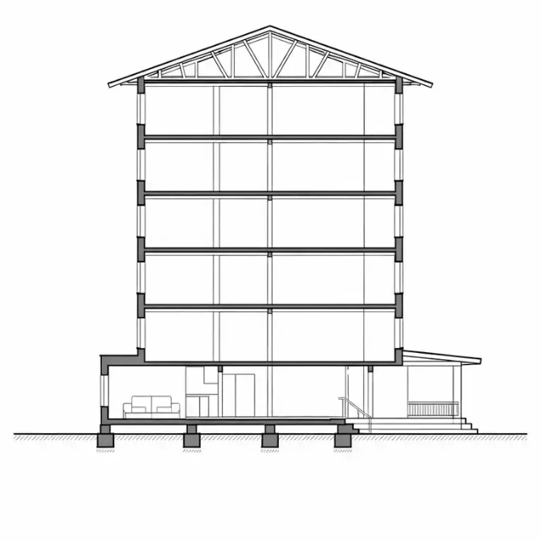
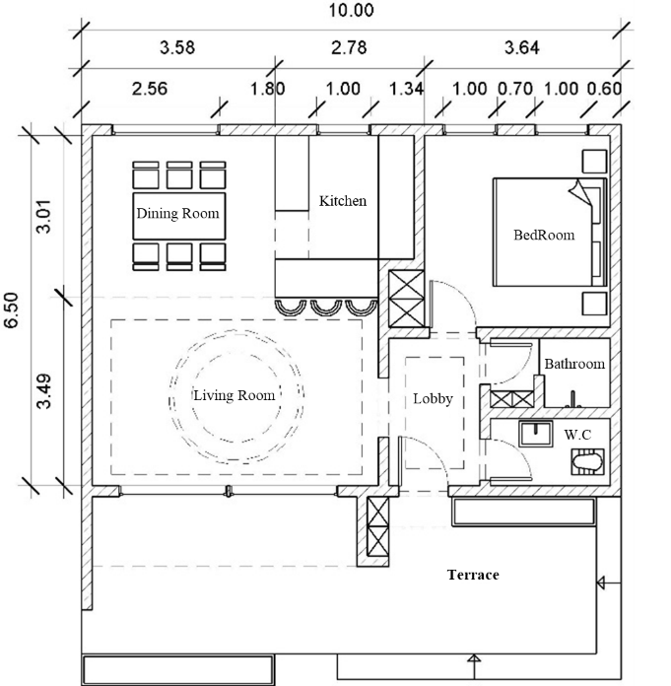
In order to evaluate the impact of Phase Change Materials (PCMs) on building energy performance, a mid-rise residential building located in Rasht was selected as the case study. The building typology was defined based on common construction patterns observed in the urban residential fabric of Gilan Province and represents a typical multi-family residential building frequently constructed in the region. The proposed model consists of five residential floors with a relatively typical floor plan and a compact building form, which is common in contemporary residential developments in the study area.The building envelope includes external walls, roof, floor, and waterproofing insulation layers, all of which play a significant role in controlling heat transfer between the indoor environment and outdoor climatic conditions. In humid coastal climates such as Rasht, roof surfaces are particularly exposed to solar radiation and can significantly influence indoor thermal conditions during warm periods. Therefore, the roof assembly was selected as the primary location for PCM integration due to its considerable contribution to heat gain and its potential to improve thermal buffering. In the present study, particular attention is given to the waterproofing insulation layer of the roof assembly, where the Phase Change Material is integrated. This approach was selected because waterproofing insulation layers are widely used in building construction in humid climates such as Rasht. Integrating PCM within this layer provides an opportunity to enhance the thermal energy storage capacity of the building envelope without significantly altering conventional construction practices. It should be noted that the selected building represents a typical mid-rise residential typology commonly found in Rasht. Therefore, the findings of this study are primarily representative of similar residential configurations and should not be interpreted as universally applicable to all building types in the region.
Figure 4. Plan and section of the case study building, Source: Authors.

Table3 .Specifications of the Case Study Building, Source: Authors.
Parameter | Value | Unit
Building Type | Mid-Rise Residential
Number of Floors | 5 | floors
Floor Height | 3 | m
Floor Area per Floor | 120 | m²
Total Building Area | 600 | m²
Plan Form | Rectangular
Building Orientation | East–West Longitudinal Axis
Window-to-Wall Ratio (WWR) | 30 | %
Window Type | Double-Glazed Windows
Cooling System | Air Conditioning System
Heating System | Boiler and Radiators
Number of Units per Floor | 2 | units
Building Function | Residential

Table 4. Roof layer configuration and thermophysical properties of the PCM-integrated roof assembly, Source: Authors.
Layer | Material | Thickness (mm) | Thermal Conductivity (W/m·K) | Density (kg/m³) | Specific Heat (J/kg·K) | Notes
Exterior Finish | Protective Roof Coating | 10 | 0.90 | 1800 | 840 | Surface protection
Waterproofing Layer | Bituminous Membrane | 5 | 0.17 | 1100 | 1000 | Moisture barrier
PCM Layer | Phase Change Material | 20 | 0.20 | 800 | 2000 | Phase change range: 24–28°C
Thermal Insulation | Rigid Insulation Board | 50 | 0.035 | 35 | 1400 | Reduces heat transfer
Structural Roof Slab | Reinforced Concrete | 200 | 1.70 | 2400 | 880 | Main structural component
Interior Finish | Plaster Layer | 15 | 0.70 | 1600 | 840 | Interior ceiling finish

The roof assembly of the case study building was modeled as a multilayer construction including a phase change material (PCM) layer integrated within the roof system. Table 4 presents the configuration of the roof layers along with their thermophysical properties used in the simulation model. The PCM layer was assumed to have a thickness of 20 mm with a phase change temperature range of 24–28°C. This configuration was selected to provide sufficient latent heat storage capacity while remaining compatible with common roof construction practices. Due to the relatively low density of PCM compared with structural materials such as reinforced concrete, the additional dead load introduced by this layer is considered negligible in the overall structural performance of the roof.

Phase Change Material (PCM)
Phase Change Materials (PCMs) are thermal energy storage materials capable of absorbing and releasing large amounts of heat during phase transition processes. By storing latent heat during temperature increases and releasing it when the temperature decreases, PCMs can reduce indoor temperature fluctuations and enhance the thermal stability of building envelopes. In this study, an organic paraffin-based PCM was selected due to its chemical stability, high latent heat capacity, and compatibility with building applications. The phase change temperature range of the PCM was chosen as 24–28°C, which is close to the typical indoor thermal comfort range in residential buildings. According to common thermal comfort standards, indoor temperatures in residential environments are generally maintained between approximately 23°C and 27°C. Selecting a PCM with a phase transition temperature close to this range allows the material to absorb excess heat when indoor temperatures exceed the comfort threshold and release stored heat as temperatures decrease, thereby improving thermal regulation within the building envelope. The PCM layer was integrated within the waterproofing insulation layer of the roof assembly. This configuration allows the waterproofing system to maintain its primary function of moisture protection while simultaneously providing additional thermal energy storage capacity. The thickness of the PCM layer was assumed to be 20 mm, which falls within the typical range used for PCM integration in building envelope applications reported in previous studies. This thickness provides sufficient latent heat storage while remaining compatible with common roof construction systems. Considering the relatively moderate density of PCM compared with structural materials such as reinforced concrete, the additional dead load introduced by this layer is minimal and does not significantly affect the structural performance of the roof.
Table 5. Thermophysical properties of the selected phase change material used in the simulation model
Property | Value | Unit
Material Type | Organic Paraffin-Based PCM | —
Phase Change Start Temperature | 24 | °C
Phase Change End Temperature | 28 | °C
Latent Heat of Fusion | 180 | kJ/kg
Density (Solid State) | 880 | kg/m³
Density (Liquid State) | 760 | kg/m³
Thermal Conductivity | 0.20 | W/m·K
Specific Heat Capacity | 2.1 | kJ/kg·K
PCM Layer Thickness in the Model | 20 | mm
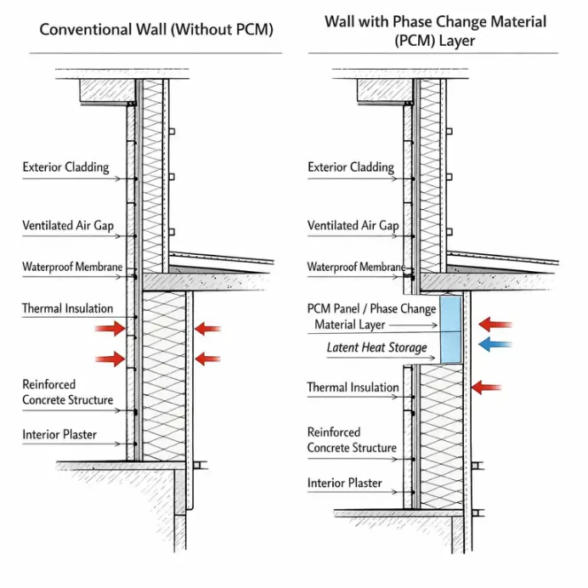
Figure 5. Sectional detail of the building envelope showing thermal behavior with and without PCM integration in the waterproofing layer, Source: Authors.

Energy Performance Evaluation Method
To evaluate the impact of Phase Change Materials (PCMs) on building energy performance, a comparative building energy simulation approach was adopted. The simulation framework was designed to address the research questions concerning the potential of PCM integration within the waterproofing insulation layer to reduce heating and cooling loads and to improve the overall annual energy consumption of a residential building located in a humid temperate climate. Two main simulation scenarios were defined in order to analyze the thermal behavior of the building under identical climatic and operational conditions. In the first scenario, the building was modeled in its reference configuration without the incorporation of PCM in the waterproofing insulation layer. This configuration represents the baseline case and serves as the benchmark for evaluating the building’s energy performance. In the second scenario, a layer of Phase Change Material was integrated within the waterproofing insulation layer of the building envelope. In this configuration, the simulation model accounts for the latent heat storage capacity of PCM and its influence on the thermal behavior of the building. The results obtained from these two scenarios were compared using several performance indicators, including annual cooling loads, annual heating loads, and total building energy consumption. This comparative analysis enables the assessment of the extent to which PCM integration contributes to improving the thermal performance and energy efficiency of the building.
Table 6. Simulation Scenarios for Evaluating the Impact of PCM Integration on Building Energy Performance
Scenario | Model Description | PCM Status | Analysis Objective
Scenario 1 (Reference Case) | Base building model without Phase Change Material in the waterproofing insulation layer | Not Applied | Establishing the baseline building energy performance
Scenario 2 (PCM-Integrated Model) | Building model incorporating a PCM layer within the waterproofing insulation system of the building envelope | Applied | Evaluating the influence of PCM on thermal load reduction and overall energy performance

Building Energy Simulation
To evaluate the thermal performance of the building and investigate the effect of incorporating Phase Change Materials (PCMs) within the waterproofing insulation layer, building energy simulations were conducted using TRNSYS software. This simulation platform is widely used in building energy research due to its capability in modeling building thermal systems and analyzing heat transfer processes, including materials with latent heat storage characteristics such as PCMs. In this study, a mid-rise residential building model was developed within the TRNSYS simulation environment. The climatic data of Rasht city were used as boundary conditions for the simulations in order to represent the humid temperate climate of the region. The weather data were implemented in the form of a typical meteorological year (TMY) file, which allows the simulation to capture representative climatic conditions throughout the year. The simulation period was defined for a full year to accurately represent seasonal variations in temperature and solar radiation. This approach enables the evaluation of PCM performance under different climatic conditions occurring throughout the year. Operational parameters of the building, including indoor thermal comfort temperature ranges, ventilation rate, occupancy schedules, and internal heat gains, were defined based on commonly accepted assumptions for residential buildings in building energy simulation studies. The simulation time step was set to one hour in order to ensure a sufficiently detailed representation of the transient thermal behavior of the building envelope and the phase change process occurring within the PCM layer. The main parameters used in the simulation model are summarized in Table 7.
Table 7. Main Simulation Parameters Implemented in the TRNSYS Building Energy Model
Parameter | Value
Simulation Software | TRNSYS
Weather Data File | Rasht Typical Meteorological Year (TMY) Data
Simulation Period | One Year (8760 hours)
Simulation Time Step | 1 Hour
Cooling Setpoint Temperature | 26 °C
Heating Setpoint Temperature | 20 °C
Air Change Rate | 0.5 ACH
Building Use Type | Residential
Operation Schedule | Typical residential occupancy schedule
Analysis Method | Comparative analysis between baseline and PCM-integrated scenarios

Analysis of Cooling and Heating Loads
This section evaluates the influence of integrating Phase Change Materials (PCMs) within the waterproofing insulation layer of the roof assembly on the heating and cooling energy demands of the studied residential building. The analysis addresses the first research question of the study, which investigates the extent to which PCM integration can reduce thermal loads in a mid-rise residential building located in the humid temperate climate of Rasht. Two simulation scenarios were defined and compared:
(1) a reference model without PCM and
(2) a modified configuration in which a PCM layer was incorporated within the roof waterproofing system.
The comparison between these two scenarios allows the influence of latent heat storage on the thermal performance of the building envelope to be evaluated under identical climatic and operational conditions.
Cooling Load Analysis
Due to the humid temperate climate of Rasht, cooling demand represents a significant share of the annual energy consumption of residential buildings. Table 8 summarizes the simulated cooling loads for the reference model and the PCM-integrated configuration. The results indicate that incorporating PCM into the roof assembly reduces the building’s annual cooling energy demand. The annual cooling load decreases from 18,450 kWh in the reference case to 16,120 kWh in the PCM-integrated scenario, corresponding to a reduction of approximately 12.6%. This reduction can be attributed to the latent heat storage capacity of PCM. During periods of elevated daytime temperature, the PCM absorbs part of the incoming heat flux through the roof while undergoing phase transition. This process delays heat transfer into the interior spaces and reduces peak indoor temperatures, thereby decreasing the cooling demand of the building.
In addition to the annual comparison, monthly simulation outputs were examined to evaluate the seasonal behavior of PCM performance. The results indicate that the effectiveness of PCM is more pronounced during the late spring and summer months, when higher ambient temperatures and larger diurnal temperature variations promote repeated phase-change cycles. Considering that the climate of Gilan Province includes a high frequency of cloudy and rainy days, the performance of PCM may vary depending on solar radiation levels. During extended cloudy periods, reduced solar gains and smaller temperature fluctuations may limit the activation of the phase change process. Consequently, the cooling load reduction associated with PCM is expected to be less pronounced during these periods and more noticeable during warmer months with higher solar radiation.
Table 8. Seasonal Cooling Load Comparison Between the Reference and PCM-Integrated Scenarios
Scenario | Spring (kWh) | Summer (kWh) | Autumn (kWh) | Winter (kWh) | Annual Total (kWh) | Reduction (%)
Reference Building (Without PCM) | 3,120 | 10,980 | 3,050 | 1,300 | 18,450 | —
PCM-Integrated Roof | 2,860 | 9,480 | 2,910 | 870 | 16,120 | 12.6

Heating Load Analysis
The impact of PCM integration on the heating energy demand of the building was also investigated. Although heating demand represents a smaller share of the total annual energy consumption in the humid temperate climate of Rasht, evaluating PCM performance during colder periods provides a more comprehensive assessment of its thermal behavior. The simulation results indicate that the annual heating load decreases from 9,780 kWh in the reference scenario to 9,120 kWh in the PCM-integrated model, corresponding to a reduction of approximately 6.7%. This improvement is related to the ability of PCM to store heat during warmer daytime periods and release it gradually when indoor temperatures decrease. The delayed heat release helps stabilize indoor temperatures and slightly reduces the heating energy demand during cooler hours. Monthly analysis of heating loads suggests that the influence of PCM is mainly observable during transitional seasons such as early spring and autumn, when daily temperature fluctuations allow partial activation of the phase change cycle. During colder winter months, the phase change process occurs less frequently due to lower ambient temperatures, which limits the contribution of PCM to heating load reduction.
Table 9. Seasonal Heating Load Comparison Between the Reference and PCM-Integrated Scenarios
Scenario | Spring (kWh) | Summer (kWh) | Autumn (kWh) | Winter (kWh) | Annual Total (kWh) | Reduction (%)
Reference Building (Without PCM) | 2,410 | 210 | 3,100 | 4,060 | 9,780 | —
PCM-Integrated Roof | 2,260 | 180 | 2,890 | 3,790 | 9,120 | 6.7

Uncertainty and Model Limitations
The results presented in Tables 8 and 9 are derived from deterministic building energy simulations performed under identical boundary conditions for both scenarios. Therefore, the reported reductions represent the relative difference between the baseline model and the PCM-integrated configuration rather than statistical estimates derived from repeated experimental measurements. Because the simulation uses fixed input parameters, conventional statistical confidence intervals are not directly applicable. Nevertheless, the comparative scenario-based approach enables the direct assessment of the impact of PCM integration under the same climatic conditions, building geometry, and operational assumptions. To further strengthen the robustness of the findings, future research could include sensitivity analyses examining the influence of key parameters such as PCM thickness, phase-change temperature range, and roof thermal properties. In addition, experimental validation or monitored case studies would help verify the simulation results under real operating conditions.
Figure 6. Seasonal Cooling Load Comparison Between the Reference Building and PCM-Integrated Roof, Source: Authors.
Figure 7. Annual Heating and Cooling Load Comparison, Source: Authors.

Analysis of Total Building Energy Consumption
This section compares the total building energy consumption for two simulation scenarios: the reference model without PCM and the configuration in which PCM is integrated within the roof waterproofing insulation layer. The total energy consumption represents the combined heating and cooling loads obtained from the annual building energy simulation. Table 10 summarizes the seasonal and annual energy consumption of the building for both scenarios. The results show that integrating PCM into the roof assembly reduces the overall energy demand of the building envelope by improving its thermal storage capacity and moderating heat transfer through the roof. According to the simulation results, the total annual energy consumption decreases from 28,230 kWh in the reference case to 25,240 kWh in the PCM-integrated configuration, corresponding to an overall reduction of approximately 10.6%. This reduction is primarily associated with the decrease in cooling demand during the warmer months, when the phase change process is more frequently activated due to higher ambient temperatures and greater diurnal temperature variations. The seasonal comparison also indicates that the contribution of PCM to energy savings is more significant during the summer period, while its impact during colder months remains relatively moderate. This behavior reflects the dependence of PCM performance on temperature fluctuations and the occurrence of phase-change cycles. It should be noted that the presented results correspond to the investigated case study and a specific PCM configuration. Therefore, the reported energy savings should be interpreted as the performance of the simulated building under the defined climatic and operational conditions rather than a universal value applicable to all residential buildings in humid climates.
Table 10. Seasonal and Annual Comparison of Total Building Energy Consumption, Source: Authors.
Scenario | Spring (kWh) | Summer (kWh) | Autumn (kWh) | Winter (kWh) | Annual Total (kWh) | Reduction (%)
Reference Building (Without PCM) | 5,530 | 11,190 | 6,150 | 5,360 | 28,230 | —
PCM-Integrated Roof | 5,120 | 9,660 | 5,800 | 4,660 | 25,240 | 10.6

Figure 9. Seasonal breakdown of total building energy consumption for reference and PCM-integrated scenarios, Source: Authors.
Energy Saving Potential
To further evaluate the impact of PCM integration, the energy saving potential of the PCM scenario was calculated in comparison with the reference case. The results are derived from dynamic energy simulations of the studied residential building and therefore represent the performance of the investigated case under the specific climatic conditions of Gilan. According to the simulation outputs, the total annual energy consumption of the building decreases from 28,230 kWh/year in the reference case to 25,240 kWh/year when PCM is integrated into the roof waterproofing insulation layer. This corresponds to an annual energy saving of approximately 2,990 kWh, representing a reduction of 10.6% in the total building energy demand. These results indicate that incorporating PCM into the roof assembly can enhance the thermal storage capacity of the building envelope and contribute to moderating heat transfer through the roof. However, it should be emphasized that the reported energy savings correspond specifically to the simulated building configuration and PCM properties considered in this study. Therefore, the results should not be interpreted as universally applicable to all residential buildings in humid climates. From an economic perspective, the integration of PCM into the building envelope may influence both the initial investment costs and the operational energy costs over the building life cycle. Within the framework of the cost-optimal methodology adopted in this study, several parameters related to the envelope configuration were examined to assess their influence on both energy demand and life-cycle costs.
Table 11. Energy Savings Achieved in the PCM Scenario, Source: Authors.
Indicator | Value
Annual Energy Consumption – Reference Building | 28,230 kWh/year
Annual Energy Consumption – PCM Roof Configuration | 25,240 kWh/year
Annual Energy Saving | 2,990 kWh/year
Percentage Reduction in Total Energy Consumption | 10.6%

These parameters include the insulation thickness of the external walls, roof, and floor slab (parameters ResO, ResR, and ResS), as well as the characteristics of building openings such as window type (WT, WTS, WTR) and opening dimensions (Bm and Blr). The variation ranges and step sizes of these parameters were determined according to building regulations, technical feasibility, and currently available construction solutions.
Figure 1-. Energy Savings Achieved in the PCM Scenario, Source: Authors.
As illustrated in Figure 11, these parameters were analyzed while considering the potential integration of PCM layers into the building envelope. Changes in these parameters influence not only the building’s energy demand but also the associated economic performance, including the initial implementation cost of envelope components and PCM technology. In this study, replacement costs of building elements were not included in the life-cycle cost calculations, as it was assumed that the service life of the envelope components is comparable to the economic calculation period considered.
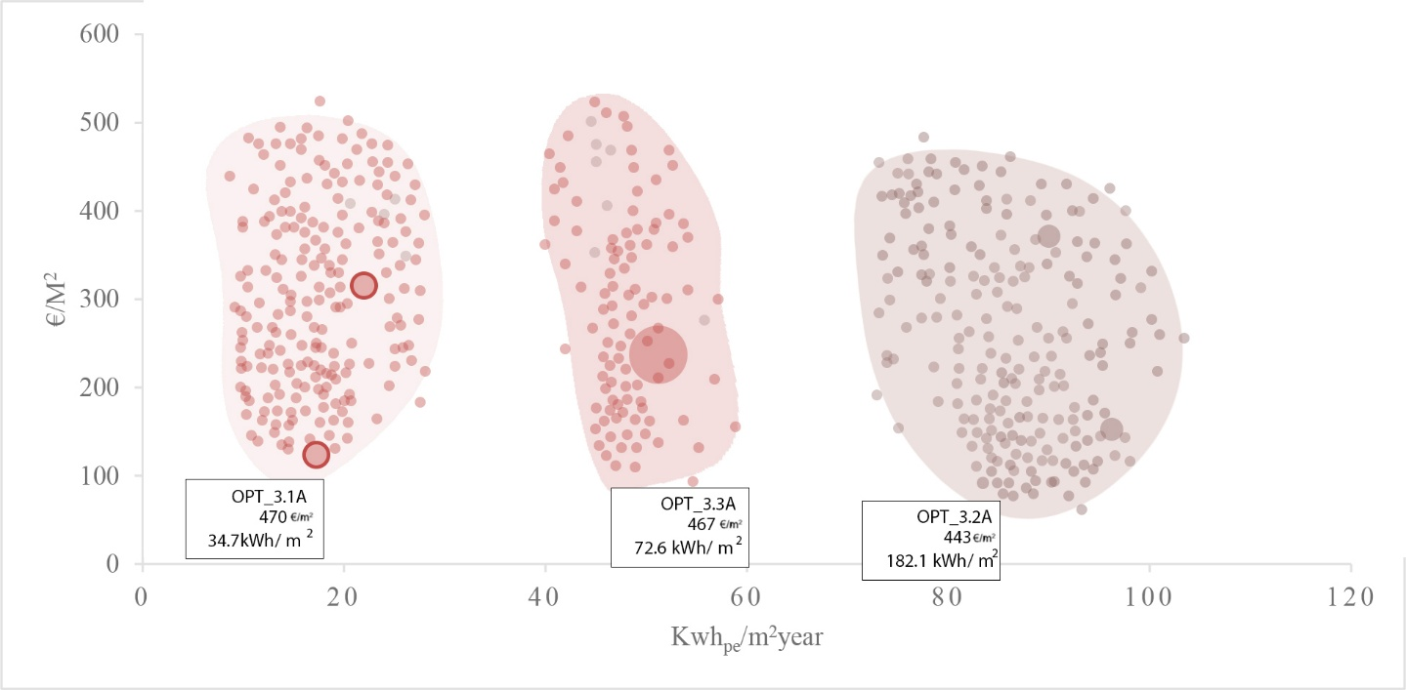
Figure 11. cost-effective clouds of optimal cost points, source: Authors.
The relationship between these parameters and the resulting cost-optimal solutions can be observed in Figure 12, which illustrates the distribution of optimal configurations obtained from the parametric analysis. The results indicate that adjustments in envelope properties—particularly those enabling PCM integration—can simultaneously influence both the building’s energy demand and its life-cycle cost. It should be noted that the presented results are based on numerical simulations and represent the investigated case study. Experimental validation of PCM performance under real climatic conditions of humid regions such as Gilan would further improve the reliability of the findings and is recommended for future research.
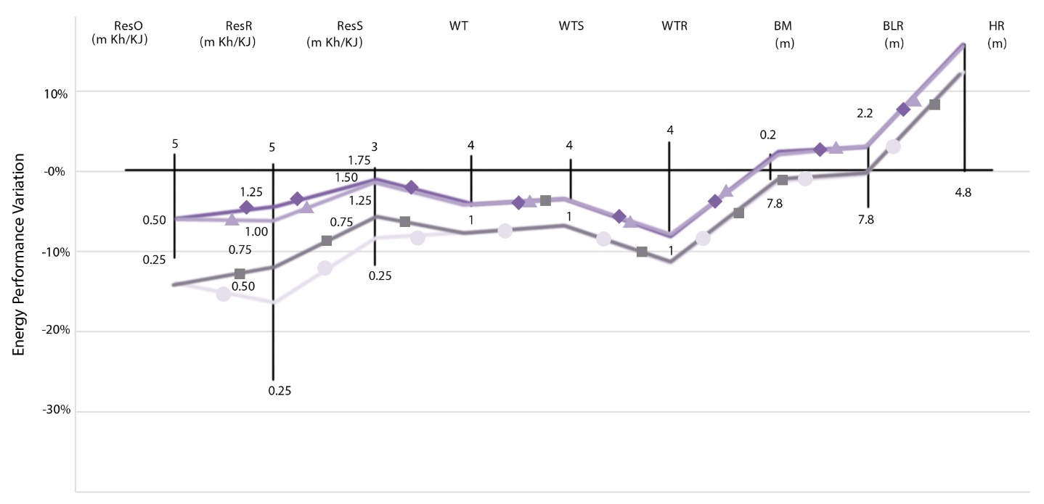
Figure 12. the set of parameter values ​​of the final optimization point, source: Authors
Results and Discussion
The simulation results suggest that the integration of Phase Change Materials (PCM) within the waterproofing insulation layer can contribute to reducing the energy demand of the studied residential building under the specific climatic conditions of Rasht, located in the humid region of Gilan. The findings presented in this study are limited to the investigated building configuration and the selected PCM properties. The latent heat storage capability of PCM enables the building envelope to temporarily absorb and release thermal energy, which helps moderate temperature fluctuations across the roof assembly and influences the building’s cooling and heating loads. The numerical simulation results indicate that incorporating PCM into the waterproofing insulation layer reduces heat transfer through the roof during periods of high outdoor temperature. During warmer daytime hours, PCM absorbs excess heat and stores it in the form of latent thermal energy during the phase transition process. This mechanism delays the penetration of heat into the indoor environment and contributes to lowering the cooling demand. During cooler periods, the stored heat is gradually released, helping stabilize the thermal behavior of the building envelope. The seasonal analysis indicates that the influence of PCM on cooling load reduction is more pronounced than its impact on heating demand. This behavior is consistent with the climatic characteristics of Rasht, where humid summers generate higher cooling requirements, while winter heating demand remains comparatively moderate.
It should also be noted that the thermal performance of PCM depends on sufficient daily temperature fluctuations to activate the phase change cycle. In Gilan province, which experiences a high number of cloudy and rainy days annually, reduced diurnal temperature variation may limit the frequency of PCM charging and discharging cycles. Under such conditions, the overall effectiveness of PCM may decrease compared to periods with stronger thermal gradients. Furthermore, the results of this study can be interpreted in relation to the principles of vernacular architecture in Gilan. Traditional residential buildings in this region typically incorporate lightweight construction materials, elevated floors, semi-open spaces such as verandas, natural ventilation pathways, and sloped roofs designed to manage heavy rainfall and high humidity levels. These features reduce direct solar gains, enhance airflow, and improve indoor thermal comfort through passive climate-responsive strategies. Within this framework, the integration of PCM into the roof assembly can be interpreted as a modern technological complement to these traditional passive design strategies rather than a replacement for them. However, the present study did not explicitly model the combined interaction between PCM integration and natural ventilation systems, which are fundamental components of vernacular architecture in Gilan. Although Gilan’s climate is characterized by high relative humidity, the direct influence of humidity on the thermophysical behavior and long-term performance of PCM materials was not explicitly modeled in the present simulations. The numerical analysis primarily focused on conductive heat transfer through the building envelope. Therefore, experimental investigations under real high-humidity conditions would be necessary to validate and extend the present findings. Finally, it should be emphasized that all conclusions presented here are derived from numerical simulations of a specific building configuration and PCM type. While the results suggest potential energy-saving benefits in humid climates such as Rasht, broader generalization requires additional simulations, alternative PCM configurations, and experimental validation.

Conclusion
The increasing energy consumption in the building sector has become one of the major challenges in contemporary architecture and building engineering. Improving the thermal performance of the building envelope is widely recognized as an effective strategy for reducing building energy demand. In this context, Phase Change Materials (PCMs), due to their ability to store and release thermal energy during phase transitions, have received growing attention as a potential solution for improving building energy efficiency. This study evaluated the impact of integrating PCM into the waterproofing insulation layer of a mid-rise residential building located in Rasht, within the humid temperate climate of Gilan Province. Two scenarios were analyzed using TRNSYS simulation: a reference case without PCM and a PCM-integrated configuration in which the material was incorporated into the roof waterproofing insulation layer. The results indicate that, for the investigated building and PCM configuration, the integration of PCM can contribute to reducing both cooling and heating loads. The simulations showed that PCM is particularly effective in reducing cooling demand, as it absorbs excess thermal energy during warm daytime periods and stores it as latent heat, thereby delaying heat transfer into the indoor space and moderating indoor temperature fluctuations. The seasonal analysis also revealed that the cooling load reduction is more significant than the heating load reduction. This finding is consistent with the climatic characteristics of Rasht, where humid summers lead to higher cooling demands, while winters are relatively mild and therefore require less heating energy. The analysis of total annual energy consumption showed that the PCM-integrated scenario resulted in a noticeable reduction in building energy demand. The total annual energy consumption of the building decreased from approximately 28,230 kWh/year in the reference case to 25,240 kWh/year in the PCM scenario, corresponding to an annual saving of about 2,990 kWh, or approximately 10.6% of the total building energy consumption. These results provide a direct answer to the first and second research questions of this study, demonstrating that the integration of PCM in the roof insulation layer of the investigated building can reduce heating and cooling loads and decrease the overall annual energy consumption under the climatic conditions of Rasht. From an architectural perspective, the findings suggest that PCM technology may serve as a modern complementary strategy to the climate-responsive principles of vernacular architecture in Gilan. Traditional residential buildings in this region employ strategies such as sloped roofs, natural ventilation, semi-open spaces, and lightweight construction to adapt to high humidity and rainfall. The incorporation of PCM into the roof assembly can enhance the thermal energy storage capacity of the building envelope while working alongside these passive design strategies rather than replacing them.
However, it should be emphasized that the findings of this study are derived from numerical simulations of a single building configuration and a specific PCM type. Therefore, the results should not be generalized to all buildings in humid climates without further investigation. In addition, the high frequency of cloudy and rainy days in Gilan may limit daily temperature fluctuations and potentially influence the charging and discharging cycles of PCM, which could affect its real operational performance. Moreover, although the climatic conditions of Gilan are characterized by high humidity levels, the direct influence of humidity on the thermophysical behavior and long-term performance of PCM materials was not explicitly modeled in this study. Experimental investigations would therefore be necessary to validate the simulation results under real environmental conditions. With respect to the third research question concerning economic feasibility, the present study did not perform a detailed economic analysis of PCM implementation. Therefore, while the energy savings observed in the simulations indicate potential benefits, further studies incorporating cost analysis and payback period assessment are required to determine whether PCM integration can achieve a cost-effective balance between improved energy performance and construction investment.
Limitations and Recommendations for Future Research
Despite the promising results, several limitations should be acknowledged. Only one PCM type and one placement location within the building envelope were investigated, and the analysis was based solely on numerical simulations without experimental validation. Future research could expand this work by:
- Investigating PCM materials with different phase change temperature ranges to determine the most suitable PCM for humid climates.
- Evaluating the integration of PCM in other building envelope components such as walls and floors.
- Conducting experimental or full-scale field studies to validate simulation results.
- Examining the combined performance of PCM with climate-responsive design strategies such as natural ventilation, shading systems, and indigenous construction materials.
- Performing detailed economic analyses to evaluate cost effectiveness and payback periods.
- Investigating PCM applications in different building typologies including high-rise and non-residential buildings.
- Applying optimization methods to determine the optimal quantity and placement of PCM in building envelopes.
In summary, the findings of this study suggest that PCM integration in the roof assembly of the investigated residential building can contribute to improving thermal performance and reducing energy demand. When combined with climate-responsive architectural strategies, PCM technology may support the development of more energy-efficient and environmentally responsive buildings.
References
- Al Jebaei, H., Abdul Rahman, A. M., & Omar, W. M. S. (2024). Energy performance and CO₂ emission reduction of building envelope integrated with phase change material wallboards. Energy and Buildings, 303, 113951. https://doi.org/10.1016/j.enbuild.2024.113951
- Alshuraiaan, B. (2022). Effective utilization of phase change materials in building envelopes under hot climatic conditions. Journal of Building Engineering, 46, 103738. https://doi.org/10.1016/j.jobe.2021.103738
- Ascione, F., Bianco, N., Mauro, G. M., & Vanoli, G. P. (2019). A new comprehensive framework for the multi-objective optimization of building energy design: Harlequin. Applied Energy, 241, 331–361. https://doi.org/10.1016/j.apenergy.2019.03.028
- azemati, saeed, jamshidzadeh, kimia. “Analysis of the amount of natural light and the effect of photovoltaic cells in green educational buildings using the native architecture of Gilan (Case study: Imam Ali Boys' High School, Rasht).” Sustainability, Development & Environment, vol. 5, no. 1, 2024, pp. 85-101.
- Cai, Z., Wang, X., Yu, H., & Li, M. (2021). Optimization of phase change material parameters in building envelopes: A review. Renewable and Sustainable Energy Reviews, 135, 110120. https://doi.org/10.1016/j.rser.2020.110120
- Delshad, Mehsa, Hosseinpour, Maryam. (2017). Analyzing the concepts of native architecture of Gilan in accordance with the stable characteristics of Iranian architecture. Construction Engineering and Housing Sciences, 12(1), 31-37.
- Demirbas, M. F., "Thermal Energy Storage and Phase Change Materials: an Overview", Energy Sources, Part B Econ. Planning, Policy, Vol. 1, No. 1, pp. 85–95, 2006.
- Energies Review, 2025: The application of PCMs in various building components improves energy efficiency, reduces peak energy loads, and enhances indoor thermal comfort.
- Gurji Mahlbani, Youssef, Yaran, Ali. (2010). Sustainable architecture solutions of Gilan along with comparison with Japanese architecture. Journal of Fine Arts: Architecture and Urbanism, 2(41), 43-54.
- jamshidzadeh, kimia, azemati, saeed, Labibzadeh, Razieh. “Feasibility of using optimization solutions for mid-rise residential buildings in temperate and humid regions with the aim of achieving zero energy.” Sustainability, Development & Environment, vol. 6, no. 3, 2025, pp. 89-107.
- Kamali, S. Review of free cooling system using phase change Material for building. Energy and Buildings, 80, 131-136, 2014.
- Miri, S. (2015). Application of smart PCM materials in sustainable architecture. In Proceedings of the International Conference on Modern Research in Civil Engineering, Architecture, and Urban Development. SID. https://sid.ir/paper/857962/fa
- Naghavi, P., & Kiani, M. (2019). Explaining the relationship between vernacular architecture and contextualism. Restoration and Architecture of Iran (Restoration of Historical-Cultural Monuments and Contexts), 9(18), 71–89. https://sid.ir/paper/371334/fa
- nasir, walya, Azemati, Saeed, Ahmed, fiza, Zand, Amirhossein. “Measuring the optimal effectiveness and energy storage through the system of photovoltaic collectors and phase change materials in a hot and dry climate (case study: Khodadoost Hospital in Shiraz).” Journal of Environmental Science and Technology, vol. 27, no. 3, 2025, pp. 33-52.
- Xing Y, Hewitt N, Griffiths P. Zero carbon buildings refurbishment—a hierarchical pathway.Renewable Sustainable Energy Rev 1122;2212112–22.
- Zalba, B., Marín, J. M., Cabeza, L. F., & Mehling, H. (2003). Review on thermal energy storage with phase change: Materials, heat transfer analysis and applications. Applied Thermal Engineering, 23(3), 251–283. https://doi.org/10.1016/S1359-4311(02)00192-8
- Zhang, A., Xiong, Y., Zhao, Y., Wu, Y., Xu, Q., & Ding, Y. (2025). A review of passive building thermal management with phase-change materials. Renewable and Sustainable Energy Reviews, 211, 115334. https://doi.org/10.1016/j.rser.2025.115334
- Zhang, Y., Zhou, G., Lin, K., Zhang, Q., & Di, H. (2007). Application of latent heat thermal energy storage in buildings: State-of-the-art and outlook. Building and Environment, 42(6), 2197–2209. https://doi.org/10.1016/j.buildenv.2006.07.023
- Abdel-Rahman, O., Rouby, E., & Afify, M. M. (2025). Thermal performance evaluation of phase changing materials in double glazing units for office buildings in Egypt. Scientific Reports, 15(1), 1–16. https://doi.org/10.1038/s41598-025-88206-x
- Barea, G., Mercado, M. V., Filippin, C., Monteoliva, J. M., & Villalba, A. (2022). New paradigms in bioclimatic design toward climatic change in arid environments. Energy and Buildings, 266, 112100. https://doi.org/10.1016/j.enbuild.2022.112100

∗ This article is an excerpt from the first author's master's thesis entitled "Design of a Mid-Rise Residential Complex with an Emphasis on Eco-Friendliness in Rasht City," which was compiled with the guidance of the second author at the Faculty of Civil Engineering, Architecture and Art, Islamic Azad University, Science and Research Branch. 1- Department of Architecture, Research Sciences Branch, Islamic Azad University, Tehran, Iran. kimia.jamshidzadeh@srbiau.ac.ir 2- Department of Architecture, East Tehran Branch, Islamic Azad University, Tehran, Iran.*(Corresponding Author). Saeed.azemati@iau.ac.ir

