Assessment of the Overt and Covert Characteristics of Transparency Policy in the Esfahan Urban Administration System

Daryoush Moradi Chadegani¹, Hamidreza Rabiei-Dastjerdi² Mohammad Hosein Asgari³, Effat Saboohi⁴, Khatereh Amiri⁵, Molud SalehiNajfabadi⁶

- Urban Planning Department, Faculty of Architecture and Urban Planning, AUI (Art University of Isfahan), Isfahan, Iran
- School of History and Geography, Faculty of Humanities and Social Sciences, Dublin City University (DCU)
- Urban Planning Department, Faculty of Architecture and Urban Planning, AUI (Art University of Isfahan), Isfahan, Iran
- Urban Planning Department, Faculty of Architecture and Urban Planning, Islamic Azad University (Dolatabad Branch), Isfahan, Iran
- Urban Planning Department, Faculty of Architecture and Urban Planning, Islamic Azad University, Isfahan Branch (Khorasgan), Isfahan, Iran
- Urban Planning Department, Faculty of Architecture and Urban Planning, AUI (Art University of Isfahan), Isfahan, Iran

Abstract
This paper examines the overt and covert features of transparency policy within the context of Urban Administration System, using a mixed-methods research design with a clear division of analytical paths. Quantitative methods are employed to investigate the overt characteristics of transparency policy as it operates in urban planning processes, focusing on observable patterns, instruments, indicators, and the formal orientations embedded in transparency-related planning policies. In parallel, qualitative methods are applied to explore the covert characteristics of transparency policy in urban planning decision-making, capturing latent meanings, implicit assumptions, and normative dimensions through systematic content analysis of policy and planning documents complemented by semi-structured expert interviews. The findings indicate that within urban decision-making and decision-taking processes, transparency policy is challenged by discontinuous policy interpretation, unclear allocation of participatory roles, outcome-oriented approaches, and the absence of a shared political language. The study identifies key factors for improving transparency policy quality in urban planning systems, including clarifying policy costs, reducing interpretive ambiguity, formulating coherent, consistent transparency commitments for policymakers, and adopting practical guidelines to support transparent urban decision-making processes.
Keywords: Transparency policy, Overt and covert dimensions of policy, Policy analysis, Public policy.

- Introduction
Policy analysis is used to predict and value the potential effects of policies as one of the methods of informing decision-makers (Adelle & Weiland, 2012). Policy analysis broadly examines the what, why, how, and consequences of government actions (Dye, 1976). The outcome of policy analysis is recommendations and plays a crucial role in assessing the boundaries of transparency and dissemination, and the accessibility of information about policy formulation and decision-making within society. Various stakeholders, such as government entities, non-governmental organizations, auditing bodies, media outlets, and social networks, are involved in this process to enhance the efficiency of the public sector in delivering goods and services, resource allocation, planning, and fostering learning and policy enhancement (Emami Meybodi, 2015; Fischer & Miller, 2017; Weimer & Vining, 2017). Public policies need self-correcting mechanisms on this basis. Policy assessment has been widely praised for increasing transparency in governmental decision-making on complex issues. The interaction between actors in the Urban Administration system and the use of analysis has also received considerable attention. These included increased transparency, knowledge levels, the interest-group environment, inter-organizational coordination, and the openness of the decision-making environment. The increase in transparency about the urban administration system comes from cost-benefit analysis (Baekgaard et al., 2019; Shapiro, 2016). Policy analysis is a practical tool for real-world decision-making, whose literature can be found in public administration, political science, philosophy, organizational psychology, economics, and business management (Gill & Saunders, 1992). The operational definition of politics entails the analysis of policies formulated in a manner that encompasses the utilization of tools, methods, and criteria for assessing and envisioning the prevailing circumstances (Geva-May, 2012).
This evaluation examines the reasons, quality, and course of policy developments, grounded in learning and accountability, to address the limitations and weaknesses of the existing administrative system and improve its efficiency. The policy analysis output can include reports that describe experiences, offer criticism, analyze problems, and articulate the overt and covert features of the policy and the assessment system, accompanied by a proposal for capacity building and for improving the quality of policy-making. Policy analysis can determine the limits of transparency and dissemination, and availability of information related to policy-making and decision-making for society and the role of the government, non-governmental organizations, auditing activities, media, and social networks with the motivation to improve the performance of the public sector in producing and distributing goods and public services, planning, allocation of resources, and learning and policy reform(Emami Meybodi, 2015). Achieving results in policy analysis necessitates adopting a procedural and long-term perspective (Arnold & Long, 2019). The examination of public policy should consider both its structure and behavior (Egeberg, 2020). This article’s main goal is to discover the nature of overt and covert features of transparency policy in the Esfahan Urban Administration System. From a holistic perspective on Urban Administration System, improvements in operational performance are influenced by transparency in public policies, stakeholder engagement in the public sector, and resource allocation. Implementing an extended subsystem within the Urban Administration System to monitor and evaluate transparency levels, especially the overt and covert aspects of transparency policy, helps politicians enhance public participation and preserve public trust. The research questions are formulated as follows:
- What are the features and the overt and covert dimensions of transparency policy in the Urban Administration System of Esfahan?
- At what level are the basic principles and requirements in transparency policy institutionalized in the Esfahan Urban Administration System?
- To what extent do the overt dimensions of transparency policy (formal rules, instruments, and measurable indicators) correspond with and support the covert dimensions (normative assumptions, interpretive practices, and informal decision logics) across policy formulation, decision-making, and implementation stages in the Esfahan Urban Administration System?

The objectives of the research are 1. to investigate the features and the overt and covert aspects of transparency policy in the Esfahan Urban Administration System, 2. to achieve the thresholds of institutionalization and compliance with the basic principles and requirements of transparency policy in the Esfahan Urban Administration System, and 3. achieve a degree of alignment and coordination of the overt and covert aspects of transparency policy in the Esfahan Urban Administration System.
Accordingly, a theoretical framework is established based on policy analysis within the urban decision environment and the policy-making cycle to achieve the research objectives. The research procedure and methodology are derived from an adopted policy cycle in public administration (see Figure 1) and organized into seven stages (see section 3). Concentration on quantitative (positive) and qualitative (normative) policy analysis to identify the overt and covert features of transparency policy in the Esfahan Urban management System and on coordination between key actors, as an essential factor for enhancing transparency policy performance, is the main part of the research structure.
- Theoretical framework
With three main assumptions, including urban policy, policy-making process, and transparency policy, the theoretical research framework seeks to present definitions, theories, and applicable approaches.
  - Urban policy-making definition and characteristics
The concept of policy-making can be traced back to the works of Lasswell and Lerner in the early days. The primary objective of policy-making is to achieve a desirable quality of life for the citizens, and it should always be in the public's best interest. Several factors should be considered when shaping public policy, including the characteristics of society, the government's role, and citizens' rights and obligations. Ensuring that the policy-making aligns with the public's best interests (Capano & Howlett, 2020; Lazarsfeld et al., 1951; Ward, 2017). But its application in public sector administration began in the late sixties, the main reasons for which are the increasing political and social pressures for the practical use of social sciences in solving everyday problems and the formation of ideas based on the role of socio-economic factors in government decisions against beliefs based on the role of political parties and ideologies. Since the 1970s, the research on policy-making have become more diverse and expanded, which can be divided into four groups: 1. analysis of policy-making areas, 2. policy analysis and study of results, 3. policy-making processes and factors affecting the formulation and application of policies and 4. anticipation of alternative policies and the study of the effectiveness of various tools in the field of political operation (Sabatier, 1991). Therefore, policy-making and policy analysis should be viewed not just as a form of interest or ideologically-driven struggle but rather as a form of collective puzzlement on society’s behalf (Dunlop et al., 2018).
Urban public policies are made by decision-makers with legitimate authority in urban administration to set policy (Barberio, 2015). Managers and decision-makers in urban administration systems can adopt a policy compatible with the problem among the various policies and solutions. These levels include the meso and micro levels; the macro-level focuses on national interests or values; the meso-level focuses on problems and issues at regional levels, such as provinces and countries. It bridges macro and micro levels, both organizational and geographical, and operationalizes the micro level of executive decisions (Ali Ahmadi & Mirabedini, 2019). Theories of power and influence in the administrative system, and the degree of change achieved by public policies, are essential to understanding the political nature of public policy. Both elite and pluralist theories of power can help guide our understanding of the nature of public policy and analyze the degree of change it brings about (Barberio, 2015).
Urban policies are related to these levels, and they can be seen as an attempt to order, control, and manage the forces that shape urban areas, which is the product of the actions of various groups with power and interests, and play an essential role in choosing urban issues and directing interests and resources towards authorities. Adopting these policies with social needs, requests, and values leads to providing public services, supporting the development of the local economy, and promoting the welfare and comfort of residents in an urban society (Ali Ahmadi & Mirabedini, 2019; Blackman, 2013; Cowan, 2005).
Urban policymaking is directly related to the urban administration system that underpins it, both theoretically and practically. The power structure and elitist rules serve as inspiration for urban policy-making processes and policy analysis through policy monitoring and evaluation.

  - Policy cycle adopted in the public planning system
The policy cycle serves as a fundamental framework for policy development, utilizing a step-by-step approach to decision-making, especially in public administration systems, and is used to describe the policy process to indicate that the steps of the process can be continuous and cyclical (Kraft & Furlong, 2019).
The classification of policy cycles is primarily determined by the number of main levels involved. The classification of policy cycles is primarily determined by the number of levels involved. Compatible Policy Cycles for policy-making in the Public Sector are two primary classifications: the five-stage and seven-stage policy cycles. The five-stage policy cycle includes the following stages: (1) identifying questions, (2) formulating a problem, (3) anticipating, (4) prescribing, and (5) monitoring (Dunn, 2015).
- (1) problem identification, (2) agenda preparation, (3) policy formulation and adoption, (4) policy implementation, (5) evaluation, policy adjustment, or completion (Clemons & McBeth, 2020).
- (1) defining and analyzing the problem, (2) creating policy options, (3) choosing valuation criteria, (4) evaluating alternatives, and (5) concluding (Kraft & Furlong, 2019).
Seven-stage policy cycles cover various research methods and discuss the broad government’s organization, planning, and management, and include:
- (1) problem statement, (2) policy analysis, (3) policy tools, (4) conclusion, (5) coordination, (6) decision-making, (7) implementation, and evaluation (Bridgman & Davis, 2003).
- (1) policy agenda, (2) formulation, (3) adoption, (4) choice, (5) implementation, (6) evaluation, (7) alternation and completion (Dunn, 2015).
Policy cycle processes share commonalities and differences that can be summarized in an integrated seven-stage policy process for evaluating policies in the Esfahan Urban Administration System (Table 1).

Table 1. Typology and comparison of different processes and the formation of an integrated policy-making process at seven stages.
Stages | Five-stage policy cycle (Dunn, 2015) | Five-stage policy cycle (Clemsons & McBeth, 2017) | Five-stage policy cycle (Kraft & Furlong, 2018) | Seven-stage policy cycle (Bridgeman & Davis, 2003) | Seven-stage policy cycle (Dunn, 2015) | The integrated policy cycle
First stage | Questioning | Identifying the problem | Defining and analyzing the problem | Stating the problem | - | Determining the boundaries of the problem
First stage | Structuring the problem | - | Defining and analyzing the problem | Stating the problem | - | Determining the boundaries of the problem
Second stage | Anticipating policy | Preparing the agenda, formulating and choosing a policy | Constructing policy alternatives | Analyzing policy | Building the agenda | Making policy alternatives
Third stage | - | - | Developing evaluative criteria | Policy-making tools | Formulating policies | Selecting policy criteria
Fourth stage | - | - | Assessing the policy alternatives | Concluding |  | Evaluating policy alternatives
Fourth stage | - |  | Drawing conclusions | Concluding |  | Evaluating policy alternatives
Fifth stage | Prescribing policy | Implementing policy | - | Coordinating | Adopting policies | Creating inter-organizational coordination and implementing policy
Fifth stage | Prescribing policy | - | - | Making decisions
Fifth stage | Prescribing policy | - | - | Implementing policy | Implementing policies
Sixth stage | Monitoring policy | Valuating policy | - | Valuating policy | Valuating policies | Valuating and interpreting policy effects and consequences
Seventh stage | Monitoring policy | Modifying or completing the policy | - | - | Adapting policies | Revising policy
Seventh stage | Monitoring policy | - | - | - | Alternating policies | Revising policy
Seventh stage | Monitoring policy | - | - | - | completing policies | Revising policy

This process in the public sector, emphasizing the element of coordination in policy-making (in a way that can be used to create coordination in inter-organizational and intra-organizational policy-making), can be introduced as follows (Figure 1):
The first stage (Determining the boundaries of the problem) focuses on defining and specifying the boundaries of the problem. It supports problem-finding, designing questions, structuring, defining, and analyzing problems.
The second stage (Making policy alternatives): In this stage, policy analysis and foresight are included, along with preparing the agenda, creating and adopting the policy option, and providing its definitions and features.
The third stage (Selecting policy criteria): Represents policy tools, policy formulation, and the selection of valuation criteria.
The fourth stage (Assessing policy alternatives): In this stage, evaluation and conclusions are made based on the policy selection criteria.
The fifth stage (Creating inter-organizational coordination and implementing policies) articulates executive concepts such as decision-making, implementation, prescription, and coordination, based on the results obtained, to support policy implementation and inter-organizational coordination.
The sixth stage (Evaluating and interpreting policy impacts and outcomes) includes policy evaluation and the assessment of policy impacts and outcomes.
The seventh stage (Revising policies): This stage concerns the compliance, replacement, adjustment, and completion of policies, during which new proposals are formulated regarding the policy and its related executive processes. The results of this stage are grounded in quantitative and qualitative evidence from policy and planning documents and expert interviews within the Esfahan Urban Administration System.
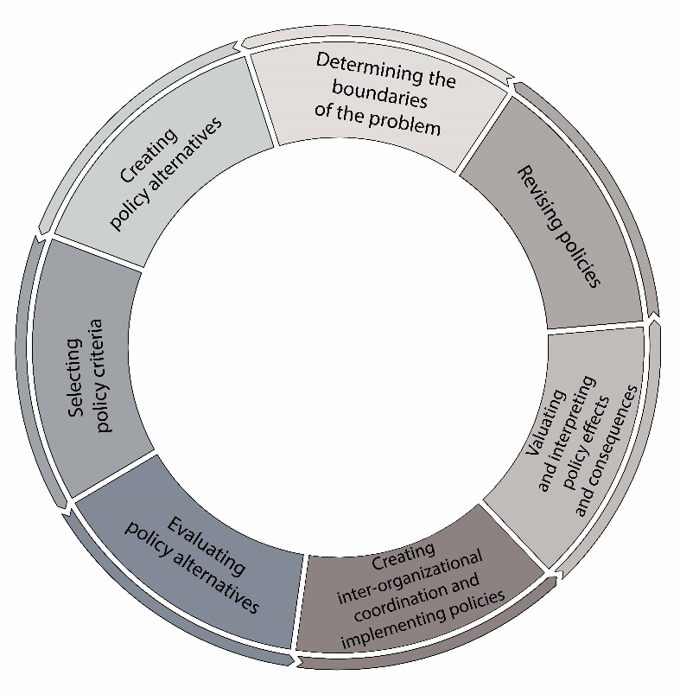
Figure 1. Introducing the policy cycle in the Urban Administration System with an emphasis on intra- and inter-organizational coordination in policy-making.

  - Transparency policy in public sector
Transparency is the dissemination and facilitation of access to information; it is the opposite of secrecy in decision-making and helps prevent corruption. This policy is based on the free flow of information, clarity of actions, and continuous awareness of citizens about incomes, information sources, and decision-making processes(Ball, 2009; Barakopour & Asadi, 2009; UNDP, 2014). In addition, it is a suitable tool for describing access to information, auditing, and the role of citizens in policies. Transparency emphasizes the four strategies of regulatory structures, market-based mechanisms, professional arbitration standards, and inspection (Finkelstein, 2000). The most significant achievements of increasing transparency in public policy include improving the quality of decisions and decision-making, increasing the number of beneficiaries and role in the decision-making cycle, reducing corruption and abuse of political positions to gain individual or group interests, improving the quality of informing, and individual and collective awareness of decision-making processes in society. These achievements increase impartiality and fairness in decision-making and policies (Mahmoudi & Davoudi, 2014). Transparency literature is categorized into distinct groups based on "objects" and "activities". Promoting objectives, administrative, political, and budget transparency are considered part of the object-oriented category. On the other hand, activities encompass decision-making, policy, and transparency of policy outcomes. This classification allows for a comprehensive understanding of the various dimensions of transparency within different contexts (Cucciniello et al., 2017). "Policy actors worldwide perceive transparency as a means to achieve good governance. Research often focuses on the determinants of fiscal and economic transparency and gives less attention to administrative transparency” (Rutherford & Wightman, 2021, p.1). In Public Administration, Transparency should be in data, agency, and structures (Roelofs, 2019).
Markus & Krings (2020) contend that the privatization of public responsibilities will lead to a reduction in transparency. In a research titled "Going against institutionalization: New forms of urban activism in Poland," Polanska emphasizes the significance of transparency, particularly in financial matters, as a crucial element contributing to the credibility and dependability of a group or organization (Polanska, 2020). According to the research conducted by Benito et al. (2021), it was contended that municipalities with higher efficiency levels prioritize the dissemination of information about various aspects of their management. The research carried out by da Cruz et al. (2016) aids in advancing the municipal transparency index, formulated based on data obtained from the official websites of local government authorities. Based on the analysis of data obtained from the 2009 E-Participation Survey conducted by the Seoul Metropolitan Government, the research article titled "E-Participation, Transparency, and Trust in Local Government" establishes a direct correlation between the satisfaction of E-participants with E-participation applications and their perception of government transparency. The study reveals that E-participants who are satisfied with the government's responsiveness are more likely to believe they influence government decision-making. Additionally, there is a positive relationship between participants' perceptions of their influence on government decision-making and their assessment of government transparency. Lastly, the article concludes that e-participants with a favorable assessment of government transparency are more likely to place trust in the local government that provides the E-participation program. Indeed, the shift towards digital technologies broadens the scope of management processes and facilitates the proliferation of the "audit culture" within governance(Bernards et al., 2022; Kim & Lee, 2012). The effectiveness of transparency in managing the COVID-19 pandemic is highlighted in the article "Fighting COVID-19 with Agility, Transparency, and Participation: Wicked Policy Problems and New Governance Challenges"(Moon, 2020). Porumbescu (2015) conducted a study investigating the correlation between citizens' perception of government trustworthiness and the use of various tools, such as social media and e-government websites. Cifuentes-Faura et al. (2023) asserted that transparency, in general, significantly impacts efficiency. Seetharam Sridhar et al. (2020) emphasize the importance of transparency within a comprehensive framework that includes public accountability and participation. They contend that urban governance surpasses government as a superior concept for fostering transparency. Marantz and Ulibarri (2022) believe that transparency in governance is the foundation of effective planning and policy. However, Marantz argues that there is no clear operational definition of transparency and that the requirements often clash with accountability, participation, and inclusion objectives. Araujo and Tejedo-Romero (2016) conducted a case study where they extracted different transparency measures, including electoral participation, political ideology, and political competition. Albalate (2012) explores the concept of transparency in connection with economic, social, and institutional attributes. The author contends that cities with mayors who hold right-wing political ideologies and enjoy an absolute political majority, as well as provincial centers and tourist destinations, exhibit limited transparency. Upon initial examination, the studies above emphasize developing transparency metrics, the outcomes and impacts of transparency, and the fundamental role of transparency in governance. To ensure the effectiveness of a transparency policy, it is imperative to consider the transparency of legal and executive mechanisms (Mungiu-Pippidi, 2023). When examining transparency within an organizational context, scholars suggest employing an exploratory framework with in-depth and longitudinal case analysis (Meijer, 2013). Transparency enables public administration systems to collaborate to produce public services and allocate resources. Increased transparency (with accountability and responsibility) coming from multiple sources(Immordino, 2017; Simme, 2004):
- internal (both elected and appointed leaders and the career managers and staff who are trying to stretch limited resources),
- external (the public at large, the direct recipients of services, the media, legislators, political leaders at various levels, and advocacy groups).

- Methodology

  - Research methods
This study adopts a sequential mixed-methods research design, integrating quantitative and qualitative approaches to provide a comprehensive understanding of transparency mechanisms within Esfahan Urban Administration System. The methodological framework is grounded in a data-driven decision-making logic (Weitzman et al., 2006), allowing empirical evidence to guide both analytical stages and policy-oriented interpretations. In the quantitative phase, data were collected using structured instruments and systematically compiled to examine observable patterns in transparency practices. Quantitative analysis was conducted using descriptive statistical techniques and mean-based ranking methods, enabling comparisons and indicator prioritization across different dimensions of urban administration. This phase aimed to identify dominant trends, relative performance levels, and statistically significant gaps relevant to the research questions, particularly those concerning the extent and distribution of transparency-related practices.
Building upon the quantitative findings, the qualitative phase was designed to deepen interpretation and contextual understanding. Qualitative data consisted of policy documents, official reports, and semi-structured interviews with relevant stakeholders within the Urban Administration System. Two complementary analytical techniques were employed: content analysis, to systematically identify recurring themes, concepts, and narratives within documents and interviews; and policy analysis, to critically examine the underlying rationales, priorities, and normative assumptions embedded in transparency-related policies. This phase addressed research questions focused on how transparency is conceptualized, institutionalized, and operationalized in practice. The integration of quantitative and qualitative phases followed a sequential, explanatory logic, in which the results of the quantitative analysis informed the selection, focus, and interpretation of the qualitative inquiry. In this way, numerical patterns identified in the first phase were explained, contextualized, and critically assessed through qualitative insights. This methodological integration ensures alignment with the research questions by linking measurement and comparison (quantitative) with interpretation and meaning-making (qualitative), ultimately enabling a more robust and policy-relevant understanding of transparency within urban administration.

  - Research procedure
To ensure a systematic and coherent analytical process, the research is organized into five interrelated analytical stages.
The first stage is preparing databases capable of simultaneously performing quantitative and qualitative analysis of policy-making texts in Microsoft Access and ATLAS.ti.
The second stage is to conduct quantitative (positive) policy analysis and trace the overt features of transparency policy using descriptive statistical methods.
The third stage is conducting qualitative analysis (normative policy analysis) and tracing the covert features of transparency policy using the content analysis method, with open and closed coding.
The fourth stage is evaluating the degree of inter-organizational coordination in transparency policy based on the results of quantitative and qualitative analyses.
The Fifth stage: Interpreting the findings from the three positive, normative, and coordination analyses.
    - Preparing databases
A database is a structured collection of information that can be defined, managed, retrieved, and updated. These bases are divided into two groups according to their function. The first category performs data analysis and storage, suitable for converting text into quantitative data, and the second category performs document management with qualitative open and closed coding. Each database has been used in this paper to reduce extensive, raw transcribed data into evaluable data. The established databases include the following:
The First is to create an analysis and storage database for quantitative analysis in Microsoft Access software, with the possibility of sharing information with other statistical software to analyze the overt criteria of transparency policy.
The second is creating a document management database for qualitative analysis in ATLAS.ti by converting documents into open and closed qualitative codes to analyze covert criteria in the transparency policy.

    - Conducting quantitative analysis (positive policy analysis) and tracing the overt features of transparency policy
Data and information, the approvals of the Esfahan city council in two periods (2013 to 2017 and 2017 to 2021) related to transparency policy, and the report of Determining Esfahan’s Strategic Priorities (DISP) had a nature appropriate to the analysis and storage database. The transcribed documentary data were classified to perform quantitative analysis and trace the policy’s overt features (Table 2).
Table 2: Checklist of overt Characteristics of transparency policy.
Theme | Interrogative concept | Characteristics of Transparency Policy
Subject | Who? | 1. Have the policy maker and policy implementer been specified?  2. Is the target population of the policy defined?
Object | What? | 1. Should the scope of influence (what or who it applies to) be modified?  2. Is the main topic of the policy identified? What phenomenon does the topic of policy refer to?
Tools | How? | 1. Have the policy, the stakeholder’s determination, and the participation share’s conclusion been made?  2. Has a strategy been introduced to achieve the goals of this policy?
Time | When? How long? | 1. Has the timing of the policy been included in the implementation process?
Place | Where? | 1. Has the introduction of the affected area's borders been made known?
Criterion | How much/how many? | 1. Has there been any deviation from this policy during the last years?  2. Is there a common understanding of policy?  3. Have the evaluation criteria of this policy been introduced?
Reason | Why? | 1. Has the reason for this policy been clearly explained?
Objective | For what purpose? | 1. Are the policy and its effects continuously explained to the public?  2. Is the policy in line with public needs?
Output | With what results? | 3. Are the results of this policy predictable?

    - Conducting qualitative analysis (normative policy analysis) and tracing the covert features of transparency policy
To trace the covert features of transparency policy, the documents of programs (Esfahan 2026 Strategic Plan), official reports (e.g., reports of a city and dialogue and Determining Esfahan’s Strategic Priorities (DISP)), semi-structured interviews and approvals related to the transparency policy of Esfahan Council (2013 to 2017 and 2017 to 2021) were entered in the form of text management databases in the ATLAS.ti. The software was analyzed based on the shape of the network of concepts, density, communication, influence, and causal relationships related to qualitative measures (Table 3).
Table 3: Qualitative Assessment Measures and Content Analysis.
1- Improvement of the quality of decisions made  2- Increase in the number of members of the decision-making circle  3- Reduction of corruption and abuse of position  4- Legitimately informing citizens about decision-making processes  5- Dissemination of information  6- Responsibility of those involved  7- Adherence to the law by Urban Administration System  8-Transparency | Qualitative Assessment Measures

    - Assessment of the level of inter-organizational coordination in transparency policy
One of the most critical factors for implementing the transparency policy is inter-organizational coordination within the Urban Administration System, which minimizes inconsistencies in policy implementation and provides a basis for its performance. Using the policy coordination features (Table 4), a database in Microsoft Access software in three sections (1) legal documents and texts, (2) resources, and (3) existing knowledge and technology, to measure the level of transparency policy, for assessing the coordination degree of the transparency policy in the rewritten documents of city council approvals (1392 to 1396 and 1396 to 1400), and plans were formed.
Table 4: Checklist for assessing characteristics of transparency policy coordination.
Coordination questions | Subject areas of coordination
Is there coordination between the goals and policy of strategic plans?  Is there coordination between the resources under investigation and strategic plans?  Is there coordination between policy and existing laws? | Legal documents
Is there coordination in resource allocation?  Is there coordination in the implementation of resources?  Is there coordination in the assessment of resources? | Resources
Is there any coordination in matching policy with existing knowledge and technology? | Knowledge and Technology

    - Interpreting the findings from the integrated analysis
The findings of a positive, normative, and coordinated analysis of the shortcomings, gaps, and policy requirements of the Urban Administration System of Esfahan were interpreted through an integrated comparative analysis to improve transparency and policy quality.
- Research Materials and Data Collection
Based on available sources, the snowball method was used to identify data and information sources related to the transparency policy. Based on this and using the checklist method, several managers and experts involved in the Esfahan Urban Administration System policy were interviewed. The output was to identify the data sources and information needed to assess the transparency policy in the Esfahan Urban Administration System. These sources of data and information were categorized as follows:
First: strategic plans (such as the Esfahan 2026 Strategic Plan).
Second: reports on projects and actions, such as a report on a city and dialogue, and a report on Determining Esfahan’s Strategic Priorities (DISP).
Third: conducting interviews with managers and policy-makers, including the mayor, members of the city council, and deputy mayors of Esfahan.
Fourth: receiving the approval of the Esfahan City Council approval system.
There are different methods for collecting data and information, depending on the nature and purpose of the research, the level of access to data, and resource and time limitations. This study employed sources of data and information such as correspondence, official reports, programs, and documents resulting from conducting semi-structured interviewsThe data were obtained by reviewing and rewriting documents and interviews.

- Findings and discussion
The discussion and findings of this study on transparency policy were carried out in three parts: quantitative (positive) analysis and tracing of overt features; qualitative (normative) analysis and covert features; and analysis of inter-organizational coordination of policies.
  - Quantitative (positive) analysis and tracing of the overt feature of transparency policy
The finding of the quantitative features (evidence) based on the checklist is performed and shows these results (Table 5):
- In all the policy statements of the transparency policy, its implementation and purpose are clear.
- The primary stance of the transparency policy is evident in all policy statements, and the scope of influence in most approvals (90%) does not need to be modified.
- All policies are informed, but the stakeholder and their participation amounts are unknown.
- The strategy to reach policy-making objectives is defined for transparency.
- The Esfahan Urban Administration System needs to perform better regarding implementation time. The results of implementing approvals compared to other policy components, with nearly one-third of the policies being timeless, and an accurate forecast of their results yet to be determined; therefore, their implementation and assessment will be a challenge.
- Most transparency policies (90%) have a specific geographical arena, especially in the 15 districts of Esfahan.
- All policies have evaluation criteria.
- Half of the transparency policy statements provided beneficiaries with the same understanding of transparency policies.
- While the results measures of policies need to be specified, their deviation from the goals cannot be tracked.
- All policies have a cause.
- All policies are co-oriented with public needs.
- Most of the policies and their impacts (70%) are interpreted as very low for the citizens.
Expectations for the policies and predictions of the outcome results have been established for most of the guidelines.

Table 5: The findings of the analysis of the overt dimension of transparency policy in the Esfahan Urban Administration System.
Results of Characteristics of Transparency Policy | Characteristics of Transparency Policy | Theme
- All approvals of transparency policies(100% ) have a specific policy-maker, most of which is the Esfahan City Council.  - All approvals of transparency policies (100%) have specific policy implementation, most of which is by the Esfahan Municipality. | Have the policy maker and policy implementer been specified? | Subject
- Virtually total of the transparency policies(90%) have a target population. The target population is in a physical territory such as the city of Esfahan, city districts of Esfahan, and specific places such as declined urban districts and, parks. The target population includes citizens of Esfahan City, municipal employees and related organizations, investors, and members of the Supreme Investment Council. | Is the target population of the policy defined? | Subject
- Virtually all transparency policies(90%) do not need to modify the scope of influence. | Should the scope of influence (what or who it applies to) be modified? | Object
- All of the transparency policies(100%) have a central theme, such as proposal, approval, and liquidation of the budget and proposals. | Is the central theme of the policy identified? What phenomenon does the topic of policy refer to? | Object
- Informing about the preparation and implementation of the transparency policy is 100% due to the website of the Council’s approvals.  Stakeholders are fully introduced in each transparency policy, and the rate is 100%.  - Determination of the contribution of participation in each transparency policy is such that 91% of approvals were deficient, and 9% of approvals were low. The contribution could be higher, and no plan has been specified for it. | Has the informing policy, the stakeholders, and the determination of the share of participation been done? | Tools
- All transparency policies have a strategy to achieve goals(100%), such as agility, cost reduction, outsourcing of activities, and adaptability of budget documents and forecasts with liquidation, transparency, and legalization of all municipal revenues. | Has a strategy been introduced to achieve the goals of this policy? | Tools
- Most transparency policies(70%) have an implementation date, but the dates are associated with the implementation deadline instead of the beginning and end being clear. | Has the timing of the policy concerning the implementation process been considered? | Time
- virtually total of the transparency policies(90%) have introduced regional borders. Most transparency policies overtly or covertly refer to the region’s borders, which include each of the fifteen districts of the Esfahan metropolis, specific places, or the whole of Esfahan city. | Have the borders of the affected area been introduced? | Place
- All of the transparency policies(100%) have evaluation criteria such as specifying costs, holding auction and sale conditions, and specifying liquidation budget. | Are the criteria for assessing policy introduced? | Criteria
The level of shared understanding of the transparency policy is as follows: 54% (moderate), 36% (high), and 10% (very low). If all the members of the City Council or the majority of them agree, the same understanding of policies is evaluated as high or very high. | Is there a common understanding of policy? | Criteria
The degree of deviation from the transparency policies is as follows: 10% deviation is low, and 90% lacks information. The uncertainty of the deviation of the transparency policies reflects that the results need to be adequately explained to check the deviation. | Has there been any deviation from the policy during the past years? | Criteria
-All of the transparency policies(100%) have the cause of the occurrence, including reducing costs, helping to create sustainable income, and improving the livability and competitiveness of Esfahan city. | Is the policy's rationale clearly stated? | Reason
- All the transparency policies(100%) were adopted to meet public needs, such as restarting stagnant projects, identifying money laundering units, organizing disruptive businesses, and preserving historical identity. | Is this policy consistent with public needs? | Objective
The interpretation of transparency policies for citizens is that 10% is very high, 10% is high, 10% is moderate, and 70% is very low. This statistic shows the poor performance of the policy cycle in the urban administration structure of Esfahan city. | Are policies and effects consistently explained to the public? | Objective
- A sizeable majority of transparency policies(82%) have results; some include the volumes of budget approval and liquidation, the preparation of instructions and the sale of part of the municipal property, and the implementation of the predicted dedicated budget. | Are the results of the policy predicted? | Output

  - Qualitative (normative) analysis and tracing of the covert features of transparency policy
The qualitative characteristics of the transparency policy were analyzed using content analysis of strategic plan documents and official reports, as well as documents derived from semi-structured interviews and approvals related to the transparency policy of the Esfahan City Council.
Tracing the covert and normative characteristics of transparency policy in strategic plans indicates rational decision-making based on the current needs of the target population. The high frequency of increasing members of the decision-making circle, dialogue, and participation of private organizations shows the contribution of citizens to the administration of city affairs via conversation and information. In addition, concepts such as the legality of the urban administration system, the accountability of those involved, and the reduction of corruption to build trust and improve the conditions for dialogues and transparency have been considered (Figure 2).

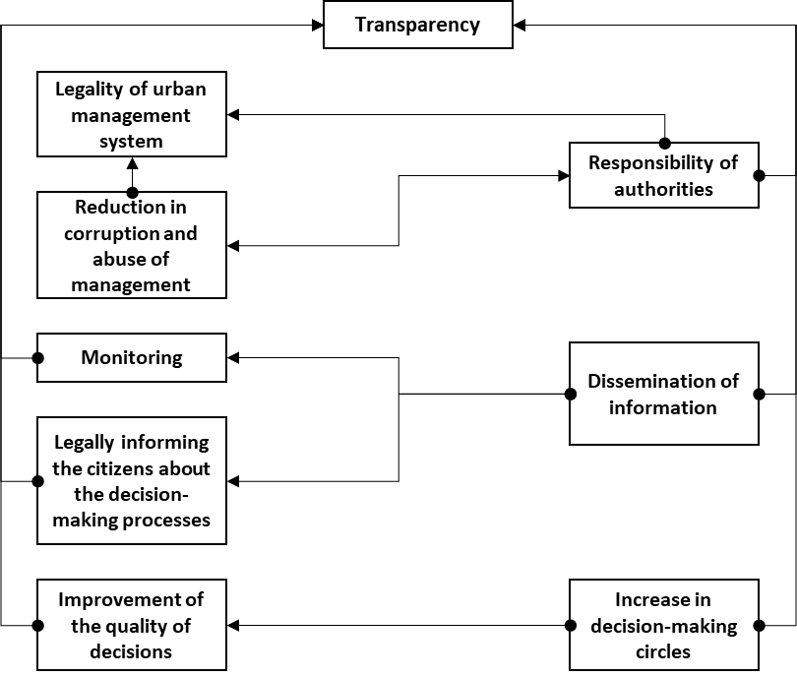

Figure 2. Covert characteristics of the transparency policy in the Esfahan Strategic Plans (based on content analysis method).
Tracing the covert features of the transparency policy in project and action reports shows a limited increase in transparency during implementation, achieved only by inviting informal social groups to increase members’ decision-making power. The most crucial demand of the social groups promoting the transparency policy is to increase the number of members in decision-making circles, and citizens want to be present at the highest decision-making levels of the city for greater transparency (Figure 3).

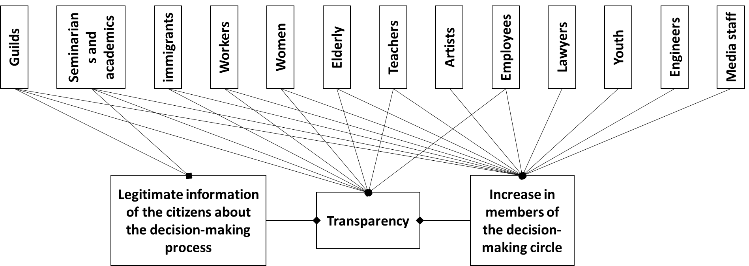

Figure 3. Covert characteristics of transparency policy in the official reports of the projects and actions of the Esfahan Urban Administration System(based on content analysis method).
The content analysis of approvals related to the transparency policy in the Esfahan Public Administration System shows that managers and politicians distrust society, resulting in incomplete implementation of the policy. Although in the statement of approvals, resolutions determining and approving the budget often address concepts such as legally informing citizens about decision-making processes to a small extent, in practice, the main focus is on listening to individual citizens' conversations. The emergence of concepts such as inter-organizational transparency in the analysis of the content of approvals indicates a desire to monitor the details of the performance of the Esfahan Urban Administration system. However, there is no desire to report to the citizens (Figure 4).
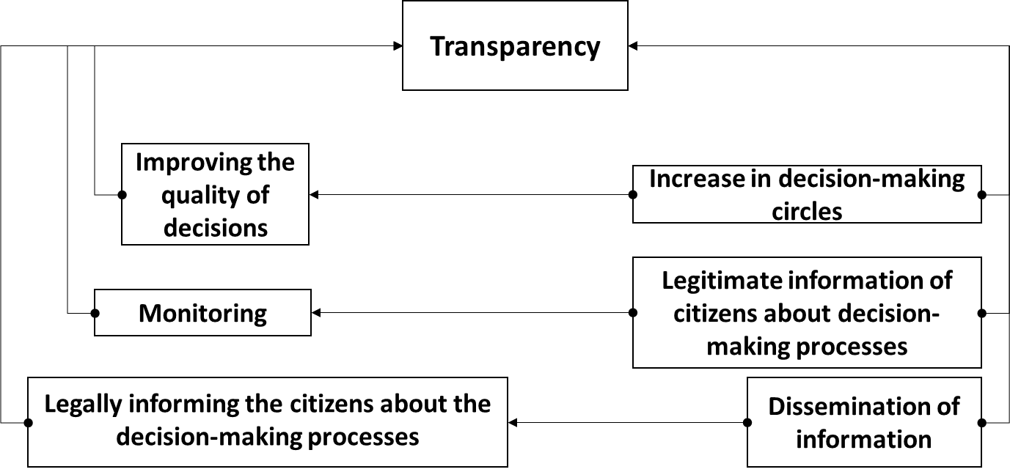

Figure 4. Covert characteristics of transparency policy in the Esfahan Urban Administration System approvals (based on content analysis method).
Interviews with urban managers and policy-makers show that for them, understanding the concept of transparency is “informing citizens.” Despite their awareness of the effects of implementing the transparency policy, especially on information dissemination, public awareness, and legalization within the urban administration system, no accepted changes have been made in line with its implementation. They consider the implementation of the transparency policy limited to their inclusion in the Esfahan strategic plans. They define the plans as a platform for improving the relationship between citizens and officials and moving towards a more democratic society. Besides, the cultural background of society, the absence of administrative processes and guidelines, the lack of a valuation platform for the implementation and assessment of transparency policy, the existence of monitoring by higher governmental institutions on the municipality, legal restrictions, the short length of the management period and the continuous change of urban managers are obstacles to achieving this implementation of the policies are stated. Managers and members of the Council consider the lack of suitable platforms for assessing the transparency policy to be a reason for the incorrect or incomplete assessment.
The city managers’ proposal to update the transparency policy is to provide written guidelines for the implementation of the transparency policy to overcome the weakness of the policy evaluation system and upgrade inter-organizational relations based on policy implementation and coordination in the urban administration system, with these features (Figure 5):
First: Compatibility with the description of duties and the opinions of experts of each organization in the Public Planning System, with the continuous evaluation of the implementation of the policy, its results, and feedback.

Responsibility of authorities
Transparency
Reduction in corruption and abuse of management
Legality of urban management system
Legally informing the citizens about the decision-making processes
Monitoring
Dissemination of information
Informing
Improvement of the quality of decisions
Increase in members of the decision-making circle
Limitations in law
Short duration of management period
Evaluation of system excellence
Embedding in the urban management system
No process and guidelines
Trust
Problem tracking
E-municipality
Subjective evaluation by officials
Description of municipal duties
Evaluation
unsystematic and unintegrated policy making process
Responsibility
Existence of the monitoring of government institutions on the municipality
Public culture
Incomplete or wrong evaluation
Needs assessment and public survey
No evaluation platform and evaluation capability
There is only systems and process evaluation
Mutual relationship of participation and transparency
Citizen-orientedness
Efficiency
Features different from the theoretical framework
Semi-structured interviews with city managers and policy makers
Transparency consultant

Figure 5. Covert characteristics of transparency policy in semi-structured interviews with urban managers and authorities (based on content analysis method).

Second: Creating opportunity space for citizens' participation in urban decision-making.
Third: Expansion of the electronic municipality.
Fourth: Ability to measure and evaluate the transparency policy in the Esfahan municipality.
Fifth: Implementation of the transparency policy with a neighborhood-based approach.
Sixth: Public Information with emphasis on modern electronic facilities such as city screens.
Seventh: Delegation of power and authority to non-governmental organizations.
Eighth: Acceptance and implementation of the transparency policy in the upper layers of the municipal and government administration system.
  - Analysis of inter-organizational coordination and implementation of transparency policy
The findings of the analysis of intra/inter-organizational coordination to implement the transparency policy can be summarized as follows:
First: Policy coordination for transparency in Esfahan’s Urban Administration System, with laws and regulations, is moderate (40%); coordination with program goals is low (19%), and with the plan, resources are very low (14%). Therefore, implementing the transparency policy in Esfahan’s Urban Administration System in the planning field faces significant conflicts of interest, and legal challenges further complicate its implementation.
Second: coordination for resource allocation (provision and distribution of resources) to policies related to transparency is low (20%), and, in addition, the monitoring of resource allocation could be higher (12%). These findings show that coordination for implementing and executing policies to improve transparency in the Esfahan Urban Administration System is severely constrained by resource limitations.

Third: Coordination in using up-to-date knowledge and technology to promote transparency policies in the Esfahan Urban Administration System could be higher (22%).
In general, the policies to promote transparency in Esfahan’s Urban Administration System are weak and lacking in various dimensions of coordination in execution and implementation, except for coordination with laws and regulations, which is close to average, in other dimensions of policy coordination, such as allocation of resources, supervision of implementation and distribution of resources, and having up-to-date knowledge and technology, efforts are needed to promote coordination (Table 6).

Table 6. Summarizing the findings of the covert and overt features of transparency policy and their relationship with coordination in policy-making
Coordination analysis findings | Qualitative (normative) analysis findings | Quantitative (positive) analysis findings
- There is a deficiency in coordinating the transparency policies with the strategic plans’ goals.  - Compliance of most transparency policies with existing laws is moderate. | -A rational decision has been made based on the population’s needs. | - The target population of policies is clear.  - The implication of transparency policies is clear on who and what.  - Transparency policies are consistent with public needs. | Decision- making
- Most transparency policies have resources aligned with the strategic plan.  - For most of the transparency policies, there is favorable inter-organizational coordination.  - Most transparency policies are moderate in matching existing knowledge and technology. | - Transparency has been adopted preliminarily and established to build trust and improve the conditions of transparency policies. | - Stakeholder groups are determined in the transparency policy.  - The strategies to reach the transparency policy have been specified.  - The boundaries of policies are defined.  - Policy evaluation criteria are specified.  - The policy-maker and executive have been identified.  - The informing of transparency policies has been done well. | Decision-taking and setting up a platform
- Coordination for the implementation of resource transparency policies is high.  - There needs to be more coordination to evaluate the implemented policy resources. | - There is distrust towards society, and the policy implementation needs to be completed.  - Conversations with citizens are heard individually, and transparency is limited to awareness.  - There is a desire for intra-organizational transparency without organized reporting to the citizens in the municipality.  - There are no guidelines for the widespread implementation of transparency. | - There is only a deadline for implementation without a start and end date.  - There needs to be a partial and complete understanding of transparency policies.  - The results and, as a result, their deviation from politics could be more precise.  - The interpretation of policy effects needs to be clarified for citizens.  - Presentation of the transparency policy can only be seen in documents rather than in an operational way. | Implementation and operationalization

- Conclusion
Generally, the research results can be summarized via quantitative (positive), qualitative (normative), and coordinated analysis of the transparency policy in the Esfahan Urban Administration System. The weakness and deficiency in implementing the transparency policy stem from the poor performance of the urban administration system in consistently interpreting the policy and determining the share of participation in its implementation. Urban managers and policymakers in urban decision environments want to accept only some changes. They have a results-oriented view in which fundamental concepts related to the transparency policy are not significant. Regarding transparency, it has not been done correctly, and the lack of a conclusion reflects the society's cultural context. The Urban Administration System in developing communities has weaknesses in its public policy-making mechanism, including the lack of policy-coordinating agendas across organizational levels and a lack of a unified definition of policy. This weakness prevents the emergence of a common political language among public policy actors. In addition, as the policy moves from the theoretical to the practical level, the barriers and factual issues for mainstreaming increase.
The current literature and views on transparency policy must be defined, precise, and unambiguous for all urban managers and policy-makers to improve this administration system’s transparency policy at both theoretical and practical levels. A practical guideline should be approved to implement the decision-making process and participate in implementing the policy. The allocation of resources for implementing the transparency policy needs to be transparent, and the monitoring and evaluation system for its performance has to be designed and implemented. There should be a sufficient understanding of knowledge and technology, and the policy needs to be formulated based on these possibilities. The expected achievements of the policy should be clearly defined in each program, and the policy should neither under-cover nor over-cover the target population. Public needs and wishes are considered in formulating policy, and a guideline needs to be developed to adapt the organizational ecosystem to transparency policy and to the adaptability of employees, managers, and policy-makers within the urban administration system. Concentrating on monitoring and evaluating the transparency policy center and its reporting subsystem within an integrated system based on a holistic view will enhance transparency performance in the future. Developing quantitative (positive) and qualitative (normative) policy analysis methods and techniques to support the overt and covert aspects of positive and normative transparency policy in real and virtual spaces could be implemented in new directions in public participation through transparency promotion. Moreover, the inter-organizational coordination mechanism in the urban administration system is directly connected to the transparency policy and must be compatible with its content.

References
Adelle, C., & Weiland, S. (2012). Policy assessment: The state of the art. Impact Assessment and Project Appraisal, 30, 25–33. https://doi.org/10.1080/14615517.2012.663256
Albalate, D. (2012). “The Institutional, Economic and Social Determinants of Local Government Transparency.” Journal of Economic Policy Reform, 16. https://doi.org/10.1080/17487870.2012.759422
Ali Ahmadi, A., & Mirabedini, Z. (2019). Examining the Public Policy Making Process in Tehran’s Urban Management (2012-2018). Iranian Journal of Public Policy, 5(1), 75–98.
Araujo, J., & Tejedo-Romero, F. (2016). Local government transparency index: determinants of municipalities’ rankings. International Journal of Public Sector Management, 29, 327–347. https://doi.org/10.1108/IJPSM-11-2015-0199
Arnold, G., & Long, L. A. N. (2019). Policy Expansion in Local Government Environmental Policy Making. Public Administration Review, 79(4), 465–476. https://doi.org/https://doi.org/10.1111/puar.12905
Baekgaard, M., Larsen, S. K., & Mortensen, P. B. (2019). Negative feedback, political attention, and public policy. Public Administration, 97(1), 210–225. https://doi.org/https://doi.org/10.1111/padm.12569
Ball, C. (2009). What Is Transparency? Public Integrity, 11(4), 293–308. https://doi.org/10.2753/PIN1099-9922110400
Barakopour, N., & Asadi, E. (2009). Urban management and governance (Third). Municipal Publications.
Barberio, R. P. (2015). The politics of public policy. Pearson Higher Ed.
Benito, B., Guillamón, M.-D., & Ríos, A.-M. (2021). Transparency and efficient management in local governments. Cities, 115, 103234. https://doi.org/10.1016/j.cities.2021.103234
Bernards, N., Campbell-Verduyn, M., & Rodima-Taylor, D. (2022). The veil of transparency: Blockchain and sustainability governance in global supply chains. Environment and Planning C: Politics and Space, 23996544221142764. https://doi.org/10.1177/23996544221142763
Blackman, T. (2013). Urban policy in practice. Routledge.
Bridgman, P., & Davis, G. (2003). What Use is a Policy Cycle? Plenty, if the Aim is Clear. Australian Journal of Public Administration, 62, 98–102. https://doi.org/10.1046/j.1467-8500.2003.00342.x
Capano, G., & Howlett, M. (2020). A Modern Guide to Public Policy. Edward Elgar Publishing. https://doi.org/10.4337/9781789904987
Cifuentes-Faura, J., Benito, B., Guillamón, M.-D., & Faura-Martínez, Ú. (2023). Relationship between Transparency and Efficiency in Municipal Governments: Several Nonparametric Approaches. Public Performance & Management Review, 46(1), 193–224.
Clemons, R., & McBeth, M. K. (2020). Public policy praxis: A case approach for understanding policy and analysis. Routledge.
Cowan, R. (2005). The Dictionary of Urbanism. In Streetwise Press (Vol. 1, Issue 1). https://doi.org/10.1057/palgrave.udi.9000158
Cucciniello, M., Porumbescu, G. A., & Grimmelikhuijsen, S. (2017). 25 Years of Transparency Research: Evidence and Future Directions. Public Administration Review, 77(1), 32–44. https://doi.org/https://doi.org/10.1111/puar.12685
da Cruz, N. F., Tavares, A. F., Marques, R. C., Jorge, S., & De Sousa, L. (2016). Measuring local government transparency. Public Management Review, 18(6), 866–893.
Dunlop, C., Radaelli, C., & Trein, P. (2018). Learning in public policy. Cham: Springer International Publishing, 1–25.
Dunn, W. N. (2015). Public policy analysis: An integrated approach. Routledge.
Dye, T. R. (1976). Policy Analysis: What Governments Do, why They Do It, and what Difference it Makes. University of Alabama Press. https://books.google.ca/books?id=V2ZxfSCu8xkC
Egeberg, M. (2020). Policy design or organizational design: On the relevance of the study of public policy and administration. Public Administration, 98(3), 801–804. https://doi.org/https://doi.org/10.1111/padm.12671
Emami Meybodi, R. (2015). Comparative Analyses of Policy Evaluation Systems; Principles and Rules. Quarterly Journal of Political Science, 21(1), 45–68. https://dorl.net/dor/20.1001.1.20080743.1394.11.1.2.1
Finkelstein, N. D. (2000). Transparency in Public Policy: Great Britain and the United States, New York: St. Martins Press.
Fischer, F., & Miller, G. J. (2017). Handbook of public policy analysis: theory, politics, and methods. Routledge.
Geva-May, I. (2012). An Operational Approach to Policy Analysis: The Craft: Prescriptions for Better Analysis. Springer US. https://books.google.com/books?id=tJ7LBgAAQBAJ
Gill, J. I., & Saunders, L. (1992). Toward a definition of policy analysis. New Directions for Institutional Research, 1992(76), 5–13. https://doi.org/https://doi.org/10.1002/ir.37019927603
Immordino, K. M. (2017). Organizational assessment and improvement in the public sector. Routledge.
Kim, S., & Lee, J. (2012). E‐participation, transparency, and trust in local government. Public Administration Review, 72(6), 819–828.
Kraft, M. E., & Furlong, S. R. (2019). Public policy: Politics, analysis, and alternatives. Cq Press.
Lazarsfeld, P. F., Barton, A. H., Lerner, D., & Lasswell, H. (1951). The policy sciences. Stanford University Press.
Mahmoudi, A., & Davoudi, K. (2014). The effect of establishing electronic municipality on the transparency of municipalities’ performance. Journal of Urban Management, 13(35), 55–66. https://www.sid.ir/paper/491046/fa
Marantz, N. J., & Ulibarri, N. (2022). The tensions of transparency in urban and environmental planning. Journal of Planning Education and Research, 42(3), 401–412.
Markus, G. B., & Krings, A. (2020). Planning, participation, and power in a shrinking city: The Detroit Works Project. Journal of Urban Affairs, 42(8), 1141–1163. https://doi.org/10.1080/07352166.2020.1779009
Meijer, A. (2013). Understanding the Complex Dynamics of Transparency. Public Administration Review, 73(3), 429–439. https://doi.org/https://doi.org/10.1111/puar.12032
Moon, M. J. (2020). Fighting COVID-19 with Agility, Transparency, and Participation: Wicked Policy Problems and New Governance Challenges. Public Administration Review, 80(4), 651–656. https://doi.org/https://doi.org/10.1111/puar.13214
Mungiu-Pippidi, A. (2023). Transparency and corruption: Measuring real transparency by a new index. Regulation \& Governance, 17(4), 1094–1113. https://doi.org/https://doi.org/10.1111/rego.12502
Polanska, D. V. (2020). Going against institutionalization: New forms of urban activism in Poland. Journal of Urban Affairs, 42(2), 176–187. https://doi.org/10.1080/07352166.2017.1422982
Porumbescu, G. (2015). Linking Transparency to Trust in Government and Voice. The American Review of Public Administration, 47(5), 520–537. https://doi.org/10.1177/0275074015607301
Roelofs, P. (2019). Transparency and mistrust: Who or what should be made transparent? Governance, 32(3), 565–580. https://doi.org/https://doi.org/10.1111/gove.12402
Rutherford, A., & Wightman, G. B. (2021). Inside the Push for Good Governance: Institutional Predictors of Administrative Transparency in Public Organizations. The American Review of Public Administration, 51(8), 590–604. https://doi.org/10.1177/02750740211031925
Sabatier, P. A. (1991). Political science and public policy. PS: Political Science & Politics, 24(2), 144–147.
Seetharam Sridhar, K., Gadgil, R., Dhingra, C., Seetharam Sridhar, K., Gadgil, R., & Dhingra, C. (2020). Good governance in the transparency, accountability, public participation and capacity (TAP-C) framework. Paving the Way for Better Governance in Urban Transport: The Transport Governance Initiative, 1–18.
Shapiro, S. (2016). Analysis and public policy: successes, failures and directions for reform. Edward Elgar Publishing.
Simme, J. (2004). Innovation Networks and Learning Regions? Routledge.
UNDP. (2014). Discussion paper Governance for Sustainable Development Integrating Governance in the Post-2015 Development Framework. https://www.undp.org/sites/g/files/zskgke326/files/publications/Discussion-Paper--Governance-for-Sustainable-Development.pdf
Ward, K. (2017). Public Policy. In International Encyclopedia of Geography (pp. 1–3). John Wiley & Sons, Ltd. https://doi.org/https://doi.org/10.1002/9781118786352.wbieg0239
Weimer, D., & Vining, A. (2017). Policy analysis: Concepts and practice. Routledge.
Weitzman, B. C., Silver, D., & Brazill, C. (2006). Efforts to Improve Public Policy and Programs through Data Practice: Experiences in 15 Distressed American Cities. Public Administration Review, 66(3), 386–399. https://doi.org/https://doi.org/10.1111/j.1540-6210.2006.00596.x

Interviews were conducted with fifteen managers of the Esfahan Urban managment system, including the mayor, deputy mayors, and members of the city council.

