A Study on Improving Kansei Engineering Precision through the Implicit Association Test
Ali Dasmeh ¹
Nasser Koleini Mamaghani * ²
Peyman Hasani Abharian ³

¹ Human Development, Max Planck Institute, Berlin, Germany. Email: dasmeh@mpib-berlin.mpg.de
² Industrial Design Department, School of Architecture and Environmental Design, Iran University of Science and Technology (IUST), Tehran, Iran. Email: koleini@iust.ac.ir
³ Department of Cognitive Psychology and Rehabilitation, Institute for Cognitive Science Studies, Tehran, Iran. Email: abharian@icss.ac.ir
Abstract
Background: In Kansei Engineering, measuring user emotions often relies on self-report methods, which can be biased and imprecise. The Implicit Association Test (IAT) offers a more objective way to assess emotions that are implicitly and non-consciously expressed. Aim: This study investigates whether the IAT can serve as a precise and less biased tool for measuring affective responses in Kansei Engineering. Methods: We developed a software platform to record participants’ reaction times (n=16) as they categorized product stimuli (reception chairs, n=9) with Kansei-related words. Faster responses were assumed to indicate stronger or more confident opinions, providing a potential metric for emotional intensity. Results: The data revealed a W-shaped distribution of reaction scores, with high concentrations at both extremes and in the middle. This deviates from the expected normal distribution, indicating that participants tended to hold either strong or neutral opinions, while moderate opinions were rare. This pattern emerged through an implicit cognitive measure rather than self-reporting, suggesting it reflects underlying cognitive mechanisms. Conclusion: This finding aligns with the "gap instinct," which posits that humans tend to dichotomize their experiences to reduce cognitive load. The results indicate that the IAT offers a valuable tool for enhancing the measurement of affective responses in Kansei Engineering by capturing these implicit, underlying cognitive tendencies.
Keywords: Kansei Engineering, Implicit Association Test, Reaction time, processing fluency

Introduction
Marvin Minsky (Minsky, 2007) suggests that although emotions may appear distinct from ordinary thinking, in reality, the notion of purely logical thinking is a myth. This is because our minds are always influenced by assumptions, values, and goals—which themselves are shaped by emotional sources. According to Minsky, the term “emotion” encompasses a complex and vast array of phenomena whose interrelations are not yet fully understood. He notes that in infants, emotions can serve as mechanisms for understanding situations, conveying a type of knowledge about how to respond, and initiating motor or muscular actions aimed at achieving a purpose. Minsky conceptualizes the mind as a cloud of fundamental emotional resources that combine in various ways when different emotions are expressed.
Damasio (Damasio, 1994) argues that humans tend to make irrational decisions based on their feelings—or on how they anticipate they will feel—and subsequently rationalize those decisions. In essence, emotion and feeling act as bridges between rational and non-rational processes, that is, between cortical and subcortical structures.
It appears that emotions, in the context of human mental functioning, if not identical to cognition, are at least equally important. Accordingly, behavior—including decision-making as a component of behavior—is influenced by emotions. Studying and measuring emotions therefore contributes to a better understanding of human behavior. In this regard, a well-defined and expanding field has emerged within the discipline of design that focuses specifically on emotion in design, known as emotional design.
Norman (Norman, 2005) posits that human characteristics arise from three distinct levels of the brain: visceral, behavioral, and reflective. These levels influence one another and act in a mutually regulating manner. Based on this categorization, Norman divides the act of design into three corresponding types and asserts that, at the reflective level of design, the designer’s task is to design for the user’s emotions. He further explains that the reflective level concerns the overall impact a product has on an individual.
Desmet (Desmet, 2002) states in his book that the influence of emotions on both product pleasantness and purchase decisions suggests that understanding how products affect people—and having tools to measure the emotions elicited by designed products—can be practically applied in the design process. Nevertheless, our knowledge about how individuals emotionally respond to products and how design triggers these emotions remains limited.
Schütte (Schütte, 2005) acknowledges that the idea of incorporating users’ emotional values into products is not entirely new. Since the early 1970s—following approximately two decades of economic growth in Europe that began with post–World War II reconstruction—this approach gradually evolved. The ongoing shifts in consumer demands highlighted the need for new or improved tools capable of integrating emotional aspects into product development.
Although the concept of emotion-driven design is well-recognized among designers, its associated methodologies remain relatively limited in variety, and none of the existing approaches appear to be widely adopted in practice. In the following sections, we will examine the efforts and methods that have been developed in pursuit of emotional design.
Küller (Küller, 1975) developed a method for describing the semantic qualities of environments. This approach, applied in the field of architecture, was used to evaluate architectural structures based on their aesthetic qualities. Since aesthetic aspects are directly linked to emotions, this method belongs to the category of emotion-driven design methodologies.
Akao (Akao, 1990) developed the Quality Function Deployment (QFD) method in Japan. This technique, considered a type of engineering method, clarifies the relationship between user needs and the technical-engineering specifications of a product.
Nagamachi (Nagamachi, 1989) introduced Kansei Engineering for the first time, which is based on a Japanese concept of sensory perception. Kansei Engineering is also an engineering tool that assesses the emotional needs of users and, through a predictive mathematical model, elucidates the relationship between emotional needs and the features of a specific category of products.
In general, emotion measurement methods can be categorized into two main types: self-report and implicit methods. Self-report methods rely on the participant’s conscious effort to express their internal emotional state through an explicit action. This action may involve verbalizing a word, indicating the intensity of an emotion on a predefined rating scale, or altering the state of a button on a specific interface.
In contrast, implicit emotion measurement methods involve the assessment of parameters while participants perform simple tasks—such as viewing a screen or clicking a button. These parameters are typically physiological and involve the monitoring of physical responses that are not consciously controllable.
Mauss and Robinson (Mauss & Robinson, 2009) refer to an emotion measurement approach based on the autonomic nervous system, which is primarily responsible for regulating physiological functions. The most prominent methods in this category involve electrodermal and cardiovascular responses. Electrodermal responses are typically assessed through skin conductance level (SCL) or short-term skin conductance responses (SCRs), reflecting changes in sweat gland activity associated with emotional arousal. Cardiovascular measures include heart rate, blood pressure, total peripheral resistance, cardiac output, pre-ejection period, and heart rate variability. Each of these indicators differs in terms of whether it primarily reflects sympathetic activity, parasympathetic activity, or a combination of both within the autonomic nervous system.
Stemmler (Stemmler, 2004) concluded from his research that when autonomic nervous system (ANS) responses are considered in isolation—based on a single physiological factor—they tend to reflect emotional dimensions (such as arousal or valence) more than discrete emotional states (such as fear, joy, or anger). However, taking multiple ANS indicators into account simultaneously enhances the precision and reliability of emotion measurement through autonomic responses.
A number of researchers have explicitly recommended the use of brain activity measurements for the assessment of discrete emotional states (Buck, 1999; Izard, 2007; Panksepp, 2007). The two principal methods for measuring brain activity are electroencephalography (EEG) and brain imaging techniques, with functional magnetic resonance imaging (fMRI) being the most widely used. Mauss and Robinson (Mauss & Robinson, 2009), through a review of studies employing these techniques, concluded that due to the complex nature of emotions—which likely involve multiple neural circuits—neuroimaging methods that examine distributed brain regions may hold greater promise for understanding why and how emotional features emerge in the brain.
In light of the increasing need for more precise and less biased methods of capturing user emotions in Kansei Engineering, this study explores the integration of Implicit Association Assessment as a novel evaluative tool. For this aim, a software platform has been developed that incorporates subjects, Kansei product samples, and Kansei-related words categories. The primary research question investigates whether there is an inverse relationship between participants’ response times during a product categorization task and the strength or clarity of their expressed opinions—that is, whether faster responses indicate more intense or confident judgments. The stimuli and Kansei vocabulary used are based on a rigorously selected and categorized dataset drawn from a prior case study. The overarching objective of this first study is to propose an effective tool for implicit emotional evaluation that enhances the measurement of affective responses while reducing data noise and subjective bias.

Litrature Review
Greenwald and colleagues (Greenwald, McGhee, & Schwartz, 1998) were the first to introduce the Implicit Association Test (IAT). The IAT consists of two binary classification tasks: a target task and an attribute task, both performed by pressing two keys. A key aspect of the test is that key assignments differ across the two test blocks. In the congruent block, participants are instructed to press one key for the target category associated with positive attributes (e.g., flowers and good) and the other key for the category associated with negative attributes (e.g., insects and bad). In the subsequent block, the key assignments are reversed so that a positive target is paired with a negative attribute on one key, and a negative target is paired with a positive attribute on the other.
Rijtecin and colleagues (Richetin, Perugini, Prestwich, & O’Gorman, 2007) used the IAT to examine individuals’ preferences between snacks and fruits. The data from this experiment corresponded with participants’ real-life behavior. Over a period of several weeks, they monitored the participants’ eating habits. Subsequently, an implicit evaluation was conducted in which participants were asked to categorize snacks (unhealthy) and fruits (healthy) into different groups. The speed of participants’ responses in the assigned categories aligned with their actual eating behaviors.
Meissner et al. (Meissner, Grigutsch, Koranyi, Müller, & Rothermund, 2019) stated that with the use of implicit measures such as the IAT, researchers hoped to ultimately bridge the gap between self-reported emotional states and actual behavior. They also argued that while the intended aim of the IAT is to measure users’ “wanting,” what it actually captures is “liking.”
Finally, the response times of the participants are recorded, and if there is a difference between the results of the third and fourth stages, it can indicate the individual’s tendency to associate "action" or the completion of a task with "artifacts" – or vice versa. In this test, participants generally responded faster when categorizing "actions and living creatures" into one group and "attributes and artifacts" into another, compared to when they were required to categorize "actions and artifacts" into one group and "attributes and living creatures" into the other. This suggests that individuals have an implicit association between actions and living creatures in their minds, while such a connection is not typically made between actions and artifacts.
In another definition, Wojnowicz and colleagues (Wojnowicz, Ferguson, Dale, & Spivey, 2009) described the IAT as a method for interpreting individuals’ implicit attitudes, which reveals their unconscious tendencies by examining the strength of associations between words through the analysis of response times.
Namaguchi and Anoda (Yamaguchi & Onoda, 2012), based on behavioral data, proposed that the relationship between emotion processing and selective attention involves the extraction of emotional value from sensory stimuli, which in turn leads to an appropriate response.
Rothermund and colleagues (Rothermund, Teige-Mocigemba, Gast, & Wentura, 2009) introduced the free recording variant of the IAT. In the original IAT procedure, category pairings remained fixed within each block, and only the stimuli varied. In the revised method, both the stimuli and the category pairings are randomly changed in each trial. As a result, scores in this new approach are calculated based on the difference in performance between compatible and incompatible trials, rather than between congruent and incongruent blocks.
Karpinski and Steinman (Karpinski & Steinman, 2006), in a case study, proposed a new type of IAT called the Single-Category Implicit Association Test (SC-IAT), the figure 1 is images of IAT and SC-IAT. This method is nearly identical to the original IAT, with the key difference being that in each stage, a single category is paired with one attitude, while the opposing attitude forms its own separate category. To align this with the earlier example: in the third stage, "artifact and action" are grouped together versus "attribute," and in the next stage, "living being and attribute" are grouped versus "action." In their study, the researchers focused on two soft drinks: Coca-Cola and Pepsi. The experiment was conducted in two phases. In the first phase, one category included "positive words and Coca-Cola," while the other included only "negative words." In the second phase, the categories were "negative words and Coca-Cola" versus "positive words." A total of 7 images and 21 words were presented to participants in a completely randomized order for classification. The two-phase experiment was then repeated, this time replacing Coca-Cola with Pepsi—both in the category labels and in the 7 images shown to participants. Ultimately, the study concluded that the Single-Category IAT is capable of measuring the associative values connected to a single object or category.
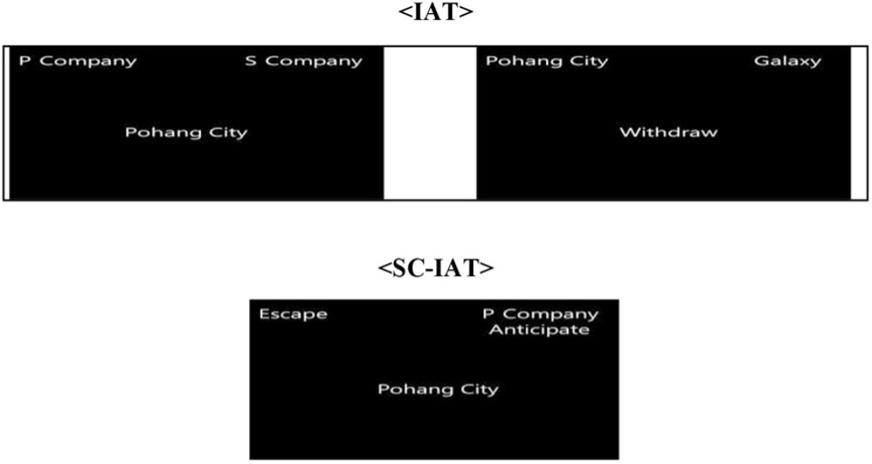
Figure 1: Single-Category Implicit Association Test
Ralf Reber (Reber, 2012) proposed the Processing Fluency Theory in the context of evaluating the aesthetic appeal of an artwork. According to this theory, the ease with which a stimulus is processed—measured by individuals’ reaction times—serves as an indicator of its perceived beauty. Reber hypothesized and tested that shorter reaction times reflect greater processing fluency, which in turn correlates with a stimulus being perceived as more beautiful or more favorably evaluated. His experiments supported this hypothesis. However, other researchers have questioned his findings by raising concerns such as the natural decrease in reaction time with aging, which could confound the relationship between processing fluency and aesthetic judgment.

Methodology
In this study, the subjects are reception chairs that were previously examined using the conventional Kansei method—specifically, the semantic differential technique—in a study conducted by the authors (Dasmeh, Koleini Mamaghani, & Hassani-Abharian, 2024).
Nine chairs (figure 2), selected from the best-selling waiting room chairs based on the rankings of the Digikala website, were used as stimuli in this study. The selection was guided by predefined Kansei categories and attributes. The Kansei-based criteria used in this study included:
- backrest
  - Full (a1)
  - Half (a2)
- seat
  - Plastic (b1)
  - Thin cushion (b2)
  - Thick cushion (b3)
- armrest
  - Present (c1)
  - Absent (c2)
These categories served as the foundation for evaluating the emotional and perceptual responses to the chairs.
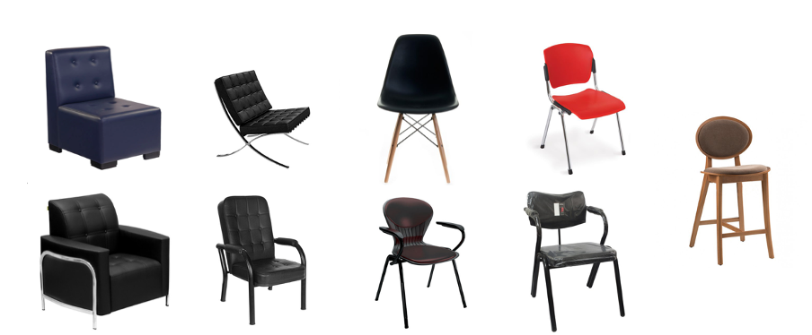
Figure 2: Nine chairs selected based on the Kansei method.
In Kansei Engineering, subjects are selected to represent the full scope of the study. In the present research, three components of reception chairs—backrest, seat, and armrest—were identified as the focus of the investigation. Accordingly, different configurations of each component were defined as categories. For instance, in Kansei Engineering, the backrest is considered an item, while “full” and “half” are its two categorical variations. Given the presence of two categories for the backrest, three for the seat, and two for the armrest, a total of 12 unique combinations would be required to comprehensively represent the study’s domain. However, three of these 12 theoretical combinations were not available in the Iran’s market and had not previously been designed—for example, a chair with a thick cushion and a half backrest could not be found. As a result, nine chairs currently available in the market were selected based on their high sales rankings and were used as the final set of stimuli.
The Kansei adjectives were extracted using a web engineering technique known as scraping. A custom program was developed to systematically access all product pages related to chairs on the Digikala website. This program navigated through each page, retrieved the user review sections, and analyzed individual words by cross-referencing them with the Vajehyab online dictionary. If a word was identified as an adjective based on grammatical criteria, it was added to a list. The resulting list of adjectives was then filtered and ranked based on frequency of use. Ultimately, only 11 adjectives were found to be relevant. After further evaluation, the author paired each of these adjectives with an appropriate antonym, selected through additional reference to Vajehyab and in consultation with the academic advisor. Table 1 lists the English translation of Kansei words.
Kansei Words - Translated to English
pair number | English
1 | Casual – Official
2 | Modern – Classic
3 | Fake – Authentic
4 | Ugly – Beautiful
5 | Rough – Delicate
6 | Breakable – Chic
7 | Decorative – Practical
8 | Fragile – Durable
9 | Ugly – Eye-catching
10 | Calming – Tension-inducing
11 | Professional design – Non-professional design
The application for the experiment was developed by the researcher using web stacks. In the developed assessment, several trials are presented to the participant, each consisting of an image with a pair of contrasting adjectives. These adjectives are placed at the top left and right of the image, Figure 3 is an example of one trial. After viewing each trial, the participant must decide which of the two adjectives better describes the presented chair, in their opinion. Their choice is recorded by pressing either the left or right key on keyboard. Following the selection, a fixation cross appears for 1500 milliseconds before the next trial is shown. In this display sequence, the pair of opposing adjectives remains fixed at the top left and right, while only the chair image changes across consecutive trial—each chair is shown three times. After all chairs have been displayed three times for the current adjective pair, a new pair of adjectives is introduced, and the randomized presentation of the chairs begins again, each appearing three times. With every keypress, the participant’s response time (in milliseconds), latency between presenting the image and the user keypress, is recorded for further analysis.
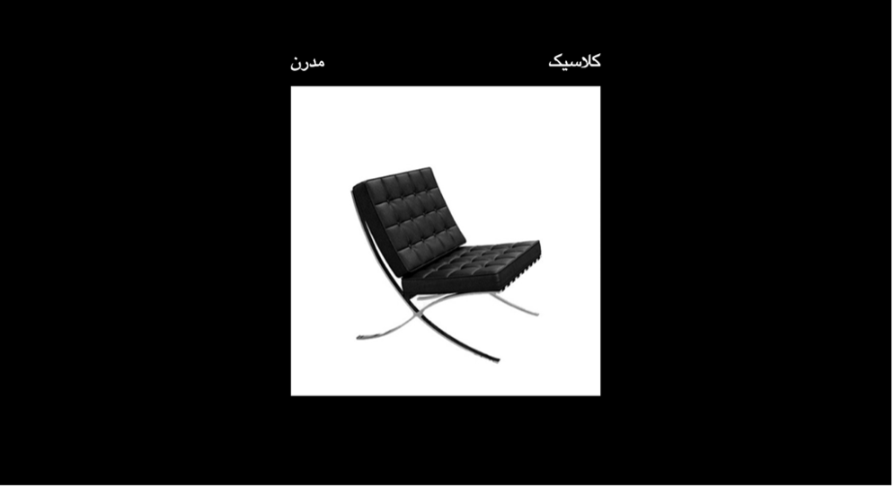
Figure 3: Example of a trial.
In this evaluation, 16 participants (9 female, average age = 28 years) volunteered to participate. All of them were master’s students or graduates in Industrial Design. The average daily computer usage among the participants was 4.9 hours. Prior to the evaluation, participants were asked about their use of prescription medication, drugs, or cigarettes. If any of these were reported as positive, the individual was excluded from the study. Participants were then provided with a standardized explanation of the experimental procedure. Due to the length of the testing process, the adjectives were divided into two sections, and the test was conducted in two approximately 10-minute sessions, with a 5-minute break in between. Figure 4 represents the flow of the experiment for a single participant.
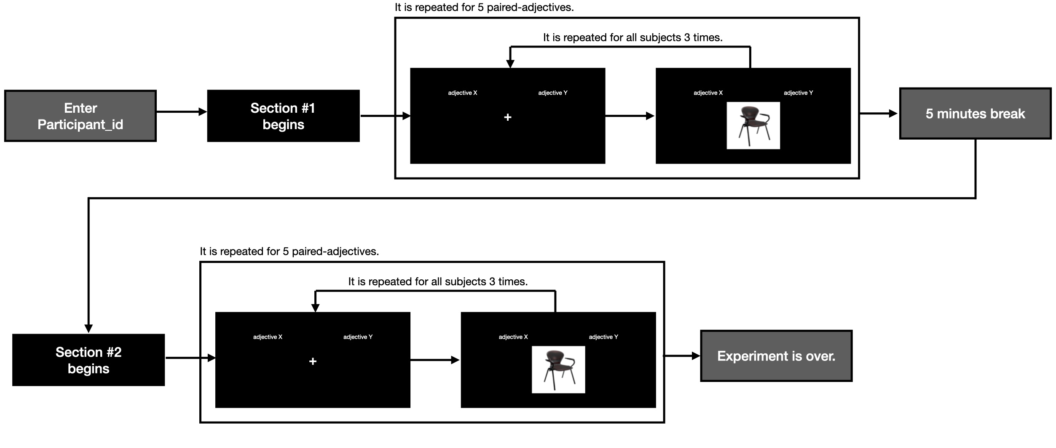
Figure 4: Experiment flow for a participant.
Reactions with latencies shorter than 200 millisecond were classified as non-intentional responses, while those exceeding 30 seconds were considered indicative of distraction and were excluded from analysis. Data from one participant were excluded due to multiple instances of distraction occurring across several trials.

Results
According to the Processing Fluency Theory, shorter reaction times indicate easier cognitive processing and thus reflect a higher degree of approval or affirmation of the stimulus by the participant. As previously mentioned, one criticism of this theory is that reaction times tend to increase with age, even though a person’s feelings toward a given stimulus may remain unchanged. More broadly, due to individual differences in cognitive abilities, reaction times can vary significantly between participants. Additionally, a person might require varying amounts of time to form a judgment depending on the specific attribute of the stimulus being evaluated. Therefore, in this study, each participant’s response times were normalized individually and separately for each Kansei word.
Furthermore, the objective was to derive a score where higher values reflect stronger emphasis or affirmation of the selected response—since greater emphasis corresponds to shorter reaction times in this context. To achieve this, the normalized reaction times were subtracted from one, resulting in a final score where higher values indicate stronger implicit endorsement. The Equation 1 is representing that.
$$\text{score}=1-\frac{\text{reaction} \text{time}-\text{shortest reaction} \text{time}}{\text{longest reaction} \text{time}-\text{shortest reaction} \text{time}}$$
Equation 1: Normalizing the reaction times.
As mentioned in the previous section, for each trial -one chair and a pair of adjectives- 3 responses were collected from each participant. If all three responses were identical (for example, if the participant chose beautiful in all three trials for the beautiful–ugly pair), the average of the three corresponding scores was calculated and recorded as the participant’s final score for that chair and adjective pair. However, if one of the three responses differed (e.g., two responses for beautiful and one for ugly), the average score of the two identical responses was first calculated. Then, this average was algebraically combined with the score of the differing response (for instance, if two beautiful responses and one ugly were recorded, the average score for beautiful would be subtracted by the score for ugly). Finally, depending on the position of the selected adjective, a positive or negative sign was added to the score: if the chosen word appeared on the right side, a positive sign was added; if on the left side, a negative sign was applied. These signs are added solely to differentiate scores and do not place any value on the attributes.
Table 2 is a general results of all participants.
The calculated scores for each chair and each Kansei word pair were organized into Table 3. In this table, the Kansei words are listed across the columns, while each row corresponds to a specific chair. The intersection of each row and column represents the average score of all participants for that particular Kansei word and chair.

The distribution of the scores calculated using the above method is shown in the Figure 5. As can be observed, there is a high concentration of scores at both ends of the spectrum as well as in the middle, forming what is commonly referred to as a W-shaped distribution.
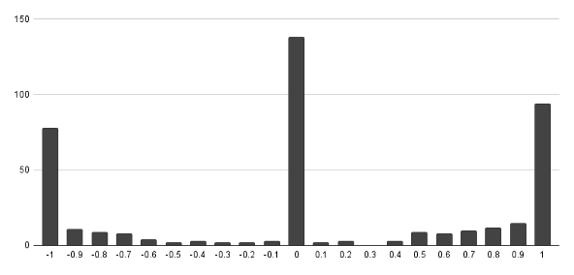
Figure 5: Distribution of all participants’ scores

Gender | Longest RT | Shortest RT | Average | S.D. | Average Scores | S.D. of Scores
M | 15152 | 344 | 1470 | 1718 | 0.11 | 0.75
F | 10252 | 460 | 1433 | 1002 | 0.11 | 0.73
M | 16238 | 305 | 1152 | 1352 | 0.03 | 0.75
M | 5160 | 368 | 1145 | 938 | 0.1 | 0.64
F | 26893 | 692 | 2665 | 3264 | 0.22 | 0.69
F | 8675 | 309 | 1488 | 1248 | 0.12 | 0.74
F | 24604 | 537 | 2514 | 2284 | 0.03 | 0.75
M | 15704 | 478 | 1398 | 1483 | -0.1 | 0.75
F | 7916 | 540 | 1424 | 1057 | 0.11 | 0.75
F | 9330 | 498 | 1472 | 1176 | -0.01 | 0.73
F | 21394 | 577 | 2522 | 2711 | -0.03 | 0.76
M | 22398 | 259 | 2344 | 2692 | 0.16 | 0.74
M | 10880 | 382 | 1745 | 1404 | -0.08 | 0.71
F | 24444 | 682 | 2538 | 2446 | -0.05 | 0.74
M | 13147 | 235 | 1688 | 1641 | 0.01 | 0.69
F | 9169 | 572 | 1818 | 1167 | 0.04 | 0.75
Table 2: Distribution of all participants’ scores

product ID  /pair number | 1 | 2 | 3 | 4 | 5 | 6 | 7 | 8 | 9 | 10 | 11
a1b1c1 | -0.16 | -0.17 | -0.23 | -0.03 | -0.04 | 0.15 | 0.65 | 0.02 | 0.03 | 0.39 | 0.43
a1b1c2 | 0.58 | 0.67 | 0.62 | -0.56 | -0.11 | 0.89 | 0.11 | 0.7 | -0.16 | 0.43 | -0.04
a1b2c1 | -0.72 | -0.67 | -0.6 | 0.76 | -0.03 | -0.06 | -0.43 | -0.63 | -0.17 | -0.59 | 0.02
a1b2c2 | 0.06 | 0.66 | 0.55 | -0.13 | -0.21 | -0.6 | -0.44 | -0.68 | -0.14 | -0.51 | -0.23
a1b3c1 | -0.29 | -0.08 | 0.11 | 0.79 | -0.48 | 0.23 | 0.04 | -0.75 | 0.51 | -0.18 | -0.05
a1b3c2 | 0.23 | -0.23 | -0.01 | 0.71 | -0.1 | 0.26 | -0.4 | -0.66 | 0.18 | -0.48 | 0.28
a2b1c2 | -0.04 | 0.21 | 0.18 | 0.43 | -0.13 | 0.56 | 0.13 | -0.69 | 0.51 | 0.17 | -0.28
a2b2c1 | -0.42 | -0.61 | -0.32 | 0.23 | -0.28 | 0.01 | -0.6 | -0.4 | -0.43 | -0.52 | -0.24
a2b2c2 | 0.73 | 0.56 | 0.46 | 0.26 | -0.04 | -0.005 | 0.28 | 0.4 | -0.03 | 0.26 | -0.44
Table 3: Product scores for each pair-words

Conclusion
As reported in the previous section, the distribution of participant scores in this study follows a W-shaped pattern. This indicates that when participants hold an opinion about a stimulus, it tends to lean toward one of the two extremes.
As Posner (Posner & Weyl, 2018) argues, is not typically expected in normally distributed responses; rather, opinions would naturally be expected to follow a normal distribution, with around 70 percent of responses clustering around the middle of the scale. For example, in a Likert-scale survey from 1 to 5, most responses would typically fall in the 2–4 range, while only about 30 percent would be at the extremes (1 or 5). However, the current study supports Posner’s claim that, in practice, responses tend to skew toward the poles of the scale.
Posner attributes this deviation to limitations in the Likert scale format and proposes an alternative ranking method that forces respondents to distribute their answers according to a normal curve. In contrast, the present study employs an implicit cognitive methodology—rather than a behavioral one like the Likert scale—yet still results in a similar W-distribution. This suggests that the phenomenon is not merely an artifact of survey design but may reflect an underlying cognitive mechanism.
Participants in this study often responded either very quickly—analogous to selecting a strong opinion (1 or 5) on a Likert scale—or very slowly, suggesting a neutral stance (similar to selecting 3). Rarely did responses occur with medium reaction times, which would equate to moderate opinions (2 or 4). This finding supports Posner’s notion that the skew is cognitively driven.
Further support for this interpretation comes from Rosling Rönnlund et al. (Rönnlund, Rosling, Rosling, Pharao, & Ringhof, 2019), who described the gap instinct in their book, arguing that the human mind instinctively dichotomizes complex phenomena to reduce cognitive load. In other words, people are naturally inclined to categorize experiences or objects as either good or bad rather than considering nuanced in-between states. The present findings align with this cognitive tendency.
Although Dasmeh et al. (Dasmeh et al., 2024) found that Likert-scale data in a Kansei engineering context followed a normal distribution—seemingly supporting Posner’s hypothesis—the current study, along with others cited earlier, presents a different perspective. It suggests that even when using cognitively grounded, nonverbal evaluation methods, responses tend toward extremes. Thus, the W-shaped distribution may be rooted in deeper cognitive processes rather than being a simple flaw of the Likert scale.
The results obtained from this experiment were consistent with the behavioral data reported earlier, and the important observation that the distribution of emotional scores should align with a normal distribution was not achieved. The results of this experiment suggest that the absence of a normal distribution in user opinions is not due to errors in the ranking scales but rather due to fundamental cognitive reasons.
This study focused exclusively on a single participant to evaluate the proposed tool. Another limitation of the study is the small sample size. In future research, it is recommended to apply this tool to a broader range of products and vocabulary sets. Additionally, studies should be conducted with larger and more diverse populations.
GitHub Repository for SD-Kansei by IAT:
https://github.com/alidasmeh/Semantic-Differential-Kansei-by-IAT

References
Akao, Y. (1990). History of quality function deployment in japan. Hansa Publisher.
Buck, R. (1999). The biological affects: A typology. Psychological review, 106(2), 301.
Damasio, A. R. (1994). Descartes’ error: Emotion, reason, and the human brain. Grosset/Putnam, Inc.
Dasmeh, A., Koleini Mamaghani, N., & Hassani-Abharian, P. (2024). Comparison between discrete and analog semantic differential scales accuracies in kansei engineering (case study: Reception chairs). Journal of Design Thinking, 5(1), 47–56.
Desmet, P. (2002). Designing emotions.
Greenwald, A. G., McGhee, D. E., & Schwartz, J. L. (1998). Measuring individual differences in implicit cognition: The implicit association test. Journal of personality and social psychology, 74(6), 1464.
Izard, C. (2007). Levels of emotion and levels of consciousness. Behavioral and Brain Sciences, 30(1), 96–98.
Karpinski, A., & Steinman, R. B. (2006). The single category implicit association test as a measure of implicit social cognition. Journal of personality and social psychology, 91(1), 16.
Küller, R. (1975). Semantic environmental description (smb). Psykologiförlaget AB Liber Tryck.
Mauss, I. B., & Robinson, M. D. (2009). Measures of emotion: A review. Cognition and emotion, 23(2), 209–237.
Meissner, F., Grigutsch, L. A., Koranyi, N., Müller, F., & Rothermund, K. (2019). Predicting behavior with implicit measures: Disillusioning findings, reasonable explanations, and sophisticated solutions. Frontiers in Psychology, 10, 2483.
Minsky, M. (2007, November). The emotion machine: Commonsense thinking, artificial intelligence, and the future of the human mind (Illustrated) [Paperback edition]. Simon & Schuster.
Nagamachi, M. (1989). Kansei engineering. Kaibundo.
Norman, D. A. (2005). Emotional design: Why we love (or hate) everyday things (1st). Basic Books.
Panksepp, J. (2007). Neurologizing the psychology of affects: How appraisal-based constructivism and basic emotion theory can coexist. Perspectives on psychological science, 2(3), 281–296.
Posner, E. A., & Weyl, E. G. (2018). Radical markets: Uprooting capitalism and democracy for a just society. Princeton University Press.
Reber, R. (2012). Processing fluency, aesthetic pleasure, and culturally shared taste. Aesthetic science: Connecting minds, brains, and experience, 223–249.
Richetin, J., Perugini, M., Prestwich, A., & O’Gorman, R. (2007). The iat as a predictor of food choice: The case of fruits versus snacks. International Journal of Psychology, 42(3), 166–173.
Rönnlund, A. R., Rosling, O., Rosling, H., Pharao, K., & Ringhof, L. O. (2019). Factfulness - hvordan den moderne verden virkelig skal forstås. Lindhardt og Ringhof.
Rothermund, K., Teige-Mocigemba, S., Gast, A., & Wentura, D. (2009). Minimizing the influence of recoding in the implicit association test: The recoding-free implicit association test (iat-rf). Quarterly Journal of Experimental Psychology, 62(1), 84–98.
Schütte, S. (2005). Engineering emotional values in product design-kansei engineering in development. Linkopings Universitet (Sweden).
Stemmler, G. (2004). Physiological processes during emotion. In The regulation of emotion (pp. 48–85). Psychology Press.
Wojnowicz, M. T., Ferguson, M. J., Dale, R., & Spivey, M. J. (2009). The self-organization of explicit attitudes. Psychological Science, 20(11), 1428–1435.
Yamaguchi, S., & Onoda, K. (2012). Interaction between emotion and attention systems. Frontiers in neuroscience, 6, 139.

