A Systematic Review for Selecting Simulation and Applied Technology methods in Different Landscape Analytical Approaches

Sajjad Bahrami Hamedani$^{a}$, Seyed Hassan Taghvaei$^{b}$, Mohammad Tahsildoost$^{b}$

$^{a}$ PhD Candidate, Faculty of Architecture and Urban Planning, Shahid Beheshti University, Tehran, Iran
$^{b}$ Associate Professor, Faculty of Architecture and Urban Planning, Shahid Beheshti University, Tehran, Iran

Abstract
Landscape architecture confronts multifaceted challenges—from rapid urbanization and climate change to the complexity of managing large-scale ecological data—demanding advanced assessment methods to guide sustainable design and planning. As technological innovations reshape analytical capacities, this systematic review explores how emerging digital tools are enhancing landscape assessment across diverse domains. A comprehensive literature search across multiple databases initially identified 482 articles. Using the PRISMA methodology, a rigorous screening process narrowed this to 92 studies for in-depth analysis. This review categorizes landscape assessment into four key domains: visual, psychological, spatial, and ecological. It further organizes simulation methods into four distinct groups and classifies applied technologies into three primary categories: data management, visual and neuroscience applications, and photogrammetry.
By systematically comparing technological methods, assessment indicators, and software applications across these classifications, this study offers evidence-based guidance for landscape architects in selecting context-appropriate tools. Findings indicate notable advancements in objective assessment technologies—particularly in spatial and ecological domains—while highlighting ongoing challenges in integrating subjective human dimensions, such as psychological perception, into digital frameworks. The proposed taxonomy serves as a practical decision-making roadmap, enabling professionals to align simulation techniques and technological tools with specific evaluation goals—whether addressing visual impacts, social dynamics, ecological processes, or spatial configurations. Beyond mapping current technological trends, this review identifies critical gaps and opportunities at the intersection of landscape architecture and digital innovation, pointing to essential directions for future research and practice.
____________________
Keywords: Landscape analysis; applied technology; simulation method

1.Introduction
The integration of advanced technologies into landscape analysis has profoundly reshaped the field of landscape architecture, offering innovative methodologies to tackle the complex challenges of contemporary environments (Hancock et al., 2017). From urbanization and climate change to the management of large-scale ecological data, technological advancements are transforming how professionals approach landscape analysis, design, and construction—enhancing precision, efficiency, and sustainability across all project phases (Shen et al., 2024). These interventions span a broad spectrum, encompassing both passive processes such as cognitive perception and analysis, and active interventions like design implementation and landscape management.
A core component of landscape analysis is landscape cognition, rooted in environmental psychology, which seeks to understand the intrinsic characteristics of landscapes, human behavior, and perceptual responses. Traditional methods—including content identification (Evered, 2016), landscape preference pattern analysis (Massoni et al., 2016), and scenic beauty estimation (T. C. Daniel & Meitner, 2001)—have predominantly relied on subjective tools, such as questionnaires and semantic differential scales (Negrín et al., 2017). However, recent advances in physiological measurement techniques, such as eye-tracking (C. Su et al., 2023) and electroencephalography (EEG) (Roe et al., 2013), offer objective insights into human interactions with landscapes, bridging the gap between qualitative perception and quantitative analysis.
In the active phases of landscape architecture, simulation technologies play a pivotal role by enabling designers to create, manage, and optimize interventions. Digital twins, for example, simulate physical environments over time to support urban planning (Batty, 2018) and scenario testing (Cheshmehzangi, 2016). LiDAR technology has revolutionized the development of 3D urban models, supporting Digital Elevation Model (DEM) generation (Kraus & Pfeifer, 2001), building extraction (Park & Guldmann, 2019), and urban parameterization (Bonczak & Kontokosta, 2019). These models facilitate dynamic visualization (Nebiker et al., 2010), spatial change detection (Richter et al., 2013), and landscape evaluation (Sedláček et al., 2020). Although digital tools are applicable throughout all stages of landscape architecture, this review focuses specifically on landscape analysis, where their use is both more specialized and technically nuanced.
While technologies such as GIS (Richiardi et al., 2023), remote sensing, and virtual reality (Bai, 2020) have advanced objective assessments—particularly in spatial and ecological domains—subjective dimensions, such as psychological and visual perceptions, remain underrepresented within technological frameworks. This review addresses this gap by systematically categorizing landscape assessment into four domains: visual, psychological, spatial, and ecological. It further classifies simulation methods into four typologies (e.g., agent-based modeling, Monte Carlo simulations), and groups applied technologies into three categories: data science, photogrammetry, and visualization and neuroscience.
By leveraging these classifications, the review aims to offer landscape professionals a structured framework for understanding and selecting appropriate technologies based on specific analysis goals. Despite significant technological progress in related disciplines such as urban planning and architecture, the application of such methodologies in landscape architecture remains comparatively underexplored. This study addresses several critical objectives: identifying quantifiable landscape indicators, categorizing relevant technological approaches, determining strategic points of integration, exploring methodological synergies, and synthesizing emerging techniques for landscape analysis.
Moreover, the review examines evolving trends in technology adoption and evaluates how various simulation methods correspond to existing software and hardware systems. Previous studies have seldom examined the relationships between landscape analysis domains (visual, ecological, social, and spatial), simulation types, and associated digital tools in a comprehensive and interconnected manner. In addition, existing literature is often confined to urban design or limited to bibliometric and scoping reviews, lacking broader systematic syntheses.
This study pioneers a cross-domain evaluation that maps simulation methodologies to specific landscape assessment objectives. By aligning technologies with assessment domains and simulation typologies, it provides a practical decision-making roadmap for practitioners and researchers. It also addresses key research questions: How can simulation approaches and digital tools be matched to specific landscape analysis types to guide optimal method selection? Recognizing the diversity of methodologies and indicators proposed across case studies, this research also considers the potential of emerging technologies—including artificial intelligence—for comprehensive landscape evaluation. Importantly, it acknowledges an unresolved epistemological challenge: the universal applicability and validity of simulation methods across heterogeneous landscape paradigms.
  - landscape assessment approaches

The classification of landscape assessment into four discrete yet interrelated domains—visual, psychological and social, spatial, and ecological—is predicated on the need to address the multidimensional nature of human-environment interactions through a structured analytical framework. This taxonomy reflects fundamental epistemological distinctions in how landscapes are perceived, experienced, and evaluated: visual assessment focuses on aesthetic perception and scenic quality (T. C. Daniel & Meitner, 2001); psychological and social evaluation examines cognitive, emotional, and behavioral responses (Gobster et al., 2007; Roe et al., 2013); spatial analysis quantifies morphological patterns and functional relationships (Bonczak & Kontokosta, 2019); and ecological assessment investigates biophysical processes and ecosystem services (Mairota et al., 2014). Such categorization enables targeted methodological selection—for instance, eye-tracking for visual analysis (C. Su et al., 2023), EEG for psychological measurements (Schäfer et al., 2015), GIS for spatial modeling (Richiardi et al., 2023), or remote sensing for ecological monitoring (Wulder et al., 2019)—while acknowledging their frequent interdependence in holistic landscape studies. This framework not only aligns with established theoretical paradigms in environmental psychology and landscape ecology but also addresses a critical gap in technological adoption by mapping tools to specific assessment objectives, thereby enhancing methodological rigor and practical applicability in both research and professional practice.

1.2 Simulation methods
Simulation models serve as sophisticated analytical frameworks for examining landscape transformations across environmental and socioeconomic contexts, enabling researchers to evaluate system responses to diverse disturbance regimes. These computational approaches facilitate the interrogation of complex systemic interactions while supporting robust future projections. Based on our systematic review, we classify simulation methods into four distinct yet complementary typologies:
- Statistical Analysis Simulations:
This category encompasses quantitative techniques including ANOVA, Pearson correlation analyses, and other inferential statistical methods that identify significant relationships between landscape variables. Such approaches enable rigorous hypothesis testing and pattern detection within ecological and spatial datasets (Aitken & Hayes, 2006).
- Representational Modeling:
Including both static and dynamic modeling approaches, this typology focuses on spatial representation through cartographic outputs and 3D visualizations. Advanced computational tools generate high-fidelity models for applications ranging from educational demonstrations to tourism planning (Y. Li & Xu, 2017), while real-time modeling facilitates immediate feedback during design iterations (Wei et al., 2020).
- Scenario Comparison and Projection:
Exemplified by Monte Carlo techniques, these simulations employ probabilistic sampling to model complex system behaviors and future scenarios. Such methods provide critical insights for landscape management strategies, particularly for assessing ecosystem service outcomes like carbon sequestration potential (Aitken & Hayes, 2006), vegetation dynamics under climate change (Landguth et al., 2017), forest landscape models (FLMs) (Mladenoff, 2004), and optimization of infrastructure cost parameters (AZIZ, 2017).
- Methodological Comparison:
This analytical approach systematically evaluates different simulation techniques against common benchmarks, enabling researchers to identify optimal methodologies for specific landscape assessment contexts. These comparisons facilitate comprehensive environmental impact assessments and support evidence-based tool selection (MacDonald et al., 2022).
Landscape graphs are widely used to represent ecological networks and analyze connectivity. Unlike individual-based models, they require less ecological data (Galpern et al., 2011). These models can prioritize vulnerable elements in need of protection and identify key locations to improve landscape connectivity (Foltête et al., 2014). Landscape graphs are efficient in addressing various operational issues, such as reforesting agricultural land, creating ponds, changing agricultural practices, designing wildlife corridors, and establishing linear infrastructures (Girardet et al., 2016).
Simulation tools also contribute to transportation assessment (Kim et al., 2009), urban climate studies (Moonen et al., 2012), microclimate analysis (Kugler et al., 2019), and dynamic environmental assessments, such as flood modeling (Lin & Girot, 2014). Iterative prototyping enables continuous evaluation of design solutions (Cantrell & Holzman, 2015), reinforcing simulation's value in design management and operational performance.
Collectively, these simulation typologies empower landscape professionals to: (1) quantify system relationships through statistical rigor, (2) visualize spatial dynamics via representational models, (3) project future conditions through scenario analysis, and (4) optimize methodological selection through comparative evaluation. This classification framework not only structures current analytical approaches but also highlights opportunities for methodological integration in addressing complex landscape challenges.
1.3 Applied Technlogy

In this review, to advance the analysis of articles more quickly and systematically, the technologies used were classified into three general categories, which are discussed in more detail below.
1.3.1 Visualization and Neuroscience
Immersive technology, including virtual reality (VR) and augmented reality (AR), is used interchangeably with extended reality. It enhances education by integrating learning environments and human interactions through computer technology and perceptual devices. VR creates fully virtual environments with realistic graphics and interactive content, while AR overlays virtual content onto the real world. Both technologies are increasingly blended in education to offer comprehensive educational content and support different learning scenarios. (Kee & Zhang, 2022) Landscaping technology involves analyzing image features from landscape images or photographs for landscape recognition, where high-dimensional random vectors are mapped to a low-dimensional feature space (Da‐Hong et al., 2020). In the VR environment, each learner is an individual and their organs are completely immersed in the virtual reality environment, isolated from the real world. There are different tasks that can be analyzed after 3D modelling in VR technology such as 3D measurement, daylight analysis, field of view analysis, profile analysis (Trinidad-Fernández et al., 2021).
Residents are influenced by their surroundings and have aesthetic reactions to green scenery (Gobster et al., 2007), which ultimately affects how they evaluate a landscape. Previous studies have used various methods for perception-oriented approaches (T. C. Daniel, 2001), including the semantic differential technique, scenic beauty estimation method (T. Daniel & Boster, 1976), and law of comparative judgment (Buhyoff & Wellman, 1980). However, quantitatively measuring human perception remains challenging and requires more holistic and innovative approaches (Zhao et al., 2020). Psychological methods such as electroencephalography (EEG) (Roe et al., 2013) and eye tracking (Cottet et al., 2018), commonly used in other majors, can now be applied to landscape evaluation. Eye tracking, in particular, is a valuable technique for objectively measuring attention by capturing eye movements and analyzing visual attention and perception. It has been widely used in various disciplines (Dupont et al., 2017).
Eye tracking is a cost-effective and portable research tool, enabling the collection and analysis of big data for landscape preferences (Amati et al., 2018). There is a need to analyze how landscape elements affect evaluation from the perspective of human perception (J. Li et al., 2020). This technology also offers a quantitative index and guidance for landscape optimization like in rural areas (T. Su et al., 2022).
Brain activity measurements are objective indicators of how engaged individuals are with their surroundings (Schäfer et al., 2015). Brain imaging can help measure the impact of unconscious stimuli (Teplan, 2002), often relying on EEG frequency features. EEG features, including frequency, time, and spatial domain features, represent brain activities. Many studies have used EEG (Liu et al., 2018); such as emotion, object structure, color, landscape, and animal image recognition. EEG technology has also been applied to environmental perception and landscape assessment (Chang et al., 2008).
1.3.2 Data Science
The integration of AI and smart technology is transforming various aspects of life, including streetscape design, where AI helps meet functional and aesthetic needs (Verma, 2024). Digital image processing, which originated in the 1950s and developed as a discipline in the 1960s, uses techniques like enhancement, restoration, coding, compression, transformation, segmentation, description, and classification to improve image quality and analyze data. Neural network image classification and algorithms such as Scale Invariant Feature Transform (SIFT) are applied in streetscape design to analyze and classify images effectively (J. Yu & Zhang, 2022).
The rise of big data has introduced challenges in managing and analyzing massive datasets, which traditional methods cannot handle. While large datasets enhance statistical power, high complexity increases the risk of false discoveries. Advances in data storage and mining have sparked global interest, with solutions including parallel processing and distributed systems like cloud computing and social networks (Breur, 2016).
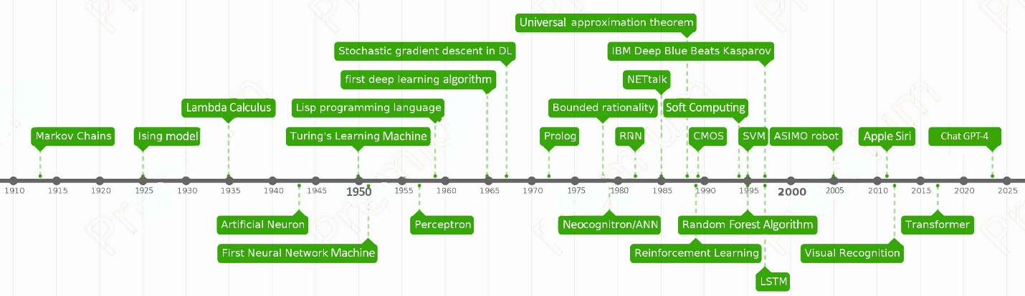
Figure 1. Timeline of progress in data science through the century

AI technologies, including machine learning and deep learning, are increasingly applied across domains such as landscape architecture (Hassija et al., 2024). Grasshopper, a Rhino software plug-in initially designed for product design and complex surface modeling, allows users to modify shapes through program logic dynamically (Sweatt et al., 2019). Unlike Grasshopper, machine learning algorithms are typically non-parametric.
Shallow learning, which involves a machine learning model with one hidden layer, is exemplified by support vector machines (SVM), a statistical approach for supervised learning (Luo, 2021). Deep learning, introduced in 2006 by Hinton et al., builds on artificial neural networks (ANNs) to emulate human intelligence and automate analytical model building (Sarker, 2021). Additionally, the Internet of Things (IoT) facilitates the remote monitoring, control, and management of data like energy systems in buildings (Liao & Zhong, 2022).
Geographic Information Systems (GIS) manage and analyze spatial data, enabling storage, analysis, and visualization of geographic information. Despite their capabilities, limitations in accuracy and data updates in tools like ArcGIS can hinder mapping processes (Zhou et al., 2021). GIS is widely applied in areas such as urban-landscape evaluation, tourism landscape analysis, settlement conservation planning, and three-dimensional visibility studies (Y. Zhang & Qiao, 2008).
Public Participation Geographic Information Systems (PPGIS), introduced in 1996, integrate GIS technology to empower marginalized communities by combining local-level mapping and participatory methods. Advances in platforms like Google Maps, Google Earth, OpenStreetMap, and user-generated geographic data have broadened PPGIS applications. However, its effectiveness depends on participation rates, data quality, and sampling practices (Brown & Pullar, 2012).
Building Information Modeling (BIM) automates parametric data identification in construction but is primarily tailored to architectural models. To enhance its use in landscape design, digital strategies focusing on scientific and objective analyses are proposed (Wang & Ma, 2022).
1.3.3 Photogrammetry
Traditional diagnostic methods like photographs, drawings, and topographical surveys have evolved with advancements in technology. Modern tools such as laser scanners, thermal cameras, Lidar, and UAVs (unmanned aerial vehicles) enable the creation of orthophotos, 3D models, and digital elevation models (Themistocleous, 2020). For documentation, techniques including aerial and terrestrial mapping, etc can be combined (Lim et al., 2015).
Lidar technology enhances precision in landscape design by creating high-density, three-dimensional point cloud models, applicable at city and regional scales (Urech et al., 2020). Similarly, UAVs have become indispensable in cultural heritage and archaeological research, providing high-resolution imagery for inaccessible areas and geospatial analysis (Themistocleous, 2020).
Remote sensing, once a political tool, is now a crucial resource for environmental data, supporting urban and policy assessments (Wulder et al., 2019). It aids in urban heat island analysis, leveraging datasets like Landsat (Wellmann et al., 2020). Despite rapid urbanization in developing nations, remote sensing highlights the need to monitor stable or shrinking cities also highlights (Wolff & Wiechmann, 2018).
The integration of 3S technology—Remote Sensing, GIS, and GPS—into education is enhancing environmental and landscape training by fostering specialization, scientific approaches, and spatial learning capabilities (X. Zhang et al., 2018). These tools enable practical problem-solving and efficient data management, advancing the field.
2. Materials and Methods
This systematic review employed a thematic approach to evaluate analytical methodologies in landscape architecture, with a particular focus on technology-driven simulation and assessment. Based on this framework, five core keywords were selected for the literature search: simulation, landscape, analysis, architecture, and technology. Recognizing the growing influence of digital tools in the field, the search targeted studies published from the year 2000 onward to encompass both foundational developments and contemporary advancements. To ensure the inclusion of the most recent technological innovations—such as artificial intelligence (AI), virtual reality (VR), and parametric modeling—conference papers published after 2021 were also considered. Eligible studies were those that explicitly addressed either subjective or objective methods of landscape assessment in conjunction with technological applications. Studies were excluded if they lacked empirical data or focused solely on ecological metrics without any direct linkage to design, planning, or human-environment interactions. In addition to mainstream academic databases such as Scopus, Web of Science, and ScienceDirect, IEEE Xplore was included to ensure adequate coverage of computational methodologies, owing to its specialization in engineering and digital sciences.
To ensure methodological rigor, the review process followed the Preferred Reporting Items for Systematic Reviews and Meta-Analyses (PRISMA) guidelines. The use of PRISMA enhances transparency and reduces researcher bias by centering the analysis around clearly defined research questions (O’Brien & Mc Guckin, 2016). Its effectiveness has been demonstrated in recent environmental studies addressing climate resilience and ecological restoration, highlighting its relevance for addressing contemporary challenges in landscape architecture (Qasha et al., 2024).
2.1. Literature selection
A comprehensive literature search was conducted on November 20, 2024, using four major academic databases: Web of Science, Scopus, ScienceDirect, and IEEE Xplore. The search strategy was designed to identify relevant publications from 2000 to 2024, reflecting both foundational studies and recent advancements in technology-driven landscape assessment.
Five key thematic areas guided the search, targeting article titles, abstracts, and keywords. The primary search terms included:
- Simulation or simulating,
- Landscape, green space, green infrastructure, park, green belt, green wedge, ecology, protected area, heritage, or garden,
- Analysis, assessment, evaluation, valuation, or assessing,
- Architecture, design, planning, or management,
- Technology or digital.
To enhance inclusivity and reduce the risk of omitting relevant studies, synonyms and closely related terms were included for each category. Boolean operators were applied to structure the search logically, with "AND" used to connect term groups and "OR" employed within groups to link synonymous terms.
This systematic search initially yielded a total of 482 articles: 114 from Web of Science, 278 from Scopus (the highest yield), 37 from ScienceDirect, and 53 from IEEE Xplore. To ensure currency and comprehensiveness, the search process was repeated, capturing the most recent publications and reinforcing the review’s relevance to emerging trends and innovations in the field.
2.2. Literature evaluation
In the next step, all identified articles were imported into Rayyan (https://www.rayyan.ai/) for screening. Rayyan is a web-based application that facilitates semi-automated screening of preliminary article content with a high degree of accuracy (Olofsson et al., 2017). Its versatility and built-in features support duplicate detection, verification, collaborative screening, and decision-making in systematic reviews (Abreha, 2019).
A total of 118 duplicate entries, 26 non-English articles, and 52 conference papers published prior to 2021 were excluded. In addition, a manual review of titles and fields was conducted to remove non-relevant articles, resulting in 145 papers retained for abstract screening.
In the final screening phase, the abstracts of these 145 articles were carefully reviewed to ensure relevance to the research objectives. This process, conducted with increased precision, led to the selection of 92 articles for full analysis.
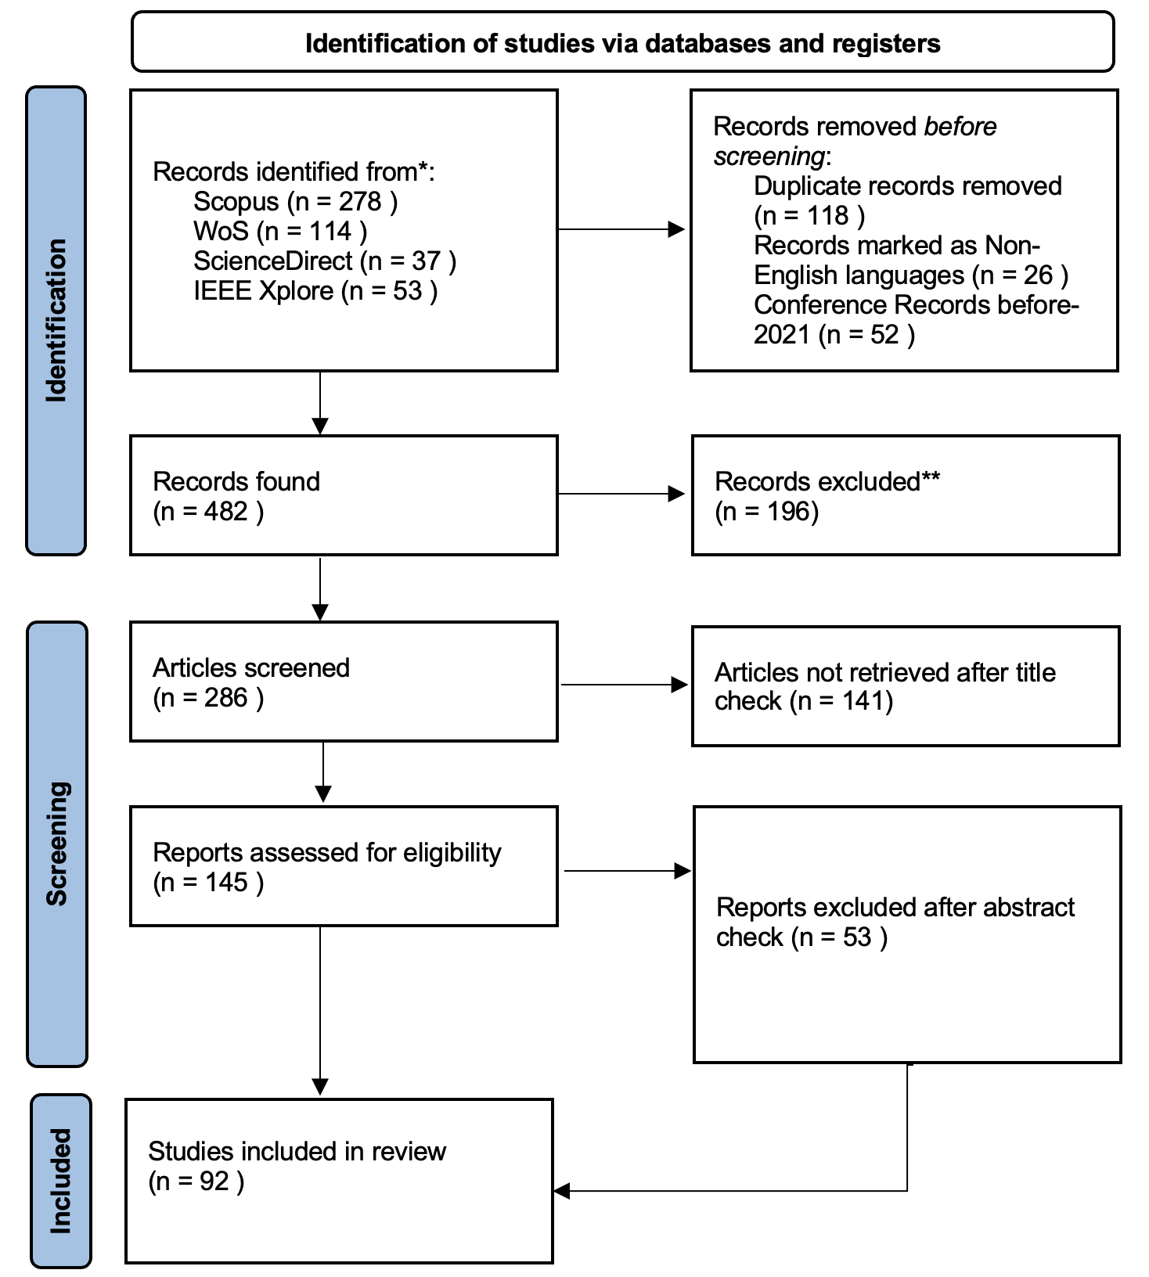
Figure 2. PRISMA process of the systematic literature review
- Results
Between 2000 and 2010, publications addressing landscape planning, urban planning, or urban design in relation to technological methodologies appeared sporadically. Theory-based articles were excluded from this review, resulting in the inclusion of only the earliest applied studies from this period. Notable examples include the evaluation of visual properties using GIS (Germino et al., 2001) and dynamic forest simulation (Cumming & Vernier, 2002). From 2010 to 2017, the publication of relevant studies became more regular and systematic. Beginning in 2017, a marked increase in the number of published articles was observed, reflecting growing interest and advancements in technology-supported landscape assessment.

Figure 3. Number of annual published articles
The number of publications has steadily increased over the past decade, with 76% of the reviewed articles published after 2020. This upward trend reflects the growing integration of digital technologies in landscape assessment. The annual distribution of publications is illustrated in Figure 3. It is important to note that the literature search was conducted in November 2024, ensuring the inclusion of the most recent developments.

Figure 4. Most Used Journals (at least 2 times) in the review (selected articles)
Among the 92 selected articles, 86 were journal papers published across 54 different journals, while the remaining six were conference proceedings or book chapters. Figure 4 highlights the 10 journals in which more than one of the selected articles were published.

Figure 5. Quartile Classification of Articles focusing on the country of the origin of articles
The majority of the journals were ranked in Q1 (42%) and Q2 (35%), according to the SJR citation index. Figure 5 presents the classification of the selected articles by SJR quartile and the country of origin of each journal. Journals based in Switzerland (29%), the Netherlands (17%), the United Kingdom (15%), and the United States (11%) accounted for the largest share of publications.
The 92 selected articles focus on technological approaches to landscape analysis and represent a wide global distribution, as illustrated in Figure 6. More than two-thirds of the studies were published by authors affiliated with institutions in China (53%), followed by the United States (8%), Germany (5%), Italy (4%), and Australia (3%).
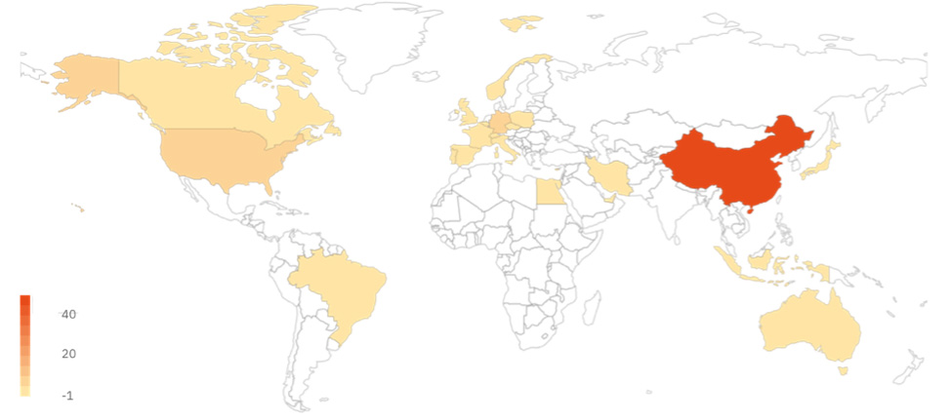
Figure 6. Distribution map of the location of the article authors
However, persistent challenges—such as data management (Shan & Sun, 2021), limited technical expertise, and resource constraints—continue to hinder widespread adoption, underscoring the need for innovative and adaptable solutions (Calkins, 2005).
This discussion explores the intersection of emerging technological methods with the broader challenges in landscape architecture, illustrating how these tools address specific needs while simultaneously introducing new complexities for practitioners. Within this context, the role of technology in advancing landscape analysis is critically examined, with particular emphasis on its transformative potential and the opportunities it presents for future development (Shen, 2023).
3.1. Landscape architecture challenges and approaches
This systematic review categorizes the identified challenges into five major themes (see Figure 7) for better clarity and analysis. The review highlights a spectrum of approaches to nature, from conservative to radical, with a growing emphasis on sustainability and future generations. Post-WWII urbanization led to intensified efforts to protect cultural and historical heritage, including historic urban landscapes (Bandarin & Van Oers, 2012). At the same time, population growth and human expansion have significantly altered land use and landscapes (Dadashpoor et al., 2019), causing fragmented and fragile environments (Merlotto et al., 2016). These transformations disrupt ecological functions (Mendoza-Ponce et al., 2021), impact the global carbon cycle (Zhu et al., 2021), climate systems (Thapa, 2021), biodiversity (Davison et al., 2021), and ecological integrity (Qu et al., 2021). Consequently, monitoring LULC changes has become essential for land management, planning, and conservation efforts (Abebe et al., 2022).
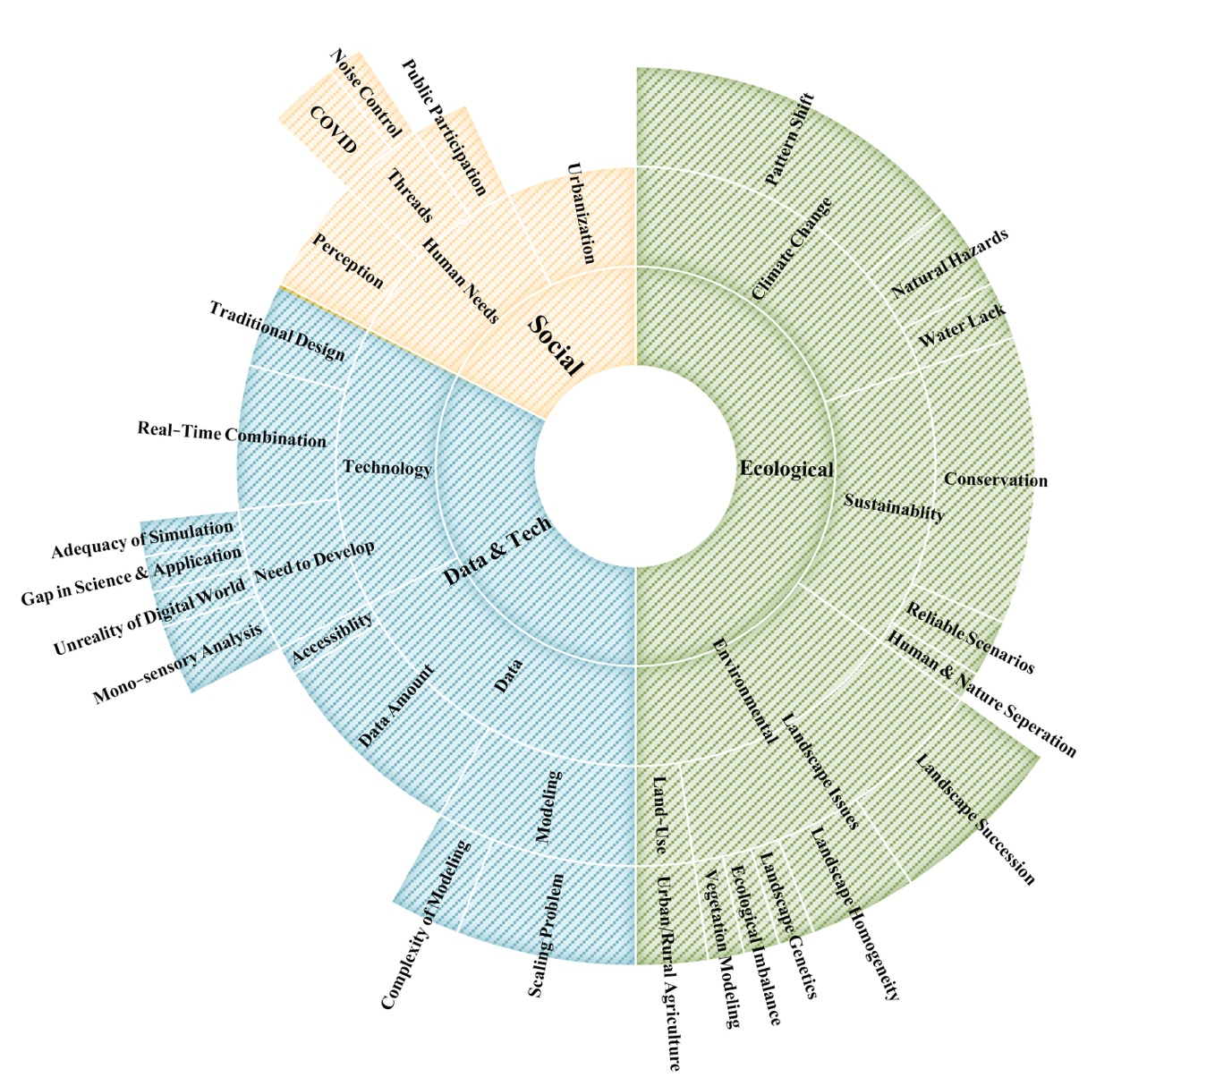
Figure 7. Classification of challenges in three levels and categories
Land use change analysis forms a critical foundation for understanding landscape patterns, including patch shape, area, quality, and spatial composition (Křováková et al., 2015). Geographic Information Systems (GIS) and remote sensing technologies play a central role in land use/land cover (LULC) mapping and change detection on a global scale (Mohamed et al., 2020). Analytical tools such as FRAGSTATS and APACK, in combination with landscape metrics, enable the quantitative description of landscape structure and support both environmental assessments and the study of ecological processes (Boongaling et al., 2018; Istanbuly et al., 2021).These metrics are particularly valuable for addressing pressing challenges such as urban sprawl, loss of natural lands, and agricultural instability (Fiener et al., 2011), while also informing evidence-based land use policies (Shafie et al., 2023).
Climate change, driven by industrialization, global warming, and urbanization, introduces critical threats including sea-level rise and the urban heat island (UHI) effect—where urban areas exhibit significantly elevated temperatures due to altered land-use patterns (Farhadi et al., 2019). The impacts of UHI include health risks, economic losses, and increased energy consumption (Seletković et al., 2023).
Urbanization continues to disrupt ecosystems—abandoning marginal farmlands and transforming mountainous terrains. Data-intensive approaches in landscape architecture are increasingly essential for addressing large-scale environmental investigations and the analysis of complex indicator systems, thus facilitating more informed and sustainable planning strategies. Conversely, a positive trend is the growing emphasis on public engagement in urban planning, increasingly supported by smart city technologies and participatory decision-making frameworks (Gushchin & Divakova, 2022).
- Discussion
The integration of technological methods into landscape analysis has profoundly impacted the practice of landscape architecture, reshaping how professionals address the complexities of contemporary environmental challenges (Hancock et al., 2017). By examining the core phases of landscape architecture—analysis, design, and construction—it becomes evident that technology enhances precision, efficiency, and sustainability at each stage (Shen et al., 2024). Despite these advancements, challenges such as data management (Shan & Sun, 2021), technical expertise, and resource constraints remain, underscoring the need for continued innovation(Calkins, 2005). This discussion explores the intersection of these technological methods with the broader challenges faced in landscape architecture, highlighting how emerging tools address specific needs while also raising new considerations for practitioners. From this perspective, the role of technology in advancing landscape analysis is critically evaluated, with a focus on its transformative impact and the areas for future development (Shen, 2023).
Technologically driven methodologies in landscape analysis can be systematically categorized into three key phases: input data, data processing, and output data. This tripartite structure mirrors the logical workflow of technological systems: input data (e.g., raw sensor measurements, user surveys, geographic datasets) provides the foundation for analysis; data processing (e.g., algorithmic modeling, machine learning, statistical normalization) transforms these inputs into actionable insights; and output data (e.g., visualizations, predictive reports, or design recommendations) delivers applied results. This classification ensures transparency, scalability, and reproducibility—qualities that are particularly important in interdisciplinary fields like landscape assessment, where the integration of raw data (e.g., ecological metrics) with processed outputs (e.g., simulated designs) requires clearly defined, traceable stages to validate findings and align tools with the needs of stakeholders.
To facilitate a meaningful comparison of results, we categorized technological methods and fields into broader groups. The classification framework comprises three main categories:
- Based on Data Interaction, which includes:
  - Inputs: Receiving and Mapping Data
• Laser Scanner/LiDAR
• Drone Imaging
• Remote Sensing
• Virtual Reality (VR)
• Augmented Reality (AR)
• Eye-Tracking
• Electroencephalography (EEG)
  - Process: Data Processing
• Big Data
• ENVI-met
• Geographic Information Systems (GIS)
• Participatory GIS (PPGIS)
• Artificial Intelligence (AI)
• Internet of Things (IoT)
• Building Information Modeling (BIM)
• Machine Learning
  - Output: Data Representation
• Image-Based Modeling
• Digital Twin
- Based on Applied Technology, which includes:
  - Neuroscience (NS)
  - Data Science (DM) (such as BIM, Big Data, GIS, Machine Learning, etc.)
  - Photogrammetry (PS) (including Remote Sensing and LiDAR)
After reviewing the selected articles, we compared them within these categories, as summarized in Table 1 (see Appendix). This classification method allowed for a systematic exploration of trends and developments within each category of applied technology, as illustrated in Figure 8.

Figure 8. Technologic method trends through the recent years
In another classification (Fig. 9), different simulation types were explored. These types are categorized as follows:
- (A) Statistical Methods: This category involves using statistical techniques such as ANOVA and Pearson correlation for analysis.
- (B) Modeling: This includes methods focused on representing maps and conducting real-time modeling.
- (C) Scenario Comparison and Future Projections: This category is concerned with techniques like Monte Carlo simulations used for comparing different scenarios or projecting future outcomes.
- (D) Method Comparison: This type involves comparing various methodologies.
Figure 9 illustrates the trend for each simulation type, highlighting how the application of these methods has evolved over time. An important point to note is that some articles utilize multiple simulation types in combination. For example, AC indicates a combination of type A (Statistical Methods) and type C (Scenario Comparison and Future Projections).

Figure 9. Simulation type trends through the recent years
In Fig. 10, the relationship between applied technology and simulation type is illustrated. This figure highlights the predominant simulation types used in each technology category. For instance, in the case of Neuroscience (as shown in Fig. 10), simulation type (A), which involves statistical methods, is the most frequently employed, accounting for 67% of the cases.
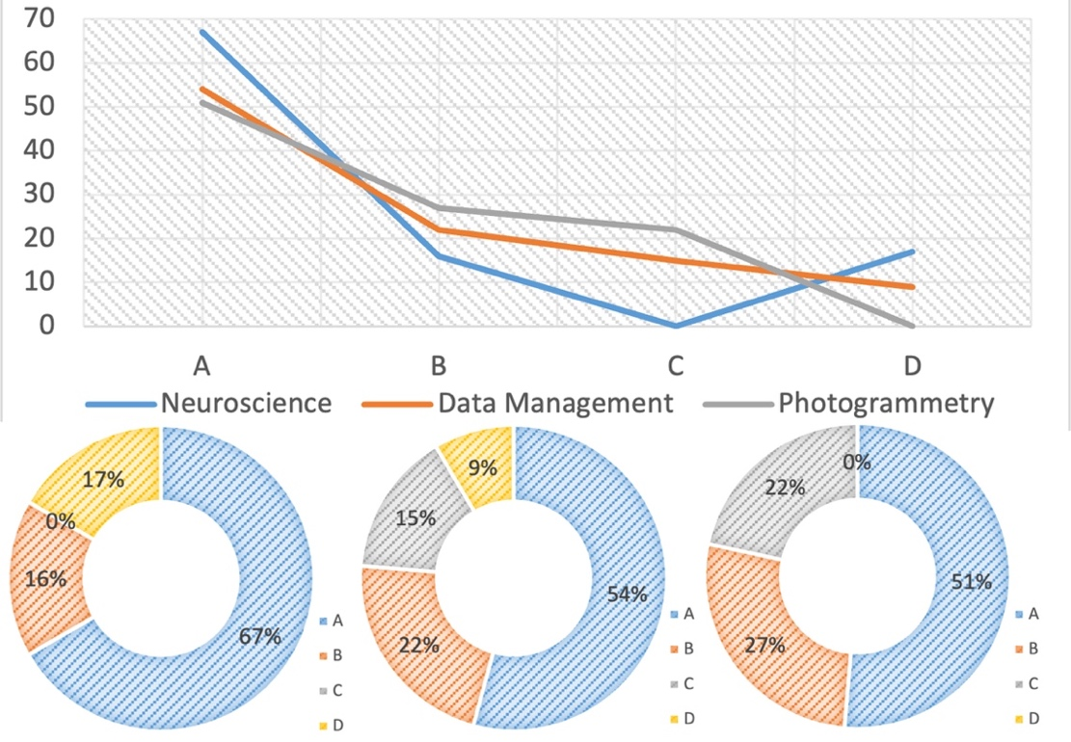
Figure 10. The relationship of applied technologies and simulation types
The analysis field types in this article are classified as follows: S for spatial, P for psychological-social, E for ecological-environmental, and V for visual assessment. Fig. 11 illustrates the relationship between applied technology and analysis field type. This figure allows for identifying the most frequently used analysis type within each category. For example, in the case of Neuroscience (as shown in Fig. 11), visual analysis (V) is the most prevalent, comprising 58% of the cases.
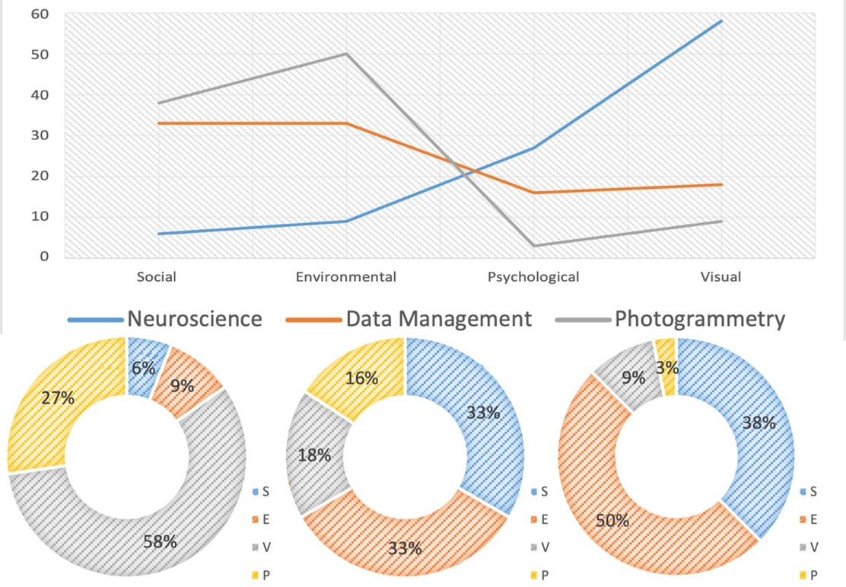
Figure 11. The relationship of applied technologies and analysis field types
The relationships among the three applied technology domains are illustrated in Figure 12, alongside the second categorization method (i.e., input, processing, and output data). This figure offers a comprehensive visualization of how specific methods within each domain interact and contribute to various stages of data handling. It emphasizes the integrative nature of these domains, showcasing their role in ensuring a smooth flow of information from data acquisition to analysis and, ultimately, to the final output.
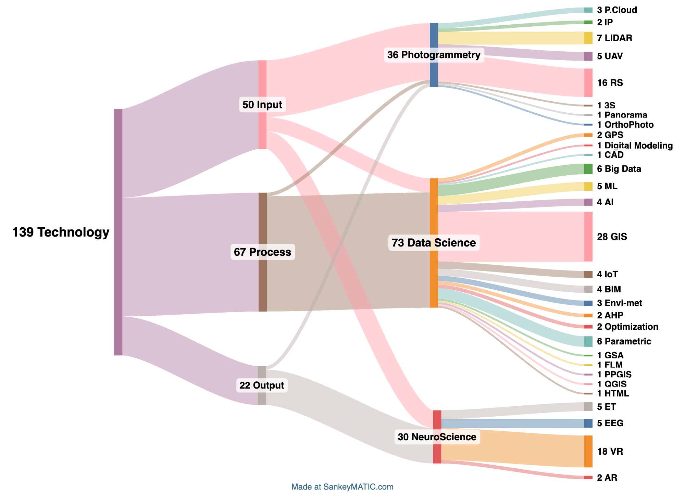
Figure 12. Sankey diagram of technologic methods in applied technology and interactive data categories
Additionally, the relationships among the three technology domains—Neuroscience, Data Science, and Photogrammetry—as well as their connection to analysis fields and simulation types, are depicted in the Sankey diagram presented in Fig. 13. This diagram also includes the categorization of methods, providing a clear visualization of how these domains align with different analysis approaches and simulation techniques.
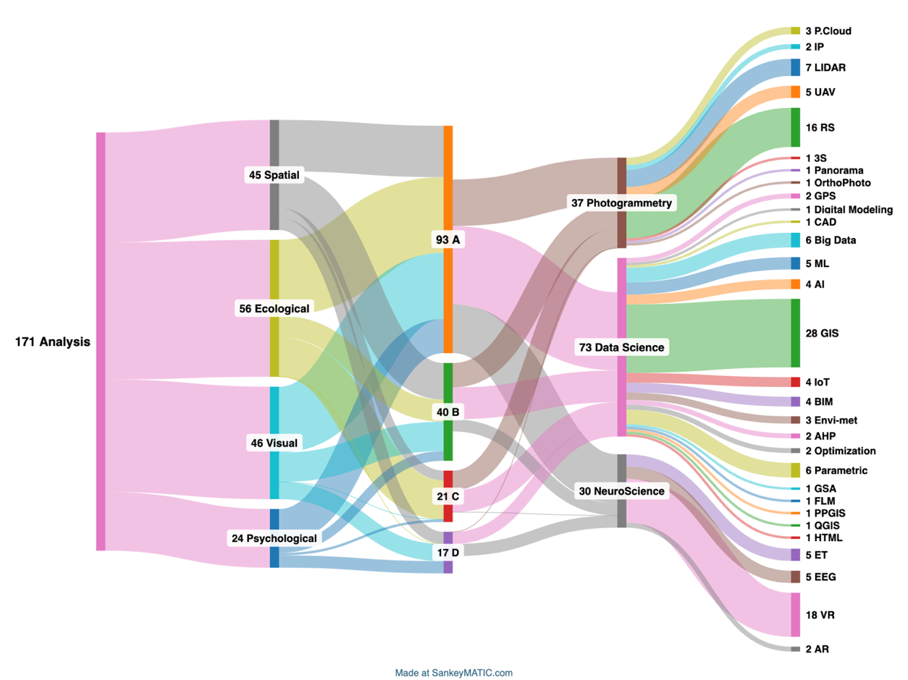
Figure 13. Sankey diagram of technologic methods in analysis field and simulation type categories
Several software tools and applications are commonly employed for landscape simulation. For example, GIS software is frequently used to generate 3D models of terrain and prepare essential data for landscape simulation (Dinkov & Vatseva, 2016). Tree growth software and landscape visualization tools help explore future possibilities and landscape succession (Ackerman et al., 2021). Landscape Builder is utilized to create spatially explicit landscapes using classified satellite imagery and multi-year data collection (Dijak, 2013).
In this review, the top five software tools identified are ArcGIS, AutoCAD, SPSS, Matlab, and Photoshop (Fig. 14). These simulation software tools are integral to landscape design, particularly for climate adaptation planning and landscape development. However, the implementation of these tools is not without its challenges, including issues related to interoperability and data loss (Keibach & Shayesteh, 2022). Depending on the specific objectives of the landscape analysis and the available data, these tools can be used individually or in combination to optimize outcomes.
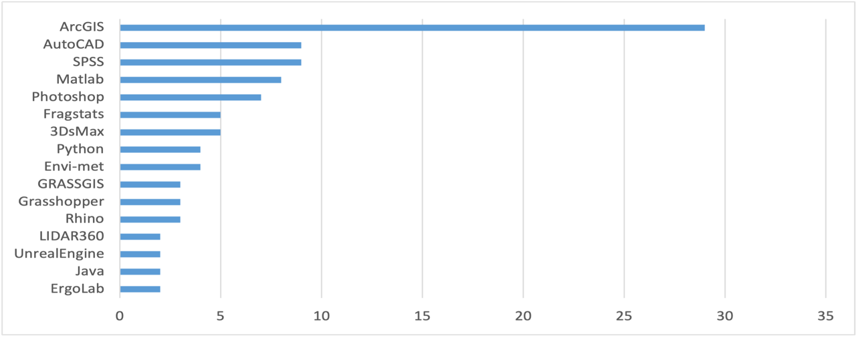
Figure 14. Most Used Software in selected articles
The review highlighted the most frequently utilized indicators across the analyzed studies, emphasizing their prevalence and relevance in various applications. The Digital Elevation Model (DEM) emerged as the most commonly employed indicator, appearing in 15 instances, followed by the Normalized Difference Vegetation Index (NDVI), which was used in 10 studies. Both Land Surface Temperature (LST) and Triangulated Irregular Network (TIN) were each employed 5 times, while Digital Surface Model (DSM), Land Use and Land Cover (LULC), and electroencephalogram (EEG) waves—particularly alpha waves—were each referenced 4 times (Fig. 15).
This distribution highlights the diverse range of indicators utilized in landscape and environmental analyses, showcasing their ability to capture both physical characteristics and cognitive dimensions. The variety of indicators underlines the interdisciplinary nature of landscape assessments, where multiple facets of the environment are considered to gain a holistic understanding.
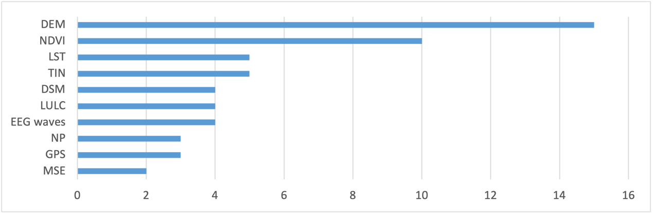
Figure 15. Most Used Indicators in the selected articles
In this review, we encountered various conceptual approaches, such as modeling and replicating real-world phenomena in the virtual domain (e.g., digital twins), investigating and comparing different scenarios, algorithms, or methods, and utilizing statistics and charts to depict variance. Based on these distinctions, we categorized the articles into three main groups: first, articles that explored methods driven by the novelty of the technological issue (56%); second, articles that focused on the design (4%) or analysis (40%) of existing technologies applied in case studies. To illustrate differences, several studies employed statistical methods, including Pearson correlation (38%), ANOVA (31%), and the Mann-Whitney test (19%), among others.
- Conclusion
The integration of advanced technologies into landscape evaluation has revolutionized environmental management, planning, and design, offering robust solutions to complex challenges—from quantifying ecological dynamics to simulating socio-environmental futures. This review demonstrates how hybrid methodologies, combining traditional practices with innovations like agent-based modeling and machine learning, enable holistic analysis of landscapes in all aspects.
This systematic review establishes a structured framework for aligning simulation methods and digital tools with specific landscape assessment approaches to guide evidence-based methodological selection. For visual assessment, immersive technologies like VR combined with eye-tracking systems enable quantitative evaluation of aesthetic preferences, while 3D modeling supports scenario visualization. Psychological and social assessments benefit from agent-based modeling integrated with biometric sensors (EEG) and participatory GIS, capturing both behavioral patterns and emotional responses. Spatial analysis is best served by GIS-based cellular automata and LiDAR processing, which effectively quantify morphological changes and connectivity. Ecological evaluation requires probabilistic methods like Monte Carlo simulations paired with remote sensing and AI-driven biodiversity monitoring to address complex biophysical relationships.
The proposed matching system emphasizes that optimal method selection depends on three key factors: assessment priorities (objective metrics vs. human perception), data availability (existing datasets vs. new sensor deployments), and project scale (site-specific vs. regional analyses). While significant progress has been made in objective assessment tools, persistent gaps remain in standardizing subjective evaluation protocols and improving interoperability between technical systems (e.g., BIM-GIS integration). Future development should prioritize hybrid approaches that combine quantitative precision with qualitative depth, such as explainable AI for cultural landscape valuation. By adopting this tailored framework, landscape professionals can more effectively navigate the growing array of technological solutions, ensuring both methodological rigor and context-sensitive outcomes across all assessment domains. Ultimately, this integration of targeted simulation methods and digital tools will advance more holistic, sustainable landscape management practices that balance measurable ecological patterns with the richness of human experience.
References
Abebe, W. B., Tilahun, S. A., Moges, M. M., Wondie, A., Dersseh, M. G., & McClain, M. E. (2022). Environmental flow assessment and implications on sustainability of aquatic ecosystems in Ethiopia: A literature review on global and national evidences. Environmental Development, 44, 100758.
Abreha, S. K. (2019). Model-based cost-effectiveness analysis of external beam radiation therapy for the treatment of localized prostate cancer: A systematic review. Cost Effectiveness and Resource Allocation, 17, 1–12.
Ackerman, A., Crespo, A., Auwaerter, J., & Foulds, E. (2021). Using Tree Modeling Applications and Game Design Software to Simulate Tree Growth, Mortality, and Community Interaction. J. Digit. Landsc. Archit, 6, 163–170.
Aitken, M., & Hayes, J. L. (2006). Roads in landscape modeling: A case study of a road data layer and use in the interior northwest landscape analysis system. Res. Note PNW-RN-552. Portland, OR: US Department of Agriculture, Forest Service, Pacific Northwest Research Station. 27 p, 552.
Amati, M., Parmehr, E. G., McCarthy, C., & Sita, J. (2018). How eye-catching are natural features when walking through a park? Eye-tracking responses to videos of walks. Urban Forestry & Urban Greening, 31, 67–78.
AZIZ, A. L. I. (2017). Techno-economic analysis using different types of hybrid energy generation for desert safari camps in UAE. Turkish Journal of Electrical Engineering and Computer Sciences, 25(3), 2122–2135.
Bai, Y. F. (2020). The Application of Virtual Reality Technology in Landscape Architecture Design. 2020 4th International Conference on Computer Engineering, Information Science & Application Technology (ICCIA 2020). https://api.semanticscholar.org/CorpusID:233474213
Bandarin, F., & Van Oers, R. (2012). The historic urban landscape: Managing heritage in an urban century. John Wiley & Sons.
Batty, M. (2018). Digital twins. Environment and Planning B: Urban Analytics and City Science, 45(5), 817–820.
Bonczak, B., & Kontokosta, C. E. (2019). Large-scale parameterization of 3D building morphology in complex urban landscapes using aerial LiDAR and city administrative data. Computers, Environment and Urban Systems, 73, 126–142.
Boongaling, C. G. K., Faustino-Eslava, D. V., & Lansigan, F. P. (2018). Modeling land use change impacts on hydrology and the use of landscape metrics as tools for watershed management: The case of an ungauged catchment in the Philippines. Land Use Policy, 72, 116–128.
Breur, T. (2016). Statistical Power Analysis and the contemporary “crisis” in social sciences. Journal of Marketing Analytics, 4(2), 61–65.
Brown, G. G., & Pullar, D. V. (2012). An evaluation of the use of points versus polygons in public participation geographic information systems using quasi-experimental design and Monte Carlo simulation. International Journal of Geographical Information Science, 26(2), 231–246.
Buhyoff, G. J., & Wellman, J. D. (1980). The specification of a non-linear psychophysical function for visual landscape dimensions. Journal of Leisure Research, 12(3), 257–272.
Calkins, M. (2005). Strategy use and challenges of ecological design in landscape architecture. Landscape and Urban Planning, 73(1), 29–48.
Cantrell, B. E., & Holzman, J. (2015). Responsive landscapes: Strategies for responsive technologies in landscape architecture. Routledge.
Chang, C.-Y., Hammitt, W. E., Chen, P.-K., Machnik, L., & Su, W.-C. (2008). Psychophysiological responses and restorative values of natural environments in Taiwan. Landscape and Urban Planning, 85(2), 79–84.
Cheshmehzangi, A. (2016). Multi-spatial environmental performance evaluation towards integrated urban design: A procedural approach with computational simulations. Journal of Cleaner Production, 139, 1085–1093.
Cottet, M., Vaudor, L., Tronchère, H., Roux-Michollet, D., Augendre, M., & Brault, V. (2018). Using gaze behavior to gain insights into the impacts of naturalness on city dwellers’ perceptions and valuation of a landscape. Journal of Environmental Psychology, 60, 9–20.
Cumming, S., & Vernier, P. (2002). Statistical models of landscape pattern metrics, with applications to regional scale dynamic forest simulations. Landscape Ecology, 17(5), 433–444. https://doi.org/10.1023/A:1021261815066
Dadashpoor, H., Azizi, P., & Moghadasi, M. (2019). Land use change, urbanization, and change in landscape pattern in a metropolitan area. Science of the Total Environment, 655, 707–719.
Da‐Hong, L., Hong‐Yan, L., Wei, L., Guo, J., & En‐Zhong, L. (2020). Application of flipped classroom based on the Rain Classroom in the teaching of computer‐aided landscape design. Computer Applications in Engineering Education, 28(2), 357–366.
Daniel, T., & Boster, R. (1976). Measuring Landscape Esthetics: The Scenic Beauty Estimation Method.
Daniel, T. C. (2001). Whither scenic beauty? Visual landscape quality assessment in the 21st century. Landscape and Urban Planning, 54(1–4), 267–281.
Daniel, T. C., & Meitner, M. M. (2001). Representational validity of landscape visualizations: The effects of graphical realism on perceived scenic beauty of forest vistas. Journal of Environmental Psychology, 21(1), 61–72.
Davison, C. W., Rahbek, C., & Morueta‐Holme, N. (2021). Land‐use change and biodiversity: Challenges for assembling evidence on the greatest threat to nature. Global Change Biology, 27(21), 5414–5429.
Dijak, W. (2013). Landscape Builder: Software for the creation of initial landscapes for LANDIS from FIA data. Computational Ecology and Software, 3(2), 17.
Dinkov, D., & Vatseva, R. (2016). 3D modelling and visualization for landscape simulation. 6th International Conference on Cartography and GIS, 1, 320–333.
Dupont, L., Ooms, K., Duchowski, A. T., Antrop, M., & Van Eetvelde, V. (2017). Investigating the visual exploration of the rural-urban gradient using eye-tracking. Spatial Cognition & Computation, 17(1–2), 65–88.
Evered, E. (2016). The role of the urban landscape in restoring mental health in Sheffield, UK: service user perspectives. Landscape Research, 41(6), 678–694.
Farhadi, H., Faizi, M., & Sanaieian, H. (2019). Mitigating the urban heat island in a residential area in Tehran: Investigating the role of vegetation, materials, and orientation of buildings. Sustainable Cities and Society, 46, 101448. https://doi.org/10.1016/j.scs.2019.101448
Fiener, P., Auerswald, K., & Van Oost, K. (2011). Spatio-temporal patterns in land use and management affecting surface runoff response of agricultural catchments—A review. Earth-Science Reviews, 106(1–2), 92–104.
Foltête, J.-C., Girardet, X., & Clauzel, C. (2014). A methodological framework for the use of landscape graphs in land-use planning. Landscape and Urban Planning, 124, 140–150.
Galpern, P., Manseau, M., & Fall, A. (2011). Patch-based graphs of landscape connectivity: A guide to construction, analysis and application for conservation. Biological Conservation, 144(1), 44–55.
Germino, M. J., Reiners, W. A., Blasko, B. J., McLeod, D., & Bastian, C. T. (2001). Estimating visual properties of Rocky Mountain landscapes using GIS. Landscape and Urban Planning, 53(1), 71–83. https://doi.org/10.1016/S0169-2046(00)00141-9
Girardet, X., Clauzel, C., & Foltête, J.-C. (2016). Influence of the regional landscape connectivity on the location of roe deer roadkill hotspots. IENE 2016 International Conference on Ecology and Transportation.
Gobster, P. H., Nassauer, J. I., Daniel, T. C., & Fry, G. (2007). The shared landscape: What does aesthetics have to do with ecology? Landscape Ecology, 22, 959–972.
Gushchin, A., & Divakova, M. (2022). A smart landscape for a smart city. AIP Conference Proceedings, 2657(1).
Hancock, G., Verdon-Kidd, D., & Lowry, J. (2017). Soil erosion predictions from a landscape evolution model—An assessment of a post-mining landform using spatial climate change analogues. SCIENCE OF THE TOTAL ENVIRONMENT, 601, 109–121. https://doi.org/10.1016/j.scitotenv.2017.04.038
Hassija, V., Chamola, V., Mahapatra, A., Singal, A., Goel, D., Huang, K., Scardapane, S., Spinelli, I., Mahmud, M., & Hussain, A. (2024). Interpreting black-box models: A review on explainable artificial intelligence. Cognitive Computation, 16(1), 45–74.
Istanbuly, M. N., Dostál, T., & Jabbarian Amiri, B. (2021). Modeling the soil erosion regulation ecosystem services of the landscape in polish catchments. Water, 13(22), 3274.
Kee, T., & Zhang, H. (2022). Digital Experiential Learning for Sustainable Horticulture and Landscape Management Education. SUSTAINABILITY, 14(15). https://doi.org/10.3390/su14159116 WE - Science Citation Index Expanded (SCI-EXPANDED) WE - Social Science Citation Index (SSCI)
Keibach, E., & Shayesteh, H. (2022). Digitalization of climate adaptation planning: The potential of simulation software tools for landscape design. IOP Conference Series: Earth and Environmental Science, 1101, 022024. https://doi.org/10.1088/1755-1315/1101/2/022024
Kim, J., Sridhara, V., & Bohacek, S. (2009). Realistic mobility simulation of urban mesh networks. Ad Hoc Networks, 7(2), 411–430.
Kraus, K., & Pfeifer, N. (2001). Advanced DTM generation from LIDAR data. International Archives Of Photogrammetry Remote Sensing And Spatial Information Sciences, 34(3/W4), 23–30.
Křováková, K., Semerádová, S., Mudrochová, M., & Skaloš, J. (2015). Landscape functions and their change–a review on methodological approaches. Ecological Engineering, 75, 378–383.
Kugler, Z., Tóth, Z., Szalay, Z., Szagri, D., & Barsi, Á. (2019). Supporting microclimate modelling with 3D UAS data acquisition. Időjárás/Quarterly Journal Of The Hungarian Meteorological Service, 123(3), 279–294.
Landguth, E. L., Bearlin, A., Day, C. C., Dunham, J., & Travis, J. (2017). CDMeta POP: an individual-based, eco-evolutionary model for spatially explicit simulation of landscape demogenetics. Methods in Ecology & Evolution, 8(1).
Li, J., Zhang, Z., Jing, F., Gao, J., Ma, J., Shao, G., & Noel, S. (2020). An evaluation of urban green space in Shanghai, China, using eye tracking. Urban Forestry & Urban Greening, 56, 126903. https://doi.org/10.1016/j.ufug.2020.126903
Li, Y., & Xu, Y. (2017). Application and value analysis of urban landscape design based on computer simulation. Revista de La Facultad de Ingenieria, 32, 119–126.
Liao, J., & Zhong, Y. (2022). Application of Internet of Things and Data Optimization in the Design of Smart Medical Park. Mobile Information Systems, 2022. https://doi.org/10.1155/2022/4344333
Lim, S. B., Seo, C. W., & Yun, H. C. (2015). Digital map updates with UAV photogrammetric methods. Journal of the Korean Society of Surveying, Geodesy, Photogrammetry and Cartography, 33(5), 397–405.
Lin, E., & Girot, C. (2014). Point cloud components: Tools for the representation of large scale landscape architectural projects. Peer Reviewed Proceedings of Digital Landscape Architecture, 208–218.
Liu, S., Tong, J., Meng, J., Yang, J., Zhao, X., He, F., Qi, H., & Ming, D. (2018). Study on an effective cross-stimulus emotion recognition model using EEGs based on feature selection and support vector machine. International Journal of Machine Learning and Cybernetics, 9, 721–726.
Luo, J. (2021). Online design of green urban garden landscape based on machine learning and computer simulation technology. Environmental Technology & Innovation, 24, 101819. https://doi.org/10.1016/j.eti.2021.101819
MacDonald, A., Clarke, A., & Huang, L. (2022). Multi-stakeholder partnerships for sustainability: Designing decision-making processes for partnership capacity. In Business and the ethical implications of technology (pp. 103–120). Springer.
Mairota, P., Leronni, V., Xi, W., Mladenoff, D., & Nagendra, H. (2014). Using spatial simulations of habitat modification for adaptive management of protected areas: Mediterranean grassland modification by woody plant encroachment. ENVIRONMENTAL CONSERVATION, 41(2), 144–156. https://doi.org/10.1017/S037689291300043X
Massoni, E. S., Varga, D., Sáez, M., & Pintó, J. (2016). Exploring aesthetic preferences in rural landscapes and the relationship with spatial pattern índices. Journal of Landscape Ecology, 9(1), 5–21.
Mendoza-Ponce, A., Corona-Núñez, R. O., Nava, L. F., Estrada, F., Calderón-Bustamante, O., Martínez-Meyer, E., Carabias, J., Larralde-Corona, A. H., Barrios, M., & Pardo-Villegas, P. D. (2021). Impacts of land management and climate change in a developing and socioenvironmental challenging transboundary region. Journal of Environmental Management, 300, 113748.
Merlotto, A., Bértola, G. R., & Piccolo, M. C. (2016). Hazard, vulnerability and coastal erosion risk assessment in Necochea Municipality, Buenos Aires Province, Argentina. Journal of Coastal Conservation, 20(5), 351–362.
Mladenoff, D. J. (2004). LANDIS and forest landscape models. Ecological Modelling, 180(1), 7–19.
Mohamed, M. A., Anders, J., & Schneider, C. (2020). Monitoring of changes in land use/land cover in Syria from 2010 to 2018 using multitemporal landsat imagery and GIS. Land, 9(7), 226.
Moonen, P., Defraeye, T., Dorer, V., Blocken, B., & Carmeliet, J. (2012). Urban Physics: Effect of the micro-climate on comfort, health and energy demand. Frontiers of Architectural Research, 1(3), 197–228.
Nebiker, S., Bleisch, S., & Christen, M. (2010). Rich point clouds in virtual globes–A new paradigm in city modeling? Computers, Environment and Urban Systems, 34(6), 508–517.
Negrín, F., Hernández-Fernaud, E., Hess, S., & Hernández, B. (2017). Discrimination of urban spaces with different level of restorativeness based on the original and on a shorter version of Hartig et al.’s perceived restorativeness scale. Frontiers in Psychology, 8, 1735.
O’Brien, A. M., & Mc Guckin, C. (2016). The Systematic Literature Review Method: Trials and Tribulations of Electronic Database Searching at Doctoral Level. (No Title).
Olofsson, H., Brolund, A., Hellberg, C., Silverstein, R., Stenström, K., Österberg, M., & Dagerhamn, J. (2017). Can abstract screening workload be reduced using text mining? User experiences of the tool Rayyan. Research Synthesis Methods, 8(3), 275–280.
Park, Y., & Guldmann, J.-M. (2019). Creating 3D city models with building footprints and LIDAR point cloud classification: A machine learning approach. Computers, Environment and Urban Systems, 75, 76–89.
Qasha, V., Manyevere, A., Flynn, T., & Mashamaite, C. V. (2024). Assessing the impact of ecological forest restoration on soil carbon stocks in Sub-Saharan Africa: A systematic review. Carbon Management, 15(1), 2404409. https://doi.org/10.1080/17583004.2024.2404409
Qu, Y., Zong, H., Su, D., Ping, Z., & Guan, M. (2021). Land use change and its impact on landscape ecological risk in typical areas of the Yellow River Basin in China. International Journal of Environmental Research and Public Health, 18(21), 11301.
Richiardi, C., Minciardi, M. R., Siniscalco, C., & Adamo, M. (2023). Cumulative Spatial and Temporal Analysis of Anthropogenic Impacts in the Protected Area of the Gran Paradiso National Park in the NW Alps, Italy. Land, 12(6), 1124.
Richter, R., Kyprianidis, J. E., & Döllner, J. (2013). Out‐of‐Core GPU‐based Change Detection in Massive 3 D Point Clouds. Transactions in GIS, 17(5), 724–741.
Roe, J., Aspinall, P., Mavros, P., & Coyne, R. (2013). Engaging the brain: The impact of natural versus urban scenes using novel EEG methods in an experimental setting. Journal of Environmental Sciences, 1(2), 93–104.
Sarker, I. H. (2021). Machine learning: Algorithms, real-world applications and research directions. SN Computer Science, 2(3), 160.
Schäfer, P. J., Serman, M., Arnold, M., Corona-Strauss, F. I., Strauss, D. J., Seidler-Fallböhmer, B., & Seidler, H. (2015). Evaluation of an objective listening effort measure in a selective, multi-speaker listening task using different hearing aid settings. 4647–4650.
Sedláček, J., Klepárník, R., & Kopřivová, I. (2020). When does the point cloud become a real tool for a landscape architect? Teaching experience with bachelor and master student programmes in landscape architecture. Journal of Digital Landscape Architecture, 254–261.
Seletković, A., Kičić, M., Ančić, M., Kolić, J., & Pernar, R. (2023). The Urban Heat Island Analysis for the City of Zagreb in the Period 2013–2022 Utilizing Landsat 8 Satellite Imagery. Sustainability, 15(5), 3963.
Shafie, B., Javid, A. H., Behbahani, H. I., Darabi, H., & Lotfi, F. H. (2023). An analysis of the landscape structure changes as an ecological approach to achieve sustainable regional planning (case study: Latian Dam watershed). Journal of Environmental Engineering and Landscape Management, 31(1), 9–22.
Shan, P. Y., & Sun, W. (2021). Research on landscape design system based on 3D virtual reality and image processing technology. ECOLOGICAL INFORMATICS, 63. https://doi.org/10.1016/j.ecoinf.2021.101287
Shen, X. (2023). Identifying the role of technology within the discipline of 21st century landscape architecture.
Shen, X., Padua, M. G., & Kirkwood, N. G. (2024). Transformative Impact of Technology in Landscape Architecture on Landscape Research: Trends, Concepts and Roles. Land, 13(5), 630.
Su, C., Huang, M., Zhang, J., & Yang, R. (2023). The Application of Eye Tracking on User Experience in Virtual Reality. 000057–000062.
Su, T., Wang, K., Li, S., Wang, X., Li, H., Ding, H., Chen, Y., Liu, C., Liu, M., & Zhang, Y. (2022). Analysis and optimization of landscape preference characteristics of rural public space based on eye-tracking Technology: The case of huangshandian village, China. Sustainability, 15(1), 212.
Sweatt, A. J., Hedlin, H. K., Balasubramanian, V., Hsi, A., Blum, L. K., Robinson, W. H., Haddad, F., Hickey, P. M., Condliffe, R., & Lawrie, A. (2019). Discovery of distinct immune phenotypes using machine learning in pulmonary arterial hypertension. Circulation Research, 124(6), 904–919.
Teplan, M. (2002). Fundamentals of EEG measurement. Measurement Science Review, 2(2), 1–11.
Thapa, P. (2021). The relationship between land use and climate change: A case study of Nepal. The Nature, Causes, Effects and Mitigation of Climate Change on the Environment, 1–11.
Themistocleous, K. (2020). The use of UAVs for cultural heritage and archaeology. Remote Sensing for Archaeology and Cultural Landscapes: Best Practices and Perspectives Across Europe and the Middle East, 241–269.
Trinidad-Fernández, M., Beckwée, D., Cuesta-Vargas, A., González-Sánchez, M., Moreno, F.-Á., González-Jiménez, J., Joos, E., & Vaes, P. (2021). Differences in movement limitations in different low back pain severity in functional tests using an RGB-D camera. Journal of Biomechanics, 116, 110212.
Urech, P. R. W., Dissegna, M. A., Girot, C., & Grêt-Regamey, A. (2020). Point cloud modeling as a bridge between landscape design and planning. Landscape and Urban Planning, 203, 103903. https://doi.org/10.1016/j.landurbplan.2020.103903
Verma, R. (2024). The Evolutionary Landscape of Artificial Intelligence.
Wang, Z., & Ma, C. (2022). BIM Technology Based on the Cost of Landscape Engineering. 2146(1), 012033.
Wei, X., Bonenberg, W., Zhou, M., & Wang, J. (2020). Application of BIM simulation and visualization in landscape architecture design. Advances in Human Factors in Architecture, Sustainable Urban Planning and Infrastructure: Proceedings of the AHFE 2020 Virtual Conference on Human Factors in Architecture, Sustainable Urban Planning and Infrastructure, 16-20 July, 2020, USA, 215–221.
Wellmann, T., Lausch, A., Andersson, E., Knapp, S., Cortinovis, C., Jache, J., Scheuer, S., Kremer, P., Mascarenhas, A., & Kraemer, R. (2020). Remote sensing in urban planning: Contributions towards ecologically sound policies? Landscape and Urban Planning, 204, 103921.
Wolff, M., & Wiechmann, T. (2018). Urban growth and decline: Europe’s shrinking cities in a comparative perspective 1990–2010. European Urban and Regional Studies, 25(2), 122–139.
Wulder, M. A., Loveland, T. R., Roy, D. P., Crawford, C. J., Masek, J. G., Woodcock, C. E., Allen, R. G., Anderson, M. C., Belward, A. S., & Cohen, W. B. (2019). Current status of Landsat program, science, and applications. Remote Sensing of Environment, 225, 127–147.
Yu, J., & Zhang, L. (2022). Urban Landscape Information Construction and Visual Communication Design Based on Digital Image Matrix Reconstruction. Mathematical Problems in Engineering, 2022(1), 8517464. https://doi.org/10.1155/2022/8517464
Zhang, X., Du, S., Wang, Q., & Zhou, W. (2018). Multiscale geoscene segmentation for extracting urban functional zones from VHR satellite images. Remote Sensing, 10(2), 281.
Zhang, Y., & Qiao, L. (2008). The Application of GIS Technology in Urban Landscape Planning and Design in China. 2008 International Workshop on Education Technology and Training & 2008 International Workshop on Geoscience and Remote Sensing, 2, 95–98.
Zhao, Z., Ren, J., & Wen, Y. (2020). Spatial perception of urban forests by citizens based on semantic differences and cognitive maps. Forests, 11(1), 64.
Zhou, Q., Su, J., Arnbjerg-Nielsen, K., Ren, Y., Luo, J., Ye, Z., & Feng, J. (2021). A GIS-based hydrological modeling approach for rapid urban flood hazard assessment. Water, 13(11), 1483.
Zhu, X., Sun, C., & Qin, Z. (2021). Drought‐induced salinity enhancement weakens mangrove greenhouse gas cycling. Journal of Geophysical Research: Biogeosciences, 126(8), e2021JG006416.

