Older adult’s perception toward landscaping of nursing home

Ahmad Hami*¹, Roghayyeh Ghasemzadeh², Zanyar Samadi Todar³

^{1*} Associate Prof. of Landscape Engineering Dep., Faculty of Agriculture, University of Tabriz, Iran. Email address: hami@tabrizu.ac.ir, Tel: 04133392043, postal code: 516616471

² Master of landscape engineering, University of Tabriz, Iran. Email address: ecolopatra@yahoo.com
Tel: 00984133392043, postal code: 5671955963
3³Student of MSc, Landscape Engineering, Department of Landscape Engineering, Faculty of Agriculture, University of Tabriz, East Azerbaijan, Tabriz, 5166614766, Iran, Zanyar.samadi51@gmail.com

Older adult’s perception toward landscaping of nursing home

Abstract
This study evaluates older adult’s views towards open environment plantation of nursing home based on their psychological foundations. A photo questionnaire using CIM (Content Identify Method) involving three parts (respondents' personal information, dependent variables, visual image of Khooban nursing home in Tabriz) was distributed among 277 older adults at Nursing Home. According to the results, the respondents were ranked "watching the green space causes comfort” and also in security section “using proper flooring” as highly preferred options. Also, "having a good seat for sitting in the greenery of ​​ nursing-homes” was the first priority of the older adult. The results of factor analysis revealed four spatial factors namely complexity, mystery (α = 0.71), prospect (α= 0.63), and refuge where complexity received the highest preference (mean= 3.96 of 5). They also declared “sense of comfort” in landscape content is highly appreciated. Regarding to visual quality indices, older adult prefer prospect followed by mystery, complexity and refuge.
Keywords: Aging fact, landscape content, landscape spatial, image simulation, nursing home

- Introduction
Many older adults describe aging as an age of loneliness in their lives and fear it as an unpleasant experience (Moustakas, 1961). Based on evidence, loneliness is a widespread phenomenon, affecting 22 to 25 percent of the total population over the age of 52 years by sex and age (Shearer, Davidhizar, 1993). Experts believe that nowadays, because of the advancements of science and knowledge and the improvement of health, medical, economic, social and cultural conditions in many countries, the age of life expectancy has increased and this growing trend is continuing (Zandieh, 2012). The global aging process is on the rise, and the number of people over the age of 80 is increasing and it will increase from 125 million in 2015 to 242 million in 2050 (United Nations, 2015). As people get older, they are more likely to live in nursing homes. Older adult should be able to continue living in nursing homes (Verbeek, 2016). Therefore, some health organizations try to provide an environment for older adult with an emphasis on "good living" and provide an environment that evokes the ‘At Homeness’ (van Dijck-Heinen et al., 2014). ‘At Homeness’ for the older adult means the feeling of being in a place where security, comfort and the medical environment exist (Edvardsson, 2008). Across the globe, nursing homes mostly emphasize on relationships between the older adult and the outside environment (Anderzhon et al., 2012). When considering outdoor space to improve human health, we need information about outdoor spaces and their importance and effective factors in outdoor spaces.
  - Older adult definition and attitudes
Researchers believe that aging from a biological point of view means: a common form of gradual diminishing in structure and activity, which occurs as a result of aging and the pace of life after evolution and this diminishing as well as aging consists of physiological, dynamic, ambulatory, gastrointestinal, genital, endocrine, neurotic, and mental systems (Bruner et al., 1988). In the psychology of the older adult, changes in behavior and emergence of psychological traits due to aging are studied. As human beings grow older and physically changes, their internal and psychological factors also change. Among the psychological changes, reduction of intelligence, memory, accuracy, communication and correlation of thoughts, impairments of positioning and orientation, forgetfulness, introversion and its forced influence on one's behaviors and personality can be mentioned (Nozari et al., 2004).
The stages of human life and the passage of time through different ages are pure biological and physiological fact that can only be understood through biological explanations. In other words, the length of the period, stages, features, issues and problems, opportunities and facilities of individuals in each stage of life (childhood, adolescence, youth, middle age, and old age) are highly dependent on the social and cultural structure of the community in which they live (Riahi, 2008). For example, people in North America are not considered as old until they are 60 or 70, while among Ugandans (who have the life expectancy of about 40), aging begins in the final years of the second decade of their lives and early 30s. Also in industrial societies the concept of death is associated with the concept of aging, but in traditional societies people die more in childhood than in aging (Robertson, 1995). It is assumed that the relationship between age and chronology and disease and death is a product of the biological decline which is associated with the aging process. But it can be argued that aging is also a socio-cultural process and some issues of the older adult are related to the psychosocial process of aging, not to its biological process only (Armstrong & Tavakol, 1992). Incorrect beliefs about the older adult are just as prevalent as in other areas such as fanatical beliefs. For example, it is often believed that most people over the age of 65 are in the hospitals or nursing homes, or a large proportion of them suffer old-age disorders, all of which are false (Giddens, 1997). Numerous studies have shown that there is a negative attitude towards the older adult at all ages. Richman, examining 160 common jokes about the older adult, showed the deterioration of society's negative attitudes toward the older adult; from the social perspective, aging is considered as the end of everything, disability and death (Eshghiepour, 1991).
  - Older adult recreational demands
Aging is a critical period of human life and attention to the issues and needs of this stage is a social necessity. Considering the growing population of the older adult, their specific needs and the WHO's definition of health in 1948 as its full dimensions in the form of complete physical, mental and social well-being and not just illness, it is necessary to measure health and evaluate interventions. Health should not be limited only to indicators of changes in the frequency and severity of illness, but also the full health status of the older adult should be considered as well (Alipour et al., 2008). Older adult, as senior citizens of society, must enjoy adequate and proper physical, mental and social health (Carter et al., 2001).
3Therefore, the role of exercising and physical activity in enhancing the quality of life and physical and mental health of the older adult is undeniable. So health is not only the absence of illness and negative emotions, but also physical and mental well-being as well (Salmon, 2001; Sheldon, 2011). The previous study shows that numerous physiological issues that occur at old ages have an impact on the reduction of quality of life during their old ages (Ahmadi et al., 2004). What all societies recognize is the importance of quality of life for the older adult as an important stage in their lives. This has led the efforts of different communities to provide an environment appropriate to the older adult's condition for their greater comfort and this environment must be able to meet the physical and mental needs of the older adult (Mastan Abadi, 2015). Therefore, designing spaces that improve their quality of life and their satisfaction is highly important. Apart from the environment and the human factors involved in the nursing of the older adult, factors such as the building in which they reside and where that building is located, environmental factors such as light, color, sound and noise, green space, climate, etc. are important to this goal (Mastan Abadi, 2015). Green space can directly affect behavior by reducing air pollution and noise pollution, reducing heat and tempering and reducing stressors (Mastan Abadi, 2015).
The recent research revealed the importance of human-nature communication in green spaces such as parks, gardens and other green spaces (Kabisch et al., 2015). However, very little research has been done on the relationship between nature and a particular age group (Kabisch et al., 2015). Therefore, urban planners should consider a variety of age groups when designing urban spaces. In this regard, the design and use of green spaces for the older adult should also be considered (Artmann, 2017). It appears that the lives of older adult generally change as they move into nursing homes (Sullivan and Asselin, 2013) and in these homes the lack of adequate open spaces as well as lack of opportunity for physical activity is quite evident (Heyn et al. al., 2004; Lobo et al., 2008).
In European countries, the way of nursing the older adult has changed in recent decades. In these countries, nursing homes for older adult are designed in such a way that convey a sense of ‘At Homeness’ for the older adult (Sweden, 2006). Nursing home members who have good access to open spaces (such as gardens) have greater improvement effects compared to those who do not have enough access to open spaces (Parker et al., 2004). Green space in nursing homes is very important for older adult because they engage in physical activities and increase their social connections (Artmann, 2017). Since physical activities such as walking depend on the age of the person (Dallosso et al., 1988), the older adult with disabilities prefers using green spaces that are easy to access. In addition to accessibility, the attractiveness of green spaces also influences their use (Sugiyama et al., 2010) and the kind and diversity of structures in green spaces affect human health (Hegetschweiler et al., 2017). Older adult need benches and shady places to rest (Rodiek and Fried, 2005). To provide a safe environment for the older adult, appropriate sidewalks without slippage and furniture appropriate to their age must be provided (Department of Health and Human Services, 2014). Since older adult is the age of confronting with a number of physical and mental limitations, the proper design of the green space can greatly provide for their mental and psychological needs and engage older adult with their surrounding environment.
According to Khoshbin (2007), 85% of leisure time of the older adult is spent on watching television. Stafford (2004) states in developed countries such as United States, leisure has been regarded as the most important dimension of American older adult health and the key to healthy aging. In this spirit, studies have shown that active participation of the older adult in leisure activities and exercises (once-a-week exercises) with the aim of preventing age-related functional problems have been effective interventions (Stafford, 2004). Older adult, due to their age and absence of employment, need a healthy and productive time proper to their physical conditions to spend. The older adult lack re-sources of friendship because most of them do not work and do not have the opportunity to create friendly relationships in the workplace and have lost some of their friends of their own age. This increases their loneliness. The best offerings for the older adult include reading books and newspapers, socializing with friends, sitting on benches, and watching the green space and walking around. Also, programs such as religious ceremonies, celebration and concerts and light games have greater effects on their moods and eliminate the monotonous feeling of that particular day (Eisaloo et al., 2016).
  - Landscaping of Nursing Houses
The open space of nursing homes for older adult accommodates a wide range of activities and functions. These spaces should be able to respond appropriately to the spiritual needs of elderlies and provide them with an appropriate level of quality (Nozari, 2004). The relationship between spaces in the nursing home should be suggested in a way that enhances the mood and social interactions and prevents the isolation and loneliness of the older adult (Paiva et al., 2015). Social interactions and outdoor activities offer many benefits to the quality of life. With such significant benefits, open spaces already have some problems, such as the decline in their public performance (Delianor & Zahara, 2014). Open spaces have long been a focus of Iranian architecture and urbanism, and it can be said that no buildings were built unless proper organization and design of its open spaces was considered. In recent years, unfortunately, with the passage of time, and especially with the presence of alien culture in the architecture of this land, attention to the creation of dynamic open spaces in harmony with the lives of the inhabitants has been lost (Farrokhzad and Manager II, 2014).
Therefore, less attention has been paid to exterior and outdoor environment in older homes, and older adult spend much of their time indoors, increasing feelings of loneliness and depression. With the start of their leisure time and early retirement, older adult experience certain conditions because they have spent their working time as one of the most important tasks of their lives. Therefore, achieving other social and family duties does not take much of their time. On the other hand, most leisure spaces and facilities are designed in such a way that is not commensurate with their abilities and interests, so they might have different ways of spending leisure time from other age groups. As a result, understanding their needs, interests, and opinions on leisure time leads to improve open spaces for their preferred leisure activities (Taba'ian, 2014). Factors that create social interactions in open spaces include proximity or closeness, familiarity, freedom to hesitate, facilities, access, movement, etc. There are many reasons to explain the desirability of social interaction. The main reason is that the social interaction is needed to respond to the needs of the older adult, to transplant and to feel a sense of belonging. Another reason is that activities such as interacting with others and observing their activities contribute to personal growth through socialization. On the other hand, in environments where there is significant social interaction between residents, older adult are more supportive of each other and less alienated (Shojaee and Partovi, 2015). Satisfaction with open spaces is one of the indicators of quality of life. With the high quality of open space, the older adult can stay longer with a wider range of activities (Delianor & Zahara, 2014). The open spaces of nursing homes have a wide range of behaviors, activities and functions. Passing, accessing, moving, walking, shopping, leisure, talking and all kinds of cultural exchanges can take place in these spaces. These spaces should be able to respond appropriately to human spiritual needs and provide an appropriate level of quality for their residents. In open spaces with higher quality, not only the essential spaces, but also many interesting recreational and social activities for the older adult are provided. However, these activities occur when the conditions are right; that is, the environment provides good quality and interesting spaces. As a result, the older adult stay in these spaces longer than really needed, as they find it enjoyable and desirable, and their social interactions increase, which significantly affects their psychological and spiritual needs (Kokabi et al., 2012).
According to information processing theory of Kaplan and Kaplan (1998), four factors related to spatial quality (complexity, coherence, legibility and mystery) influence people's preferences for the environment (Kaplan & Kaplan, 1998). Complexity is the diversity and richness of the elements within a scene. It is also defined as the interspersion of landscape elements, and the component size of the landscape elements (Tveit, Ode, & Fry, 2006). The richness of elements in the landscape containing low coherence leads to appearance of complexity. Coherence leads to direct attention to the scene, defined as the unity of the elements (brightness, size, and texture) within a scene. Coherence is also defined as the conformity between land use and natural conditions of a region (van der Jagt et al., 2014). A legible space gives the opportunity and promise of effective action to the individual, and might also be easily understood and remembered by a person. Element within a legible landscape can be easily distinguished and identified. Mystery is captured by a scene with somewhat hidden information; there is a possibility to learn more by walking into the scene. Curve paths with vegetation those somewhat limit view will exhibit mystery.

- Research Methods
  - Questionnaire structure
The first part of the questionnaire contains questions about respondents' personal information. Before rating landscape images, participants were asked to answer questions about their gender, marital status, age, level of education, monthly income, and number of children. The question about the age of the respondents had 4 options (41-50, 51-60, 61-70, and higher than 70), questions about the level of education had 4 options (Secondary, under diploma, Diploma, Bachelor and above) and questions about monthly income included 3 options (Less than 500 USD per month, 500-1000 USD per month, 1000- 1500 USD per month).
The second part of the questionnaire is devoted to assessing the dependent variables in the form of the main research question. The dependent variables are: Landscape function in the nursing home (10 items; Impact of green space on improving mental and physical health, how trees and flowers are planted, older adult landscape preferences), security (6 items: type of sidewalks, lighting, flooring type), older adult facilities (14 items; older adult furniture, older adult paths, gathering spaces, Physical and mental activities in the green space and how they spend their Leisure time) and landscape preferences for nursing home landscaping (11 items; environmental nursing preferences, type of green spaces (natural or artificial), color types, fountain in nursing home, access to the green space as well as direct or curved access to the paths) that were designed in the Likert spectrum.
Finally, a photo questionnaire include simulated images of Khooban nursing home was used. Photographs from interior spaces of the nursing home were taken and images were modified using 3Dmax software. Images were divided into five patterns of landscapes: (A) shady trees B) shrub and hedge combination C) hedgerow (D) hedge and tree combination E) combination of hedges, trees, shrubs. A total of twenty-four images were used. Each planting group contained 4 images including complexity, mystery, prospect, and refuge.
  - Survey procedure
Mitra and Lankford’s formula (1999) was used to determine sample size. We assumed the sampling error equal to 3% with the sampling size amounting to 277 people. During July and August of 2024, 277 seniors were selected systematically to complete a questionnaire containing 41 questions and 24 images. The questionnaire was completed within two weeks during the interval of 10 am to 12 am, which was the time for their resting, at the Khoban Nursing Home. Due to old age as well as illnesses of older adult patients it took about 30-45 minutes to answer the questions. In order to ensure the accuracy of the work, the purpose of the study and the structure of the questionnaire were explained to them. For the analysis of the data, various analysis techniques including descriptive statistics (Frequencies and Descriptives), factor analysis and means comparison tests (Independent Sample t-Test and One-Way ANOVA) were conducted using SPSS.
  - Study area
The study area is Tabriz city located in the northwest part of Iran. Tabriz has 48 nursing-homes where 4 daily care centers are for the older adult.
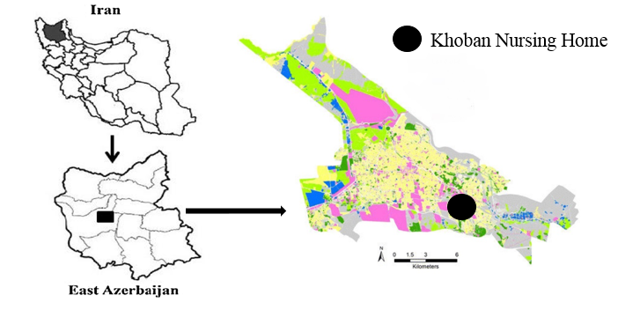
Figure1: Location of Khooban nursing home in Tabriz, Iran

Among nursing homes, Khooban nursing-home was selected as it has outdoor open green areas. Older adult residents of the nursing home are under supervision of Tabriz University of Medical Sciences and offers medication and care for over 320 older adult.
- Results
  - Demographic information
According to Table 1, of the 277 respondents, 142 (51.3%) were men and 135 (48.7%) were women. The majority of the participants are over 70 years (n=226, 81.6%). The educational status of 105 participants (37.9%) was in high school and 183 participants had a monthly income 500- 1000 USD (66.1 percent). On average, 76 participants (27.4%) had three children.
Table 1: demographic information
Variables | item | Number | Percentage |  | Variables | item | Number | Percentage
Gender | Male | 142 | 51.3 |  | Economic status | Below 500 USD | 39 | 14.1
Gender | Female | 135 | 48.7 |  | Economic status | 500-1000 USD | 183 | 66.1
Gender | Total | 277 | 100 |  | Economic status | Above 1500 USD | 55 | 19.9
Age | 61-70 | 48 | 17.3 |  | Economic status | Total | 277 | 100
Age | 70 years and above | 226 | 81.6 |  | Number of children | 0 | 39 | 14.1
Age | Total | 277 | 100 |  | Number of children | 1 | 19 | 6.9
Education status | Cycle | 74 | 26.7 |  | Number of children | 2 | 68 | 24.5
Education status | High school | 66 | 23.8 |  | Number of children | 3 | 76 | 27.4
Education status | Diploma | 105 | 37.9 |  | Number of children | 4 | 62 | 22.4
Education status | Bachelor and higher | 32 | 11.6 |  | Number of children | 5 | 12 | 4.3
Education status | Total | 277 | 100 |  | Number of children | Total | 277 | 100
  - Factor Analysis
According to results of the descriptive analysis, the respondents placed the highest priority on the option of "watching the green space causes comfort (standard deviation = 0.70, mean = 4.49), and "planting a variety of trees results in liveliness and happiness" (SD = 1.05, mean = 4.17) was next priority for respondents. The least favorable option for older adult in landscaping the nursing home was "aromatic trees in the green space" (SD = 1.54, mean = 3.31). Based on the results of the factor analysis of variables, the function of the green space in the nursing home consisted of "liveliness (α= 0.57)" and "feeling of comfort (α =0.56) and more details are shown in Table 2.
Table 2: Factor Analysis of liveliness and sense of comfort
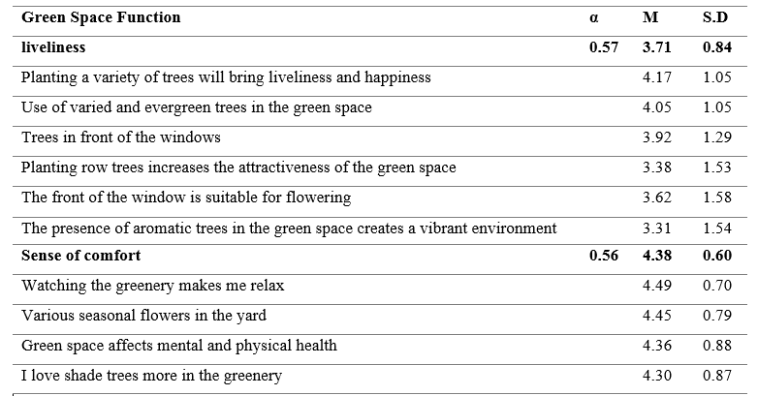
Continuing descriptive analysis of variables, "having a good seat and a chair for sitting (standard deviation = 1.26, mean = 4.79) in the greenery area of ​​the nursing-homes was the first priority of the respondents and their least preferred in the facilities section was "having spaces for mental activity" (Standard deviation = 1.39, mean = 3.60). "Having adequate furniture for the older adult to rest in the yard" (SD = 0.57, mean = 4.61) was their first priority in the physical activity factor. Results from factor analysis variables, facilities needed in the nursing home included two factors: "social interactions (α = 0.68)" and "physical activities (α = 0.57)" which is shown in more detail in Table 3.
Table 3: Factor analysis of variables of social interactions and physical activities
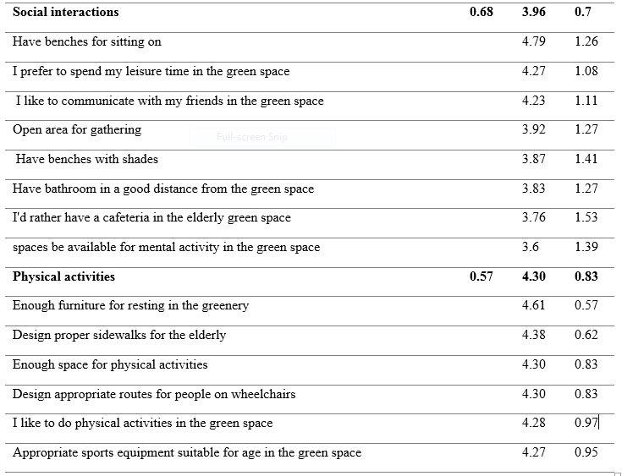
  - Spatial quality of images
Based on the results of factor analysis and descriptive results in Table 4, older adult give higher priority to complexity (Mean = 3.96, SD = 0.70, α = 0.58) in the nursing-home area, while the mysterious space (Mean = 3.71, SD = 0.83, α = 0.71), prospect (Mean = 3.32, SD = 0.96, α = 0.63) and refuge (Mean = 1.85, SD = 1.19, % = 0.54) are in the next priorities respectively.
Table 4: Descriptive results of the quality of spatial composition of images
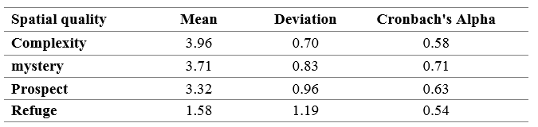
Refuge: As shown in Figure 2, images 3, 7, 15 and 19 are effective in inducing "refuge". Based on the results of the descriptive analysis, the respondents gave the highest priority to image 15 (mean = 2.5, standard deviation = 1.7) and the least priority to image 19 (mean=1.88, standard deviation=1.42).
Prospect: images 8, 12, 16, and 20 were in the Prospect Indicator group. Based on the results of the descriptive analysis, respondents gave highest priority to Figure 16 (mean = 4.47, standard deviation = 1.22) and least priority to Figure 12 (mean = 2.37, standard deviation = 1.67).
Mystery: images 9, 17 and 21 were effective in inducing "mystery" in the nursing home landscape, the older adult giving the highest priority to image 21 (mean = 1.92, standard deviation = 1.45) and the least priority to image 17 (mean = 1.81, standard deviation=1.38).
Complexity: Images 4, 10, 14, 18 were in the complexity index group. Based on the results of factor analysis, respondents had the highest preference for image 10 (mean = 3.10, standard deviation = 1.87) and the lowest priority for image 14 (mean= 2.89 and standard deviation= 1.85).
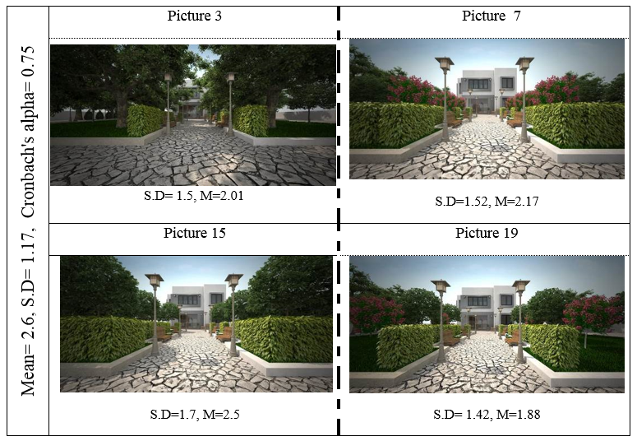

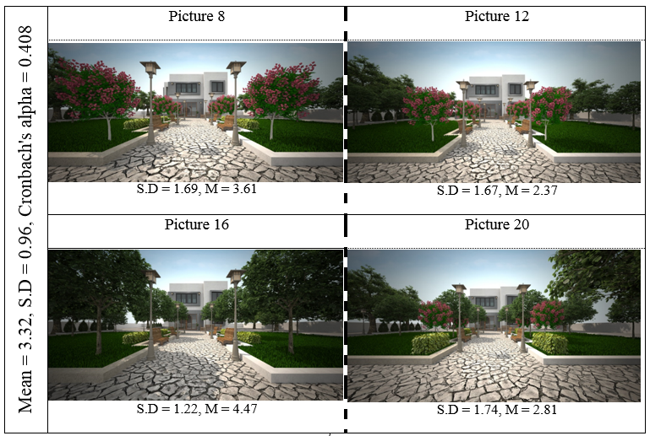
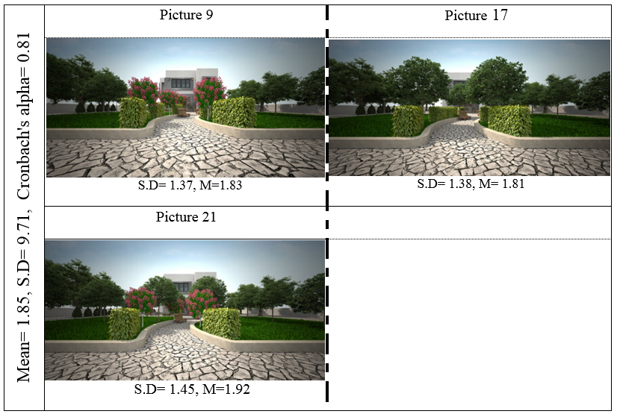
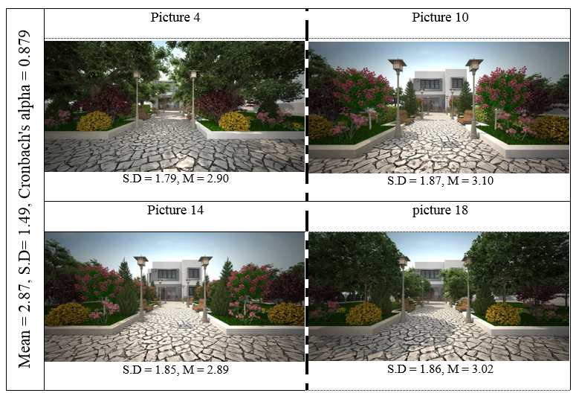
Figure 2: Spatial composition of images
3-4- Landscape content preferences
Older adult have different opinions and preferences about the importance of content quality indices in landscape planning as the sense of comfort (average rating = 5.18) is in the first, and quality of access and physical activity (mean rating = 5.05), social interactions (mean rating = 4.17), liveliness (mean rating = 3.68), and aesthetic aspect of the landscapes are in the next rankings. It should also be noted that prioritization of landscape content quality indexes preferences by Friedman test was meaningful at 0.01 level.
Table 5: Friedman test for landscape content
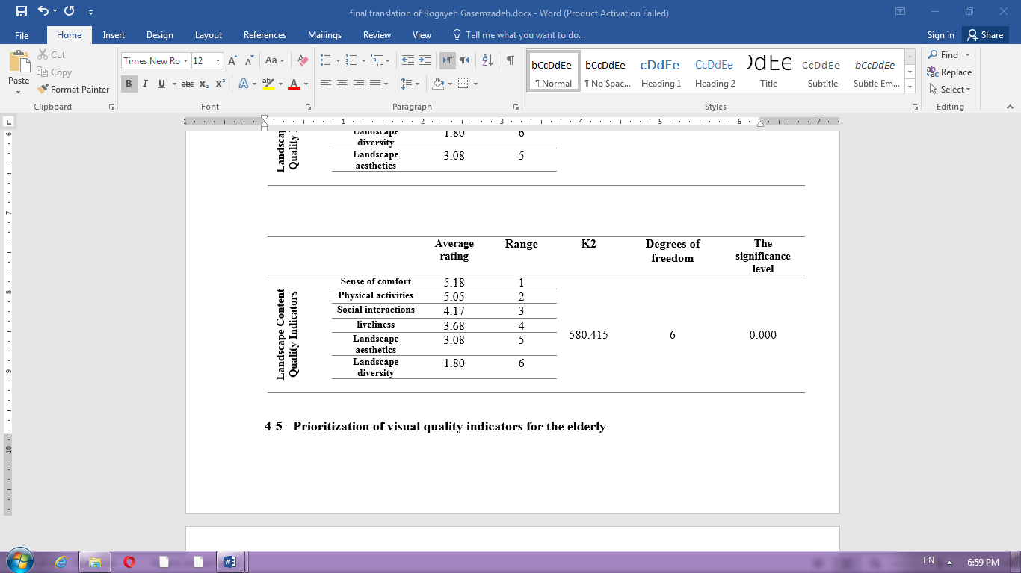
3-5- Landscape spatial preferences
As can be seen in Table 6, older adult have different opinions and preferences about the importance of visual quality indices in landscape planning as prospect (mean rating = 3.22) comes first, and mystery (mean = 2.87), complexity (Mean rating = 2.48) and refuge come in the next rankings. It is also worth noting that prioritizing the preferences of visual quality indices by the older adult in the Friedman test was meaningful in 0.01 level.
Table6: Friedman test for spatial quality
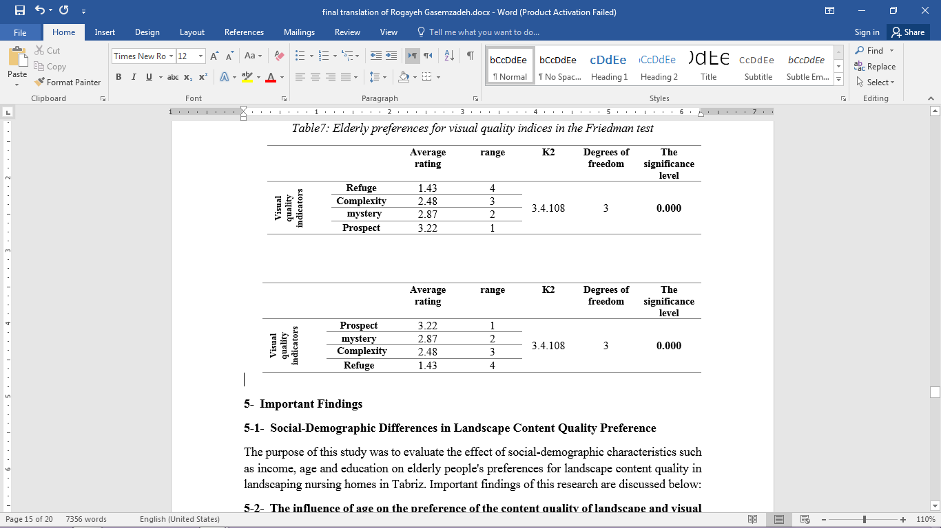
- Discussion
  - Social-Demographic and Landscape quality
The purpose of this study was to evaluate the effect of social-demographic characteristics such as income, age and education on older adult's preferences for landscape content quality in landscaping nursing homes in Tabriz. Important findings of this research are discussed below:
4-1-1- Age matter
Older adult's preferences over the quality of landscape content are affected by their age. Researchers have shown that individuals' age significantly influences his/her preferences and mental states (Aslankhani, 2008). The age factor may negatively or positively influence the people's preferences. In the present study, older adult aging from 51 to 70 years expect liveliness from the green space, which encourages people to be active and makes them feel satisfied. (Beak et al; 1989). While older adult (over 70 years) expect social interactions and a sense of comfort, however, research by Rafizadeh and et al. has suggested that older adult need to talk and interact with one another and seek ownership in the environment and tend to attract the attention of those around them (Rafizadeh et al., 2004). And about the preferences of people about the visual quality of nursing home landscapes, people over 70 years of age prefer the complexity of nursing home landscaping. However, in similar studies older adult preferred the simple and uniform agricultural perspective over complex designs (Hawley. 2011).
4-1-2 Income matter
The results of the present study indicate the effect of income on older adult preferences over landscape content and visual quality indicators. In this regard, the previous study identifies the economic situation as a factor influencing preferences (Morren & Grinstein., 2016). Older adult with income ranging from 3 to 5 (million tomans per month) have the most preferences for liveliness and a comfortable space in nursing home visioning, whereas in previous studies, older adult in different monthly income groups wanted to improve their quality of life and environment (Carter et al., 2001; Habibi et al., 2008).
4-2- The relationship between landscape content and spatial quality
Older adult's preference for visual landscape quality indicators is significantly influenced by content quality (green space, security, facilities, and landscape preferences). The impact of visual quality elements (refuge, complexity, mystery, and prospect) on the quality of landscape content in valid sources has been underestimated. For example, Mastan Abadi argues that green spaces with open landscape highly influence on people's sense of comfort (Mastan Abadi, 2015). As can be seen in the results of the present study, a strong and positive correlation between the open landscapes in landscaping can bring about a sense of comfort. Also Studies on the lack of green spaces in nursing homes and the impact on absence of opportunity for physical activity are also evident (Heyn et al., 2004; Lobo et al., 2008). In the present study, however, the relationship between physical activities of older adult with visual quality indicators has also been examined. For example, the more complex the nursing home landscaping is, the less likely are the older adult to perform. Rapp et al. in 2006 examined the relationship between self-care in older adult's homes with open landscapes with a background of green space and concluded that there was a strong and meaningful relationship between these two factors. And having open perspectives improves patients' spirits (Rappe et al., 2006). However, the results of the present study reveal that open landscape in the greenery of the area helps to increase the level of social interaction.
Older adult’s activities lead to the improvement of their mental health. According to Blenn and Netwley's research, the basis of old people’s physical activities in a green space is to ensure their security and certainty about the standards of sport facilities (Blane & Netuveli, 2008). However, the results of this study showed that being safe and secure was directly and significantly related to the physical activities of the respondents. Isalu et al stated in their research that the best recreation for the older adult in the nursing-home includes reading books and newspapers, sightseeing, socializing with friends, sitting on benches and watching the greenery and landscapes available (Isalu et al., 2016). However, in the present study, a strong and significant correlation was shown between the existence of open landscape in the area with social interactions among the older adult. Given the importance of green landscape on people’s lives, Kaplan did a research about the diversity of green space which can play an important role attracting people and concluded that for creating diversity, mystery in spaces and plantation diversity can be introduced as the most important factors (Kaplan et al. 1993) However, in this study, variation in the landscape of nursing-homes has a strong and significant correlation with the mysteriousness of spaces.
4-2-2 Perception of landscape spatial quality
According to Kaplan et al.'s (1998) theory, four factors related to spatial and visual quality (mystery, complexity, legibility, and coherence) influence people's preferences of the environment (Kaplan & Kaplan, 1998). And, as the results of the present study show, all visual content quality indices have been influenced by visual quality indices and this relationship is proved.
Complexity is defined as the diversity and richness of landscape elements as well as the dispersion of landscape elements and the size of the element components, and the richness of elements in low-coherence landscapes results in the emergence of complexity (Tveit et al., 2006). However, older adult in this study found the complexity necessary to create a sense of comfort and improvement in social interactions. Kaplan in his research has shown that the presence of plants or special elements in the landscape creates mystery in it, which reminds people to think and meditate (Kaplan, 1985), while in the present study, mystery in the area was positively and strongly in correlation with the liveliness of the environment, the feeling of comfort and social interactions.
In his research, Hildebrand states that people need a place that allows them to observe other people's activities without being noticed, and that increasing the dimension of the prospect does not necessarily reduce the amount of refuge (Hildebrand, 1991). In the present study, however, older adults find the mystery and prospect to the indicators of landscape liveliness, comfort, and social interactions.
- Conclusion
Based on the results, the older adult had different opinions and preferences regarding the importance of content quality indices in landscaping for the older adult as their expectations of landscaping were firstly to create a comfortable environment in which they can feel relaxed, and other preferences were quality of access, their safety, possibility for performing physical activities, creation of environments and spaces to enhance social interaction with other people, liveliness and happy atmosphere of the area, aesthetics in the landscapes and, ultimately, the diversity of landscaping respectively. So it can be deduced from the results of this section that creating a safe and secure environment with considering spaces for gathering for their social interactions and the happy atmosphere of the environment, along with beauty and variety are mostly preferred. It was then found that older adult's preferences for the visual quality of their surroundings were primarily open perspectives, mysteriousness, complexity, and refuge (less visible but able to see). Based on the results, it was found that older adult with middle incomes level are more likely to prefer a quiet environment and green as well as comfortable space, and those older than 70 years are more likely to prefer its sense of comfort in the nursing-home.
This study explores the relationship between visual and content quality in the nursing-home area. Based on the results, the content quality of the landscape is a factor influencing visual quality preference. As older adult see the liveliness of the sanatorium's green space in the open landscape while the same factor (prospect) is their preference for creating a sense of tranquility and beauty in the landscape and aesthetics of the enclosure. For the purpose of creating proper access based on the respondents’ preferences, complexity has an opposite relationship with access quality which means that proper accesses in the area of nursing-homes have less complexity. Older adult perceive the open and appropriate landscape and mysterious spaces as their preferences for social interactions in the sanatorium area. Also, the present study concluded that presence of spaces in which the older adult feels safe and secure increases their level of physical activity, and finally, they prefer diversity in landscaping with mysteriousness of the visual spaces. The effect of socio-demographic characteristics on older adult's preferences for visual and content quality indices was one of the studied issues in this research. Based on the results, the preferences of different age groups for the visual quality indicators varied significantly. Therefore, sanatorium landscaping approaches should be based on the characteristics of the target group.

REFERENCES

Ahmadi, F., Salar, A., & Faghihzadeh, S. (2004). Quality of life in Zahedan elderly population. Journal of hayat, 10(3), 61-67.
Alipour, F., Sajadi, H., Foruzan, A., Biglarian, A., & Jalilian, A. (2008). Elderly quality of life in Tehran's district two. Iranian journal of ageing, 3(3), 75-83.
Anderzhon, J. W., Hughes, D., Judd, S., Wijnties, M., & Kiyota, E. (2012). Design for aging: international case studies of building and program (Vol. 10). John Wiley & Sons.
Artmann, M., Chen, X., Iojă, C., Hof, A., Onose, D., Poniży, L., ... & Breuste, J. (2017). The role of urban green spaces in care facilities for elderly people across European cities. Urban Forestry & Urban Greening, 27, 203-213.
Beak et al. Mental health psychiatric Nursing. Second edition, st: Louis Washington D.C co. 1989
Blane, D., Netuveli, G., & Montgomery, S. M. (2008). Quality of life, health and physiological status and change at older ages. Social Science & Medicine, 66(7), 1579-1587.
Brunner, L. S., Suddarth, D. S., Bare, B. G., Boyer, M. J., & Smeltzer, S. C. C. (1988). Textbook of medical-surgical nursing (Vol. 2). Lippincott.
Carter, N.D. Kannus, P. Khan, K. M (2001). Exercise in the prevention of fall in older people: a systematic literature review examining the rational and evidence. Sport Med. 31(6): 427-38
Dallosso, H. M., Morgan, K., Bassey, E. J., Ebrahim, S. B., Fentem, P. H., & Arie, T. H. (1988). Levels of customary physical activity among the old and the very old living at home. Journal of Epidemiology & Community Health, 42(2), 121-127.
Edvardsson, D. (2008). Therapeutic environments for older adults: Constituents and meanings. Journal of gerontological nursing, 34(6), 32-40.
Habibi, S., Nikpour, S., Sohbatzadeh, R., & Haghani, H. (2008). Quality of life in elderly people of west of Tehran.
Hegetschweiler, K. T., de Vries, S., Arnberger, A., Bell, S., Brennan, M., Siter, N., ... & Hunziker, M. (2017). Linking demand and supply factors in identifying cultural ecosystem services of urban green infrastructures: A review of European studies. Urban Forestry & Urban Greening, 21, 48-59.
Heyn, P., Abreu, B. C., & Ottenbacher, K. J. (2004). The effects of exercise training on elderly persons with cognitive impairment and dementia: a meta-analysis. Archives of physical medicine and rehabilitation, 85(10), 1694-1704.
Hildebrand, G. (1991). The Wright space: pattern and meaning in Frank Lloyd Wright's houses. Seattle: University of Washington Press.
Kabisch, N., Qureshi, S., & Haase, D. (2015). Human–environment interactions in urban green spaces—A systematic review of contemporary issues and prospects for future research. Environmental Impact Assessment Review, 50, 25-34.
Kaplan, R., & Kaplan, S. (1989). The experience of nature: A psychological perspective. CUP Archive.
Kaplan, R. (1993). The role of nature in the context of the workplace. Landscape and urban planning, 26(1-4), 193-201.
Khoshbin S. Report of aged situation survey in Iran in 2002 (2007). Tehran: Population and Family Health Office Publication, Ministry of Health & Medical Education
Lobo, A., Santos, P., Carvalho, J., & Mota, J. (2008). Relationship between intensity of physical activity and health‐related quality of life in Portuguese institutionalized elderly. Geriatrics & Gerontology International, 8(4), 284-290.
Moustakas, C. Loneliness. New York: Prentice Hall Inc. 1961
Parker, C., Barnes, S., McKee, K., Morgan, K., Torrington, J., & Tregenza, P. (2004). Quality of life and building design in residential and nursing homes for older people. Ageing & Society, 24(6), 941-962.
Paiva, M. M., Sobral, E. R., & Villarouco, V. (2015). The elderly and environmental perception in collective housing. Procedia Manufacturing, 3, 6505-6512.
Rappe, E., Kivelä, S. L., & Rita, H. (2006). Visiting outdoor green environments positively impacts self-rated health among older people in long-term care. HortTechnology, 16(1), 55-59.
Rodiek, S. D., & Fried, J. T. (2005). Access to the outdoors: Using photographic comparison to assess preferences of assisted living residents. Landscape and urban planning, 73(2-3), 184-199.
Salmon, P. (2001). Effects of physical exercise on anxiety, depression, and sensitivity to stress: a unifying theory. Clinical psychology review, 21(1), 33-61.
Sheldon, K. M., & Lyubomirsky, S. (2004). Achieving sustainable new happiness: Prospects, practices, and prescriptions. Positive psychology in practice, 127-145.
Stafford, J. (2004, October). The importance of leisure for good health: Native American elders' perspectives. In Gerontologist (Vol. 44, pp. 534-535). 1275 K STREET NW SUITE 350, WASHINGTON, DC 20005-4006 USA: GERONTOLOGICAL SOCIETY AMER.
Sugiyama, T., Francis, J., Middleton, N. J., Owen, N., & Giles-Corti, B. (2010). Associations between recreational walking and attractiveness, size, and proximity of neighborhood open spaces. American Journal of Public Health, 100(9), 1752-1757.
Sullivan, L. J., & Asselin, M. E. (2013, July). Revisiting Quality of Life for Elders in Long‐Term Care: An Integrative Review. In Nursing forum (Vol. 48, No. 3, pp. 191-204).
Sweden, S. (2006). Living conditions of the elderly, work, economy, health and social networks 1980-2003 (No. 112). Report.
Tveit, M., Ode, Å., & Fry, G. (2006). Key concepts in a framework for analyzing visual landscape character. Landscape research, 31(3), 229-255.
United Nations, 2015. World Population Ageing 2015. United Nations, New York.
Van Dijck-Heinen, C. J. M. L., Wouters, E. J. M., Janssen, B. M., & van Hoof, J. (2014). A sense of home through the eyes of nursing home residents. IJIRST–International Journal for Innovative Research in Science & Technology, 10(4), 57-69.

