Int. J. Architect. Eng. Urban Plan, 30(2): 198-211 December 2020
DOI: 10.22068/ijaup.30.2.198
Research Paper

Passive Thermoregulation in Vernacular and Biomimetic Architecture in Hot and Arid Climate
Marjan Arbabzadeh ¹, Iraj Etessam ^{2*}, Seyyed Majid Mofidi Shemirani ³
¹ Ph.D. Candidate, Departmant of Architecture, Science and Research Branch, Islamic Azad University, Tehran, Iran
² Professor, Departmant of Architecture, Science and Research Branch, Islamic Azad University, Tehran, Iran
³ Assistant Professor, School of Architecture and Urban Development, Iran University of Science and Technology, Tehran, Iran
Received: August 2020, Revised: September 2020, Accepted: September 2020

Abstract
Disconnection with nature and history as a result of modernist approaches occurred in the early twentieth century has led to great consequences. Climate change, environmental problems and energy and resources crises have posed numerous challenges to contemporary architects across the globe. The present paper focuses on the issue of passive thermoregulation strategies in vernacular and biomimetic architecture - two approaches in architecture that connect architecture to nature and history -which can offer solutions for environmental crisis. The main objective of this study is to highlight the similarities and differences between vernacular and biomimetic architecture based on passive thermoregulation criterion. So the main question is: what are the common features of biomimetic and vernacular architecture in their use of passive thermoregulatory mechanisms. In this study, the comparative method is used to point out the similarities and differences that can be found between some case studies of vernacular and biomimetic architecture. First, some examples of biomimetic architecture are selected using desk studies and, then, their approach to heat regulation are analyzed using descriptive-analytical research methodology. The results show that while vernacular architecture has a static nature and is depended on low-tech and biomimetic architecture has a dynamic (kinetic), intelligence and interactive nature which relies on high-tech and new materials, their approaches to thermoregulation are similar in some ways. While different in form, they are both based on controlling solar radiation through shading, dissipating heat through convective and evaporative cooling systems, and using the sun as a renewable source of energy.
Keywords: Biomimetic architecture, Vernacular architecture, Thermoregulation, Hot and arid climate.

1. INTRODUCTION∗
When designing and constructing structures, human being should pay close attention to the critical situation of the nature to recognize the need for changes in the modernist construction methods of the past few decades. Today, the awareness about environmental issues like climate change, shortage of energy resources and pollution of water and soil, has attracted the interest on building energy consumption. Changes in attitudes or approaches can be brought about through an investigation into the historical memory of human, concerning eco-friendly architecture alongside technological advances based on scientific positivist philosophy. A naturalistic approach, based on harmony between architecture and nature, is possibly the most important way of dealing with the problems imposed by human being on nature. Vernacular architecture can be drawn upon to develop and investigative attitude towards the past. But, a nostalgic look at the past and relying on past experiences can make it difficult to keep up with the spirit of time. Yet, a close study of vernacular architecture and the latest scientific achievements based on naturalistic approaches can yield favorable results and contribute toward a desirable interaction with nature. Therefore, the main objective of this article is to study the past and find ways to regulate environmental conditions in order to protect nature and explore the possibility of utilizing techniques from the past, such as biomimetic architecture, in contemporary nature-based architecture. In this study it is hypothesized that there are similar techniques and strategies for thermoregulation in both vernacular and biomimetic architecture. In other words, the biomimetic architecture which relies on utilization of new materials and technology is different from the vernacular architecture in its form and some other aspects but is similar to it in its environmental knowledge content.
The methodology in the present study is of the comparative type and the data analysis is conducted through deductive and inductive reasoning. The samples were selected desk studies and examined using the descriptive-analytic method.
1.1. Research Questions
Three main questions, interconnected in different ways, are addressed in the present study: in what ways are the approaches to regulating environmental conditions in vernacular architecture and biomimetic architecture similar? What are the main differences between vernacular and biomimetic architecture in their thermoregulation methods? Can any connection be established between the environmental regulation strategies used in vernacular architecture and advanced technology and materials?
1.2. Literature Review
Numerous studies have been conducted on vernacular and biomimetic architecture and regulation of environmental conditions, most of which have adopted an approach different from that of the present study. In almost all of them vernacular architecture and biomimetic architecture have been examined separately, without any methodological comparison. In the present article, while previous studies are used in the descriptive-analytic study of vernacular and biomimetic architecture and in the theoretical framework, the final analysis and the results of the study are based a new approach adopted by the authors of the article. The book Vernacular Architecture (Alpago Novello er al.) provides us with the definition, terminology and formation of vernacular architecture and how it is related to cultural, historical and social factors [1]. In his Natural Energy and Vernacular Architecture (1986) Hassan Fathy deals with important parameters influencing the regulation of environmental conditions, such as shading, materials, orientation, central courtyard patterns, movement of air, and convection and passive cooling [2]. Beazley and Harverson (2012), in their book Living with the Desert: Working Buildings of the Iranian Plateau, study lifestyle and architectural methods in Iran plateau [3]. In Technology and Vernacular Architecture (2017), Zarghami and Sadat view vernacular architecture as a way of attaining sustainability and developing the technology required for this purpose [4]. In his doctoral dissertation, entitled “The Efficient Strategy of Passive Cooling Design in Desert Housing: A Case Study in Ghadames, Libya” (2016), Eltrapolsi examines passive cooling in local houses, adaptive thermal comfort, and bioclimatic design connected with thermal comfort [5]. Petra Gruber, in her book Biomimetics in Architecture, deals with classic approaches common in architecture and biology, architectural interpretation of life, living architecture and some case studies of biomimetic architecture [6]. In her article “Skin in Architecture, Towards Bio-inspired Facades” (2010), she compares biological skins and body-shells and facades. She also examines approaches adopted by different organisms when dealing with natural conditions, with the aim of achieving energy efficiency and sustainability [7]. In Bionic Architecture (2014) and Biotech Architecture (2019), co-authored by Mahmoud Golabchi and Morteza Khorsand Nikoo, the formation of bionic architecture and its terminology, notable examples, structures and materials have been studied. Also, ideas from nature that have affected the development of architectural concepts and the theoretical foundations of bionic architecture have been discussed in order to highlight bionic architecture as a solution for environmental crises [8, 9]. There are other books and articles on this subject, a description of which will be beyond the scope of this article. A close study of all the books and articles mentioned above revealed that no methodological comparison has been made between vernacular architecture and biomimetic architecture. However, each of them separately, has been the focus of considerable research. Thus, a comparative analysis of these types of architecture can be of use in new studies in this field.
2. MATERIALS AND METHODS
The present study was conducted in five phases:
- The theoretical foundations of the subject were studied in different books and articles.
- Some examples of biomimetic architecture which were selected based on climatic criteria and methods of heat regulation. At this stage, seven cases were selected, most of which are from hot and arid climatic zone and a few of them from other climates. These examples were selected using desk study research method.
- Approaches to heat regulation in the selected examples were studied and analyzed and the results were presented in a table.
- A comparative analysis of the examples of biomimetic architecture and vernacular architecture in hot and arid climates was conducted and their similarities (based on the comparative methodology) were examined.
- The comparative analyses were classified based on heat regulation criteria in the form of an analytic diagram and the similarities and differences were presented and analyzed. The results are utilized to identify the common approaches to heat regulation in these two types of architecture.
The following diagram shows the different steps in research process (figure 1).

Theoretical framework codify
Understanding basic concepts
Study of passive thermoregulation strategies
In the field of vernacular architecture
In the field of vernacular architecture

First step
Methodology codify
Kind of methodology
Data gathering method
Case studies domain
Comparative method
Library research
Hot and arid region
Iran
Out of Iran
Books, valid journals, Theses and valid digital resources
Data analysis
Results
Conclusion
Third step
Second step

Fig 1. Research process

There was some limitation in selecting case studies that shows in the following diagram (Figure 2).
3. THEORETICAL FRAMEWORK
The naturalistic approach in architectural design is as old as the earliest manmade structures. The first structures made by human beings can be regarded as examples of vernacular architecture. In this type of architecture, structures are inspired by the natural environment and in complete harmony with it. Therefore, it can thus be regarded as a rich source of natural and cultural heritage, revealing an intelligent relationship, based on the harmony, with the genius loci. Sim Van der Ryn believes that ecological design is based on an intimate knowledge of a specific place and how it can be in harmony with local conditions to fulfill the needs of the local people. When we are sensitive to the delicacies of a place, we can live there without damaging it [10]. Organic architecture, biomimetic architecture and biotech architecture are among the naturalistic approaches to architecture in the contemporary era. Nature-inspired architecture is much older than it seems. Of different types of inspiration, form-based inspiration can be considered the oldest way of modeling structures on nature. In the post-industrial era and with the huge advances in science and technology and the changes in attitudes toward nature, the forms of inspiration have changed. Understanding nature at micro and macro scales has led to a deeper understanding of structures and natural processes and consequently of nature-inspired architecture. Prominent theorists and designers, such as Pier Luigi Colani, Luis Sulivan, Frank Lloyd Wright, Alvar Aalto, Frank France, Buckminster Fuller, Kisho Kurokawa, Julien Vincent, Philip Steadman and Santiago Calatrava, have worked in this field. They believe that a building is a unified organism, similar to an ecosystem in nature. They regard buildings and cities as flexible structures that can organically grow over time. They have paid close attention to nature and its systems and tried to identify fundamental principles of natural structures. Julien Vincent has compared technology and biology in terms of parameters such as information, energy, time, space, structure and material [9].
3.1. Energy and Vernacular Architecture (Designing Based on Passive Cooling)
Most of the energy required for the heating, ventilation and lighting of vernacular buildings are provided through local resources. These resources have been innovatively used to help meet different local and climatic needs. The location of a building in a landscape, its orientation and location of windows, doors and heaters definitely affect energy considerations. Different regional approaches reflect the regional diversity of resources [11]. Natural ventilation is an important process in providing inner house comfort in dessert cities, where outer temperature is too high for thermal comfort. Buildings’ skins absorb heat through the roof, walls and windows, thus increasing the inner temperature, to the level of thermal discomfort. Although air conditioning systems can provide comfort, their installation and maintenance can be expensive. Also, chlorine compounds used in most chiller units of ventilation systems are likely to cause erosion in the ozone layer and global warming. In the vernacular architecture of desert areas in Iran, evaporative cooling, solar radiation control by creating shaded spaces, directing currents of air from the inner courtyard toward the rooms (convection) and optimal use of solar radiation have made it possible to create relative thermal comfort in such a critical climate [12].

Vernacular architecture

- Insufficient attention has been paid to vernacular architecture and only a few studies have been conducted on this type of architecture compared to classic architecture in the past few decades.
- Many examples of vernacular architecture have been lost over time so the field study will be difficult leading to imprecise results.
Biomimetic architecture

- No prominent example of this type of architecture can be found in Iran, especially in the hot and arid regions.
- Case studies have been selected using desk studies
- In addition to examples of vernacular architecture from Yazd and Kashan, a number of examples have been chosen from the desert areas of Egypt, Yemen, Arizona and Saudi Arabia.
- Some examples have been selected from regions with climatic conditions similar to that of the hot and arid regions of Iran.
- Some special examples have been chosen from regions with climates different from that of hot and arid areas but with highly efficient approaches to regulation of environmental conditions, which can be effectively adjusted to hot and arid climates.
Restrictions in selecting case studies
Fig 2. Reasons for selecting the examples and the existing restrictions

Scholars such as Giovani (1994, 1998) and Santamouris and Asimakopoulos (2001) have studied passive cooling and concluded that it is achieved in three ways. First, heat absorption is reduced using techniques of protecting against solar heat. This is usually done by improving the microclimate conditions around buildings using vegetation and water-covered surfaces to increase humidity and decrease the temperature of surfaces. Also, the size of openings, type of glass and solar protection used for shading and insulations on building skins can contribute to thermal resistance against heat transfer through building skins. Second, heat absorption is improved by enhancing thermal storage capacity through heat load and phase change materials. And, third, inner heat is dissipated using natural cooling techniques, in which heat from inner spaces is reduced. Accordingly, air flow and natural ventilation are important factors in passive cooling. These factors are related to wind force and some techniques like cross ventilation, evaporative cooling and passive stack ventilation (PSV) [13]. In fact, vernacular architecture has provided a bioclimatic shelter derived from the intelligent design of microclimates both inside and outside buildings [5].
- Different features of passive cooling can be found in Iranian vernacular residential buildings in hot and dry regions, usually referred to as four-season houses. The overall forms of these traditional houses were as follow:
- Ground floor and courtyard lower than entrance and street level
- Buildings are adjoined
- Houses were inward oriented with a central courtyard
- Most buildings had basements, verandas and often wind towers
- Brick or adobe vaults or dome
- High ceiling, especially on the southern side of courtyards
- Thick walls [14].
The optimization of energy consumption based on heat regulation strategies has led to a bioclimatic building. In the four-season houses, the south side of courtyard, known as Tabestanneshin was used in summer. Designing wind catchers and throne room with higher elevation and lighter volume are some of passive cooling strategies [15]. There are different residential buildings based on similar movement patterns of residents (daily or seasonal) in other countries like Yemen, Egypt and parts of Africa.
Radiant cooling is another way of passive cooling. It is based on reducing the heat inside the building with the benefit of radiant cooling. Deep courtyards and narrow allies with high walls minimize the hours of direct sunlight exposure during the day. All of these walls radiate to the sky during the night, thus the walls become quite cool by the morning. The form of roofs is another key aspect for promoting radiant cooling. The forms of dome present two different benefits. During the day, always some area of the dome is in the shadow while at night, full hemisphere faces the night sky. Thus, radiant heating is minimized while radiant cooling is maximized [16].
3.2. Biomimetic Approach in Designing Adaptive Building Skins Based on Minimal Energy Consumption
Designing adaptive building skins to provide residents with better comfort is of vital importance. Adaptive building skin should organize and adapt to outer environmental conditions and at the same time adapt properly to the needs of inner space and residents’ activities. Therefore, effective ways of heat regulation can be derived from heat regulation strategies found in nature or utilized by living organisms. Living organisms keep a limited body temperature range in order to survive. A fixed temperature range is achieved in a process of gaining and losing heat using different techniques. They can regulate inner temperatures through physiological or behavioral mechanisms and organize them using their morphological characteristics. Moreover, in order to produce metabolic heat, living organisms exchange heat with their ambient environment through thermal conductivity, convection, evaporation and thermal radiation [17]. Approaches to energy processing in nature, based on maximum energy saving and protection of the environment, have provided us with unique models for architectural design.
3.3. Case Studies
Some examples of biomimetic architecture, which are based on natural models and heat regulation and control models, are presented in Table 1. They will also be compared with examples of vernacular architecture in the next section.

Table 1. Biomimetic case studies
Building’s Name | Picture | Model in Nature | Inspiration level | Description
Al Bahr Towers (Abu Dhabi) |  |  | Process level  (Behavioral level) | - Inspired by the opening of the morning glory flower  - Shading elements like those of the morning glory flower in the skin of the building, which automatically open and close in reaction to light [18].
Minister of Municipal Affairs & Agriculture (MMAA Building( | 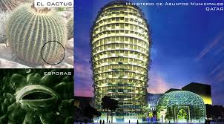 |  | Formal and process level  (Formal and behavioral level) | - Inspired by the skin of cactus (with openings that close during the day and open at night)  - The building has special shading elements that open and close in reaction to light [19].
Stoma brick  (brick with breathing orifice) | 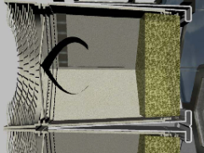 | 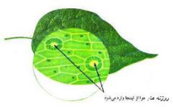 | Process and functional level | - Inspired by the protective system of camel’s eyes, leaves and human skin breathing pores.  - A four-part system: spongy section and external hair-covered layer, hydrating section, steel structure and inner filtering layer  - Heat regulation based on evaporative cooling system [20].
The Desert House | 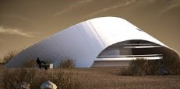 | 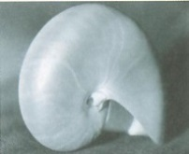 | Formal level | - Inspired by tropical snail’s shell  - The building’s façade acts as a sunshade, which refines the light and moderates inner air [21].
Melbourne Council House | 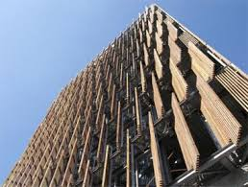 | 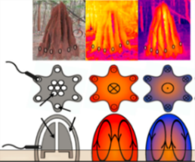 | Process and system level | - Inspired by natural ventilation in termite’s mounds  - Five shower towers based on evaporative cooling technique  Inner thermal mass  - Recycled wooden louvers, controlled by solar cells in the façade.  -Wind turbines and recycling of black water [22].
Q1 building (Germany) |  |  | Formal and functional level | - Inspired by feather-like elements  - A complicated shading system in the façade, in the form of a metal feather-like structure that blocks solar radiation and cools the air inside the building [22].
S.C.A.L.E.S  building | 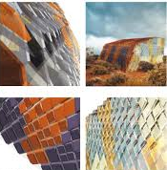 | 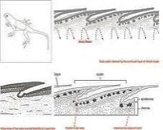 | Formal, constructional and process level | - Inspired by a kind of desert lizard  - Scales of different colors and thickness  - Bright colors in the PV panels of the western and eastern sides  - Flexible components in the walls covered by solar panels of different colors [23].

4. RESULTS
In this section some case studies of biomimetic architecture have been compared with some examples of vernacular architecture in terms of their application of thermoregulation strategies. This analytical comparison has revealed the similarities and differences between these two approaches. It is important to mention that the thermal comfort criteria in this comparison are related to hot and arid climate.
4.1. A Comparative Analysis of the case studies Based on thermal comfort criterion
Thermoregulation based on passive design strategies is the main common feature in vernacular and biomimetic architecture. Heat, as one of the most important climatic factors, can be dealt with in four ways: heat dissipation, heat retention, heat avoidance and heat gain. Heat can be regulated and managed using different techniques and strategies based on passive design. Many of these strategies have been utilized in vernacular and biomimetic architecture through the application of different materials and forms but with similar results. In the following section, these strategies have been analyzed using the comparative method.
4.1.1. Strategy 1: Utilization of evaporative cooling technique (Heat dissipation)
Evaporative cooling is an effective way of controlling temperature and preventing extreme heat, which is used in vernacular and biomimetic architecture examples. This technique has been used in the conceptual model of the Breathing Wall in Egypt and Melbourne Council House, as examples of biomimetic architecture. On the façade of Melbourne Council House, shower towers have been designed. Drops of water pour down from a height of 13 meters to help cool the fresh air that flows down from the top of the wind catcher -shaped tower, and thus cool fresh air is drawn into the building. This water, which has lost its initial temperature, is carried into some water tanks at the bottom of the building and then pumped back to the roof. In Stoma brick, which are made up of several layers, the middle layer controls the incoming air and is equipped with a water spray system (figure 3) [24].
Evaporative cooling technique is used in the architecture of hot an arid regions in different ways. Although it might be used in a different form, the technical knowledge used here is the same. In most vernacular houses in countries such as Egypt and Yemen, a special structure called mashrabiya (a section of the outer wall with a latticework design) is used. In many of these mashrabiyas a clay pitcher with a porous body (whose wall is always wet) is placed, which cools the fresh air before it enters the inner space of the house [2]. Under many wind catcher towers in Iranian houses there is a water pond, which moistens and cools the air coming from the wind catcher before it enters the inner spaces of the house. In spaces like the hawzkhaneh (part of the house with a pond), with a dome-shaped roof and a pond in the center, a similar element can be seen. In the inner courtyard of vernacular houses in the hot and arid areas of Iran, usually there is a big pond, sometimes with a fountain, which can help cool the air in the yard before it enters the house through openings in the outer walls surrounding the yard. Figure 2 presents some examples of the evaporative cooling technique in the vernacular architecture of hot and arid climates (Figure 3).

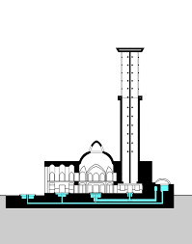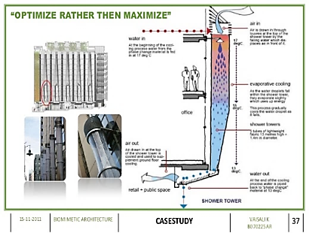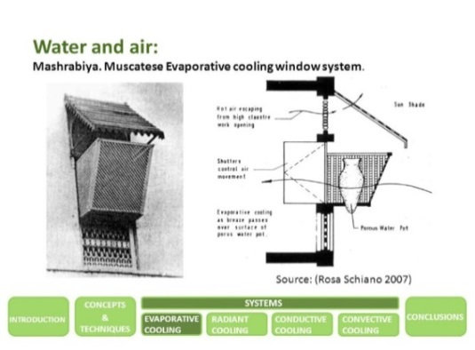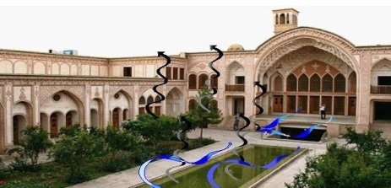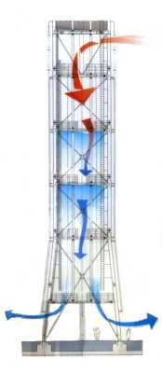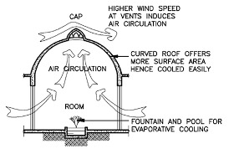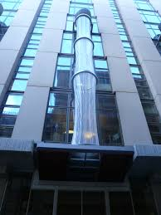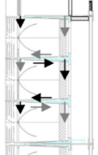
Vernacular architecture
Biomimetic architecture
Fig 3. Evaporative cooling strategy in : Melbourne Council House (above left); Stoma brick: Nama Research Team (bottom left) ; mashrabiya in Yemeni houses and Masdar City wind catcher (above right); hawzkhaneh in Iranian vernacular architecture and Inner yard of Ameri House, Dawlatabad Garden (wind catcher and ponds). (www.google.com)

4.1.2. Strategy 2: Utilization of convection technique (Heat dissipation)
The second way of dissipating heat is through improving convection. In Melbourne Council House, the ceiling has been designed in a way that offices are cooled through convective cooling. Some copper pipes have been installed inside a metal structure in the ceiling through which cold water flows. The hot air going up to the roof is cooled through this structure and then moves downward to cool the inner spaces, resulting in a convection current that creates a kind of natural ventilation in the inner spaces (Figure 4).
The convective cooling technique has been employed in some examples of vernacular architecture. The central courtyards in buildings in hot and arid climates in Iran effectively use the convective cooling technique. As can be seen in Figure 4, the spaces surrounding the central yard retain cool air during the night. As it gets hot during the day, the cool air retained in the walls surrounding the yard is gradually released into the yard and thus a movement of air is formed, causing the hot air to dissipate through convective cooling. During the night, as the building releases the heat retained in it into the yard, the hot air moves upward and the cool air of the night flows into the building. The wind catchers of buildings in hot and arid climates improve convection and thus effectively dissipate heat. In numerous examples of vernacular architecture in these regions, convection dissipates heat and pushes it out of inner spaces. In spaces used in summers in vernacular houses in Iran, with high ceilings and dome-shaped roofs with many openings on top of them, this technique has been effectively employed. Convection currents push the hot air out of inner spaces and thus dissipate heat (Figure 4).
In some examples, convection has been combined with evaporative cooling. In fact, evaporation of water is a key component in both techniques. However, convective cooling is based on reducing buoyancy and pushing cool, wet air, while evaporative cooling only relies on evaporating water.
4.1.3. Strategy 3: Utilization of thermal mass (Heat retention)
In some other approaches to heat regulation, retaining heat is of great importance. While it might seem that only in cold climates retaining heat is of importance, in hot and arid climates, as temperate drops dramatically during the night, retaining the heat for the night can be vital. Heat is retained in three ways: reducing heat exchange, retaining heat using high capacitance materials (thermal mass), and isolation. The first two ways can be found in examples of both vernacular architecture and biomimetic architecture, in different forms though. Reducing the surface-to-volume ratio is a way of reducing heat exchange and, consequently, retaining heat. As can be seen in many examples of vernacular architecture in hot and arid regions, the use of materials with a high thermal capacity has made it possible for houses to retain daytime heat and release it during the night. In other words, Thick adobe or brick walls and roofs will delay the transmition of heat to the interior, resulting in a thermal lag that can last for several houres or even for days; the greater the mass, the longer the delay [25]. In biomimetic architecture a similar approach is adopted. In the ceiling of the main spaces of Melbourne Council House concrete slabs have been used, which can retain heat during the day and gradually release it into inner spaces at night-time (Figure 5).

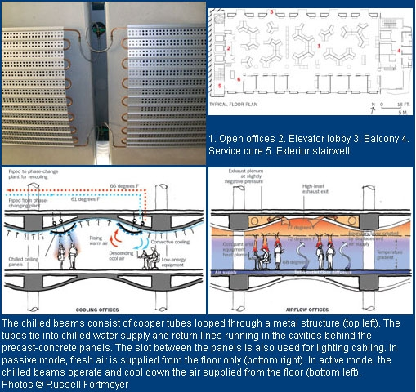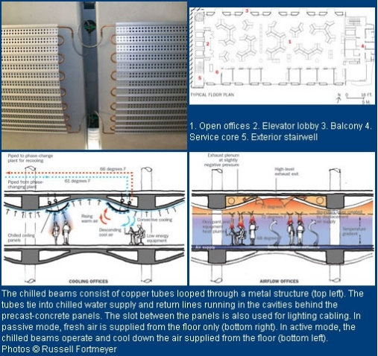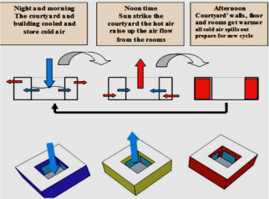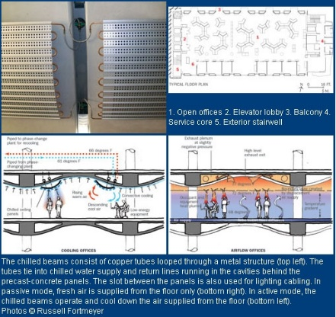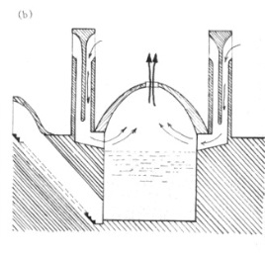
Vernacular architecture
Biomimetic architecture
Fig 4. Heat dissipation through convection in: ceiling in Melbourne Council House (left); some examples of vernacular architecture in hot and arid regions of Iran (right). (www.google.com)

4.1.4. Strategy 4: Avoiding heat techniques (Minimizing sunlight exposure)
Avoiding heat is probably of the highest importance in hot and arid climates, which can be achieved in two ways: first, minimizing exposure to sunlight and, second, minimizing heat load. Shading and reducing surface-to-volume ratio are two important techniques aimed at avoiding heat. Shading elements and some special geometric shapes that minimize exposure to sunlight during the hot hours of the day are among the most important climate-based methods used both in vernacular architecture and biomimetic architecture (Figure 6). Dense urban spaces, narrow paths with tall buildings and inner courtyards with tall walls have resulted in shading (self-shading) in urban areas [26]. Another example of shading can be seen in forms of domes on top of buildings in hot and arid regions. A part of the surface of the dome, due to its geometric shape, is always shaded. Other shading elements, such as tabeshband, sabat, latticed surfaces, orsi and iwan, are inseparable from the vernacular architecture of hot and arid climates, all intended to reduce exposure to sunlight.
In the examples of biomimetic architecture, as can be seen in the figures, attempt has been made to minimize exposure to sun. Shading elements, which constitute one layer of the outer skin of buildings such as Al Bahr Towers, Melbourne Council House, Minister of Municipal Affairs and Agriculture (MMAA) Building and the Arab World Institute in Paris, are among the important techniques used to reduce exposure to sunlight (Figure 6).

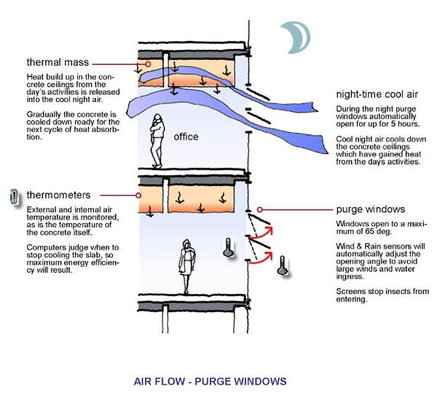

مصالح با ظرفیت حرارتی بالا (دیوار آجری یا خشتی با ضخامت زیاد)
Vernacular architecture
Biomimetic architecture
Fig 5. Heat dissipation through convection in: Melbourne Council House by concrete ceiling (left); some examples of vernacular architecture in hot and arid regions of Iran (right). (www.google.com)

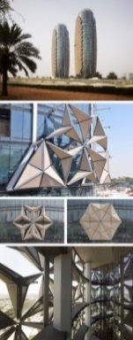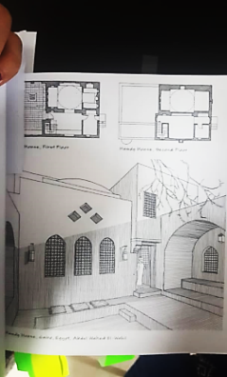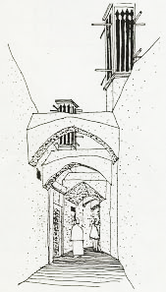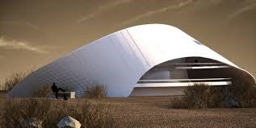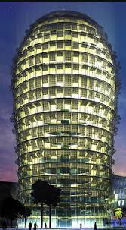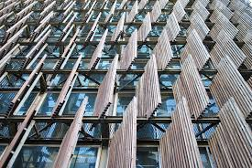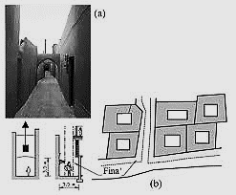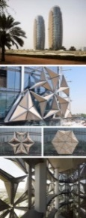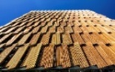
Vernacular architecture
Biomimetic architecture
Fig 6. examples of external skin layers with shading components and skins to minimize exposure to sun in Desert house, Minister of Municipal Affairs and Agriculture (MMAA) Building and Al Bahr Towers (left); methods for shading to minimize exposure to sun in the vernacular architecture of hot and arid climate (right) (www.google.com)

4.1.5. Strategy 5: Avoiding heat techniques (Minimizing heat load)
Another way of avoiding heat is the use of bright colors and reflective surfaces to minimize heat absorption, utilized in both vernacular architecture and biomimetic architecture. The color white is used in many vernacular buildings in hot and arid regions, such as the ones designed by Hassan Fathy. Some abanbars (traditional Iranian cistern) in Iran, such as Ouz Abanbar near the city of Lar, have white outer skins, which reduce heat absorption during the hot hours of the day.
In S.C.A.L.E.S., Q 1 and the Center for Disease Control Complex, as examples of biomimetic architecture, the same approach has been adopted (Figure 7).
4.1.6. Strategy 6: Utilization of Sun radiation absorption techniques (Heat gain)
Gaining heat, as the last technique discussed in this study for regulating heat is carried out through absorbing sunlight, which can be seen – however in different forms and through different processes – in both vernacular architecture and biomimetic architecture. Gaining heat in the winter is of great importance in passive heating. In buildings in hot and arid regions, some spaces are designed for winter use, which take most advantage of sunlight by gaining heat (Figure 8).
In some cases in biomimetic architecture, elements such as photovoltaic cells are installed on the outer surface of the building, making the highest amount of sunlight absorption possible, as can be seen in Al Bahr Towers, Gemini Haus, S.C.A.L.E.S., and Melbourne Council House. It should be noted that in the biomimetic architecture examples, both the direct production of heat through absorbing solar radiation and the indirect production of heat through additional components are considered (Figure 8).

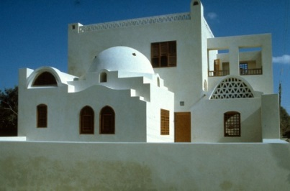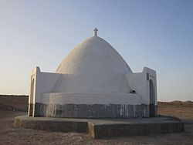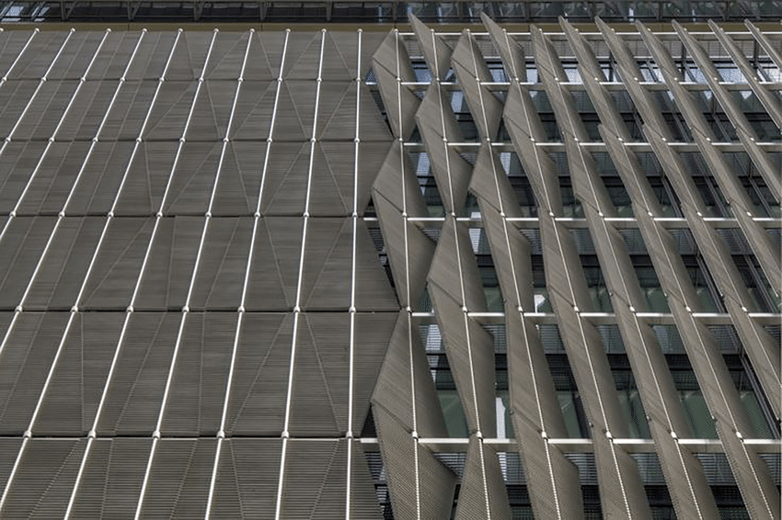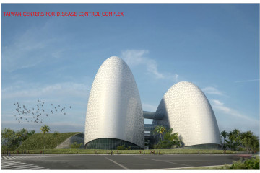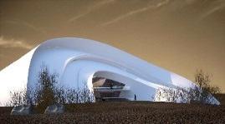
Vernacular architecture
Biomimetic architecture
Fig 7. Avoiding heat by white or bright colors and reflective surfaces in: Q 1 building, S.C.A.L.E.S. Building, Desert house, Center for Disease Control Complex by Archello (left); Akil Sami houses designed by Fathi and Ouz Abanbar (right). (www.google .com)
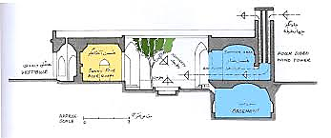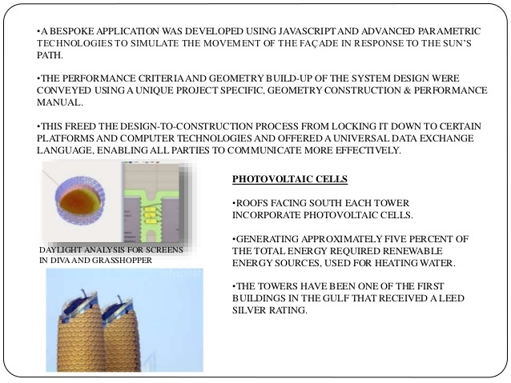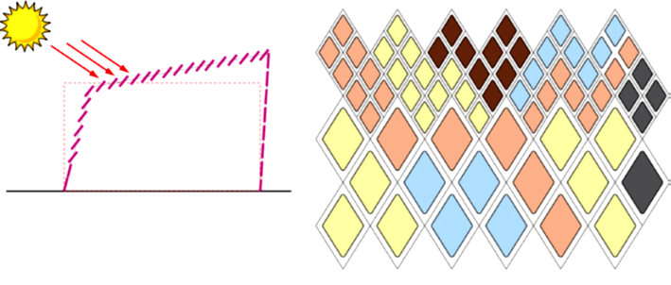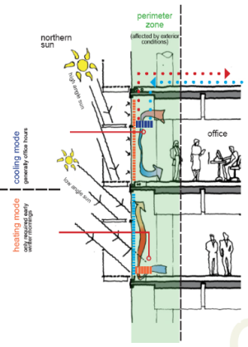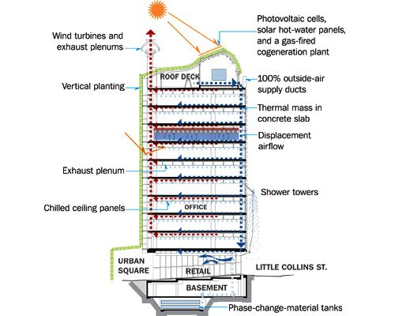

Vernacular architecture
Biomimetic architecture
Fig 8. Solar gain through solar panels of S.C.A.L.E.S., photovoltaic cells in the sunlight-absorbing roof and skins in the southern side of Melbourne Council House, photovoltaic cells of Al Bahr Towers (left); Gaining heat by absorbing sunlight in the section for winter residence in vernacular houses in hot and arid climates (right). (www.google.com)

4.2. Summary of similar thermoregulation strategies
The following diagram presents the results of the comparative analyses done in this section. It summarizes the similarities between vernacular and biomimetic architecture in their use of thermoregulation strategies (figure 9).

Heat regulation
Evaporation
Improving conduction
Improving convection
Absorbing radiation
Reduce heat exchange
Reducing surface-to- volume ratio
Isolation
Heat reservation via thermal mass
Minimizing radiation exposure
Minimizing heat load
Bright color /reflective surface
Reducing surface-to- volume
Avoiding heat
Heat gain
Heat conservation
Heat dissipation
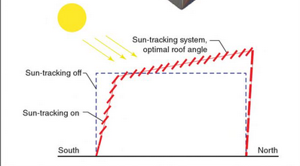
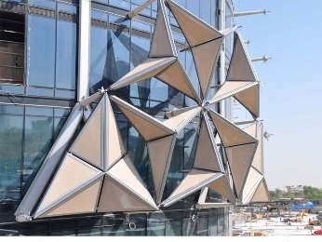
Biomimetic architecture
Vernacular architecture
Fig 9. similar approaches to heat regulation in vernacular and biomimetic architecture

  - Summary of differences
Based on the analytical comparisons in this section, there are some differences in the form, material, technology and energy use between vernacular and biomimetic architecture. In other words, the main strategies of thermoregulation are the same in both but the process through which these strategies are applied to building design is different. Also, buildings designed using these two approaches are distinct in their appearance but similar in their thermoregulation behavior. These differences have been presented in the following table (Table 2).
5. DISCUSSION AND CONCLUSION
Based on the comparisons and analyses made in the present study, vernacular architecture and biomimetic architecture share overlapping features. Their common approaches to heat regulation can be summarized as follows:
- Avoiding heat and controlling solar radiation through elements and components of the outer skin (shading through fixed components in vernacular architecture and designing intelligent and dynamic facades with attached kinetic components in biomimetic architecture).
- Optimizing the building’s thermal design by avoiding heat and minimizing heat gain through bright colors and reflective surfaces and reducing the surface-to-volume ratio (minimizing radiation).
- Dissipating heat using evaporative cooling.
- Dissipating heat using convective cooling (improving convection).
- Retaining heat using thermal mass to achieve thermal lag (against temperature fluctuation).
- gaining heat by absorbing radiation and using sun as a renewable source of energy (absorbing radiation both directly and indirectly based on proper orientation toward the sun)
The similarities in the methods of regulating environmental conditions based on passive cooling and heating in vernacular and biomimetic architecture, with examples of each approach, have been presented in Diagram 12.
The above-mentioned approaches and techniques provide an answer to the first question of the article. As already discussed, traditional methods of regulating environmental conditions can be combined with new technology and materials and incorporated in new forms of architecture in order to make environmental conditions better. These new forms of architecture can provide us with answers for the third questions of the study.
On the other hand, as indicated in Table 2, vernacular architecture and biomimetic architecture have fundamental differences in their use of materials and technology. Vernacular architecture has a static nature while biomimetic architecture is dynamic, kinetic, interactive and intelligent. In can be flexible in response to momentary environmental changes. Thus the answer to the second question was determined.
In the end, it can be concluded that biomimetic and vernacular architecture are different in the way that in biomimetic architecture new materials, such as concrete, metal and glass, modern technologies, such as intelligent control systems in facades and dynamic and responsive skins, phase change materials and generating and converting systems of energy (such as photovoltaic cells), are utilized. However, it should be noted that the knowledge relied on in dealing with climatic conditions to protect the environment in both types of architecture is to a great extent similar. As already discussed, while vernacular architecture has a static nature and uses low tech, and biomimetic architecture is dynamic, intelligent and dependent on hi tech, both types of architecture adopt similar strategies – of course in different ways – to regulate heat.

Table 2. Differences between vernacular and biomimetic architecture
Biomimetic Architecture | Vernacular Architecture
- Use of universally available new materials | - Use of locally available traditional materials
- Use of advanced technology and high tech construction techniques | - Use of low tech and traditional and experimental techniques
- Energy supply through the building itself and additional dynamic components | - Energy supply through fixed static components and the building’s form and orientation
- The capacity for utilizing transparent outer skins by taking advantage of the dynamic (kinetic) properties of the main façade components | - Non-transparent outer skins with minimum openings (introverted buildings)
- Use of multi-layer facades and skins and multi-functional walls or facades (by assigning separate functions to different layers) | - Use of monolayer building skins (for example: heavy, thick monolayer adobe or brick walls in buildings in hot and arid regions)
- Dynamic, kinetic and interactive building skins (buildings are alive)  - The capacity for processing, converting and generating energy from renewable energy resources (sun, wind and geothermal energy)  - Self-regulation, self-adjustment | - Static outer building skins  - Direct use of renewable energies (sun, wind and geothermal energy)  - Regulation and adjustment by human or human-dependent regulation and adjustment

It should be noted that although extensive research has been conducted on both vernacular architecture and biomimetic architecture, no comparative study has been carried out on these two approaches. Consequently, the results of the present study cannot be endorsed or opposed unless these two types of architecture are comparatively studied by other researchers.
ACKNOWLEDGMENTS
The present article is adapted from Marjan Arbabzadeh's doctoral thesis entitled "Illustrating the Principles and Criteria for the Comparison of Biomimetic Architecture and Vernacular Architecture in Hot and Arid Regions in Iran", which has been conducted under the supervision of Dr. Etesam and Dr. Mofidi Shemirani. I would like to appreciate their invaluable assistance and guidance.
REFERENCES
- Alpago Novello, A., Mehryar, M., Roboubi, M., Falamaki, M.M., Dadkhah, M.:2005, Architettura Popolare, Faza Publication, Tehran. [Persian]
- Fathi, H.: 1986, Natural Energy and Vernacular Architecture, University of Chicago Press; Chicago.
- Beazley, E. and Harverson, M.:2012, Living with the desert: working buildings of the Iranian Plateau. Golchin, M. and Sabouri, N. (translator), Rozaneh, Tehran. [Persian]
- Zarghami, E. and Sadat, S.A.:2017, Vernacular architecture and Technology, Shahid Rajaee Teacher Training University pressTehran. [Persian]
- Eltrapolsi, A.H.:2016, The efficient strategy of passive cooling design in desert housing: a case study in Ghamdames, Libya, P.H.D thesis of architecture. Faculty of Architecture. The University of Sheffield.
- Gruber, P.:2011, Biomimetic in Architecture-Architecture of Life and Buildings, Springer, New York.
- Gruber, P. and Gosztonyi, S.:2010, Skin in architecture: Towards bioinspired facades, Design and Nature, 138,503-513.
- Golabchi M and Khorsand Nikoo M. Bionic Architecture. Tehran: Tehran University Press; 2014.
- Golabchi, M. and Khorsand Nikoo, M.: 2019, Biotech Architecture, Pars University Press, Tehran.
- Kazimee, B.A.:2008, Learning from vernacular architecture: sustainability and cultural conformity, Eco-Architecture II, 113, 3-13.
- Edvard, B.: 2014, Rough guide to sustainability, Mehrazan, Tehran.[Persian]
- Tahbaz, M.:1995-96, The Principles of a Desert’s Architecture, SOFFEH, 19-20, 79-89. [Persian]
- Anselm, A.J.:2006, Developing designs in balance with nature, Eco-Architecture, 186, 195-204.
- Ghobadian, V.: 2015, Shape of Sustainable Houses in Iran: A Climatic Analysis, European Journal of Natural and Social Sciences, 3(3), 110-120.
- Esmaeili, S. and Litkouhi, S.:2013, Principles of sustainable architecture extent in heart of desert of Iran, International Journal of Architectural Engineering & Urban Planning, 23(2), 103-112.
- Lavafpour, Y. and Surat, M.: 2016, Towards new approaches for converting principles of vernacular architecture into energy efficient buildings in hot and dry climates, Journal of Building Performance, 2(1), 33-45.
- Badarna, L.:2017, Form follows environment: Biomimetic approaches to building envelope design for environmental adaption, Buildings, 7(40), 1-16.
- Alotaibi, F.:2015, The Role of Kinetic Envelopes to Improve Energy Performance in Buildings, Architectural Engineering Technology, 4(3), 1-5.
- Maglic Michael, J.:2012, Biomimicry: Using Nature as a Model for Design, University of Massachusetts, Massachusetts.
- Badarna, L., Nachman Farchi, Y. and Knaack, N.:2010, Solutions from nature for building envelope thermoregulation, Design and Nature, 138, 251-262.
- Benyoucef, Y.M. and Razin, A.:2018, Biomimicry Architecture from the inspiration by nature to the innovation of the Sahara architecture, Architecture and Engineering, 3(4), 3-12.
- Minsolmaz Yeler, G. and Yeler, S.:2017, Models from nature for innovative building skins, Kurklareli University Journal of Engineering and Science, 3,142-165.
- Mazzoleni, I.:2010, Biomimetic Envelope, DISEGNARECON, 3(5), 99-112.
- Elghawaby, M.:2012, Breathing façade: a new concept to create dynamic thermal ambiances in buildings located in hot climates, 2nd International Congress on Ambiances- Montreal, Canada, 215-220.
- Zandieh, M., Khaleghi, I. and Rahgoshay, R.: 2012, Iranian vernacular architecture: notable example of a thermal mass, International Journal of Architectural Engineering & Urban Planning, 22(1), 51-59.
- Brown, G.Z. and Dekay, M.:2001, Sun, Wind & Light-Architectural design strategies, 2th Edition, John Wiely & Sons Inc, New York.

AUTHOR (S) BIOSKETCHES

M. Arbabzadeh ., PhD Candidate, Departmant of Architecture, Science and Research Branch, Islamic Azad University, Tehran, Iran. Email: marjan.arbabzadeh@gmail.com

I. Etessam., Professor, Departmant of Architecture, Science and Research Branch, Islamic Azad University, Tehran, Iran. Email: i.etessam@srbiau.ac.ir

S. M. Mofidi Shemirani., Assistant Professor, School of Architecture and Urban Development, Iran University of Science and Technology, Tehran, Iran. Email: s_m_mofidi@iust.ac.ir

COPYRIGHTS

Copyright for this article is retained by the author(s), with publication rights granted to the journal.
This is an open-access article distributed under the terms and conditions of the Creative Commons Attribution License (http://creativecommons.org/licenses/by/4.0/).

HOW TO CITE THIS ARTICLE  Arbabzadeh, M., Etessam, I., Mofidi Shemirani, S.M. (2020). Passive Thermoregulation in Vernacular and Biomimetic Architecture in Hot and Arid Climate. Int. J. Architect. Eng. Urban Plan, 30(2): 198-211,. https://doi.org/10.22068/ijaup.30.2.198.  URL: http://ijaup.iust.ac.ir | 

∗ Corresponding author: i.etessam@srbiau.ac.ir

