THERMAL PERFORMANCE SIMULATION OF HYDROPONIC GREEN WALL IN A COLD CLIMATE
Maryam Farhadian¹, Sina Razzaghi Asl², Hessam Ghamari ³

ABSTRACT
The green hydroponics walls are among new kinds of building facades, which receive more attention from architects lately. In addition to the positive effect these walls have in maintaining humidity in arid regions, they also have positive thermal performance in both cold and hot weather conditions. Therefore, they are in the center of designers’ focus for public spaces such as schools. In terms of soil-free cultures, these walls are of three general types: wide, horizontal, and vertical. The use of different types of green walls in each zone allows for different thermal performance. This paper aims to investigate the thermal performance of hydroponic green walls in different facades of green school in term of thermal performance. Moreover, the present study only addresses green schools in cold climates. We conducted a simulation by using Energy Plus software with three different types of hydroponic green walls in Shahrekord city of Iran, which were monitored in 20 years" from2000 until2019".The thermal performance of each type was analyzed and compared with other samples. Finally, the best kind of green- hydroponics wall with the best thermal performance was identified for each wall.

KEYWORDS
Hydroponic green walls, Thermal performance, green Schools, Cold climate
1-INTRODUCTION
The phenomenon of high temperature in urban areas is partly due to decreasing green area and increasing area of asphalt pavement as well as constructing no attentive buildings to the global warming phenomenon. As a result, there is a growing amount of structures in our cities that are producing more temperature and consequently shaping more urban heat islands (UHI).
Among all constructed buildings in urban environments, schools are the major energy consumers in the public buildings sector [1].In this regard, keeping energy by optimizing walls has attracted architects attention for many years, particularly in cold climates in which walls connected to the open environment are a major contributor to waste energy[2]. Therefore, in recent few decades, the use of green wall attaching to buildings’ main envelops instead of common insulators as a less harmful solution to nature, has received remarkable attention from environmentalists & sustainable developers[3]. Trees and plants help mitigate the greenhouse effect, filter pollutants, mask noise, prevent soil erosion, and calm their human observers[4]. Plants which grow on green walls have good potential in the thermal equilibrium of the schools’ spaces. Studies show that by adding green layers to the walls of schools, energy-saving is improved in educational spaces[5]. Over the recent years, the application of Vertical greening systems in order to mitigate the impacts of global warming and urban heat islands are rapidly growing. These systems can be classified into facade greenings and living walls systems according to their growing method. Green facades are based on the use of climbers attached directly to the building surface, as in traditional architecture, or supported by cables or trellis. Living wall systems (LWS), also known as green walls and vertical gardens, are constructed through the use of modular panels, each of which contains its own soil or other artificial growing mediums, using balanced nutrient solutions to provide to the whole or part of the plant food and water requirements [6].
This paper focuses on the thermal simulation of green facades, where part of the solar radiation is transmitted through the vegetation and reaches the building envelope. On hydroponic green roofs, plants are planted on top of precast plastic planters floating on a water substrate[7]. Significant contributions to the thermal modeling of green facades were made in the last years, but there has been no study conducted on the effect of green walls location on the thermal performance of buildings. This paper aims to investigate the thermal performance of hydroponic green walls in different facades of green school in term of thermal performance. Moreover, the present study only addresses green schools in cold climates. We conducted a simulation by using Energy Plus software with three different types of hydroponic green walls in Shahrekord city of Iran, which were monitored in 20 years" from2000 until2019". The thermal performance of each type was analyzed and compared with other samples. Finally, the best kind of green- hydroponics wall with the best thermal performance was identified for each wall.
2. LITERATURE REVIEW
2.1.THE HYDROPONIC GREEN WALLS (HGW)
The hydroponic green walls (HGW) are the new types of green walls first introduced in the United States as a substitute for ordinary green walls. The hydroponic green walls provide an opportunity to plant richer plants compared to ordinary walls and were first used owing to their capability in the adjustment of cities temperature[8]. In this type of walls, various species of plants are grown including decorative and medicinal plants[9]. The walls provide good conditions for planting different species of plants and they also have better performance in keeping water than potting soil. In addition, by providing insulation features, these walls have many thermal advantages over ordinary green walls, including: 1- Adjustment of outdoor temperature up to 9° C in warm weather conditions[10], 2- Optimization of indoor temperature up to 33.8% in cold and dry months as well as adjustment of indoor temperature up to 58.9% in all seasons[11], and 3-Prevention of sudden thermal shock in days and nights and also in different months of a year[12]. However, green schools like Lawrence College, as a new educational system, have utilized these walls [13].
These walls are structured like special boxes pre-manufactured in a factory and then installed on the facade of the building[14]. The constituent parts of hydroponic green walls, from main side of the wall to the outside, include main wall 30cm, insulation layer 2cm, vapor barrier10cm, hydrating panel 10cm, support frame 2cm, root protector 2cm, compressed hydroponics membrane 12cm [15-16] .
FIGURE 1.Implementation details of the hydroponic green walls
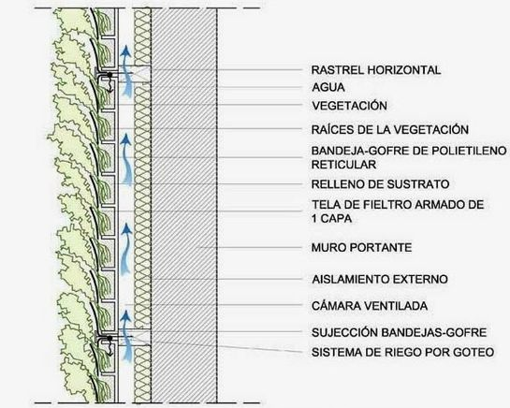
Perlite, pumice, Rice hull, Rockwool and Cocopeat are used for these types of green walls depending on different cultures. Since Perlite sacks have better performance in terms of growth quality and heat and water retention, they are more usable in cold and dry regions where humidity and cold weather damage plants[17]. In addition to its moisture advantages, it acts as insulation to building facade in cold climates and adjusts the indoor temperature. In order to better perform, these kinds of walls should be located in an appropriate space [18]. This type of green walls had some pros and cons which the first one is more than the latter according to table 1 (Table1).
Table 1. advantages and disadvantages of hydroponic green walls
advantages | role | explain
advantages | water refinery | Making use of the coco coir and perlite in hydroponic green walls can improve water absorption and drinking water treatment. Therefore, the water from municipal runoff will be treated and used. [19]
advantages | Reduce water demand | The minerals used in the hydroponic greenwalls were able to hold more water up to 20% level than the agricultural soil. Therefore, these alternatives require less water for irrigation and are widely used in arid climates.[20]
advantages | beter cooling performance | Hydroponic green walls with the ability to retain more moisture have a positive effect on lowering wall surface temperatures and indoors, thus providing thermal comfort conditions in hot climates. [21]
advantages | Consevating thermal energy | The pumice layer in the hydroponic green walls has a higher thermal resistance and therefore acts as an insulator in cold climates and prevents indoor space heat loss. [22]
advantages | Educational Effects | These walls are an educational garden special in educational spaces. HGVS can provide endless educational opportunities and can be used as tools for ecological. [23]
advantages | Reduction of Air Pollution | This kind of walls can filter pollutants from the air, and thus improve air quality in such a way that by installing these walls, the concentration of air pollutants in the vicinity of the wall will be reduced to 20%.[24]
advantages | Reduction of Noise | Hydroponic green walls have a strong effect on low to middle frequencies and they have a middle effect on higher frequencies[25]
disadvantages | Lack of the Enough studies | there has been no study conducted on the effect of green wall location [26]
disadvantages | Limited plant selection | Due to the use of minerals instead of agricultural soil only specific plant species can grow in these walls. [27]

2.2. ROLE OF HYDRPONIC GREEN WALLS IN ENERGY SAVING IN GREEN BUILDING
Green buildings are designed in order to provide sustainable solutions in mitigating significant impacts of the building stock on the environment, society and economy[28]. The Green Architecture Theory was introduced by the environmentalists following the industrial revolution in the 1950s and 1960s [29]. Since late 1985, the said theory began to be implemented in architecture and to be featured in green roof and wall designs for homes, offices, and educational environments[30]. Vertical greening systems, including green wall systems as well as green facades, mobilize high research potential, particularly addressing their contribution to thermal regulation of building envelopes. [31]
Given the15% to 20% consumption of fossil fuels in educational systems and reduction of green spaces to less than one meter per capita, the idea of green schools with green walls was first introduced in 1996 by the USA Council of the Construction and School Planning in school designs[32]. After twenty years of study, Setchelatthe from the University of California – succeeded in introducing alternatives for agricultural soil. Following him, Wignaragah introduced hydroponic growth techniques in 1995[33]. Similarly, for the first time in 2014, a study was conducted on the hydroponic green walls in Epirus Educational Institute in the University of Greece. In these walls, instead of boxes with normal soil, there was a sack containing 1 to 5 cm Perlite; two small tubes in upper and middle sections of the walls were responsible for nourishing and irrigating the plant less periodically than ordinary green walls. Finally, surplus irrigation water was collected in a small enclosure below the wall and was used in the next irrigation. As the Perlite held water longer than the ordinary soil, these types of walls had a better performance in water consumption. These kinds of systems allow easy irrigation in horizontal, vertical, and wide rows. Planter boxes are manufactured in a factory and then installed at a certain distance from the main facade of the building in vertical and horizontal arrangements with independent irrigation system.A10-to-15 cm moisture insulation is placed between the main facade of the building and the hydroponic wall. In wide green-hydroponic facades with a central irrigation system, this insulation increases up to five centimeters[34].
FIGURE 2. Different types of horizontal, vertical and wide Hydroponic green walls[34].
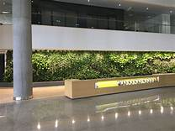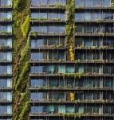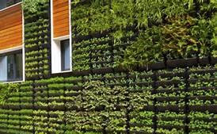
3. RESEARCH METHOD
3.1. SIMULATION DESCRIPTION
As discussed earlier, in this descriptive-analytical study, the main hypothesis is that there is a difference between different types of hydroponic green walls in each of the main walls of the green school buildings regarding the improved thermal performance in cold climate. Energy Plus ™ Version 8.7 was used for simulation. In this simulation method, two sets of data were given to software, including, 1- geographic and climatic data of the sample city for 20 years " from2000 until 2019"; 2-standards about a green modular school according to the school renovation guidelines. Firstly, the modular school was modeled according to green school's standards in cold climates and the temperature of indoor in different months were extracted. Then, after locating hydroponic green walls on the main walls, the indoor thermal load outputs were compared.
3.2. ANALYSIS
By using the step by step simulation method, Shahrekord city was selected as a sample with cold climatic characteristics[35]. Data from the past 20-year geo-meteorological data were received from Iran Meteorological Organization and, using Elements, they were converted into legible Epw data to be transferred to Energy Plus. Moreover, geometric data, previously obtained from the 3D simulation in Ecotect, were separately reentered into the software. Next, Three types of wide, horizontal and vertical green wall were installed as additional facade within 20 cm from the main building facade in all directions. Next, by comparing monthly indoor temperatures in the coldest month of winter (February) and the hottest month of summer (August), the walls with the most optimal thermal performance were identified to be used in modular schools. Finally, the average monthly temperature of indoor space resulting from wide, horizontal or vertical hydroponic green walls in the west, north, east and south facades of the school were compared.
3.3.PROPERTIES OF SAMPLE
Modeled school geometry data as an example of a modular school approved by the Iranian School Building Council in the cold climate are as follows: The three-story school with dimensions of 40m × 40m, high 3.2m ², Ventilation power 1.5 times per 1.5 hours for 300 students, 500 lux ceiling lighting, Six 4-person classes and electrical equipment equal to 2108$\frac{Btu}{h}$.
FIGURE 3. Schematic Simulation Model for selecting the most practical green-hydroponic facade in cold climates for green schools.
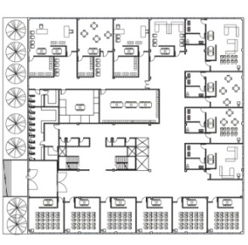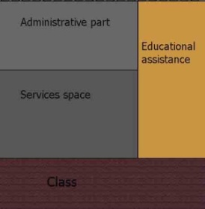
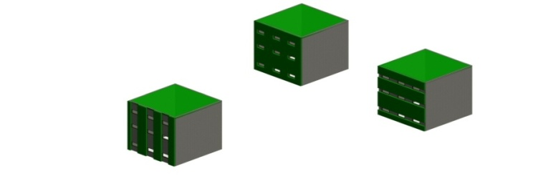
4. RESULT AND DISCUSSION
4.1. THERMAL PERFORMANCE OF ORDINAL MODULAR SCHOOLS
According to the modeling of a three-story standard green school in Shahrekord city, monthly information was obtained for interior space, in which the highest temperature was between Jan and Aug about 23.14º c and the lowest temperature was about .24ºc for Feb.(fig4)
FIGURE 4. Zone temperature in different seasons without presence Hydroponic green wall
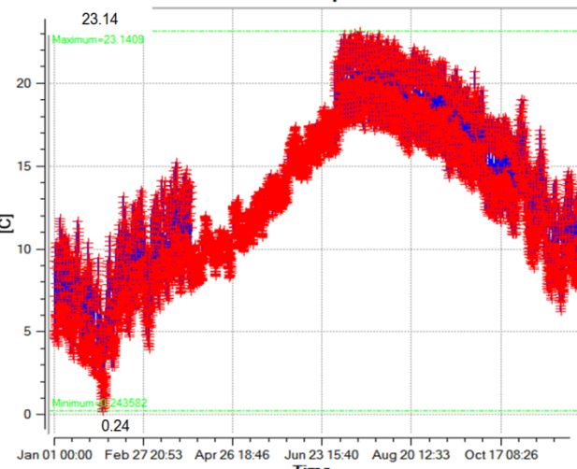
4.2.THERMAL PERFORMANCE OF THREE KINDS OF HYDROPONIC GREENWALLS
With respect to the indoor average temperature in critical months (February and August) in the simulated school space, the following findings were derived from horizontal, vertical and widespread hydroponic green walls on each east and west façade. The temperature of the interior spaces varies between 22.01ºc and 23.07ºc in the warmest month of the year, while these degrees were between 1.7ºc and 9.02ºc for the coldest month of the year. In this simulations, more temperatures of interior space in green school in cold climate were when vertical and horizontal green walls were installed in east and west facades (Figure5, 6, 7, 8, 9 and 10

FIGURE 5. Zone temperature in different seasons when a wide Hydroponic green wall is designed on the east side

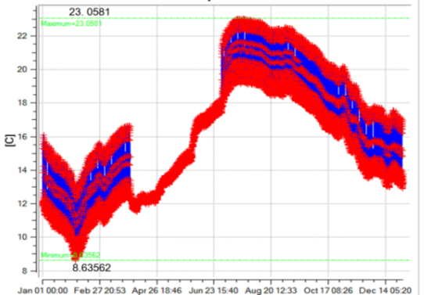
FIGURE 6. Zone temperature in different seasons when a horizontal Hydroponic green wall is designed on the east side
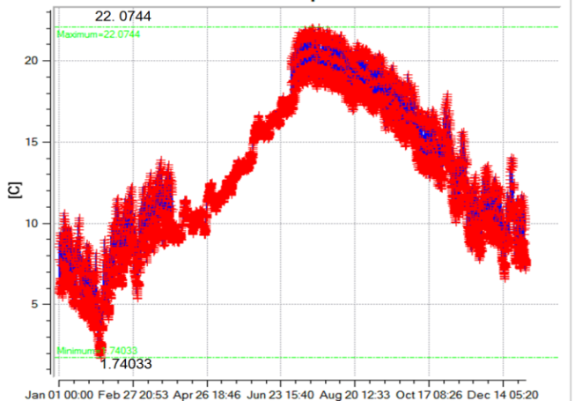
FIGURE 7. Zone temperature in different seasons when a vertical green Hydroponic wall is designed on the east side
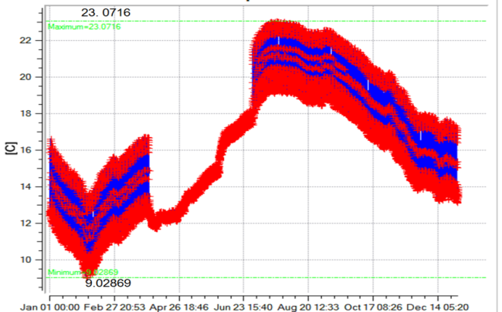

FIGURE 8. Zone temperature in different seasons when a wide Hydroponic green wall is designed on the west side
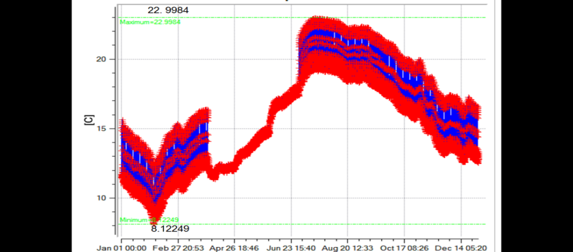
FIGURE 9. Zone temperature in different seasons when a horizontal green Hydroponic wall is designed on the west side
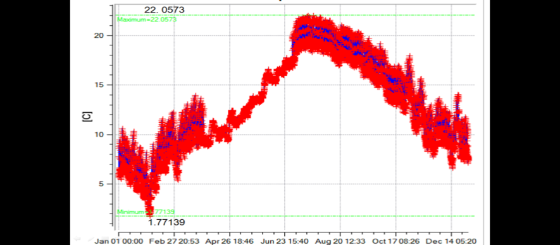

FIGURE 10. Zone temperature in different seasons when a vertical Hydroponic green wall is designed on the west side
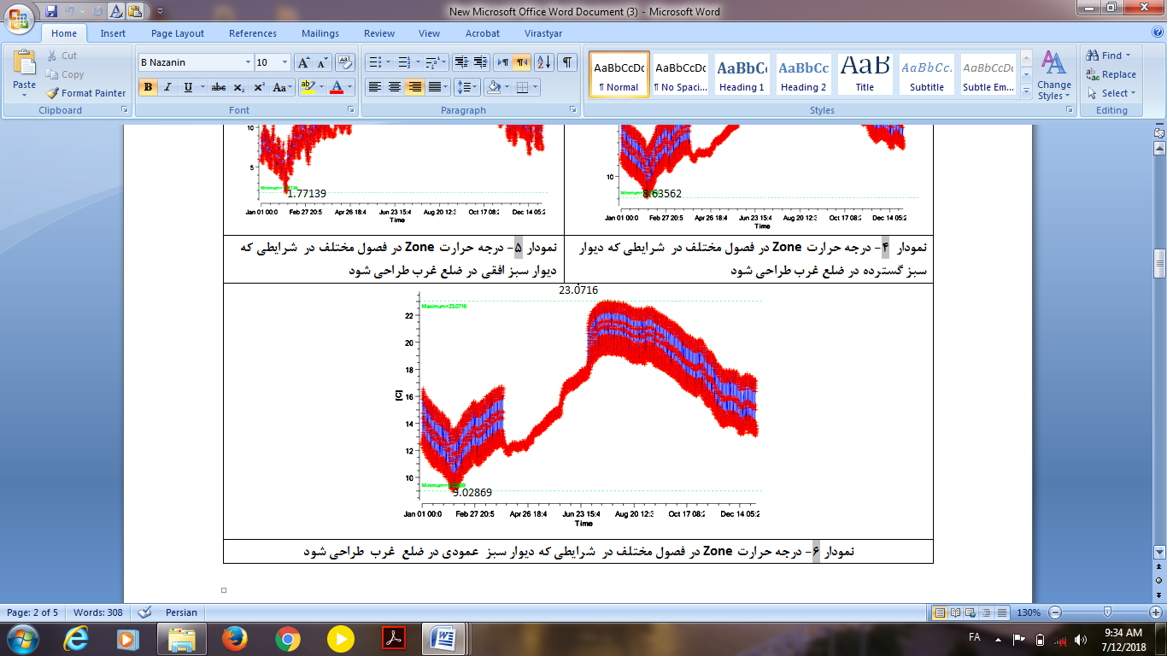
Moreover, Modeling the three types of Hydroponic green wall On both the north and the south displayed the following findings in which the temperature of interior space in the warmest month also is between 22.05ºc and 23.02ºc. Moreover, it has been from 1.7ºc until 8.9ºc for the coldest month of the year. and more temperatures of interior space were when wide hydroponic green wall and horizontal hydroponic green wall were installed in the south and the north facades respectively. (Figure 11, 12, 13, 14, 15 and16)
FIGURE 11. Zone temperature in different seasons when a wide Hydroponic green wall is designed on the north side
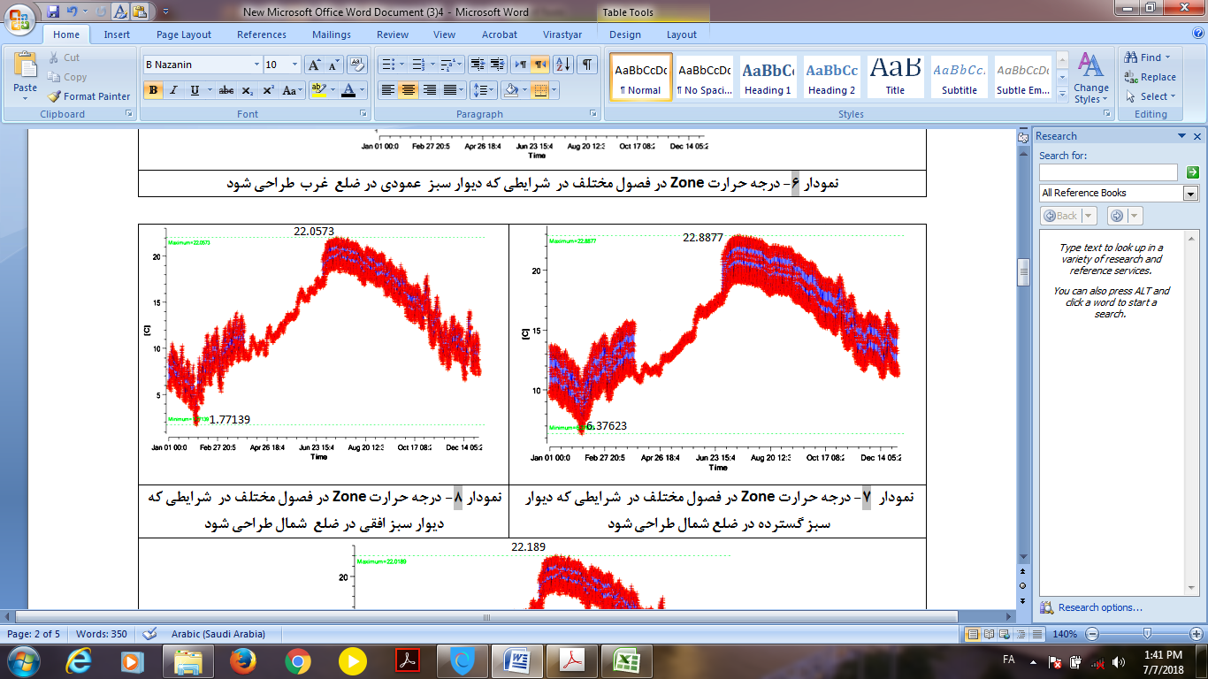

FIGURE 12. Zone temperature in different seasons when a horizontal Hydroponic green wall is designed on the north side
FIGURE 13. Zone temperature in different seasons when a Vertical Hydroponic green wall is designed on the north side
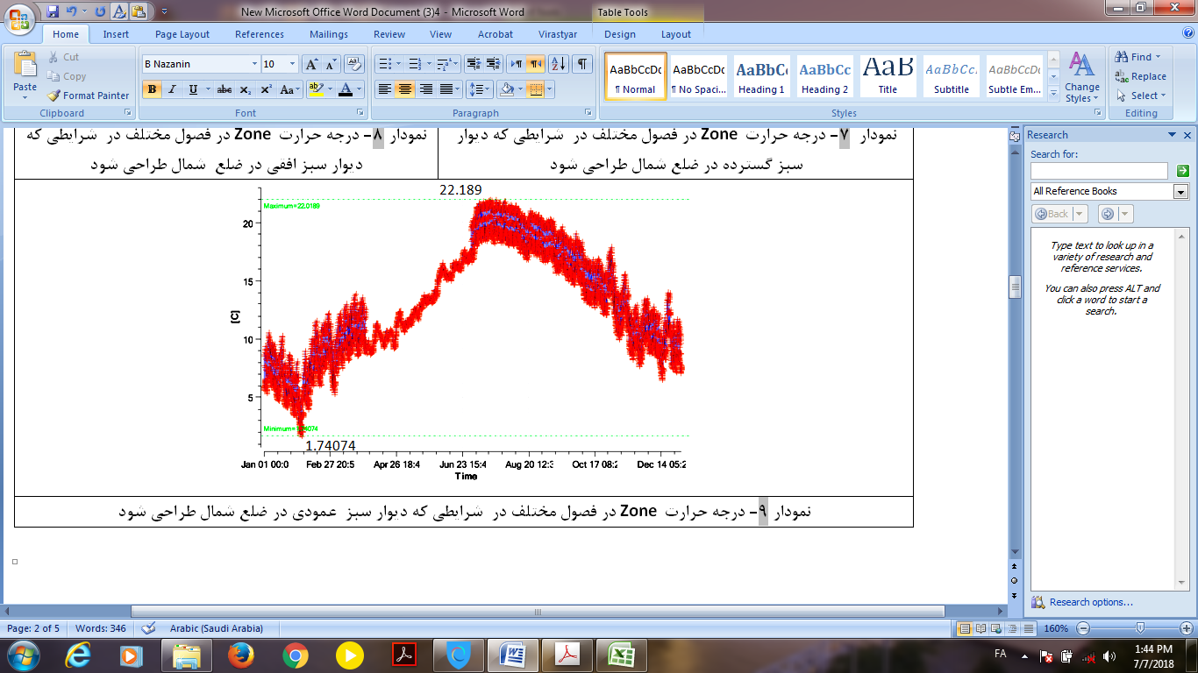
FIGURE 14. Zone temperature in different seasons when a wide Hydroponic green wall is designed on the south side
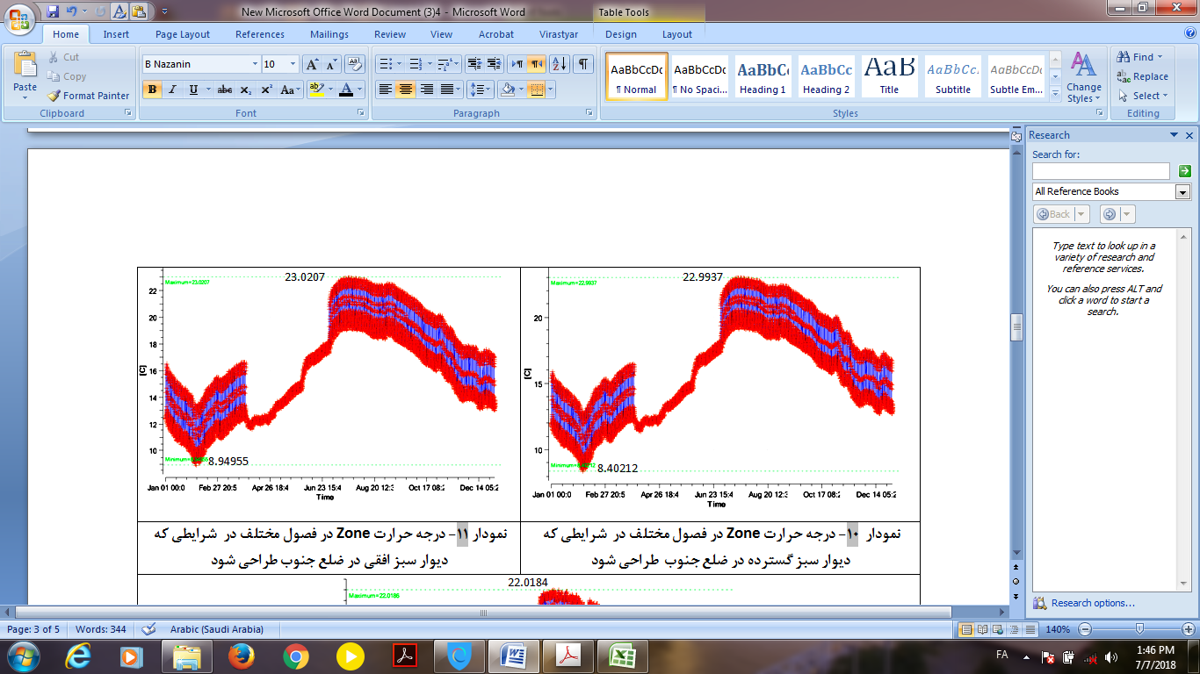
FIGURE 15. Zone temperature in different seasons when a horizontal Hydroponic green wall is designed on the south side
FIGURE 16. Zone temperature in different seasons when a vertical Hydroponic green wall is designed on the south side
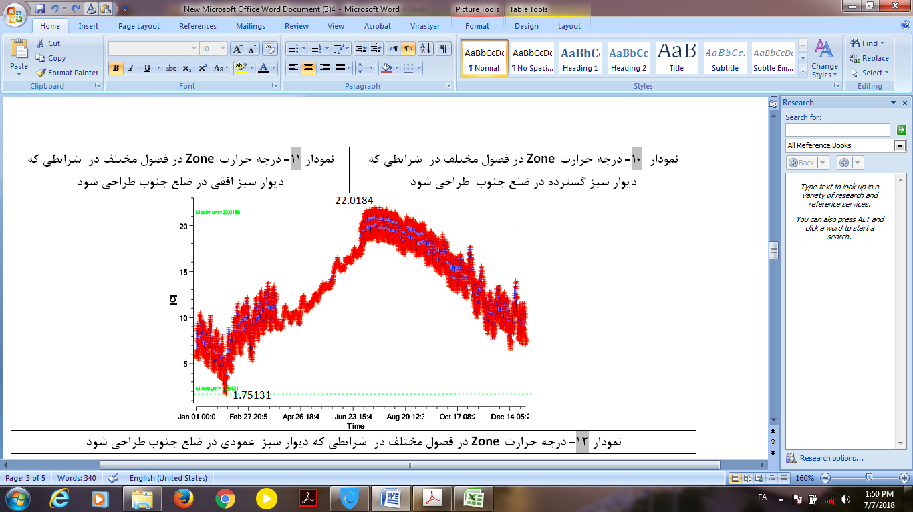
4.3.THE COMPARISON OF INDOOR TEMPERATURE IN DIFFERENT MONTHS
Generally, in all modeling of green schools with hydroponics green façades, the temperature of the warmest month of the year in the green school's interior is less than the temperature of the interior space without the presence of green walls. By contrast, the temperature of interior spaces in modeled hydroponic green schools is closer to the thermal comfort conditions in the coldest months of the year compared to the typical modular school.
According to Omrany 's study in 2016, an efficient architectural space should have a comfortable temperature in all months of the year[36]. This case by comparing the results of the average temperature of 12 months has obtained these findings. (Figure 17, 18, 19 and 20).
FIGURE 17. Comparison of the indoor average temperature where wide, horizontal or vertical green walls is designed on the eastern and western side of the school

FIGURE 18. Comparison of the indoor average temperature where wide, horizontal or vertical green walls is designed on the western side of the school

FIGURE 19. Comparison of the indoor average temperature where wide, horizontal or vertical green walls is designed on the northern side of the school

FIGURE 20. Comparison of the indoor average temperature where wide, horizontal or vertical green walls is designed on the southern side of the school

Overall, in every model, the indoor temperature is below 23.1 degrees" in the range of thermal convenience temperature" in the hottest months of the years. Moreover, when using the vertical hydroponic green wall in east and west facades and horizontal hydroponic green wall in south façade and wide hydroponic green wall in north façade, the average indoor temperature is at the most level in months of December, January, February, March, April and May that are the coldest months of the year. As discussed earlier, green walls require a systematic design for better performance. In this case, in order to optimize and improve design of green schools in cold climate; in each model, from indoor zone thermal data were compared with each other. The results are as follows:
1-By making use of the hydroponic green wall brings about reducing the indoor temperature from.07ºc(23.14-23.07) to 1.13ºc(23.14-22.01) in green school in warm seasons and improving warmth in interior space between 1.46ºc (1.7-.24) and 8.78ºc(9.02-.24) in cold seasons in green school in comparison with common schools. While, each hydroponic green walls in four frontages of buildings, have different functions for the interior space of green schools. (Figure 4)
2- Concerning the modeling of the hydroponic green walls for a high school with the conditions mentioned above, It can be concluded that by installing vertical hydroponic green walls in both east and west façades not only indoor temperature is close to comfort temperature in the hottest month of summer "August"(23.7° C< 25° C. But also, this kind of model creates better thermal performance in coldest seasons" February" in cold climate in comparison with others (9.02ºc >8.6, 8.1, 8.7) (Figure 5, 6,7, 8, 9 and 10)
3-Further on, by using all three kinds of hydroponic green walls in two south and north frontages although the indoor temperature is close to comfortable temperature in all models in summer, on the north side, the wide green- hydroponic wall has better performance than two other kinds of hydroponic green walls and, with a slight difference, the horizontal green hydroponics wall has the best performance in the south side. . (Figure 11, 12, 13, 14, 15and 16)
4- Moreover, the result extracted of comparing results of the average temperature of all 12 months display that when using a wide hydroponic green wall in the north side and vertical hydroponicgreen walls in both east and west sides and horizontal hydroponic green wall in south side the average indoor temperature was closer to the comfort range in the months of December, January, February, March, April and May as cold months of the year in Shahrekord. (Figure 17, 18, 19 and 20)
5-Generally by making use of this optimal model (wide hydroponic green wall in the north side and vertical hydroponic green walls in both east and west sides and horizontal hydroponic green wall in south side) the interior temperature of green school will be improved between .15ºc (23.14-22.9)for hottest season and10.63ºc (10.87-.24) for coldest seasons of year in this kind of climate condition . (Figure21)
FIGURE 21. comparison of the indoor temperature for a typical modular school and a hydroponic green school in cold weather condition
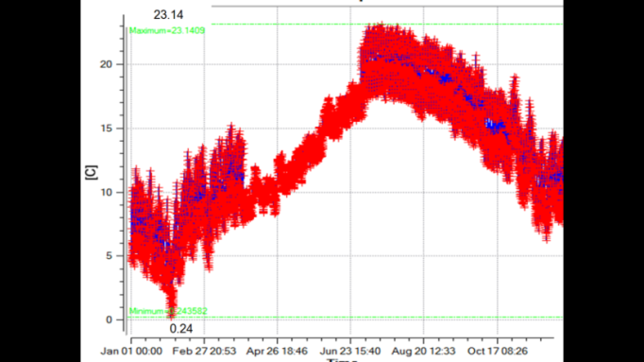
the temperature of a typical three floor modular school 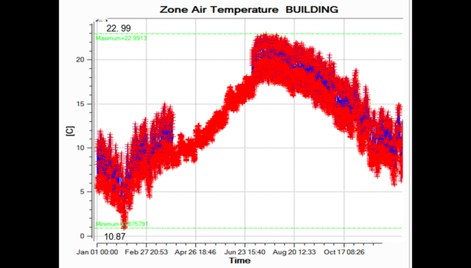
the temperature of a hydropomic three floor modular green school
5. CONCLUSION
The results of this experimental study highlighted a number of key differences in performance between the different types of hydroponic green walls in different facades of common educational buildings in cold climates. One of the limitations of this study was that the effects of vegetation on the thermal performance were not taken into the account. As a result of this study, it is suggested that, regardless of aesthetic aspects and improvement of educational efficiency in green schools, proper design of hydroponic green walls on building facades can improve the thermal performance of the schools in such a way that:
1- Horizontal hydroponics green wall installation in south facade has better thermal performance in cold and hot critical seasons in schools of cold climates compared to both wide and vertical hydroponic green walls.
2- Designing the vertical hydroponic green walls in both west and east facade despite providing the comfort temperature in August, can make the indoor temperature of cold schools closer to comfort conditions.
3-Thermal performance efficiency of wide hydroponic green walls is better than other examples of hydroponic green walls in the north side of cold climate schools in the critical seasons.
4-As a consequence of a functional installation of hydroponic walls in each of the four facades of modular green schools in Cold climates, the interior temperature between .15ºc (23.14-22.9) for hottest season and 10.63ºc (10.87-.24) for coldest seasons will be improved. in a way that, on one hand, the heat of interior space is trapped in the school in the winter and the green cover acts as insulation. And on the other hand, maximum solar radiation in cold seasons is used as well. as a result, thermal energy in all seasons will be saved.
The model of hydroponic green walls, if methodically designed on the facade of educational buildings, not only is recommended for the educational spaces of Shahrekord as a cold city, but also all schools in regions with similar climate can benefit from this combination. The finding of this study provides a reference point for further research into the functional design of these systems in other buildings in different areas with various weather conditions
6- ACKNOWLEDGEMENT
This research did not receive any specific grant from funding agencies in the public, commercial, or not-for-profit sectors. It has been done as part of my PhD dissertation in Islamic Azad University of Shahrekord in 2018.
7-EEFERENCES
[1] Alwetaishi, M., & Taki, A. (2019). Investigation into energy performance of a school building in a hot climate: Optimum of window-to-wall ratio. Indoor and Built Environment, 1420326X19842313.
[2] Niemelä, T., Kosonen, R., &Jokisalo, J. (2016). Cost-optimal energy performance renovation measures of educational buildings in cold climate. Applied energy, 183, 1005-1020.
[3] Shah, S., Venkatramanan, V., & Prasad, R. (Eds.). (2019). Sustainable Green Technologies for Environmental Management. Springer.
[4] Santamouris, M., Pavlou, C., Doukas, P., Mihalakakou, G., Synnefa, A., Hatzibiros, A. and Patargias, P. (2007). Investigating and analysing the energy and environmental performance of an experimental green roof system installedin a nursery school building in Athens, Greece. Energy 32 (2007) 1781–1788.
[5] Kelting, S., & Montoya, M. (2012). Green building policy and school performance. In ICSDC 2011: Integrating Sustainability Practices in the Construction Industry (pp. 112-118).
[6] Perini, K., & Rosasco, P. (2013). Cost–benefit analysis for green façades and living wall systems. Building and Environment, 70, 110-121.
[7] Huang, Y. Y., Chen, C. T., & Tsai, Y. C. (2016). Reduction of temperatures and temperature fluctuations by hydroponic green roofs in a subtropical urban climate. Energy and Buildings, 129, 174-185.
[8] Browne, A. (2018). Hydroponic Towering Agriculture vs Traditional Soil Farming in Southern Arizona.the university of arizona, UA campus repository.33p
[9] Katsoulakou, S., Lampraki, E., Tsirogiannis, I. L., Papakonstantinou, K., Baltzoi, P., &Karras, G. (2016, June). Evaluation of two hydroponic vertical planting systems for indoor living walls under different exposure to light. In VI International Conference on Landscape and Urban Horticulture 1189 (pp. 291-296).
[10] Karras, G., Tsirogiannis, I. L., Varras, G., Lampraki, E., Bakea, M., &Savvas, D. (2016, June). Exterior hydroponic panel-system and plants evaluation and effects on the building's outer surface conditions. In VI International Conference on Landscape and Urban Horticulture 1189 (pp. 217-222).
[11] Coma, J., Pérez, G., de Gracia, A., Burés, S., Urrestarazu, M., & Cabeza, L. F. (2017). Vertical greenery systems for energy savings in buildings: A comparative study between green walls and green facades. Building and environment, 111, 228-237.
[12] Katsoulas, N., Antoniadis, D., Tsirogiannis, I. L., Labraki, E., Bartzanas, T., &Kittas, C. (2017). Microclimatic effects of planted hydroponic structures in urban environment: measurements and simulations. International journal of biometeorology, 61(5), 943-956.
[13] Rossi, A., Johnson, I., & Koh, Y. M. (2016). Sprouting Roots at Sarah Lawrence College., at Sarah Lawrence College,Campus Environmental Sustainability Project. 7. 18p
[14] McGowan, P., Baron, D., Baron, M., Hafner, R., & Choi, H. (2017). U.S. Patent Application No. 15/461,179.
[15] Resh, H. M. (2015). Hydroponics for the home grower. CRC Press. Boca Raton London New York,Book number 978-1-4822-3926-3, 38 p
[16] Karras, G., Tsirogiannis, I. L., Varras, G., Lampraki, E., Bakea, M., &Savvas, D. (2016, June). Exterior hydroponic panel-system and plants evaluation and effects on the building's outer surface conditions. In VI International Conference on Landscape and Urban Horticulture 1189 (pp. 217-222).
[17] Al-Kodmany, K. (2018). The vertical farm: A review of developments and implications for the vertical city. Buildings, 8(2), 24.1-36.
[18] Djedjig, R., Belarbi, R., &Bozonnet, E. (2017). Experimental study of green walls impacts on buildings in summer and winter under an oceanic climate. Energy and Buildings, 150, 403-411.
[19] Prodanovic, V., Zhang, K., Hatt, B., McCarthy, D., &Deletic, A. (2018). Optimisation of lightweight green wall media for greywater treatment and reuse. Building and Environment, 131, 99-107.
[20]Beecham, S., Razzaghmanesh, M., Bustami, R., & Ward, J. (2019). The Role of Green Roofs and Living Walls as WSUD Approaches in a Dry Climate. In Approaches to Water Sensitive Urban Design (pp. 409-430). Woodhead Publishing.
[21] Radić, M., BrkovićDodig, M., & Auer, T. (2019). Green Facades and Living Walls—A Review Establishing the Classification of Construction Types and Mapping the Benefits. Sustainability, 11(17), 4579.
[22] Rakhshandehroo, M., Yusof, M., Johari, M., & Arabi, R. (2015). Living wall (vertical greening): Benefits and Threats. In Applied Mechanics and Materials (Vol. 747, pp. 16-19). Trans Tech Publications.
[23] Mäkelä, T., Helfenstein, S., Lerkkanen, M. K., &Poikkeus, A. M. (2018). Student participation in learning environment improvement: analysis of a co-design project in a Finnish upper secondary school. Learning Environments Research, 21(1), 19-41.
[24] Goud, R., Chauhan, N. K., Lokhande, H., Bohre, S., Kochar, Y., Soni, M., & Pathak, A. (2018). Vertical Forest in multistory Residential Cum Commercial to Eliminate Pollution by Hydroponic Method. Int. J. Eng. Res. Adv. Technol, 4, 72-78.
[25] Hadba, L., Mendonça, P., & Silva, L. T. (2017). GREEN WALLS: AN EFFICIENT SOLUTION FOR HYGROTHERMAL, NOISE AND AIR POLLUTION CONTROL IN THE BUILDINGS. In Living and Sustainability: An Environmental Critique of Design and Building Practices, Locally and Globally. Architecture, Media, Politics, Society (AMPS).
[26] Djedjig, R., Belarbi, R., &Bozonnet, E. (2017). Experimental study of green walls impacts on buildings in summer and winter under an oceanic climate. Energy and Buildings, 150, 403-411.
[27] Manso, M., & Castro-Gomes, J. (2015). Green wall systems: a review of their characteristics. Renewable and Sustainable Energy Reviews, 41, 863-871.
[28] Zuo, J., Zhao, Z. (2014). Green building research–current status and future agenda: A review. Renewable and Sustainable Energy Reviews 30, 271-281. doi - 10.1016/j.landurbplan.2017.04.002
[29] Drester, S.( 2005). Sustainable foundations. Translated Khaki, the publishers of ferdowsimashhad university , Iran , mashhad , secound period. 50 page.
[30] Giuliano Dall’O’.(2013),Green energy audit of buildings ,a guide for a sustaiable energy audit of buildings, Built environment and Construction engineering (ABC) Politecnico di Milano,399pp
[31] Medl A, Stangl R, Florineth F, V(2017), vertical greening systems – A review on recent technologies and research advancement, Building and Environment doi: 10.1016/ j.buildenv.2017.08.054.
[32] Ramli, N. H., Masri, M. H., Zafrullah, M., Taib, H. M., & Hamid, N. A. (2012). A comparative study of green school guidelines. Procedia-Social and Behavioral Sciences, 50, 462-471.
[33] Jones Jr, J. B. (2014). Complete guide for growing plants hydroponically. CRC Press ,Boca Raton.223p
[34] Karras, G., Tsirogiannis, I. L., Varras, G., Lampraki, E., Bakea, M., &Savvas, D. (2016, June). Exterior hydroponic panel-system and plants evaluation and effects on the building's outer surface conditions. In VI International Conference on Landscape and Urban Horticulture 1189 (pp. 217-222).
[35] Abbas Nia, M. (2015). Climatic recornization of Charmahal and bakhtiari province using mew statistical techniques, IWRJ journal, issu2(17), vo9. P216-121
[36] Omrany, H., Ghaffarianhoseini, A., Ghaffarianhoseini, A., Raahemifar, K., &Tookey, J. (2016). Application of passive wall systems for improving the energy efficiency in buildings: A comprehensive review. Renewable and sustainable energy reviews, 62, 1252-1269.

according to Humphreys’ study in 2016, the average room temperature, in which humans feels comfortable, is between 20 and 25 ° C (Humphreys et al., 2018)

