THE STRUCTURAL SOLUTION Of LIGHT SUPPLING IN IRANIAN DOMESHOUSES (

Ahmad Danaeinia ¹, Majid Heydari Dehcheshmeh², Soroush Rahman³,
- Assistant Professor, Faculty of Architecture and Art, University of Kashan
(danaeinia@kashanu.ac.ir)
- MA Student of Architecture and Art, University of Kashan
(Majid.heidari74@gmail.com)
- Student of Architecture and Art, University of Kashan
(Soroush.rahman7@gmail.com)
Abstract
In the architecture of the mosque, the light entering into the dome is a functional necessity and due to the structure, the weight of the dome and its one or more shells has caused limitations in any kind of skylights to be encumbered. The research main question is that due to the mechanism of the dome parts, how the creation and the entering of skylights to the dome were done. The research method is a combination of both quantitative and qualitative methods. Initially, based on library studies, researcher's opinions were investigated and by analyzing 14 types of mosques from the Seljuk to the Qajar era in Iran, analyzes on how to create skylights through the dome were accomplished. This research answer two essential questions which are what principles had been followed for locating skylight in the dome? Moreover, how did light enter through the dome, in one-shell and two-shell domes? The findings show that in the one-shell domes, the position of the skylight is variable. In detached two-shell domes, the skylights are placed merely in 45° areas and are not limited in terms of numbers. Conclusions state that one-shell domes had a restriction to the number of skylights, in comparison to the two-shell domes. In detached two-shell domes, lighting was possible until the 22.5° area and considering no limitations, there has been no skylight in the area between 67.5° to 90° apart from a few exceptions.
Keywords: Iranian Architecture, Dome, Technology of Skylight, Structural Principles and Rules, skylight.

1.INTRODUCTION
Forms and shape of the mosque dome have been a very important issue in Iranian architecture over time and one of the most impressive elements in most of these domes is the light entering it. Therefore, provision of light for the architecture of the mosques, beyond the functional role, has a high conceptual value and has varied widely. Farabi in his book, Ahsa-al-Ulum, divided mathematics into seven specialized fields, which light, was of them[1]. Therefore, the need to create a skylight in the dome is sufficient knowledge of the geometry (theoretical and practical) of the dome and the existential philosophy of the skylight. The most specific, purest, idealistic and content-oriented subject of architecture is in the mosque[2] .
Although domes were begun from the pre-Islamic era, in the Islamic architecture, the dome presence in the mosque architecture began from the Seljuk period (1037-1194), and during the Timurid (1370-1500) and Safavid dynasties (1501-1736) reached the highest value and continued until the Qajar period (1794-1925); So far, the dome has continued to be an essential part of mosque architecture. Morphologically, in classification, there are three types of mosques, and therefore there are three types of skylight: the domes are surrounded by porches (Figure 1.A), open Ivan that get lights from the courtyards (Figure 1.B) and simple arch dome above the rectangular room (Figure 1.C)[3].
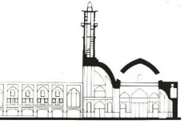
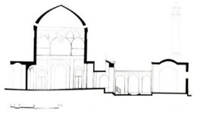
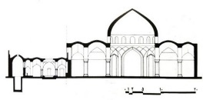

Figure.1.A: Aqa-Noor Mosque, Isfahan Figure.1.B: Seyed Mosque, Isfahan Figure.1.C: Lonban Mosque , Isfahan
In the first two patterns, lighting was performed through open space and in the third, as the dome entered into the mosque architecture, the lighting was considered through the dome. Dome shapes are always assumed as heavenly and metaphysical powers in the minds of the viewer, and the spherical shape of the sky and planets proved these ideas[4]. Therefore, with the perspective that the dome is separated from the outer world and emphasizes its inner concentration[3], architects have always tried to show the spiritual dimension of the mosque with light, shadow and decorations[5]. As a result, in addition to construction, symbolic issues have also been addressed [6]. In Islamic architecture, efforts are made to create positive atmospheres (places)[5] and reduce the negative spaces. The creation of the skylight for the positive atmosphere is the most important factor in directing the architecture of the dome: "Because human vision depends on light and our perception of space depends on the quality and quantity of light" [7]. For this reason, Zargar believes that the combination of geometry, color and light with architectural arrays, is the key of the transcendence of the soul, which "places man in the galactic space that belongs to the universe, and man feels the presence of the Holy One properly in that space" [2].
Considering the spiritual and functional role of the mosque, providing light and the atmosphere around it, was one of the main concerns that Iranian architects tried to solve logically with the attitude of the traditional mosque construction.
2. Method OF THE RESEARCH
This study examines how to provide light through the structure of the dome; not how to enter light into the dome, because the second issue concludes all lighting arrangements in the dome. The study in the field of the methodology is a combination of qualitative (analytically) and quantitative (case study). In the methodology section, initially based on library studies, the opinions of the researchers are analyzed and then, by selecting 14 samples from the Seljuk to Qajar dynasty (8 one-shell and 6 two-shells domes) based on the variables derived from theoretical foundations and field studies, in an analytical way, it has been investigated how to create lightning through the dome. In selecting samples, "date of construction" and "to be an indicator and famous " have been considered as two important aspects.
3. BACKGROUND Of The Research
The main topic in this research consists of two categories. The first category is based on the evolution of domes, the recognition of elements, the dome dimensions, the morphology and the quality of the entrance light into the architecture of the dome. Among these studies, the mystical and aesthetic dimensions of light have also been investigated. In the mystical dimension, Muslim mystics e.g, Abu-Ali-Sinai, Imam Mohammad Ghazali, Sheikh Najmuddin Kobra and Sheikh Ishraq have studied the light subject. They believed that light was the symbol of divine unity, and the Muslim artist used light to convey material. In the way that this light was ultimate, the same word that in essence has the same identity [8]. Architects have mastered the use of light in the definition of space and consciously use it as one of the important architectural factors in utilizing facilities. Considering the system works to create different spaces and then various spatial values, the light comes from the ceiling holes, due to this difference in value (the importance of spaces), and sometimes is located at the highest point of space and coincides with the axis of the circular ceiling, which is actually the point of space symmetry, and sometimes located on the far sides of the dome. The peak is in the spaces below the dome, where the ceiling hole is larger and more in shape, which leads light into space [8]. Clark relates the concepts of size, position, shape and number of holes with light as design ideas. He also stated that lightning can be a clear definition of structure, geometry, hierarchy, component integrity, repetitive elements to single elements and communicational to the used space[9]. Bemanian and Alinasab investigated the role of light in explaining the sequence of architecture in the Sheikh Lotf-Allah Mosque and introduced the disconnection, disjunction and connection in three stages of space sequences in the architecture of the mosque, which has a significant role in the formation of the light [10]. In another study, the evaluation of semantic transparency of domes in mosques with an emphasis on spatial lighting performance has been investigated and the components of transparency associated with the physical properties of the dome have been examined and ultimately the degree of transparency was presented[7] . However, it seems that the history of architecture has been tied to the light and has been used in various forms such as the entrance of light, ventilation and the control of temperature; in the churches, the Baroque era churches and the eighteenth-century houses with a common goal: the control of light and temperature[10]. Research attempts to study the effect of daylight on the creation of a spiritual atmosphere in historical mosques and the relation between the light and spirituality in the space of historical mosques has been assessed [11] .
Pirnia in Asar journal No. 20, examined the characterization of the domes and how they were used based on their shells [12]. Zomoroshidi, in the fourth chapter of the Dome and Iranian Arched Elements, described a variety of common practices in the execution of domes[13] . Vahdattalab and Rezaei Zadeh discussed the morphology of the dome and how they were dispersed on the central Iranian plateau, with emphasis on the growth of domes at different periods in the history of Islamic architecture[14]. Golabchi and Javan Dizaji in the fourth chapter of the Iranian technology of architecture studied the relationship between the shape and structure of the dome [15]. The evolution of the dome from ancient era to Qajar dynasty is the research’s title based on geometric features. This paper attempts to investigate the dependence of Iranian architecture over instrumental and advanced science of time, particularly geometry to improve the architecture of the dome [16]. Mahdavi Nezhad and Motavar (2012), with the approach of architecture-oriented approach, while studying the typology of domes in Iranian architecture, investigated the methods of lighting in Iranian domes and presented strategies for the tensile forces [4].
Some background parts are to model dome structures. Hejazi and Mirghaderi studied the architecture behavior of Iranian brick domes [17]. The issue of optimizing the shape of Iranian brick domes based on computational software was the title of research by Hejazi [18]. Bemanian and Nikoudel have investigated the study of lightning methods in Tehran's Qajar mosques. In this study, the results focused on the percentage of lightning applications in the mosque architecture[19]. In another study by Bemanian and Mohammadi, the position of the dome in the physical patterns of contemporary mosques was examined and the dominant approaches of the dome role in creating perspective to the architecture of the mosque were investigated [20]. Nemat Gorgani studied the history of using natural light and various lighting techniques in architecture. He believed the invention of "arctic" and " groin" as creativity from Iranian architects, so that the roof ‘s load can be directly applied to the piers or barrier columns, therefore creating holes in the arches can be achieved [21] . Mahdavi Nejad, Matoor and Doroodogar investigated four variables with the purpose of recognizing the natural light in mosques considering climate capacities: the extent and dependence between the number of skylights and climatic conditions according to the mosques construction period, skylight's places according to climatic conditions, number of skylights and weather conditions, and finally, examined the relationship of height with the number of skylights in accordance with climatic conditions in eight samples of Iranian mosques [22]. Danaeinia and Korsavi investigated compressive force and bending control techniques in the outer shell of spire domes, focusing on the yield of bricks through a case study on spire domes in Kashan [23]. According to the studies carried out in the field of typology of domes, it should be referred to the articles of Ashkan and Ahmad 2009, 2010 and 2012, which provided one of the most comprehensive sources of information in this field. The components of these domes include the loading system as the main part, the power transfer level for transferring the plan form to the base of the dome, the pillar as the main component for increasing the height and shells, both internal and external [24].
Baratta studied the form factor in the classification of domes and believed that their shape generally described domes. In his opinion in some cases, the skillful designation of building structures and dome systems can help to strengthen the structure and prevent failures and cracks [25], and ultimately in the research of Reis Nafchi and Azad, the coatings (Arch and dome) have been classified in terms of structure and appearance; also the types of domes have been examined and analyzed from the point of form, the layout of materials and their application for the execution of domes[26].
Furthermore, Arjmandi analyzed the Application of Transparency to Increase Day Lighting Level of Interior Spaces in the Dwelling Apartments in Tehran – A Lesson from Iranian Traditional Architecture. He and coworkers also described some types of entering light in traditional houses and how is this used in modern designing[27]. Panahizar and Matkan also analyzed qualitative and quantitative of natural light in the dome of Sanlorenz, Turin[28] Nosratabadi examined the quality of the home through supplying of light in it and understood how some of the traditional houses use daylight[29].
The historical study shows that the architecture of Iranian domes was investigated more than two descriptive and analytical dimensions. However, the issue of entering light through the dome with effective variables in determining the location and number of skylights has been neglected in the researches.
4. EFFECTIVE VARIABLES ON THE DIMENSIONS, NUMBER AND LOCATION OF SKYLIGHTS IN THE DOME
To create any type of skylight, knowledge of geometry and effective forces - the tidal and dying forces - is required. The location, dimensions and number of skylights in the dome are a function of variables, which the architect with full knowledge of the structure, selects and implements the most optimal option. These variables include:
1) The architecture of the dome concludes three parts; the first is the Dome scheme (Tahrang), which means the plan. It is the most important determinant in volume and dimensions and finally the number of skylights. The shape of the dome depends on its plan. In most cases this space is shaped in a square plan; also sometimes with circular and octagonal planes [15].
2) Type of dome: one or two-shell domes are effective in light entry technology. Domes are divided into four categories in the terms of type:
- One-shell dome: these domes are more ancient than other types. The entire shell in this type is involved in the load transferring process. The thickness of the shell decreases from the beginning to the top of the dome [6].
- Two- shell domes: They have two shells as inner and outer; these two shells are joined till 22.5° areas are gradually separated afterward [12].
- Detached two-shells domes: These domes have separate shells that are connected by the elements called stiffener [6].
- Pineapple domes: They are made of cracks and between each cracks, the gypsum groin are placed that are converted into arched edges during the process [6]. The transferring forces process is carried out through this arch, and the shell between them does not have loading role [4].
3) Dome crater: it is directly related to the thickness of the dome and the position of the skylight in the body of the dome.
4) The body of the dome: In choosing skylight size, the body (shape) of the dome is a very important factor. It is the space under the dome that is sometimes open, and the dome is only constructed on pillars, like four squares; or it has a wall with doorways.
5) Dome height (height to crater ratio): Due to the dome arc, usually the first center is placed a bit higher than the crater; therefore, three numbers introduce it: crater, height and center [30].
6) The thickness of the dome: it has a direct relation to the length of the crater and is a function of it. This factor is important in determining the number of skylights. In the past, dome constructors did not have the knowledge about orbital forces, but for meridian forces, with empirical solutions, they obtained proper coefficient [15]. The thickness of the dome was 1/16 of the crater. Therefore, the creation of holes in the dome is to enter the light; generally, in four places, which differs according to location or specific situation of the structure, dimensions and number of skylights:
- From 22.5° area: The creation of a skylight in this part of the dome, due to the presence of tensile forces, has a special sensitivity and has been carried out by special measures.
- From 22.5° to 45° area
- From 45° to 67.5° area: Components such as presence of tensile force, decreasing in the dome thickness (in two-shells domes) and the distance (due to the height), limited skylight constructions.
- From peak (90° area): This skylight type is not common in the domes of the domes, and is often used to enter and lead the light to vestibules, bazars and markets.
5. SAMPLE ANALYSIS
To investigate the effective variables in locating skylights, 14 mosques of type one-shell and two-shell domes were selected and the samples were evaluated. In the case examples, the six variables affecting location, dimensions and number of skylights in each of the samples were examined, compared and finally, results were analyzed. Table 1 shows the descriptive information of the study samples as well as the number and location of skylights.

Table 1: samples Size and position of skylights in the dome.
Number and place of skylights | The position of the skylights in the dome | Section of the Dome scheme (Tahrang) | mosque | Historical Period
8 skylights in 45° area | 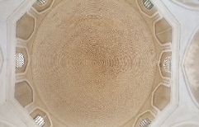 | 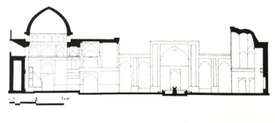 | Mir-emad Kashan | Seljuk / Kharazmshahi
1 skylight in 45° area | 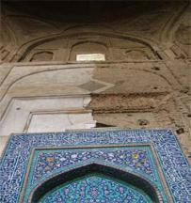 | 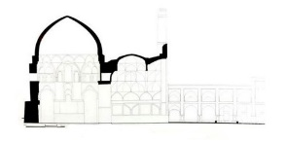 | Isfahan-Jame | Seljuk
4 skylights in 22.5°  Area | 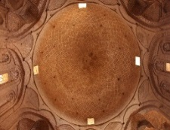 | 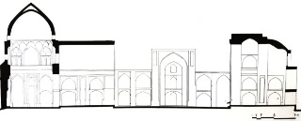 | Ardestan-Jame | Seljuk
4 skylights in 45° area | 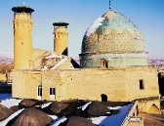 | 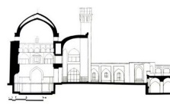 | Boroujerd-Jame | Seljuk
4 skylights in 22.5°  Area | 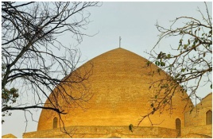 | 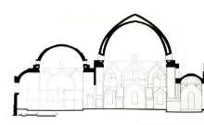 | Kaboud Tabriz | Timurid
4 skylights in 22.5°  Area | 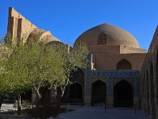 |  | Aqa-Noor Isfahan | Safavid
16 skylights in 45° area | 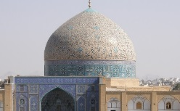 | 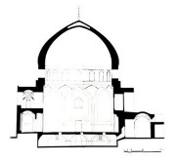 | Sheikh Loṭfollāh | Safavid
4 skylights in 22.5°  Area | 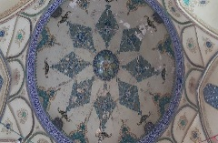 |  | Lenban Isfahan | Safavid
8 skylights in 45° area | 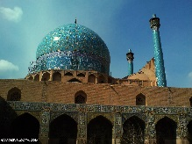 | 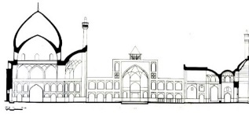 | Abbasi-Jame(Isfahan) | Safavid
16 skylights in 45° area | 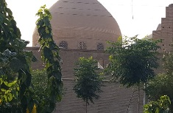 | 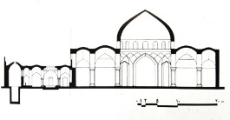 | Rahim Khan Isfahan | Qajar
4 skylights in 22.5°  Area | 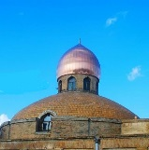 | 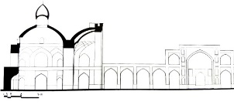 | Imam Boroujerd | Qajar
4 skylights in 22.5°  Area | 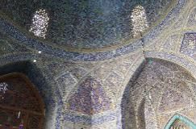 |  | Seyed-Isfahan | Qajar
12 skylights in 45° area | 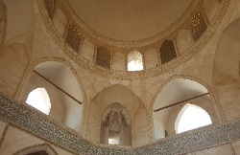 | 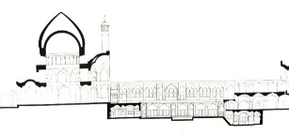 | Aqa-Bozorg Kashan | Qajar

Tables 2-1 and 2-2 investigate the domes in terms of the shells number to distinguish and describe the status of skylights in accordance with the shell type. From Table 2-1, it is stated that with the advancement of dome technology from the Seljuk to Qajar period, the evolution of skylights through domes has been improved as well.
In the sample domes, Sheikh Loṭfollāh Mosque with the bottom of 23 meters, the height of 26 meters from the surface and 9 meters from the crater, with a crater of 17 meters is the most significant dome. To strengthen this wide crater and increasing the number of skylights, the architect considered the thickness of 170 centimeters. This thickness has made it possible to place 16 lighters with an area of 32 square meters at 45° areas. In contrast, in the Lenban mosque, which the thickness has reduced to 65 centimeters, the total area of the skylights has increased to 140 centimeters (4 skylights of 35 centimeters). Examining the one-shell dome stated that:
1. By the evolution of the dome, the arc and crater of the dome have increased relatively.
2. Due to the increase in height and crater, the exposure need to space has increased and for this purpose, the thickness has increased relatively.
3. The area of skylights has increased significantly, especially in the Safavid dynasty.
4. The area of the skylights in 45° areas is higher than the 22.5° area. This area differs between 120 centimeters (Isfahan-Jame) to 56 meters (Aqa-Noor Isfahan).
Table 2-1: Position of skylights in one-shell domes based on the construction instruments.
Mosque | Effective components in the position of the skylight in the dome |  |  |  |  | Position of the Skylight on the dome and their Specifications
Mosque | Height from the crater | Dimensions of the bottom | crater | Thickness | Dome slope | Skylight  numbers | Skylight position | Skylight area
Mir-Emad | 4.2 | 8.5 | 6.9 | 0.07 | 0.60 | 8 | 45° area | 6.4
Isfahan-Jame | 8.3 | 17.2 | 14.1 | 1 | 0.58 | 1 | 45° area | 1.2
Aqa-Noor Isfahan | 5 | 12 | 9 | 0.60 | 0.55 | 4 | 22.5° area | 56
Sheikh Loṭfollāh | 9.8 | 23.8 | 17.6 | 1.75 | 0.55 | 16 | 45° area | 32
Lenban Isfahan | 4.3 | 11 | 8.5 | 0.65 | 0.50 | 4 | 22.5° area | 1.4
Rahim Khan Isfahan | 6.5 | 14 | 12.85 | 1 | 0.50 | 16 | 45° area | 36
Imam Boroujerd | 4.45 | 16.1 | 12.2 | 1.4 | 0.36 | 4 | 22.5° area | 7.2
Seyed-Isfahan | 4.8 | 11.5 | 10 | 1.1 | 0.48 | 2 | 22.5° area | 4.4

Table 2-2 examines two-shell domes. The status of skylights is analyzed in 6 domes of two-shells domes (normal and detached). Among two-shells domes, the dome of the Abbasi Mosque with a dimension of the bottom of 26.30 meters, the height of 52 meters from the surface and 27 meters from the crater and crater approximately 23.50 meters is the most significant dome. To strengthen this wide crater and increasing the number of skylights, the architect considered the thickness of 280 centimeters. This thickness has made it possible to place 8 lighters with an area of 6.50 square meters at 45° areas. In contrast, in the Bersian Jame-mosque, which the thickness has reduced to 90 centimeters, the total area of the skylights has increased to 80 centimeters (2 skylights of 40 centimeters). By Examining the two-shell dome it is stated that:
1. The dimensions of the bottom and crater of the dome have increased.
2. The height of the dome from the surface has increased.
3. Compared to one-shell domes, the height of the dome from the crater has also significantly increased.
4. Due to the increase in the crater of the dome, the thickness has also increased.
5. Studies indicated that the thickness, the number and surface of the skylights in the detached two-shells domes has increased compared to normal two-shells domes.
6- The number of skylights has not enhanced, but the overall area has increased significantly.
Table 2-2: Position of skylights in two-shell domes based on the construction instruments.
Mosque | Effective components in the position of the skylight in the dome |  |  |  |  | Position of the Skylight on the dome and their Specifications
Mosque | Height from the crater | Dimensions of the bottom | crater | Thickness | Dome slope | Skylight  numbers | Skylight position | Skylight area
Ardestan | 6.1 | 11.60 | 9.33 | 0.09 | 0.65 | 4 | 22.5° area | 1.2
Boroujerd-Jame | 4.7 | 9 | 8 | 0.08 | 0.58 | 4 | 45° area | 56
Kaboud Tabriz | 9 | 19.50 | 15.50 | 1.40 | 0.58 | 4 | 22.5° area | 32
Abbasi-Jame | 27 | 26.30 | 23.50 | 2.80 | 0.57 | 8 | 45° area | 1.4
Aqa-Bozorg | 11.80 | 14 | 10 | 1.60 | 0.60 | 12 | 45° area | 36

6. RESULTS
Samples analysis indicated that the skylights number was not a criterion in the lighting through the dome and their area was essential. The findings revealed that at 22.5° area skylight numbers were not more than 4 (Compare Tables). Obviously in two-shell domes, lightning is possible only through 45° areas due to their particular shape (see Table 2-1). For the same reasons, the area of the skylights used in 45° areas was more than 22.5° area and has been increased over time. (Compare tables 1-1, 2-1 and compare charts 1 and 2).
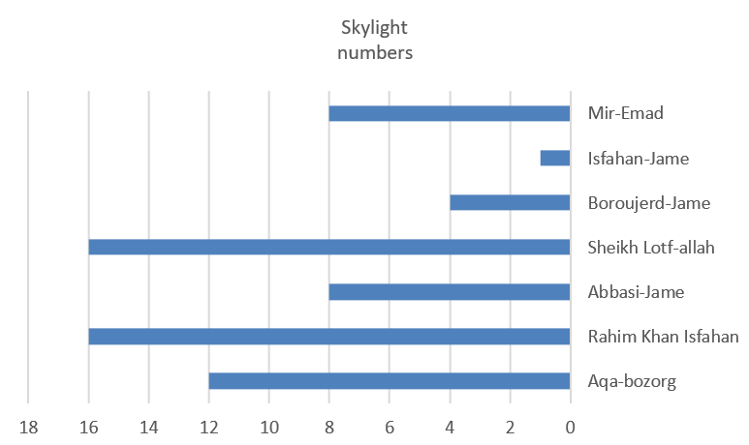Chart 1: The skylights number at 22.5° area | 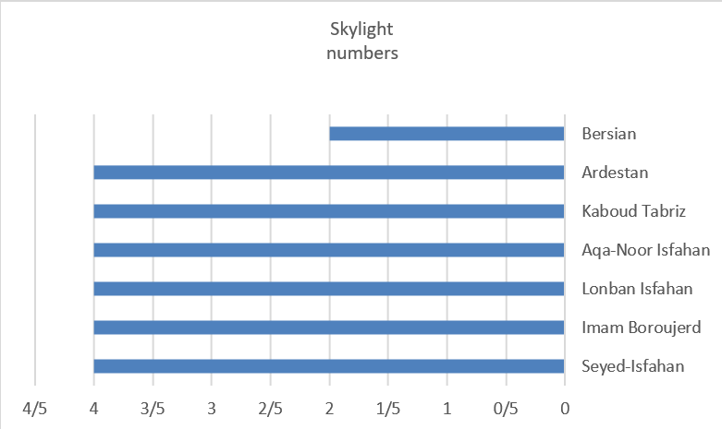Chart 2: The skylights number at 45°area
The thickness has a direct relation to the dimensions of the skylights. For example, the area of 52 meters of skylights in the Abbasi-Jame mosque with a thickness of 280 cm and a 140 cm of skylights in a Lenban mosque with a thickness of 65 cm.
Depending on the dome evolution from the Seljuk to Qajar era, the ratio of the crater to the height of the dome (slope) has increased (compare the tables). The dome slope, which is one of the important components in the position of skylight, differs from 36 cm in the dome of Boroujerd Jame-mosque to 65 cm in the Bersian Jame-mosque.

Chart 3: The evolution of dome slope from Seljuk to Qajar era in study samples.

7. CONCLUSIONS
Iranian architects by the full knowledge of geometry employed various solutions for the entrance light into the dome, in order to present the best possible quality in lighting; In response to the two main questions in the research:
- What principles have existed in the skylight position in the dome?
- How lighting was carried out through the one-shell and two-shell domes?
It should be noted that in the creation of skylights special attention were paid to the geometry of the dome as well as to the tensile and compressive forces. In these shells, which are symmetrical about their axes, the meridian and orbital forces are the main loading controller factors in the domes (Fig. 2; right). Meanwhile, there are four points of tensile-compressive-tensile-compressive forces (Fig. 2; left) from 22.5° area to 90° area. The results stated that in one-shell domes, compared to two-shell domes, the number of skylights was reduced due to the presence of tensile forces and low thickness of the shell.

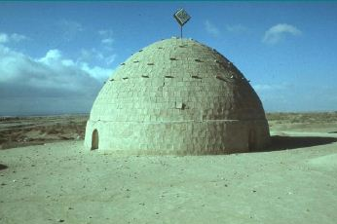 | 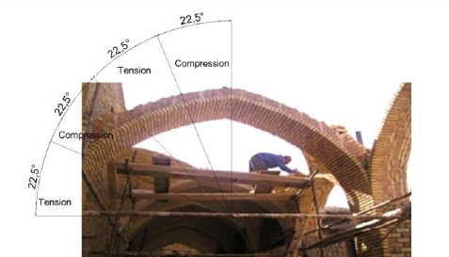

Fig. 2. Right: the meridian and orbital forces in Ashkezar-Jame mosque, left: Kashan; Division of tensile and compression forces in the arches.
Also, studies have shown a meaningful relationship between the length of the crater and the thickness with the number and dimensions of the skylights. As the dome height increases, the thickness enhances and the possibility of creating skylight and extending its dimensions are provided. Also by increasing the dome size, the area of skylights has been increased, as well. In relation to the dome height, according to studies, as the dome slope decreases, the numbers of skylights decreased relatively and moreover are existed in 22.5° area.
REFRENCES
[1] Farabi, M.i.M.F., Ahsa-al-alum. 2002. 75-93.
[2] Zargar, A., A Guide For Mosque Architecture. Tehran: Did, 2007.
[3] Pop, A.A., Persian Architecture. 1971: Farhangan Publishing House.
[4] Mahdavinejad, M. and S. Matoor, The Quality of Light-Openings in Iranian Domes (With the Structural Approach). Naqshejahan- Basic studies and New Technologies of Architecture and Planning, 2012. 2(2): p. 31-42.
[5] Nazer, z., S. Balali, and M. Keynejad, Evaluation of semantic transparency of domes in mosques with an emphasis on spatial lighting performance. Quarterly Journal of Architectural Research, 2014. No. 12: p. 94-112.
[6] Memarian, g., sazeye taghi. Vol. 1. 1988, tehran: Jahad Publishing University, Iran University of Science & Technology.
[7] Kasreian, n. and k. Afsharnaderi, iranian architecture. 2002, tehran: agah.
[8] Zarkesh, A. Space and structure compatibility in the architecture of Islamic mosques in Iran, in The 2nd International Conference on Architecture of the Mosques; Future Horizons. . 2001: kashan.
[9] Clarke, R. and M. Paus, The nature of architecture. 1996: Khak publishing.
[10] Bemanian, M. and M. Alinasab, Investigating the Role of Light in Explaining the Sequence of the Architectural Space of Mosques; Case Study: Shaikh Lotfi Mosque. Art research, 2014. 3: p. 71-82.
[11] Tamleh, H. and A. Chutarat, Poetry of daylight in Islamic architecture in Iran. Proc. Lux Pacifica, 2013, 2013. 7: p. 282-290.
[12] Pirnia, M. K, Dome in Iranian architecture. Vol. 12. 1991: Organization of cultural heritage, culture and tourism.
[13] Zemorshedi, H., Dome and Iranian Vaulted Elements. 2010, Tehran: Time Publishing.
[14] vahdattalab, m. and E. Rezaeizadeh, Dome morphology; A study on aesthetic proportions and distribution of domes of mosques in central plateau of Iran. Islamic Architecture & Urban Planning Firoozeh Islam, 2014. 2: p. 109-122.
[15} Golabchi, M. and A. javani, Technological architecture of Iran, ed. f. editor. 2013, Tehran: Tehran University Press.
[16] Mahdavinejad, M., M. Aliabadi, and E. Ghasemi, The evolution of Iranian domes from ancient to Qajar, in The first conference of technology and traditional structures with dome axes. 2013: Tehran.
[17] Hejazi, M. and M. Mirgardi, Seismic Analysis of Iranian Historical Domes. Journal of Technical College of Tehran University, 2004. 38: p. 757-747.
[18] Hejazi, M., S. Baranizadeh, and M. Daei, Optimal shape, failure times and buckling times of Iranian historical brick domes, Residential and rural environment quarters. Islamic Revolution Housing Foundation, 2016. 35: p. 61-67.
[19] Bemanian, M. and F. Nicodel, Investigation of Lighting and Lighting Methods in Qajar Period in Tehran. Islamic Architecture Research. The first year, 2014: p. 60-74.
[20] Bemanian, M. and S. Mohamadi, Study the position of the dome in the physical patterns of contemporary mosques. Naghshe-jahan, 2014: p. 7-16.
[21] Gorgani, N., The history of light in architecture and lighting fixtures in Islamic art of Iran. asar, 2002(35): p. 316-323.
[22] Mahdavinejad, M., S. Matoor, and A. Doroodgar, Recognition of light-openings in Iranian mosques’ domes With reference to climatic properties. Iran University of Science & Technology, 2011. 21(2): p. 61-68.
[23] Danaeinia, A. and S. Korsavi, Techniques to carry weight loads and resist against bending in conical shells, cases in Kashan. Iran University of Science & Technology, 2017. 27(1): p. 9-18.
[24] Ashkan, M., Y. Ahmad, and E. Arbi, Pointed dome architecture in the middle east and central Asia: evolution, definitions of morphology, and typologies. International Journal of Architectural Heritage, 2012. 6(1): p. 46-61.
[25] Baratta, A. Masonry domes: Equilibrium states and structural assessment. in WSEAS International Conference. Proceedings. Recent Advances in Computer Engineering Series. 2013. WSEAS.
[26] Reisi, M. and M. Azad, Dome in Iranian Architecture (Structural Effect in the Formation of the Architectural Effect, in The first conference of architecture. University of Tehran. 2007: Tehran.
[27] Arjmandi, H., M. Tahir, and M. Shabani, Application of transparency to increase day lighting level of interior spaces in the dwelling apartments in Tehran–A lesson from Iranian traditional architecture. Editorial Board/Sidang Editor, 2010.
[28] Panahiazar, S. and M. Matkan, Qualitative and quantitative analysis of natural light in the dome of San Lorenzo, Turin. Frontiers of Architectural Research, 2018. 7(1): p. 25-36.
[29] Nosratabadi, H., H. Noormohamadzade, and s. Omidvari, reflections on the physics of light entry into the quality of home space(case study:the Qajar houses in Yazd), in 3rd international conference on new research achievements in civil engineering , architecture and urban management. 2016.
[30] Lorzade, H., The Advent of Traditional Iranian Architecture in the Memoirs of Professor Hossein Lorzadeh Molly Publishing, 2005.

Corresponding Author, danaeinia@kashanu.ac.ir
. The sciences of account, geometry, light, astronomy, music, mass science and mechanics, which have theoretical and practical sciences each, are seven sciences that Farabi divides the science of teachings based on them.
. In Islamic Architects of Iran, it is used among the applied meanings for the space (such as the separation space of the Imam and the worshipers; Maghsoureh is referred to as the dome of the mosque, which is one of the main organs in Iranian mosques.
. In Iranian architects, the types of forces that are existed in the building are not visible and are in opposition in their stand-up, called sword forces (such as tensile, compressive, flexural and shear forces); However, parts that are designed to confront and direct these forces are said to be Tangodaz (such as backpacks, crashes, and porch).

