Making Balance between Optimum Daylight and Maximum Thermal Comfort in hot-humid climates
Case Study: Rashidy historic mansion in Bushehr city, Iran

1. Fatemeh Mehdizadeh Saradj
Associate professor, the school of Architecture and Environmental Design, Iran University of Science and Technology.

Narmak-Tehran
Po.Code: 1684613114
Phone: 0098 (21) 77240450-9 (Ext: 3249)
Fax: 0098 (21) 77240468
Email: f.mehdizadeh@gmail.com
University Email: mehdizadeh@iust.ac.ir
2. Amin alah Ahadi (corresponding author)
Master student of Architecture, the school of Architecture and Environmental Design, Iran University of Science and Technology.
Ponak-Tehran
Po.Code: 1476943955
Phone: 0098 (21) 44482677
Mobile Number: 0098 9132107673
Email: ahadi6688@yahoo.com (For correspondence)
University Email: amin_ahadi@arch.iust.ac.ir

3. Nader Maleki
Master student of Architecture, the school of Architecture and Environmental Design, Iran University of Science and Technology.
Hosein abad-esfahan
Po.Code: 8471835781
Phone: 0098 (311) 4702049
Email: nadermaleki.architect@yahoo.com

Abstract
Day lighting is one of the important qualitative factors in housing, which is also effective on health and well-being of occupants. Extensive glass surfaces and Transparency in building facades provides good daylight quantity for interior spaces. However, this lighting system is not appropriate for climates faced with higher sunlight radiation (Such as hot-humid areas), due to overheating and disturbing the thermal comfort. There are efficient day lighting strategies in the traditional Iranian architecture as one of the valuable remaining heritages of Human experiences, which are useful for today architecture.
This article intends to investigate daylight quality in the houses of Bushehr from Qajar period by modeling and simulating in a daylight calculation software (Dialux) and identify day lighting strategies utilized in these houses. As Bushehr city is located in the hot-humid region of Iran, is faced with high sunlight radiation, making balance between receiving light and heat gain through windows needs careful attention.
The houses of Qajar period in Bushehr are evolved samples of traditional architecture in the city and Rashidy house (built in 1893) is one of them which its form and details can reveal many lessons on coping with climate by merely using renewable energies.

Key words: Daylight, Traditional Iranian architecture, hot-humid climate, thermal comfort, Bushehr Rashidy house.

1. INTRODUCTION

Quality of the human residential environment has influential effect on the health of residents. Health is a state of complete physical, mental and social well-being and not merely the absence of disease or infirmity [1]. A large number of researches into the field of health psychology have been shown a direct relationship between human residential environment quality and social harm, such as suicide, mental disorders, divorce, addiction and crime [2]. One of these important qualitative factors is day lighting. Being exposure to adequate daylight is quite effective on healthiness and well-being. Extensive glass surfaces and transparency in building facades provide adequate day light for interior spaces. However this day lighting system could not be suitable for the climates faced with high sunlight radiation (Such as hot and humid), due to overheating and disturbing the thermal comfort. The study of remaining architectural heritage is useful for finding efficient day lighting strategy for today architecture. In fact, heritage is beyond than the building, time or place that is the historical reference [3]. Traditional Iranian architecture by using efficient solutions in different climates has been harmonized with climatic conditions. The bases of Iranian architecture are strongly impartible from the environment and are taken from nature and its powers, which are light, water, wind, and soil [4]. The traditional architecture of Bushehr city (which is located in hot and humid climate) in Qajar era (1785–1925) as the result of long experiences of the past heritages is one of the glowing samples. Due to the political and economic development in Bushehr port, during Qajar period, the architecture of the city developed and improved [5]. The traditional architecture of Bushehr city has been formed by considering all factors such as climatic, social, cultural, aesthetic, and the relationship between human and environment [6]. Due to the warm and humid climatic conditions of Bushehr city, most researches and studies have been mostly studied about the natural ventilation, and little attention has been paid to the day lighting aspect. This research is specifically aims to answer these questions: How is the quality of day lighting in the traditional houses of Bushehr? What are the day lighting strategies in these houses considering warm and humid climatic conditions of Bushehr city? And finally, whether these strategies are usable in today architecture?

1-1. The study area
In this paper, to assess the daylight quality in Iranian traditional houses in warm and humid climates, the Bushehr houses from Qajar period have been selected. These houses are relatively evolved samples of traditional architecture in this climate. Among them, Rashidy house as one of the indicator houses has been studied as a case study.

1-2. Methodology and data collection methods
Initially, the importance of day lighting and its impact upon human health and also appropriate day lighting characteristics have been investigated through previous researches. Then, daylight quality in Bushehr Rashidy house (as a case study) has been assessed by computer modeling in daylight simulation software (Dialux). Modeling required data, such as dimensions and construction materials, has been obtained through direct measurements in Rashidy house. Finally, the utilized day lighting strategies in this house have been identified. Moreover, the compatibility of these natural lighting strategies with the thermal comfort of occupants has been shown using the Autodesk Ecotect analysis software. Therefore, the research methodology of this article is descriptive analysis and computer modeling based on a case study.

2. The Impact of day lighting on human health
Day lighting is efficient on health and well-being of people from various points of view. Some of the physiological and psychological effects are as follows.
There are several rigorous studies that clearly show the daylight positive effects on improving mood and emotional well-being [7, 8]. Furthermore, in office environments, daylight helps people to be in a good mood and improves the feeling of being comfortable, mentally and physically as well as improving job performance and satisfaction [9]. The result of studies shows that the exposure to natural bright light is quite effective in reducing depression [10].
Daylight is effective on body’s circadian rhythm (biological events that repeat themselves at regular intervals). Lack of coordination between circadian rhythm of body and human activities cause a feeling of being bored, tired, and distracted. Body’s circadian rhythm is controlled by light hitting the retina and then affecting the hypothalamus gland and adjusting the emission of melatonin. Melatonin is secreted in darkness, and the light decreases melatonin levels. Inappropriate day lighting causes the imbalance in the secretion of melatonin and therefore, the feeling of depression and sleep disorder [11].

3. Appropriate daylight Specifications
Daylight is the combination of sunlight, skylight and reflected light from the ground. Skylight is the light which is scattered by the molecules of air, aerosols and particles such as water droplets in clouds in the atmosphere; excludes direct beam [12]. The natural brightness of spaces can be provided through direct sunlight, skylight or a combination of them. In warm climates where sunlight can cause heat generation, which is leading towards thermal comfort disruption, the different way is applied to prevent the direct sunlight from entering inside the buildings [13]. Therefore, in this climate (hot and humid climate, the case of this paper), the solution utilizes daylight, while avoiding the direct sunlight from entering into the buildings and yet using the maximum skylight and reflected light from the ground.
Efficient factors on the amount of daylight in a building are as follows: latitude and longitude, form, location, landscape, orientation, function, joinery construction materials of interior walls and exterior facades, window size and position, window components (such as the glass ratio, glazing materials and shading devices) [12].
A Current method to calculate the amount of daylight luminance is using daylight factor (DF). DF is a ratio of interior luminance to the outdoor luminance which is different from one building to another according to their function [14]. The other definition states that DF is the received illuminance at an interior space from a sky with a certain luminance distribution, [12]. If the rate of daylight factors is below 2%, the space appears to be dark and depressed and often requires the use of electric lighting during the daytime and electric lighting dominates daytime appearance. If the value of the daylight factor is between 2% and 5%, windows have provided considerable daylight, but still sometimes supplementary electric lighting is needed, and if the daylight factor is 5% or more, there would be enough light into the room and daytime electric lighting rarely needed [15]. In other researches, areas with DF under 1% are unacceptably dark with no potential to take advantage of natural light. For spaces with daylight average 1% to 2%, a potential exists in the use of daylight, which is the minimum acceptable daylight. Daylight average value of 2.5% provides a large potential for daylight utilization that is preferable, and the DF value of 5% is ideal in the study, too bright for computer work and there is total daylight autonomy [16]. Furthermore, there are standard values of DF for different functions (table 1).

Table 1. DF standard value for some of the different functions [17]
Appropriate Average daylight factor (%) | Functions
Schools and colleges
5 | Classrooms, Laboratories, Art rooms and Staffrooms
1 | Assembly halls
Banks
5 | Counters, typing, accounting book areas
in different functions
2 | Circulation areas and Stairs
2 | Reception areas
Hospitals
5 | Wards, Reading and reference rooms and Pharmacies
2 | Reception and waiting rooms
Domestic functions
5 | Kitchens
1 | Bedrooms
1.5 | Living room, lounges and multi-purpose rooms
5 | Reading and work rooms

The equation (1) is used to calculate the daylight average value (equation 1) [18]. The equation (2) is used to calculate the coefficient of reflectance of the interior surfaces [18]. Table (2) specifies the definition of terms in equations 1 and 2.

Equation 1. [18]
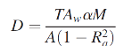

Equation 2. [18]
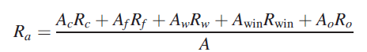

Table 2. Definition of terms in equations 1 and 2 [18]

Units | Definition | Symbol
Dimensionless | Average daylight factor | D
Dimensionless | Diffuse transmittance of the glazing material | T
m2 | Net glazed area of the window | Aw
Degrees | Vertical angle subtended by sky that is visible from the centre of the window | α
Dimensionless | Maintenance factor (upkeep of Window) | M
m2 | Total area of the internal surfaces | A
Dimensionless | Area-weighted average reflectance of the interior surfaces (including glazing) | Rα
Dimensionless | Reflectance of ceiling | Rc
Dimensionless | Reflectance of floor | Rf
Dimensionless | Average reflectance of obstructions | Ro
Dimensionless | Reflectance of unobstructed wall | Rw
Dimensionless | Reflectance of windows | Rwin
m2 | Area of ceiling | Ac
m2 | Area of floor | Af
m2 | Area of obstructions | Ao
m2 | Area of unobstructed walls | Aw

4. Bushehr city, Bushehr Qajar architecture and Bushehr Rashidy house

Bushehr area of ​​approximately 5/994 square kilometers is located on the southwest of Iran. The city is at latitude 28 degrees, 59 minutes, 30 seconds north and longitude 50 degrees, 51 minutes, 15 seconds east. The area’s proximity to the equator and low overall height causes the warm and humid climate. Bushehr is one of the important ports in Persian Gulf.

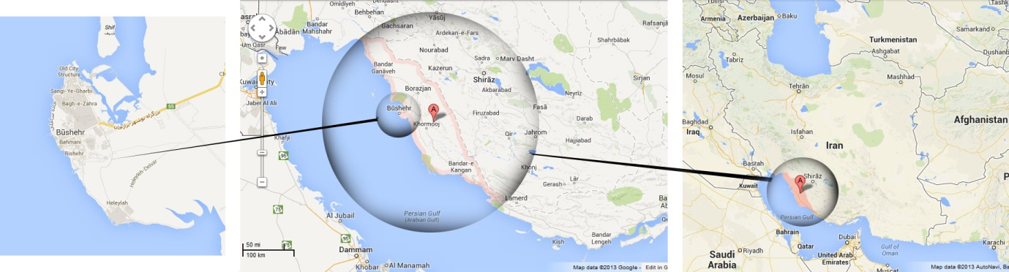

Figure 1. Position map of Bushehr (retrieved from Google map).

Bushehr climate zone is the relatively long and narrow coastal strip with more than 2000 km length that starts from the beginning of Arvand River (southwestern of Khuzestan province) and ends in the Goiter Bay (southeastern Sistan and Baluchistan province). In this area, the rate of annual rainfall is very low, most of the rainfall is in autumn and especially in winter, and the humidity is very high in all seasons. The weather is very hot and humid during summer and the winter is mild. Temperature difference between night and day is low. Vegetation cover is very low and sun radiation in spring and summer is almost vertical [19].

Bushehr architecture of the Qajar periods (1785–1925) differs from it’s before and after. In this era, Bushehr was the country’s most important port in the southern coast and was an important commercial, cultural and political center. Trade and economic growth, cultural prosperity and political significance of the Bushehr region during Qajar period, had a lasting influence in the architecture of the city [5]. Moreover, in this era, the reflection of climatic and geographical characteristics in Bushehr architecture is evident. The architectural features of Bushehr during the Qajar period are as follows: the central courtyard form, the utilization of shades and wind, increasing the height to provide passages with shadow of adjacent buildings, the use of multiple openings, multi-storey buildings, the use of spring house and Khazyneh, the existence of water reservoirs, the plaster decorations, and mirror works, colored glass in sash lattice windows (figure 2), Taremeh (a type of porch), Shenashil (figure 3), louvered window (figure 4) and wind catcher [5].

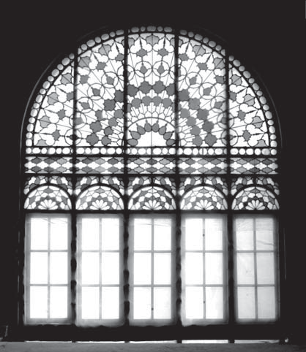
Figure 2. Sash window [20].

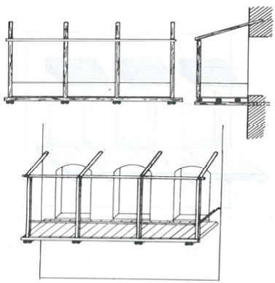
Figure 3. Shenashil [21].

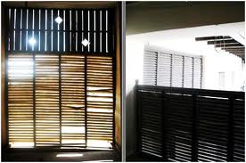
Figure 4. Bushehr louvered window [22].

The Qajar architectural evolution in the central courtyard houses because of increasing the number of openings, leads to further transparency in façade that had not been seen before [23]. In the last century, due to natural and human factors, rapid urban development and political and economic changes, many magnificent monuments of that period have been destroyed or abandoned dilapidated [5]. Rashidy house (built in 1893) is one of the remnants of mansion homes from the Qajar era (figure 5). Plans, elevations and sections of Rashidy house have been measured by authors and are presented in Figure 6 and 7.

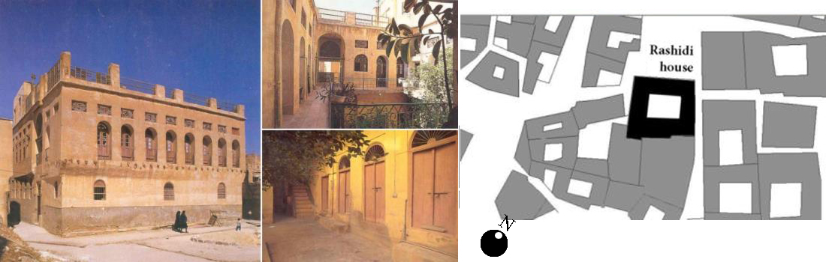

Figure 5. Rashidy mansion home [22].

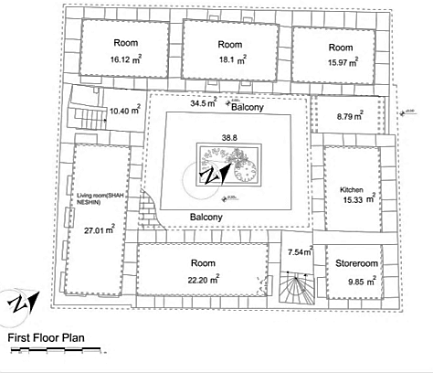
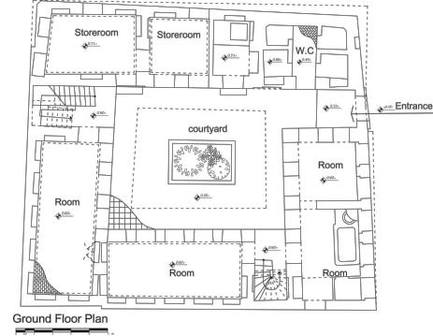

Figure 6. plan of Rashidy mansion home (drawn by authors). The building land area is ​​324 square meters, and floors area is 570 square meters, and the building occupancy is 88%.

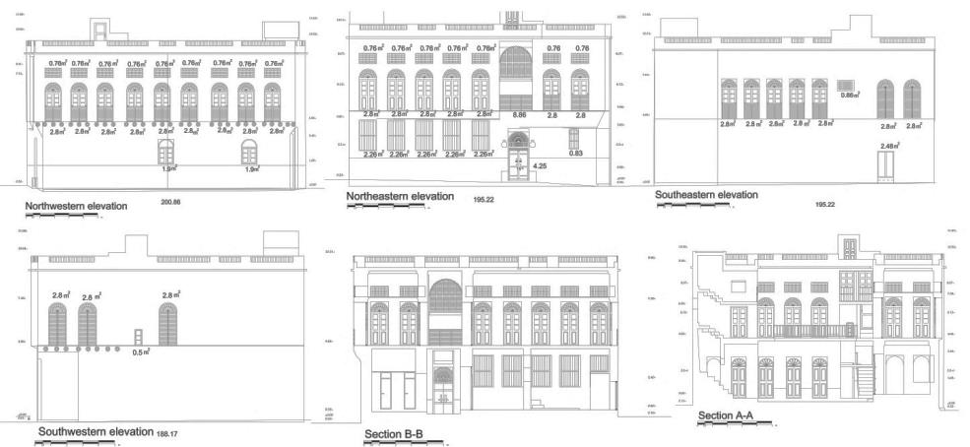

Figure 7. Elevations and sections of Rashidy house (drawn by authors).

5. The modeling and computer simulation of Rashidy house in daylight computing software (Dialux)

Considering the sizes of measured rooms and windows, joinery materials (white chalk), Bushehr geography (latitude and longitude), surrounding structures and obstacles, and around 65% transparency coefficient according to the type of glass used in building construction and structure orientation, Rashidy mansion home has been modeled in daylight computing software (Dialux) (details of modeling and outputs of the software for all parts of the house are available in Appendix 1). Figure 8 shows mean values for daylight factor (DF) in different spaces of the ground floor and daylight distribution from the level of one meter in height. Figure 9 shows the same matters on the first floor.

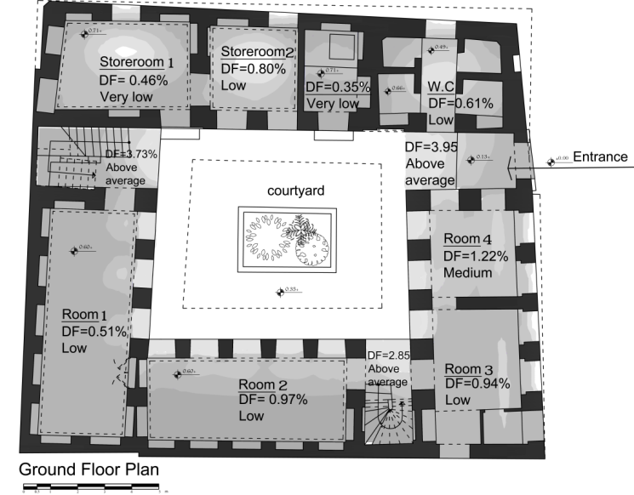
Figure 8. Mean values for daylight factor (DF) and daylight distribution in different spaces of the ground floor from the palm of one meter in height (retrieved from Dialux software calculation).

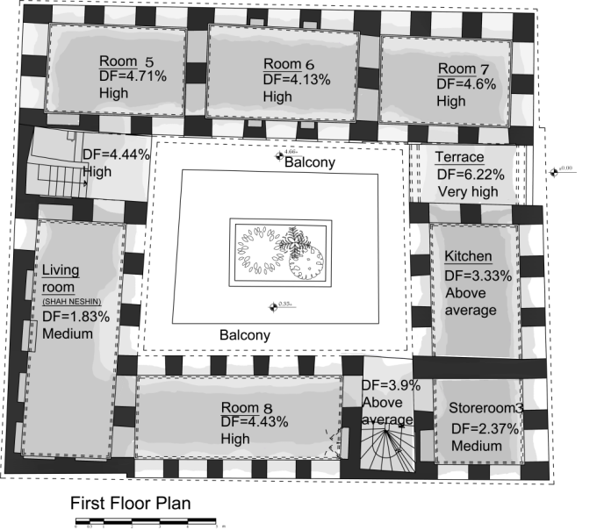
Figure 9. Mean value of daylight factor (DF) and daylight distribution in different spaces of the first floor from the palm of one meter in height (retrieved from Dialux software calculation).

The values of daylight factor in figures 8 and 9 have been re-evaluated by equations 1 and 2 that have been shown in Table 3 (details on the calculations can be realized in appendix 2).

Table 3. Comparison of obtained DF of Rashidy house spaces by calculation with equation 1 and 2 and analysis of Dialux software. The results obtained from the software and calculation with equation, approximately are in a same range.

comparison of results | result of calculation with equation | Dialux software analysis results | first floor spaces | comparison of results | result of calculation with equation | Dialux software analysis results | Ground floor spaces
Moderate in both | 3.07% | 2.37% | Storeroom 3 | very low in both | 0.51% | 0.46% | Storeroom 1
Above moderate in both | 3.79% | 3.33% | Kitchen | Low in both | 0.90% | 0.80% | Storeroom 2
High in both | 4.21% | 4.71% | Room 5 | very low in both | 0.74% | 0.51% | Room 1
In the above moderate range and high | 3.61% | 4.13% | Room 6 | Low in both | 1.38% | 0.97% | Room 2
High in both | 4.24% | 4.6% | Room 7 | Low in both | 1.40% | 0.94% | Room 3
High in both | 4.05% | 4.43% | Room 8 | Low in both | 1.97% | 1.22% | Room 4
In the moderate range and low | 1.1% | 1.83% | Living room | Low in both | 0.80% | 0.61% | W.C

With regard to the material in Section 3 and the results of computer modeling of Rashidy house, the value of daylight factor and distribution of daylight on the first floor including living room, dining room and kitchen is very suitable. In the first floor, rooms have the best daylight distribution and maximum DF (between 4 to 5 percent). Figure 10 shows one of these rooms. After rooms, kitchen with approximately 3% DF and living room with approximately 2% DF receive more daylight.

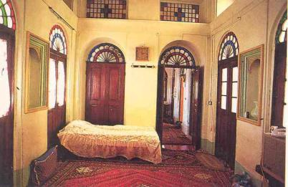

Figure 10. Quality and distributing of daylight in one of the first floor rooms of Rashidy house [22].

The situation of receiving daylight is different on the ground floor. In this floor, the average value of light (DF) is very low in most spaces, reducing under 0.5% in some places (except the courtyard and entrance space. The reason for the little light on the ground floor is that due to the hot-humid climate of Bushehr, and the need for airflow to achieve thermal comfort, the main spaces (such as rooms, kitchen and living room) are placed in the upper ground floor. In traditional homes of Bushehr such as Rashidy mansion, often the storage spaces, toilets, showers and rooms for short term accommodation are located in the ground floor, which do not need high daylight factor according to their nature of use. The next part will explain the solutions applied to the home for the optimum use of daylight.

6. Evaluation of thermal comfort and natural ventilation in Bushehr traditional houses

Bushehr is located in the hot and humid climate in all seasons with very high humidity, very hot weather in summer, the low temperature difference between night and day, and almost vertical solar radiation in the spring and summer [19]. However, the strategies adopted for receiving daylight and the characteristics of windows and openings is efficient on natural ventilation and the thermal comfort of interior spaces [12]. In this section, the thermal comfort of Rashidy traditional house of Bushehr has been analyzed by modeling in Autodesk Ecotect software. The following strategies have been used in homes to create thermal comfort, which were also effective on the quality of daylight inside spaces:
Central courtyard and the semi-introvert form
In Bushehr traditional houses, rooms are located around a central courtyard; the main difference between these central courtyards with similar buildings in the central plateau region of Iran is that despite being introverted, their relationship to the environment is not completely closed, and have tall windows and large porch facing the streets or fields, especially in the second and third floors of buildings [19]. Figure 5 shows these specifications in Rashidy mansion home. Also in these central courtyards due to hot-humid conditions, plants and trees are relatively small in size and pool was rarely used [21].

Maximum use of shadow and wind streams
In Bushehr traditional houses, bilateral ventilation (by opening windows facing the courtyard on one side and the other side towards the street) is used to alleviate the heat and intensive humidity [19]. Figure 11 shows this state in Rashidy house. Also Shenashil (figure 3) has been built to create shadow and wind stream.

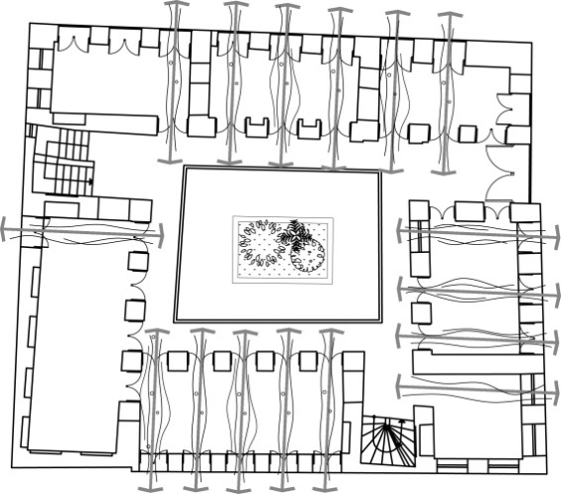

Figure 11. using double side ventilation in Rashidi house (the result of article process).

High ceiling of rooms and tall windows
The rooms’ height is built relatively higher than the other parts of Iran's climatic zones (4 meter or more), to be able to direct the risen hot air and reducing the temperature of the bottom. The windows near the ceiling on double sides, can evacuate the room from the warm air [19, 21]. In Rashidy house, first floor height is 4.60 meters (more than 4 meters), and ground floor height is 3.70 (nearly 4 meters). Also windows height is over 2 meters.
Wide and elevated porches
In this region, wide porches can be seen around the central courtyard in one or two sides. Most of the daily activities are done in these porches in warm seasons because of being in shadows and having adequate ventilation [19]. Figure 12 shows these porches in Rashidy house.
Non-residential spaces on the ground floor and the lack of basement
In the port of Bushehr, owing to the proximity with the sea and high groundwater level and humidity, the basement is not constructed. Also because of adequate natural ventilation and more privacy, the main living spaces (such as rooms, kitchen and living room) are placed in the upper ground floor [19, 21]. Figure 13 shows ground and first floor in Rashidy house.

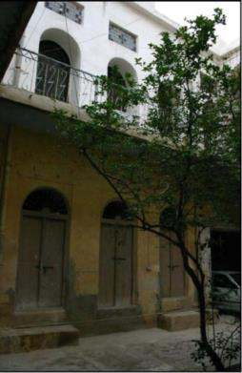
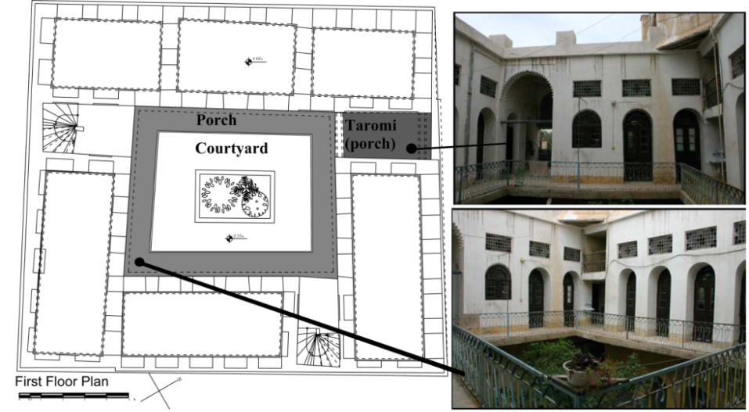

Figure 12. Using Wide porches around the central courtyard (authors).
Figure 13. Ground and first floor in Rashidy house (authors).

materials
In this region, the white plaster is mostly used for exterior walls due to its bright color. Moreover, for climatic reasons the use of materials with low thermal mass is appropriate. However, because of low vegetation in Bushehr and tending to use local material, bricks were usually used to build houses and wood was merely exploited in windows and structures [21, 19].

The results of computer modeling and simulation in Autodesk Ecotect analysis software to evaluate the thermal comfort in Rashidy House
Autodesk Ecotect analysis software is used to evaluate the thermal comfort in Rashidy house. The results indicate the proper behavior of Rashidy house in relation to the thermal comfort. Figure 14 shows the results of software analysis at the time of summer solstice (high heat) and figure 15 shows results of software analysis at the time of winter solstice. The results show that home heating zones at the time of winter solstice are in thermal comfort zone and the zone that are used in summer are approximately 5 degrees lower than environmental temperature in the hottest hours during the year that is appropriate as generally home heating zones are in the thermal comfort zone according to the images of software workspace and graphs related to Bushehr thermal comfort which are available in appendix 3.

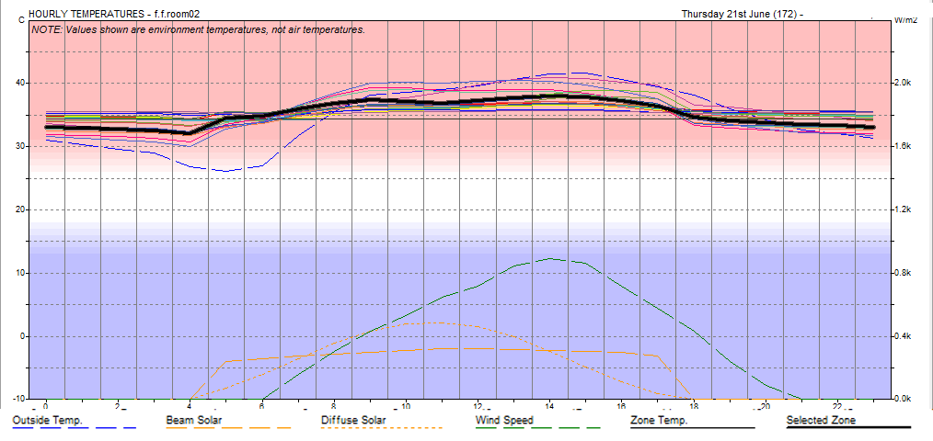

Figure 14. Results of Autodesk Ecotect analysis software 2011 during the summer solstice (authors). Dashed curve shows environmental temperature and bolded curves related to home heating zone that are used in summer (first floor) which are approximately 5 degrees lower than environmental temperature in the hottest hours of the year and that is appropriate.

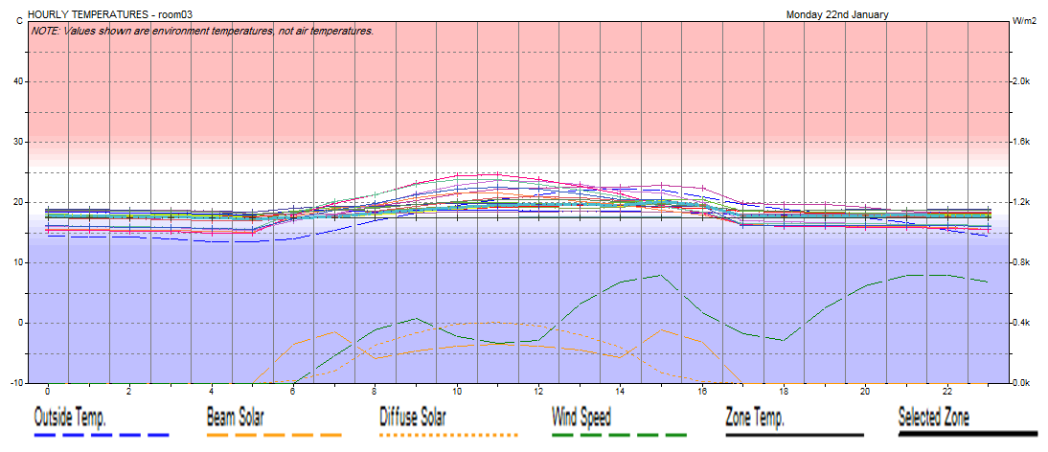

Figure 15. Results of Autodesk Ecotect analysis software 2011 at the time of winter solstice (authors). Dashed curve shows environmental temperature and other curves related to home heating zone which are in thermal comfort zone and that is appropriate.

7. Rashidy house daylighting strategies
To provide adequate daylight in a building, the following factors need to be considered: appropriate form, proper locating within the area, appropriate orientation, depth of the rooms, joinery construction materials, windows position and window glass surface details, windows components (such as glazing type, glazing ratio, light transmittance and shading devices), the size of indents, the effects of openings in a single architecture and the site characterizations [12]. These cases will be reviewed in the Rashidy home.

7-1. Building form and depth
Building form has a large impact on the mechanism of daylight and needs to be considered as a vital stage during the window design process. A major decision is whether to choose side light, skylight or a combination of both [12]. In Rashidy house and other traditional houses of Bushehr, rooms are located around a central courtyard to maximize shadow and reduce intensive heat. This makes possible to build more windows on the walls of central courtyard and more transparency (figure 16).

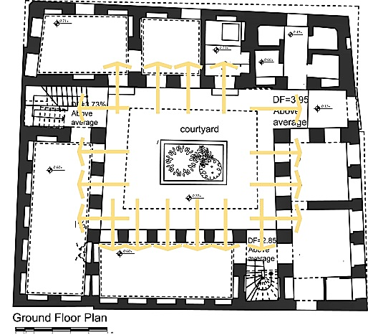
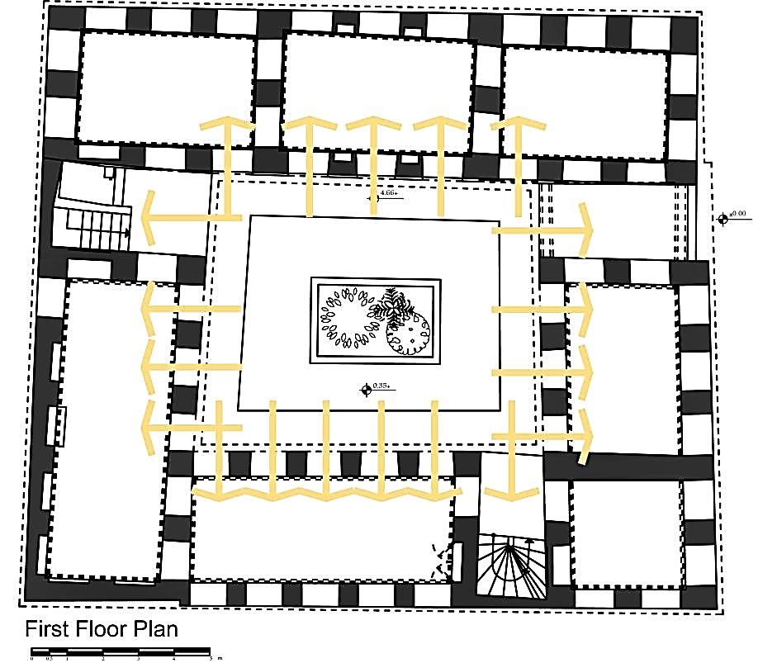

Figure 16. Impact of the central courtyard form on day lighting in Rashidy house (authors).

Furthermore, depth of rooms affects daylight quality in buildings. Daylight can penetrate about 6 m from the window at one side of elevation and rooms with more depth will look dark and gloomy [12]. In Rashidy house, most of the spaces have double side daylight and some of them receive daylight from three sides. The depth of windows is less than 3 meters, providing suitable light penetration.

7-2. Building site characteristics
Neighboring buildings and their shadows is very important for day lighting. The overall slope of the line that runs from the middle of the window section to the top of the light obstacle should not be greater than 25 degrees [15]. Figure 17 shows this condition in Rashidy house. Rashidy house and most of Bushehr traditional houses, are built as separate blocks and there are passageways surrounding the building for creating maximum air flow and also the possibility of receiving daylight from several directions (Figure 18).

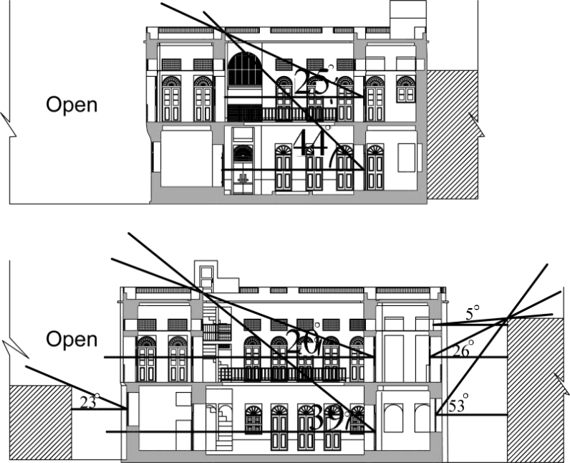

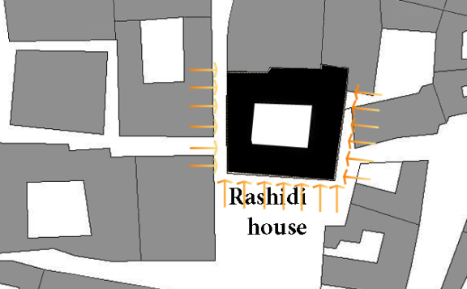

Figure 17. The line of shadow in transverse and longitudinal sections in Rashidy yard (authors). In first floor (main residential spaces), these angles are under 25 degrees and in ground floor is more than 25 degrees.
Figure 18. Receiving daylight from several directions (authors).

7-3. The construction material of joinery in interior walls
Darkness or brightness of finishing materials, especially roof cover, and the rate of light absorption or reflection by wall surfaces is effective on the distribution and utilization of daylight within a space [12]. To minimize the influence of thermal energy and at the same time taking advantage of natural light, it is recommended to use the joinery materials with the high maximum reflection coefficient [24]. Similarly the ceiling surface is also very important and then wall and floor surface are in next priorities [12]. Finishing material of interior and exterior surfaces of walls in Rashidy house and most of Bushehr traditional houses is plaster with bright color (usually white) (figure 5, 10, 12 and 13). The reflection coefficient of this material is 0.8 and is more effective in preventing the absorption of solar energy in hot-humid climate and increasing brightness inside and outside the building [25]. Moreover, the floor covering is often carpets and rugs with the reflection coefficient of 0.1, which is also considered in computer analysis.

7-4. Windows size, position and components
Window size determines the rate of daylight in rooms. Section 5 showed that windows size, and their glazing ratio in Rashidy house is appropriate in first floor according to the supply of daylight for interior spaces. In this house, ground floor windows area is 22.6 m² (7% of ground floor elevation area) and in first floor, the windows area is 89.94m² (26% of first floor elevation area). The important feature about the position of windows in this house is the arrangement of windows in all elevation surfaces which can result in uniform distribution of daylight in different spaces (figure 19).

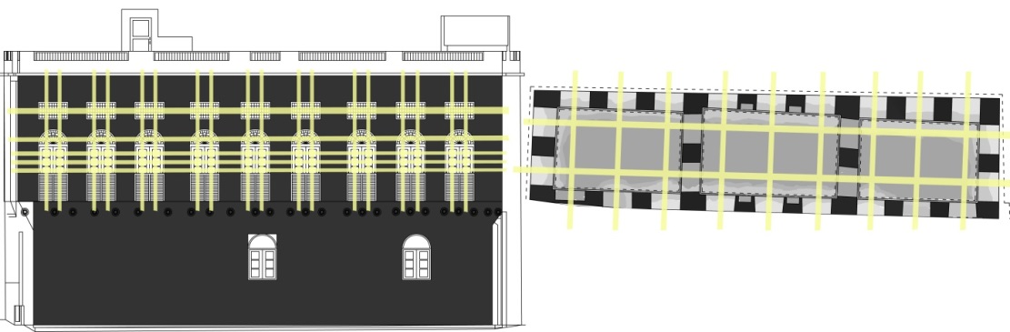
Figure 19. The arrangement of windows in all elevation surfaces and uniform daylight distribution and penetration in Rashidy house (authors).

Also, in order to prevent the entry of direct solar radiation and overheating, the following solutions are used: furnishing windows with shutters and louvers (figure 20), increasing the depth of windows (figure 21) and using colored glass in windows (figure 22).

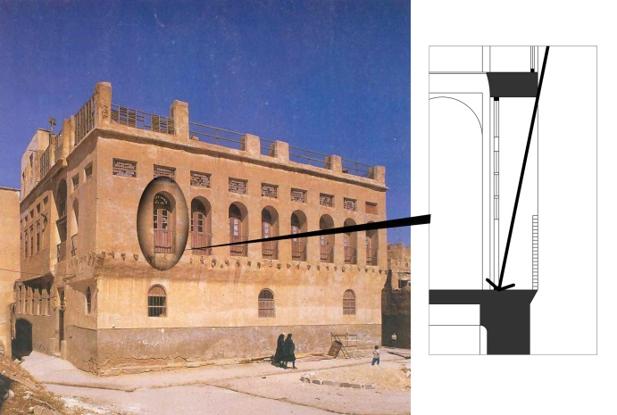
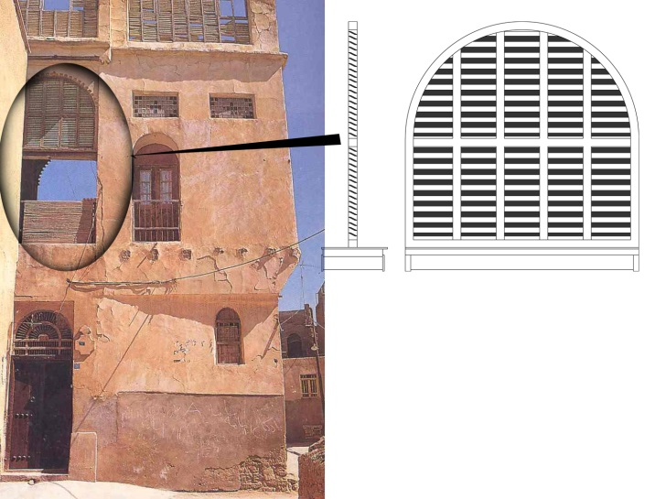

Figure 20. Windows with shutters and louvers in Rashidy house to prevent the entry of direct solar radiation (authors). Photo by [22].
Figure 21. Increasing the depth of the windows to prevent the entry of direct solar radiation in Rashidy house (authors), Photo by [22].

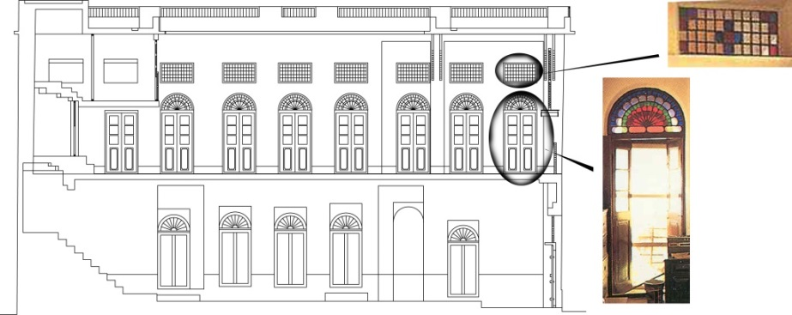
Figure 22. Windows with colored glass in Rashidy house, efficient in heat balance of interior spaces (authors). Photo by [22].

7. Conclusion

Given the importance of housing quality in daylight and its impact upon human health, and also the appropriate use of daylight in traditional Iranian architecture, especially in hot-humid climates of Iran, this article has investigated the quality and strategies of daylight in Rashidy house (as the case study of traditional houses of Bushehr city during Qajar era). It should be noted that there are many similarities between other traditional homes remained from the Qajar period and this house. First, the section 3 of the paper, has discussed the characteristics of appropriate daylight in housing, then Rashidy house plans, elevations and details of openings have been measured and recorded. Using these maps and considering the geographical conditions of Bushehr, type of materials used and building site characteristics, the average daylight factor (DF) and daylight distribution in different spaces of Rashidy house have been calculated by mathematical formula and also by modeling in daylight calculation software (Dialux). With respect to daylight standards referred to in section 3 of this article, the extent of daylight factor and distribution manner on the living spaces on the first floor (Include rooms, living room and kitchen), are desirable.
Based on modeling results, the average value of the daylight in rooms is 4 to 5 percent, in the kitchen over 3% and nearly 2% in the reception area which are all quite convenient. The average daylight factor on the ground floor is low and often below 1% and therefore, mostly non-residential spaces (such as storage spaces, bathrooms, shower rooms and temporary residence) are located on this floor due to high humidity and low air flow. The analysis of Autodesk Ecotect software proved that strategies for benefiting from daylight used in Rashidy house, in addition to providing adequate daylight, are in accordance with convenient thermal comfort in interior spaces as well.
The central courtyard form has the greatest impact upon the quality of daylight, by providing maximum shadow, which will in turn results in reducing intensive heat. Moreover, the transparency of walls is possible in courtyard forms, allows making more windows and openings.
The building proportion is also in a way that the courtyard dimensions and building height prevent from dark shadows in the yard. Furthermore, in Rashidy house and most of the other traditional houses of Bushehr, passageways surround the building to provide maximum air flow as well as making the possibility of receiving daylight from several directions. Another important factor is the type of finishing materials, which are bright-colored plasters in both inward and outward sides of these houses. Reflection coefficient of this material is 0.8 and is more effective in increasing brightness and also preventing the absorption of solar energy in this hot-humid climate. Moreover, the suitable dimensions of windows and their uniform distributions in all façades are the cause of balanced daylight spread in interior spaces. For example, 26% of the total area of the elevation in the first floor of Rashidy house is dedicated to windows, providing adequate daylight for spaces as shown throughout this paper. While other solutions applied to windows to prevent the entry of direct solar radiation and overheating of internal spaces such as shutters, increasing the depth of windows and colored glass.

8. References

[1] WHO (World Health Organization).: 1948, Constitution, Geneva: World Health Organization.
[2] Barrett, F. R.: 2000, Disease and geography: The history of anidea, Toronto, Ontario: York University Atkinson College.
[3] Edson, G.: 2004, Heritage: Pride or passion, product or service?, International Journal of Heritage Studies, 10(4): 333-348.
[4] Ahmadi, F.: 1993, Sustainable Architecture (in Farsi), Abady journal, 41(7):94-96.
[5] Gholamzade, Faraz.: 2013, Architecture of Bushehr in Zand and Qajar era (in Farsi), Tehran: abad boom press.
[6] Ghafari, A., Takapomanesh, S., Shahin, A., Tahbaz, M.: 2002, Research project of school patterns in hot-humid climates (in Farsi), Tehran: state organization of schools renovation, development and mobilization.
[7] Kellert, S., Heerwagen, J., Mador, M.: 2008, Biophilic design: the theory, science and practice of bringing buildings to life, New jersey: John Wiley & Sons.
[8] Wasserman, Danuta.: 2011, Depression, UK: Oxford University Press.
[9] Augustin, Sully.: 2009, Place Advantage: Applied Psychology for Interior Architecture. New Jersey: John Wiley & sons, Inc.
[10] McCullough, Cynthia.: 2010, Evidence based design for healthcare facilities, US: Renee Wilmeth.
[11] Lewy, A. J., Nurnberger, J. I., Wehr, T. A., Pack, D., Becker, L. E, Powell, R. L.: 1985, Supersensitivity to light: Possible trait marker for manic-depressive illness, American Journal of Psychiatry, 142(6): 720-727.
[12] CIBSE (Chartered Institution of Building Services Engineers).: 1999, Daylighting and window design, London: CIBSE.
[13] Watson, D.: 2008, Climatic Design. Translated in persian by: Ghobadian, V, Tehran: University of Tehran.
[14] Baker, N., A. Fanchiotti, K. Steemers ed.: 1993, Daylighting in Architecture, A European Reference Book, London: James and James.
[15] UK Building Research Energy Conservation Support Unit. 1998.: Desktop guide to daylighting for architects, UK,Watford.
[16] Dubois. M.C.: 2001, Impact of Solar Shading Devices on Daylight Quality: Measurements in Experimental Office Rooms, Sweden, Lund: Lund University.
[17] British Standards Institution.: 2008, BS 8206-2, Lighting for Building, Part 2 Code of Practice for Daylighting. UK: British Standards Institution.
[18] CIBSE (Chartered Institution of Building Services Engineers).: 2006, Environmental Design, London: CIBSE.
[19] Kasmaei, Morteza.: 2003, Architecture and climate (in Farsi), Esfahan: khak press.
[20] Alipoor, Niloofar.: 2011, The study on design orsie of Tehran Qajar palace (in Farsi). Negareh: Scientific Research Quarterly Journal faculty of art, 18(6): 5-23.
[21] Tavasoli, Mahmoud.: 2002, The structure of city and architecture in hot and dry climate (in Farsi), Tehran: payam press.
[22] Rasaie Kashook, sam.: 2005, The glory of a bousher (in Farsi), Boushehr: shuru press.
[23] Mirmiran, Hadi.: 1992, Today architecture, sustainable architecture (in Farsi), AU, architecture & urbanism Journal, 17(3): 10-22.
[24] Simm, S., Coley, D.: 2011, The relationship between wall reflectance and daylight factor in real rooms, Architectural Science Review, 54(4): 329-334.
[25] Adler, D. 1999.: Metric handbook planning data, London: Architectural press.

Appendix 1. calculations and modeling of Rashidy house in Dialux 4.10 software

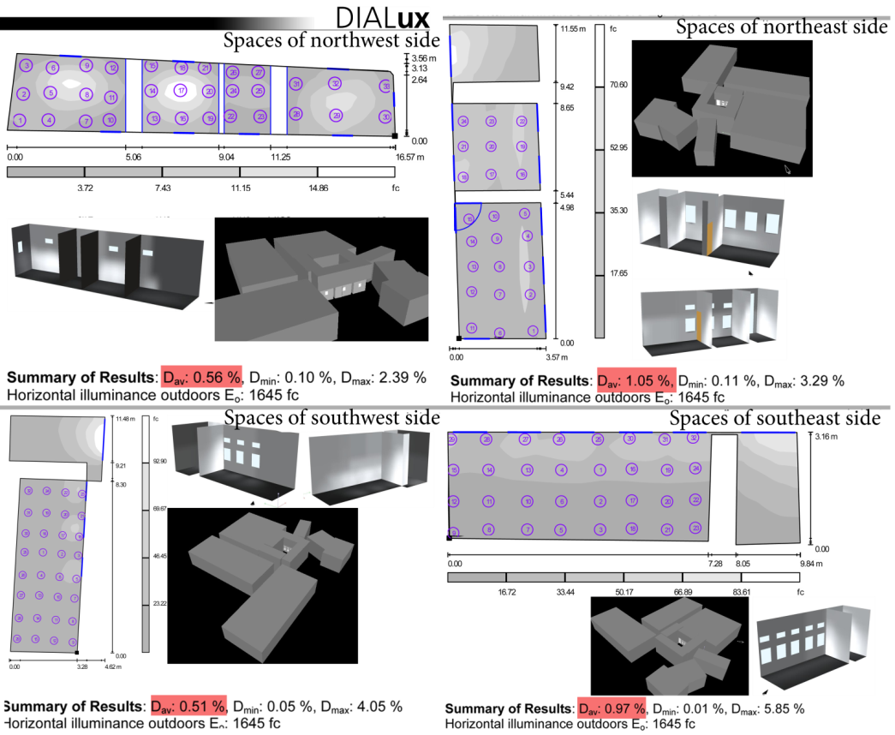

Figure 23. Calculations and daylight modeling in different spaces of ground floor (authors).

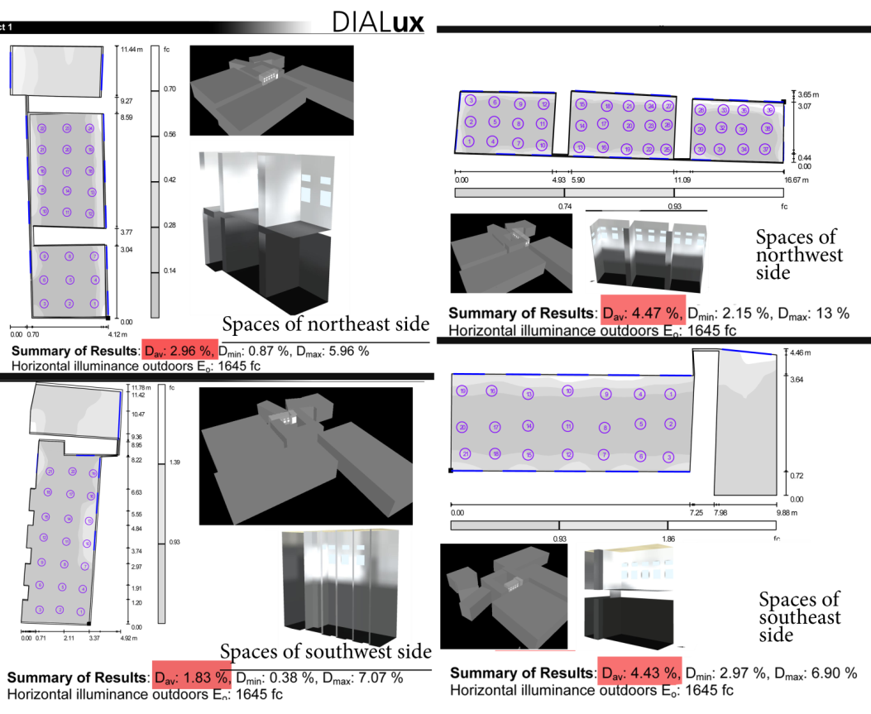

Figure 24. Calculations and daylight modeling of different spaces of first floor (authors).

Appendix 2. The Calculations of Daylight Factor in Rashidy house by equation

Table4. The Calculations of Daylight Factor in Rashidy house using equations 1 and 2 (authors). Height of spaces on the ground floor is 3.7 m and in first floor is 4.6m. Amounts of proportional M and T to Rashidy house are obtained from CIBSE (Daylighting and window design) and are 0.65 and 0.75.

Units | Ground floor spaces |  |  |  |  |  |  |  | Symbol
Units | W.C | Storeroom 2 |  | Storeroom 1 | Room 4 | Room 3 | Room 2 | Room 1 | Symbol
Dimensionless | 0.80% | 0.90% |  | 0.51% | 1.97% | 1.40% | 1.38% | 0.74% | D
Dimensionless | 0.65 | 0.65 |  | 0.65 | 0.65 | 0.65 | 0.65 | 0.65 | T
m2 | 1.9 | 2.1 |  | 1.5 | 3.4 | 3.7 | 4.07 | 2.62 | Aw
Degrees | 37 | 37 |  | 37 | 45 | 45 | 51 | 45 | α
Dimensionless | 0.8 | 0.8 |  | 0.8 | 0.8 | 0.8 | 0.8 | 0.8 | M
m2 | 68 | 68.58 |  | 89.90 | 62.48 | 92.54 | 121.96 | 137.5 | A
Dimensionless | 0.57 | 0.59 |  | 0.60 | 0.60 | 0.59 | 0.60 | 0.64 | Rα
Dimensionless | 0.8 | 0.8 |  | 0.8 | 0.8 | 0.8 | 0.8 | 0.8 | Rc
Dimensionless | 0.1 | 0.1 |  | 0.1 | 0.1 | 0.1 | 0.1 | 0.1 | Rf
Dimensionless | 0.5 | 0.5 |  | 0.5 | 0.5 | 0.5 | 0.5 | 0.5 | Ro
Dimensionless | 0.8 | 0.8 |  | 0.8 | 0.8 | 0.8 | 0.8 | 0.8 | Rw
Dimensionless | 0.1 | 0.1 |  | 0.1 | 0.1 | 0.1 | 0.1 | 0.1 | Rwin
m2 | 13.10 | 10.61 |  | 15.72 | 10.1 | 15.87 | 22.5 | 26.2 | Ac
m2 | 13.10 | 10.61 |  | 15.72 | 10.1 | 15.87 | 22.5 | 26.2 | Af
m2 | 82.51 | 62.50 |  | 52.24 | 59.30 | 92.2 | 72.21 | 48.41 | Ao
m2 | 41.82 | 47.36 |  | 58.46 | 42.28 | 60.80 | 79.96 | 85.12 | Aw
Units | First floor spaces
Units | Living room |  | Kitchen | Storeroom 3 | Room 8 | Room 7 | Room 6 | Room5
Dimensionless | 1.1% |  | 3.79% | 3.07% | 4.05% | 4.24% | 3.61% | 4.21% | D
Dimensionless | 0.65 |  | 0.65 | 0.65 | 0.65 | 0.65 | 0.65 | 0.65 | T
m2 | 5.8 |  | 6.8 | 5.2 | 13 | 7.8 | 7.8 | 7.8 | Aw
Degrees | 71 |  | 71 | 54 | 54 | 65 | 65 | 65 | α
Dimensionless | 0.8 |  | 0.8 | 0.8 | 0.8 | 0.8 | 0.8 | 0.8 | M
m2 | 161.64 |  | 104.26 | 77.66 | 140.8 | 104.6 | 117.16 | 104.26 | A
Dimensionless | 0.64 |  | 0.61 | 0.62 | 0.60 | 0.64 | 0.62 | 0.64 | Rα
Dimensionless | 0.8 |  | 0.8 | 0.8 | 0.8 | 0.8 | 0.8 | 0.8 | Rc
Dimensionless | 0.1 |  | 0.1 | 0.1 | 0.1 | 0.1 | 0.1 | 0.1 | Rf
Dimensionless | 0.5 |  | 0.5 | 0.5 | 0.5 | 0.5 | 0.5 | 0.5 | Ro
Dimensionless | 0.8 |  | 0.8 | 0.8 | 0.8 | 0.8 | 0.8 | 0.8 | Rw
Dimensionless | 0.1 |  | 0.1 | 0.1 | 0.1 | 0.1 | 0.1 | 0.1 | Rwin
m2 | 27 |  | 15.33 | 9.85 | 22.20 | 15.97 | 18.1 | 15.32 | Ac
m2 | 27 |  | 15.33 | 9.85 | 22.20 | 15.97 | 18.1 | 15.32 | Af
m2 | 29 |  | 47.5 | 30 | 46 | 41 | 49.5 | 39.5 | Ao
m2 | 107.64 |  | 73.6 | 57.96 | 95.68 | 72.68 | 80.96 | 73.6 | Aw

Appendix 3. Calculations and modeling of Rasidy house in Autodesk Ecotect analysis software 2011 version

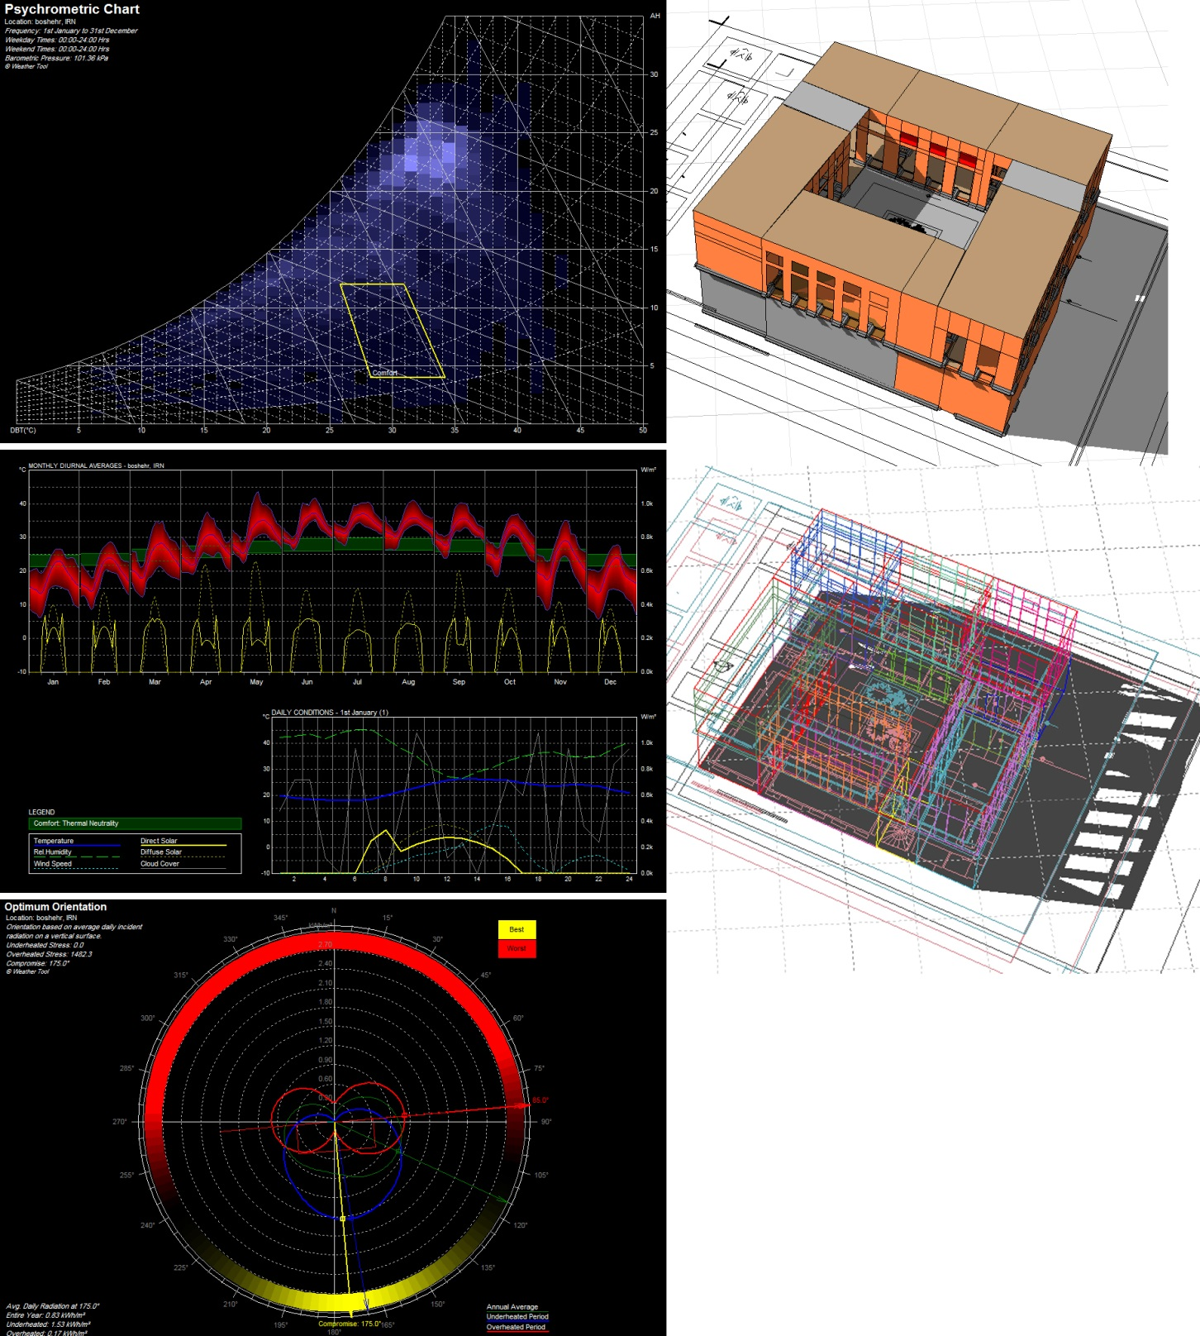

Figure 25. Images of Autodesk Ecotect software workspace and graphs related to Bushehr thermal comfort (authors).

Shenashil is a projected wooden space with louvered screens as enclosures that looks like a terrace.
6
7

