Optimizing Light Shelf Configurations for Enhanced Daylighting, Glare Reduction, and Energy Efficiency in Classroom Environments
Aida Lebasi ^{1*}, Mohamadmehdi moulaii ²
¹ Laval Virtual Center Lab, LAMPA Laboratory, ENSAM (École Nationale Supérieure d’Arts et Métiers), Laval, France
² Department of Architecture, Bu-Ali Sina University, Hamedan, Iran (m.moulai@basu.ac.ir)

Abstract
Daylighting is essential for energy conservation and maintaining a comfortable indoor climate in educational settings. This study investigates the role of light shelf configurations in optimizing daylighting and reducing discomfort glare in classrooms. Using a genetic algorithm, various light shelf configurations were assessed to enhance Useful Daylight Illuminance (UDI) and minimize glare, compared to a base case without light shelves. The optimized configurations showed notable improvements, with a 1.14% to 2.76% increase in UDI and a 10.91% to 14.13% reduction in glare. Additionally, these configurations resulted in a slight reduction in total energy load by 0.91%. These findings highlight the importance of tailored light shelf designs in creating comfortable and energy-efficient learning environments, providing valuable insights for architects and designers.
Keywords: School design, Evolutionary multi-objective optimization, Useful daylight, Thermal comfort, Energy consumption

1. Introduction
Daylighting is an ideal method to save energy in buildings and maintain a comfortable indoor climate. Numerous studies have delved into comfort conditions in schools, particularly emphasizing classrooms as the most critical learning spaces [1-5]. However, despite the recognized importance of classroom environments, many educational buildings still suffer from inadequate daylight distribution and poor visual comfort, which can negatively affect students’ concentration and academic performance. This constitutes a critical environmental design problem in school buildings. Classrooms typically accommodate groups of individuals for extended periods during learning activities. The environment established during these activities significantly influences student performance and should therefore possess characteristics that foster a stimulating environment conducive to enhancing the educational process [6].
Daylighting is a critical consideration in the design of educational spaces. The diverse spectrums provided by various forms of light have psychological and physiological effects on humans. Daylight, in particular, has been associated with numerous benefits, including improved mood, enhanced morale, reduced fatigue, and minimized eyestrain [7-10]. Studies by Winterbottom and Wilkins (2009) and Rittner and Robbin (2002) suggest that daylight plays a crucial role in aiding students to learn and retain information [11]. Küller and Lindsten (1992) noted that working in windowless or poorly illuminated environments can disrupt the chronobiologic system regulating hormone production [12], while Heschong (1999) emphasized the positive impact of daylighting on human performance in classroom settings [13]. Nevertheless, providing large window areas to increase daylight availability often introduces new challenges related to glare and thermal discomfort.
Various strategies, such as the use of light shelves, have been explored to optimize the balance between sufficient daylight and energy efficiency. Light shelves, which can be interior or exterior, are normally situated above eye level [14]. Their effectiveness is influenced by various parameters, including dimensions, rotation angle, and orientation [15]. However, excessive illuminance, along with thermal discomfort, can adversely affect satisfaction [11, 16-18]. Glare, a result of excessive illuminance, can cause visual discomfort and reduce satisfaction and productivity [11, 16]. Nonetheless, lighting that enhances visual comfort can partly compensate for thermal discomfort, potentially improving satisfaction [18]. However, most previous studies have focused mainly on increasing daylight levels or reducing lighting energy consumption, while comparatively limited attention has been paid to the specific role of light shelves in mitigating discomfort glare in real classroom settings.
The design of the building envelope, with a focus on daylight, is a critical factor in creating successful indoor environments, not only influencing occupant well-being but also contributing to energy conservation efforts [11]. Adequate daylight levels reduce the need for artificial lighting in spaces, resulting in energy conservation and decreased energy consumption. Advanced daylighting systems, such as light shelves and reflective blinds, can maximize this potential [19]. However, accurate prediction of indoor daylight illuminance is crucial for the effective use of temporary supplementary artificial lighting [20]. Philips (2012) has indicated that the use of natural light can effectively replace and reduce the demand for artificial lighting [21]. Tsikra and Andreou (2017) have acknowledged that improper building orientation and shading devices contribute to a lack of visual and thermal comfort, leading to increased long-term energy demand in educational facilities [22]. Despite these findings, there is still insufficient empirical evidence that simultaneously evaluates daylight performance, glare control, and energy-related impacts of light shelves under specific climatic conditions.
Indeed, the literature on school building design consistently highlights the impact of both daylight and thermal comfort on the health and performance of occupants within school buildings [23]. However, increasing the size of windows leads to glare, and with an enlarged window area, energy consumption for cooling in summer and heating in winter rises. Additionally, light is less distributed at the endpoints of the classrooms and is excessively intense opposite the windows. This unresolved trade-off between daylight availability, glare control, and energy efficiency indicates a clear need for optimized façade strategies that can improve daylight distribution without increasing visual and thermal discomfort.
In response to this need, the present study investigates the effectiveness of installing light shelves on classroom windows as a passive design strategy to improve daylight distribution, reduce discomfort glare, and influence energy-related performance. Accordingly, this study addresses the following research questions:
- How effectively can optimized light shelf configurations improve daylight distribution and reduce discomfort glare in classrooms at key occupied hours?
- How do seasonal variations affect the performance of light shelves in terms of UDI, GA, and total energy load?
- Which light shelf design parameters most strongly influence the trade-off between visual comfort and energy performance?
This paper offers a novel contribution to the field by addressing the gap in understanding the role of light shelves in minimizing discomfort glare within classrooms. While existing literature has primarily explored the significance of light shelves in terms of daylight availability or energy consumption, there is limited research specifically targeting the reduction of discomfort glare, a critical concern in educational settings. Additionally, this investigation stands out because it focuses on the Iranian context, particularly in Hamedan, where there appears to be a dearth of prior research on this topic. Thus, the study contributes to a body of knowledge that is increasingly essential for creating comfortable and energy-efficient learning environments globally [24].

2. Literature Review

2.1 Useful Daylight Illuminance (UDI)
Useful Daylight Illuminance (UDI) is a modern paradigm for assessing daylight in buildings, introduced by Nabil and Mardaljevic (2005). UDI focuses on the range of 100-2000 lux, aligning with occupant preferences and behavior, and is considered an improvement over the traditional daylight factor method. UDI simplifies voluminous time-series illuminance data, making it easier to interpret and apply [24]. UDI assesses the percentage of the work area that meets illuminance levels between 100 lx and 2000 lx during at least 50% of occupied hours, addressing issues of glare and excessive solar gain (Reinhart and Weissman 2012). UDI thresholds are categorized into:
- Upper (UDI >2000 lx): Indicates an oversupply of daylight causing discomfort.
- Lower (UDI <100 lx): Indicates insufficient daylight.
- Middle (UDI 100–2000 lx): Represents useful daylight (Yu and Su 2015).
Mardaljevic et al. (2009) further subdivided the useful UDI range into "supplementary" (100-500 lx) and "autonomous" (500-2000 lx) levels [25]. Pool (2019) introduced additional thresholds, such as "non-sufficient" (UDI <150 lx) and "autonomous for the task" (UDI 300-3000 lx) [26]. In this study, UDI is adopted as a dynamic metric for daylight assessment, categorizing illuminances into Under-lit (UDI <250 lx), Day-lit (UDI 250-2000 lx), and Over-lit (UDI >2000 lx) areas.

2.2 Integration of Daylighting Strategies
Integrating daylighting strategies in building design is crucial for achieving energy efficiency and sustainability [27-29]. However, effectively penetrating daylight into deeper building spaces poses challenges, especially in open-plan environments where central areas receive less daylight [30]. Daylight transporting systems, such as light shelves, offer a solution by directing daylight deeper into interiors while serving as shading devices [31].
Daylighting contributes to a comfortable indoor environment and offers significant energy-saving opportunities [32-35]. The adoption of large transparent envelopes in modern buildings necessitates effective shading systems to reduce glare, manage thermal issues, and ensure better illumination distribution. Light shelves, positioned above eye level either internally or externally, play a crucial role in intercepting direct sunlight and enhancing daylight penetration into rooms [36].

2.3 Daylight Glare Probability (DGP)
Reducing glare in classrooms is of paramount importance as it directly impacts visual comfort, student performance, and overall satisfaction within educational environments. Glare, resulting from excessive and uncontrolled illuminance, can cause significant visual discomfort, leading to eyestrain and fatigue, which in turn can negatively affect students' ability to concentrate and retain information [11]. According to Winterbottom and Wilkins (2009), minimizing glare is essential for maintaining a conducive learning atmosphere, as it enhances visual comfort and reduces distractions [11]. Effective daylighting strategies, such as the implementation of light shelves, can help balance natural light while mitigating glare, thus optimizing the classroom environment for both comfort and energy efficiency [13]. Furthermore, Heschong (1999) emphasized that controlled daylighting not only improves visual performance but also supports the psychological well-being of students, fostering a more productive and engaging learning experience [13]. Addressing glare through thoughtful design and appropriate daylighting solutions is therefore crucial for creating educational spaces that promote both health and academic success.
Daylight Glare Probability (DGP) is a metric used to assess the potential for discomfort glare caused by daylight in indoor spaces. Discomfort glare refers to the visual discomfort experienced when exposed to excessive brightness or contrasting light conditions, leading to visual distraction and difficulty in seeing objects or details [34].

2.4 Energy Use Intensity (EUI)
Energy Use Intensity (EUI) is a critical metric for assessing building performance. It is calculated by dividing the total annual energy usage by the building's total square footage. EUI encompasses various elements, including climate conditions, thermal and cooling requirements, and occupant activity patterns. As a comprehensive measure of energy consumption, EUI serves as a robust optimization benchmark for energy efficiency in building design [28].
By focusing on these key metrics—UDI, DGP, and EUI—this study aims to optimize light shelf configurations to improve daylighting, reduce discomfort glare, and enhance energy efficiency in educational environments.

2.1. Light shelves
Light shelves are horizontal architectural components designed to redirect daylight deeper into interior spaces. They are particularly effective in classrooms, activity rooms, and offices, where optimizing natural light can enhance comfort and reduce energy consumption [37]. By reflecting sunlight onto ceilings and further into rooms, light shelves can significantly improve indoor lighting conditions.
Recent studies have demonstrated the potential of light shelves in enhancing daylight performance. For example, research by Bahdad, Fadzil, and Taib (2020) employed genetic algorithms and simulation modeling to optimize light-shelf parameters in fully glazed work environments [38]. Their findings highlighted substantial improvements in illuminance levels, showcasing the effectiveness of well-designed light shelves [38].
The impact of light shelves on daylight distribution has been studied under various sky conditions, providing valuable insights for optimal design [5, 39-43]. Key factors influencing their effectiveness include height, width, material composition, angle, and whether they are positioned internally or externally [44].

2.1.1. Design Considerations:
- External Shelves: Block direct sunlight, reducing glare but may be less effective in directing light deep into interiors.
- Internal Shelves: Reflect light inward towards the ceiling, enhancing interior daylight penetration.
- Combined Approach: In some scenarios, a combination of both internal and external shelves may offer the most effective solution [45, 46].
Proper positioning is crucial to avoid reflective glare and obstructed views. Ideally, light shelves should be placed around 2.4 meters above the floor, above eye level, to prevent glare from low-positioned shelves [47].

2.1.2. Challenges and Solutions:
Daylighting can face challenges such as inappropriate window designs leading to wasted energy for electric lighting, particularly during peak daylight hours (8 a.m. to 6 p.m.). While glass-covered building sides guarantee direct daylight, they compromise thermal comfort due to heat transfer [48]. Balancing optimal daylight, thermal conditions, and low energy consumption remains a critical objective in designing learning and office spaces [49, 50].
Studies, including those by Lakhdari, Sriti, and Painter (2021) and Salem Bahdad et al. (2022), emphasize the need for multi-objective optimization to balance daylight availability, indoor thermal performance, and energy efficiency [49, 50]. Addressing discomfort glare remains a priority, particularly in educational facilities where visual comfort directly impacts learning outcomes [44].
The literature review reveals notable gaps in studies addressing light shelf optimization across various contexts. While each study provides valuable insights, distinct gaps require attention. For instance, Mangkuto et al. (2018) and Berardi and Anaraki (2018) focus on visual performance, comfort, daylight distribution, and energy savings but do not explicitly address the impact of light shelves on glare reduction [36, 51].
Ebrahimi-Moghadam et al. (2020) and Fadaee et al. (2019) examine energy consumption and daylight distribution in residential buildings but do not delve into potential discomfort glare caused by light shelves [52, 53]. Furthermore, studies by Warrier and Raphael (2017), Moazzeni and Ghiabaklou (2016), and Meresi (2016) touch on daylight efficiency, visual comfort, and energy saving but do not specifically explore discomfort glare reduction [15, 54]. Additionally, Lee and Lee (2019) aim to reduce glare issues in high school classrooms, yet lack details on the effectiveness of different shading devices [44]. Finally, the studies by Sabbagh, Mandourah, and Hareri (2022) and Lakhdari, Sriti, and Painter (2021) emphasize daylight improvement, thermal comfort, and low energy consumption but lack a specific focus on discomfort glare reduction [50, 55]. Therefore, the research gaps primarily center around the need for more explicit attention to discomfort glare and its mitigation strategies when optimizing light shelf parameters across diverse contexts.
Table 1. Examples of studies conducted on light shelves.
Study | Case Study | Location | Optimization Tool and/or Simulation Software | Light Shelf Variables | Research Objectives | Research Gaps
Sabbagh, Mandourah, and Hareri (2022) | Typical classroom | Saudi Arabia | Revit | Position, width, material, shape | Improving daylight | Implementing solar tubes and fiber optic daylighting systems
Lakhdari, Sriti, and Painter (2021) | School building | Saharan, Algeria | Genetic algorithm using Octopus plugin | Width, height, angle | Daylight, thermal comfort, low energy consumption | Minimize UDI exceeded, DGP or DGI
Bahdad, Fadzil, and Taib (2020) | Typical office | Malaysia | HoneyBee, Ladybug, Genetic algorithm using Galapagos plugin | Height, depth, ratio | Balance of daylight availability (UDI), thermal comfort, visual comfort (glare probability), and energy saving | —
Ebrahimi-Moghadam et al. (2020) | Residential buildings | Mashhad, Iran | Genetic algorithm | Angle, depth, number of light shelves | Total energy consumption, predicted percentage of dissatisfied people | —
Lee and Lee (2019) | High school classroom | Seoul, South Korea | DIVA for Rhino | Depth | Reduce glare issue | Different shading devices
Fadaee et al. (2019) | Residential building | Mashhad, Iran | HoneyBee, Ladybug | Width | Daylight distribution, energy consumption | —
Mangkuto et al. (2018) | Dental hospital | Bandung, Indonesia | Genetic algorithm using Octopus plugin | External and internal widths, external tilt angles, specularity | Maximize sDA; minimize ASE | Optimize visual performance and comfort
Berardi and Anaraki (2018) | Office building | Toronto, Canada | AGi32 | External and internal widths; height | UDI, daylight distribution, energy saving | —
Warrier and Raphael (2017) | Hypothetical building | Chennai, India | Radiance lighting simulation | Rotation, material | Improve daylighting and visual comfort | —
Meresi (2016) | Typical classroom | Athens, Greece | Radiance | Width, mounting height, inclination, reflection index | Daylight exploitation | Daylight Glare Index, energy saving
Moazzeni and Ghiabaklou (2016) | Educational space | Tehran, Iran | DIVA-for-Rhino | Dimensions, shelf rotation angle, orientation | Daylight efficiency and visual comfort (DA, UDI) | Energy and electricity consumption; different latitudes of Iran

3. Method

3.1. Simulation tools and algorithms employed
The simulation process begins with detailed computational modelling of the school environment using Rhino, a 3D modelling tool. Energy modelling is then imported into Grasshopper, an algorithmic modelling plugin for Rhino. Within Grasshopper, the building zones are designed with the assistance of Honeybee, a tool for energy and environmental performance analysis.
To establish a baseline for comparison, a representative classroom is selected, and its daylighting conditions and energy usage are measured without the incorporation of light shelves. This initial scenario serves as the reference model for subsequent optimizations. Figure 1 illustrates the process and tools used for optimization in this study.
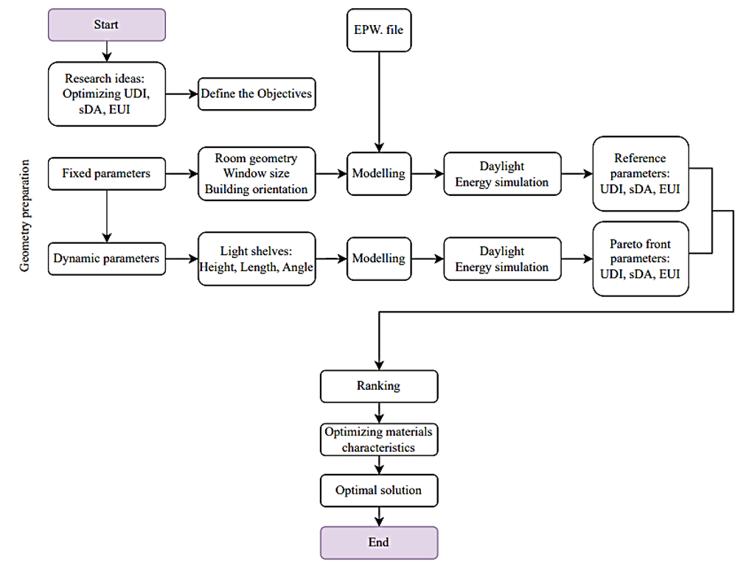
Figure 1. Framework for Research: Exploring the Process and Tools Optimization.
Our analysis focuses on a comprehensive evaluation of Useful Daylight Illuminance (UDI), Spatial Daylight Autonomy (sDA), Glare Analysis (GA), and total energy consumption. Geometric representation was accomplished using Rhino and imported as a Honeybee zone for conducting environmental simulations. Leveraging Ladybug, climatic metrics were derived to enhance the analytical process. Honeybee was instrumental in assessing UDI, sDA, and GA, while the EnergyPlus component within Honeybee facilitated the analysis of total energy consumption. UDI measured the quality of natural light within urban spaces, sDA gauged daylight availability, GA evaluated potential discomfort from glare, and total energy use provided insights into the building's overall energy performance.
This integrated approach allows for the exploration of diverse parameter combinations to identify solutions that enhance daylighting, mitigate discomfort glare, and optimize energy usage. Simulation scenarios systematically vary the selected input variables to assess their impact on the targeted objectives. Over the past decade, architectural design tools have increasingly included parametric tools and optimization algorithms (Jalali, Noorzai, and Heidari 2020). Rhinoceros and its Grasshopper plug-in are prominent platforms for these processes, manipulating geometric parameters through algorithmic models (Eltaweel and Su 2017). According to Chi et al. (2017), Ladybug and Honeybee offer energy analysis using EnergyPlus/Archsim and daylight analysis through Radiance/DAYSIM.

3.3. Selection of case study
Hamedan, situated at coordinates 34.85° N latitude and 48.53° E longitude, is a city located in the western part of Iran. Positioned at an elevation of approximately 1749 meters above sea level, Hamedan experiences a BSk climate classification, indicating an arid climate with cold winters. The region is characterized by steppe vegetation, reflecting the semi-arid nature of the area. With distinct seasons, the city encounters relatively harsh winter conditions due to its elevated altitude. The BSk climate classification suggests a dry climate with a notable precipitation deficit, and the steppe designation points to the presence of grassland vegetation adapted to semi-arid environments.
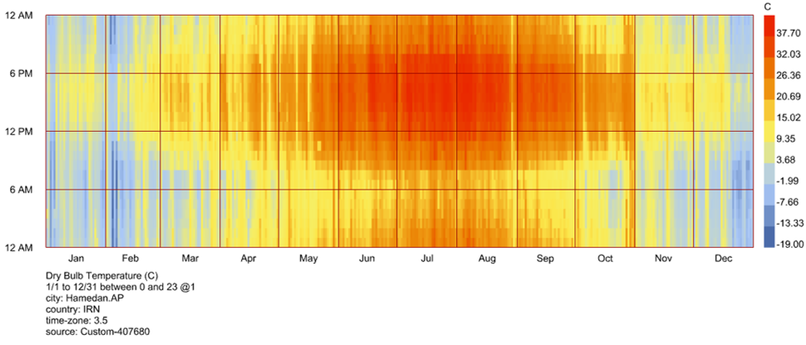
Figure 2. Dry bulb temperature of Hamedan, Iran.
Based on the climatic data illustrated in Figure 2 Hamedan experiences prolonged periods of low outdoor temperatures during the winter months, particularly from December to February, while higher temperatures dominate during summer, especially between June and August. These seasonal variations indicate that during winter, classrooms not only face thermal challenges but also reduced daylight availability due to shorter day lengths and lower solar angles. Under such conditions, maximizing the use of natural daylight becomes essential to reduce dependence on artificial lighting and to enhance indoor environmental quality. Light shelves can play a critical role in this context by redirecting low-angle winter sunlight deeper into the classroom, improving daylight penetration and distribution across the space. This strategy supports both visual comfort and potential passive solar gains, contributing to reduced lighting energy demand during cold periods when energy consumption is typically higher.
Conversely, during summer months, when solar radiation and outdoor temperatures are significantly higher, uncontrolled daylight can result in excessive illuminance, glare, and increased cooling loads. Light shelves can mitigate these adverse effects by blocking direct sunlight near the window zone while reflecting diffuse daylight toward the ceiling, thereby maintaining adequate illumination levels without causing visual discomfort. Therefore, in a climate such as Hamedan’s, characterized by cold winters and warm summers, adaptive daylighting strategies like light shelves are particularly relevant, as they can enhance daylight utilization in winter while simultaneously controlling glare and overheating risks in summer. This dual functionality supports the need for climate-responsive façade design that balances visual comfort and energy efficiency throughout the year.
A specific classroom within an existing school building is chosen for detailed parametric analysis. The schools in Hamadan exhibit a northeast-southwest orientation, strategically positioning classrooms to capture natural light from the south. As illustrated in Figure 3, three types of school buildings in the city of Hamadan are identified. Here, we have selected one type of school building as a representative sample, and it exemplifies the overall typology of schools in Hamadan. This chosen example reflects the prevalent architectural approach adopted by all schools in the city, aligning with a specific orientation to optimize sunlight utilization, particularly in the southern direction. The selected case study is Farzanegan 2 High School, located in District 2 of Hamadan, Iran.

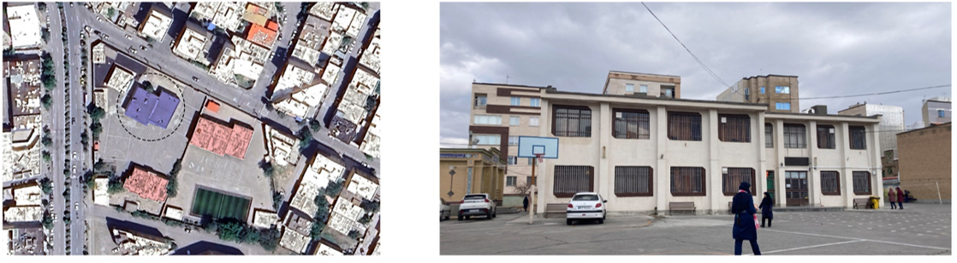
Figure 3. Typical schools in the city (left) and selected case (right).
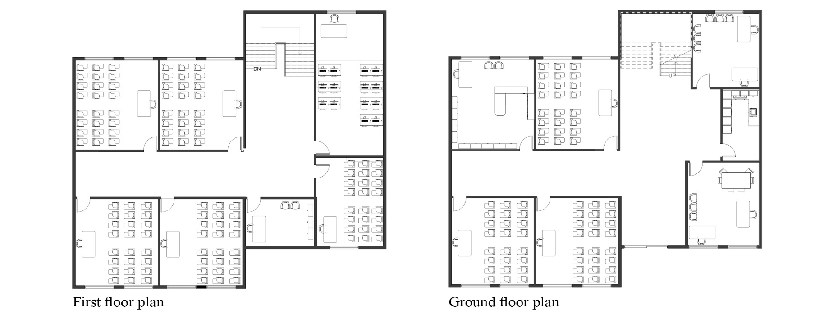
Figure 4. Ground floor (right) and First floor plan (left) of the selected case.
Figure 4 illustrates the architectural plans of the ground and first floors of the selected school, including the furniture layout and window placements. The chosen classroom has dimensions of 6 meters in length, 7 meters in width, and a height of 3.2 meters. The classroom dimensions and their layout are presented in Figure 5.
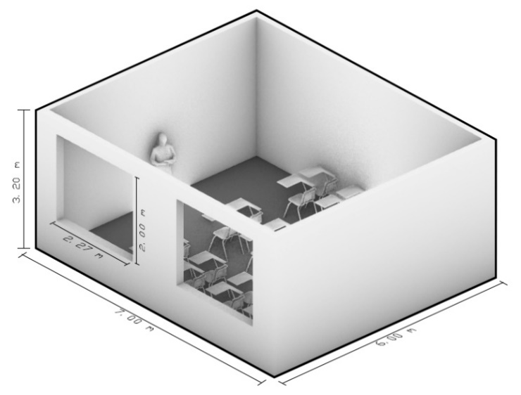
Figure 5. 3D Dimensions of the selected classroom.
This particular classroom serves as the focal point for detailed parametric analysis to explore the impact of light-shelf configurations on daylight availability, glare reduction, and energy consumption within the context of the region. Accordingly, the reflectance values are set as follows: the ceiling is assumed to have a reflectance of 80%, the walls at 60%, and the floor at 20% as shown in Table 2. These values align with established practices and contribute to the realism and accuracy of the simulation, ensuring that the chosen classroom model is representative of typical conditions in Hamedan, Iran.
Table 2. Material characteristics of the school building and dimensions.
Location | Hamedan, ON (IRXX0048 weather) | Window dimension | 2m * 2.27m (W * H)
Dimension | 6m * 7m * 3.20m | Window-to-wall ratio | 40%
Interior reflectance | Ceiling 80%, walls 60%,  floor 20% | Light shelf reflectance | 80%
Work plane height | 0.75m | Illuminance grid spacing | 0.5 m * 0.5 m (551 Points)

3.4. Integration of multi-objective optimization techniques
Designing daylight and energy efficient buildings with optimization evolutionary algorithms (EAs) is becoming a fascinating tool, aligning with many of the objectives of performance-based optimization (PBO). The EAs integrated into the grasshopper tools were utilized in the optimization process [56]. EAs are utilized in this sense to address both single- and multi-objective optimization issues. To find the optimal solutions within a set of constraints and variables, EAs are integrated into PBO. Instead of utilizing an optimization procedure to discover the "best" option, the goal is to uncover superior alternatives by exploring a wide search space [57]. According to the number of objective functions, there are two types of optimization problems: multi-objective optimization (M-OP) and single-objective optimization (S-OP) [58]. GAs is one of the most widely used approaches for solving M-OP problems. According to recent research publications, NSGA-II is frequently and successfully applied to building optimization problems [59]. One advantage of using Octopus over other comparable optimization tools in Grasshopper is its capacity to find several targets for testing at the same time, yielding optimal solutions and the best goal mode [60]. Figure 6 illustrates the inputs and objectives for multi-objective optimizations in this study.
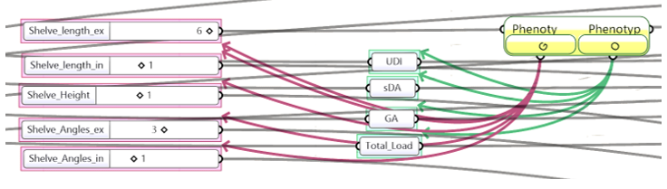
Figure 6. Inputs and Objectives in Octopus plugin.

3.5. Simulation scenarios and input variables
In this study, shelf height (Shelf-H), exterior angle (Shelf-Angle-Ex), interior angle (Shelf-Angle-In), exterior depth (Shelf-Length-Ex), and interior depth (Shelf-Length-In) serve as input variables for Octopus. Figure 7 shows dimensions of light shelf.
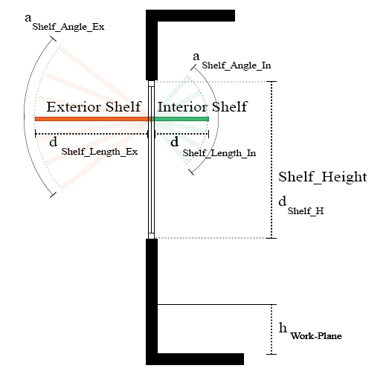
Figure 7. Light Shelf in section and dimensions.
The objectives include UDI (Useful Daylight Illuminance), GA (Glare Analysis), and total energy. For parameters aimed at maximization, UDI is multiplied by -1 to ensure its maximization. Table 3 summarize input variables of light shelf.
Table 3. Input parameters of Light Shelf and their ranges.
Value |  |  |  | Parameters and their ranges
 | Shelf Height  d _{Shelf-H} | Exterior angle  a _{Shelf-Angle-Ex} |  | Interior angle  a _{Shelf-Angle-In} | Exterior depth  d _{Shelf-Length-Ex} |  | Interior depth  d _{Shelf-Length-In}
Minimum | 1.80 m | 0.0° |  | 0.0° | 0.20 m |  | 0.25 m
Maximum | 2.20 m | ± 30˚ |  | ± 30˚ | 1.25 m |  | 1.25 m
Interval | 0.1 m | 10° |  | 10° | 0.25 m |  | 0.25 m
As depicted in Figure 8, the UDI (Useful Daylight Illuminance) and GA (Glare Autonomy) metrics are showcased for the selected time and date in the base case, without the presence of shelves.
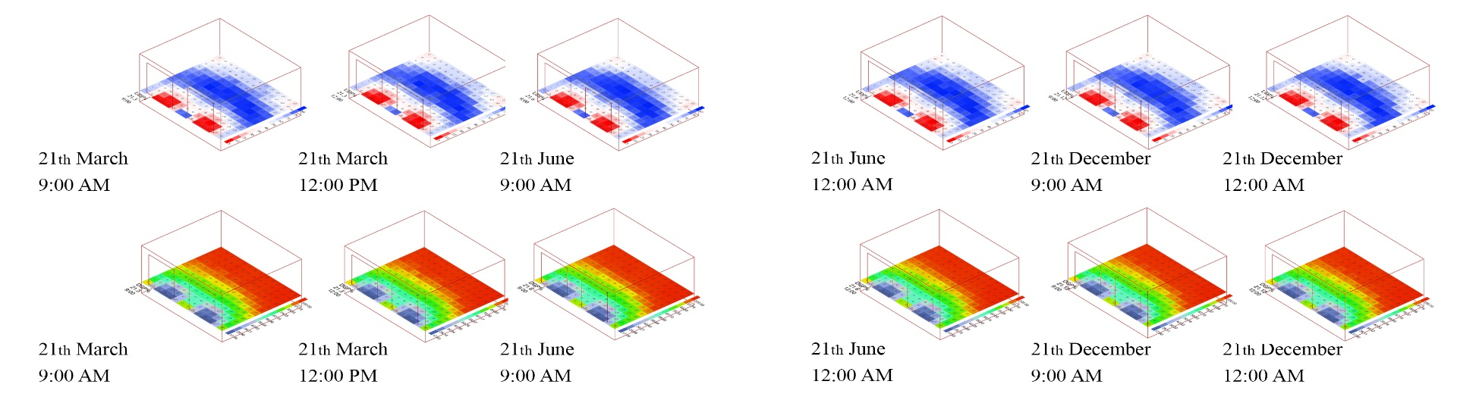
Figure 8. UDI and GA metrics of the base case.
Thermal simulations were conducted using Ladybug & Honeybee, aligning with the conditions of the thermal measurements. The simulations considered a winter day on December 21st, autumn day on 21th and a summer day on June 21th, with an assumed occupancy density of 0.03 people per square meter, representing the absence of pupils.

4. Results
In this section, we will address the challenges related to daylight and discomfort glare at two crucial times in classrooms: 9:00, and 12:00. Initially, we will outline the issues encountered in classrooms without shelves. Subsequently, we will compare 3 carefully optimized cases generated using a genetic algorithm against the base case. Finally, we will determine the optimal dimensions of the shelf based on the specific hour under consideration.
Table 4. UDI, GA, and Total Load of the selected base case in specific date and time.
Date | Time | UDI (%) | GA (%) | Total Load
21st of March | 9:00 | 59.56% | 78.13% | 291.66
 | 12:00 | 59.68 | 78.20% | 291.66
21st of June | 9:00 | 59.74% | 78.22% | 291.66
 | 12:00 | 59.79% | 78.20 | 291.66
21st of December | 9:00 | 59.64% | 78.18% | 291.66
. | 12:00 | 59.64% | 78.17% | 291.66
Table 4 presents a summary of the case design for different dates and times, with a focus on the percentage of Useful Daylight Illuminance (UDI), glare autonomy (GA), and the total load. The table is structured as follows:
- Date and Time Columns: This section outlines the specific date and time points for each case design, specifically at 9:00 and 12:00.
- UDI 500-2500 (%): This column represents the UDI percentage within the range of 500-2500 lux as measured on tables in classrooms. It serves as a baseline for assessing the impact of different case designs on daylighting conditions.
- GA (%): The GA column indicates the improvement in UDI percentage achieved through the application of a genetic algorithm. This highlights the optimization achieved by the algorithm in minimizing discomfort glare.
- Total Load: The total load column provides information on the overall energy load associated with each case design, measured in an appropriate unit. It gives insights into the energy consumption implications of the proposed solutions.
This case design table provides a clear snapshot of the performance metrics for different scenarios, aiding in the evaluation and comparison of daylighting conditions and discomfort glare mitigation strategies across various dates and times.

4.1. Optimized Solutions: 9:00 AM
The investigation into optimized solutions at 9:00 focused on assessing the efficacy of carefully designed shelf configurations generated through a genetic algorithm. The results, depicted in Table 5, showcase the percentage of Useful Daylight Illuminance (UDI) in the range of 500-2500 lux, the improvements introduced by the Glare Autonomy (GA), and the total load on specific dates. Figure 10 illustrates solution graphs and Figure 11 showcasing every cases in 20 generations respectively.
Table 5. UDI, GA, and Total Load of the optimized case in 9:00 AM.
Date | Time | Optimized case | UDI (%) | sDA (%) | GA (%) | Total Load | Shelf length Ex | Shelf length In | Shelf height | Shelf angle Ex | Shelf angle In
21st of March | 9:00 | 1 | 58.71 | 100 | 82.64 | 289.33 | 75 | 25 | 240 | 30 | -10
 |  | 2 | 59.33 | 100 | 81.40 | 289.32 | 80 | 25 | 230 | 20 | 30
 |  | 3 | 60.24 | 100 | 89.19 | 289.02 | 90 | 25 | 250 | 20 | 30
21st of June | 9:00 | 1 | 60.26 | 100 | 83.39 | 289.37 | 75 | 25 | 230 | 20 | -20
 |  | 2 | 60.74 | 100 | 83.61 | 289.22 | 80 | 25 | 240 | 20 | -10
 |  | 3 | 60.12 | 100 | 84.54 | 289.02 | 90 | 50 | 240 | 20 | 10
21st of December | 9:00 | 1 | 59.49 | 100 | 84.51 | 289.20 | 75 | 25 | 250 | 20 | -30
 |  | 2 | 59.51 | 100 | 85.03 | 289.22 | 80 | 50 | 240 | 20 | 0
 |  | 3 | 60.71 | 100 | 83.67 | 289.23 | 100 | 25 | 240 | 20 | 0
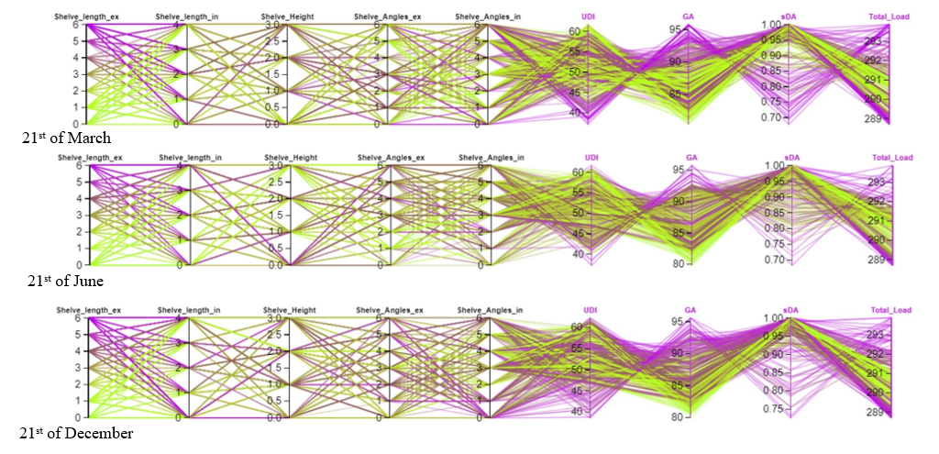
Figure 9. Pharrell charts of optimized solutions at 9:00 in different dates.
The findings suggest that the application of optimized shelf configurations consistently enhances UDI at 9:00 across different dates. Notably, the third optimized case demonstrates the most substantial improvement in UDI, indicating its effectiveness in minimizing discomfort glare during the morning. Solutions for each model the simulation loop ran for 20 generations with 33 separate solutions. Thus, in the end 414 designs had been compared in a limited amount of time. The initially randomly chosen set of solutions converged to positions on the Pareto front in the 3D solution space. Fig. 11 presents the non-dominated solutions for each time in red colour.
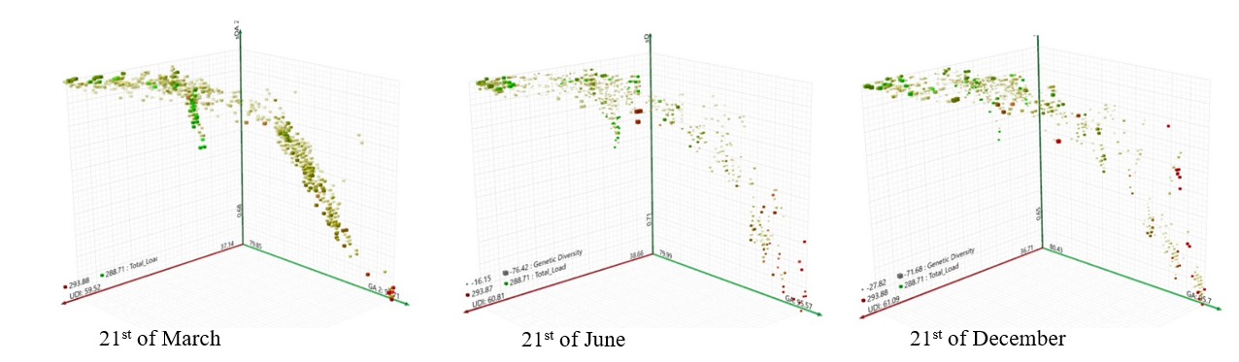
Figure 10. Solutions of the optimization after 20 generations at 9:00 AM.

4.2. Optimized Solutions: 12:00 PM
A parallel analysis was conducted for the optimized solutions at 12:00, as shown in Table 6 This examination assessed the impact of the genetic algorithm on discomfort glare reduction during midday. Figure 12 illustrates solution graphs and Figure 13 showcasing every cases in 20 generations respectively.
Table 6. GAs outputs of NSGA-II scenario solutions at 12:00 PM in defined dates.
Date | Time | Optimized case | UDI ₅₀₀₋₂₅₀₀ (%) | sDA (%) | GA (%) | Total Load | Shelf length Ex | Shelf length In | Shelf height | Shelf angle Ex | Shelf angle In
21st of March | 12:00 | 1 | 56.69 | 100 | 86.75 | 289.09 | 100 | 50 | 240 | 20 | -20
 |  | 2 | 56.79 | 100 | 86.75 | 289.25 | 90 | 100 | 230 | 20 | -20
 |  | 3 | 56.62 | 100 | 86.22 | 289.32 | 80 | 75 | 230 | 20 | 0
21st of June | 12:00 | 1 | 61.33 | 100 | 83.67 | 289.24 | 125 | 25 | 230 | 20 | 0
 |  | 2 | 60.24 | 100 | 82.01 | 289.32 | 80 | 25 | 230 | 20 | 20
 |  | 3 | 60.60 | 100 | 83.13 | 289.37 | 75 | 25 | 230 | 20 | -10
21st of December | 12:00 | 1 | 59.88 | 100 | 84.44 | 289.02 | 90 | 50 | 250 | 20 | 10
 |  | 2 | 59.69 | 100 | 82.51 | 288.81 | 125 | 25 | 240 | 30 | 10
 |  | 3 | 58.07 | 100 | 84.23 | 288.96 | 100 | 75 | 250 | 20 | 20

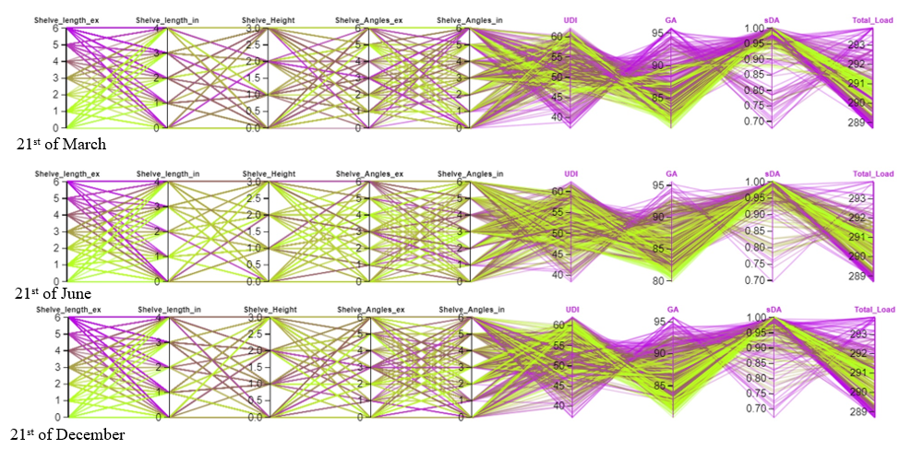
Figure 11. Pharrell charts of optimized solutions at 12:00 PM in different dates.
The results demonstrate that Cases 1 and 3 consistently offer notable improvements in UDI at 12:00, indicating their effectiveness in mitigating discomfort glare during the midday hours. Beyond the hourly assessments, a comprehensive analysis delved into determining the optimal shelf dimensions. This investigation considered factors such as shelf length, shelf height, and shelf angle, shedding light on their impact on both UDI and total load.

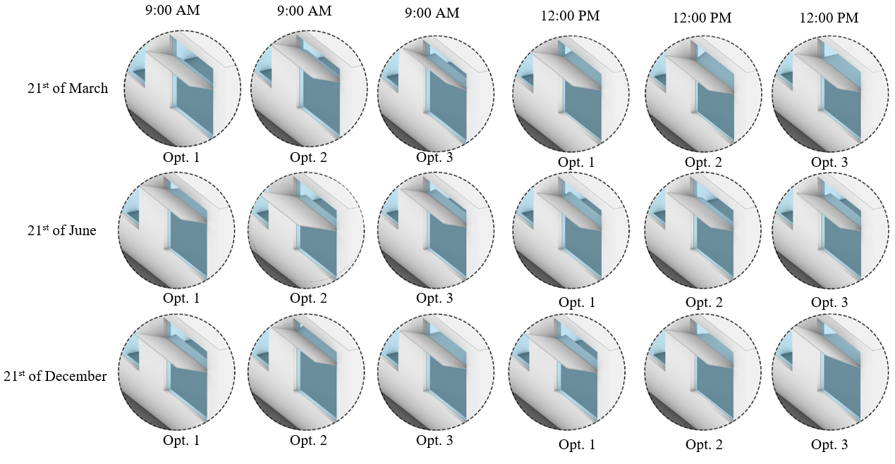
Figure 12. Optimized shelf configurations.
Figure 13 demonstrated optimized shelf configurations at 9:00 and 12:00. The carefully designed solutions, generated through a genetic algorithm, showcase remarkable improvements in Useful Daylight Illuminance (UDI) percentages, effectively minimizing discomfort glare during morning and midday hours. Notably, the third optimized case at 9:00 and Cases 1 and 3 at 12:00 stand out for their consistent effectiveness, highlighting the significance of thoughtful shelf design in enhancing daylighting conditions. The exploration extends beyond hourly assessments, unveiling insights into the pivotal role of optimal shelf dimensions, including length, height, and angle, in the quest for an optimized and glare-free learning environment. Figure 15 illustrates the optimized shelf configurations at 9:00 and 12:00.
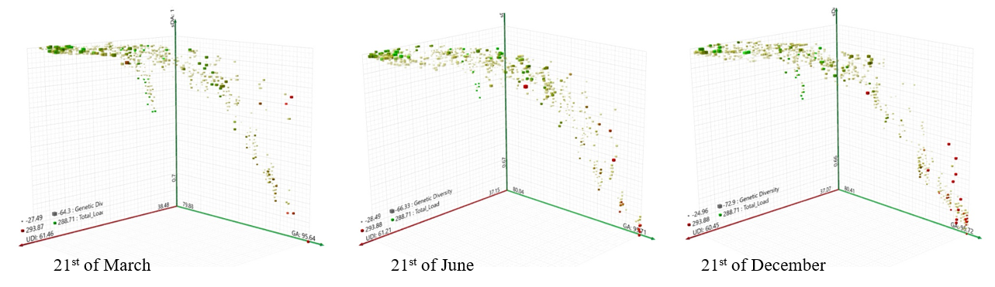
Figure 13. Solutions of the optimization after 20 generations at 12:00 PM.

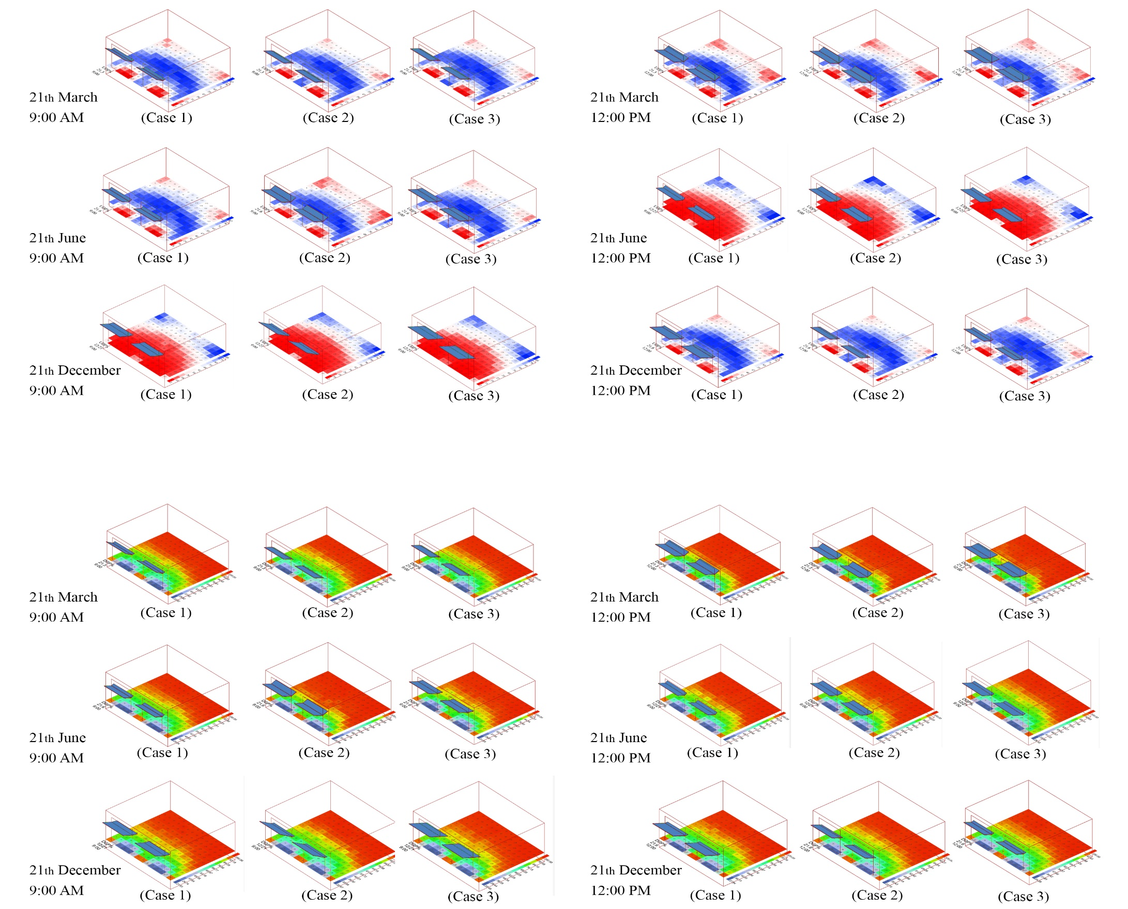
Figure 14. The optimized shelf configurations.

5. Discussion
The present study demonstrates that optimized light shelf configurations can significantly improve daylight performance—specifically Useful Daylight Illuminance (UDI)—while mitigating discomfort glare in classroom environments. The genetic algorithm used in this research successfully generated configurations that outperformed the base case without light shelves across morning and midday conditions.
Our results align with and extend findings from recent Iranian daylighting research. Masoud et al. (2025) reported that optimizing combined geometric parameters (geometry, depth, reflectance) of light shelves can yield substantial improvements in UDI and reduce glare incidence throughout the year in Tehran classrooms. They achieved a 21% increase in UDI and improved thermal comfort via season-responsive configurations, underscoring the importance of multi-parameter optimization—similar to the trends observed in this study [61].
While Masoud et al. focused on a seasonally adaptive system with photovoltaic integrations, our findings demonstrate that even static optimized shelves significantly enhance daytime performance (UDI increases of 1.14% in the morning and 2.76% at midday) and reduce glare autonomy (GA reduction up to 14.13%). This validates the crucial role of design optimization under Iranian climatic conditions where low solar altitudes exacerbate glare in winter [61].
Additionally, broader Iranian daylighting research underscores the impact of interior reflectance and geometric proportions on overall daylight efficacy. For instance, daylighting analyses in Tehran indicate that indoor surface reflectance and plan geometries substantially influence illuminance distribution, reinforcing the importance of optimized daylight strategies including light shelves [62].
Internationally, studies of light shelves in classroom contexts have consistently reported enhancements in both daylight quality and visual comfort. A study investigating typical public classrooms in Saudi Arabia [63] demonstrated that introducing light shelves redistributed natural light effectively, improving illumination uniformity—supporting our observation that optimized shelves improve daylight distribution and occupant comfort [63].
Beyond strict daylight metrics, multi‑objective daylighting research highlights the importance of balancing light availability with glare control. For example, recent optimization studies in office environments have shown that carefully designed light shelves can simultaneously improve thermal and visual comfort outcomes—validating our dual emphasis on UDI and glare reduction [64]. While these international studies apply to diverse building types and climates, their general conclusions reinforce our findings: properly designed light shelves enhance daylight performance while reducing visual discomfort, particularly when configurations are tuned to local solar conditions and room geometries. The measured improvements in UDI and GA demonstrate that optimized configurations can meaningfully improve visual comfort:
- Morning (09:00): UDI increased by 1.14% while GA improved by 14.13%, indicating more desirable daylight penetration and fewer glare incidents.
- Midday (12:00): UDI increased by 2.76% and GA improved by 10.91%, showing that performance gains persist through high‑sun conditions.
These results suggest that optimization yields moderately increased daylight availability while significantly improving visual comfort—an outcome consistent with contemporary daylighting research that prioritizes uniform illumination and glare mitigation as core performance goals [65].
The optimization’s success highlights two key design mechanisms:
- Shelf Geometry and Angulation: Optimal configurations direct daylight deeper into the indoor space while reducing direct radiant glare near windows. These effects are consistent with international evidence showing that geometric adaptation enhances daylight quality [65].
- Reflectance and Distribution: Reflective control surfaces enhance daylight distribution without elevating glare risk—supporting broader findings that surface reflectance is a critical factor in daylighting performance [66].
Furthermore, energy load reductions observed in this study—albeit modest (~0.91%)—indicate that optimized daylighting can align with energy efficiency goals, reinforcing the dual benefits emphasized in recent research [61].

6. Conclusion
This study investigated the effectiveness of optimized light shelf configurations in improving daylight distribution, reducing discomfort glare, and influencing energy performance in classrooms. By addressing a gap in the literature—specifically the combined evaluation of Useful Daylight Illuminance (UDI), Glare Autonomy (GA), and energy load—this research demonstrates that multi-parameter optimization can significantly enhance visual comfort while modestly reducing energy demand.
Results indicate that optimized configurations consistently outperformed the base case across both morning and midday hours. At 9:00 AM, UDI increased by 1.14% and GA decreased by 14.13%, while at 12:00 PM, UDI increased by 2.76% and GA decreased by 10.91%. Seasonal variations influenced performance, with adjustments to shelf dimensions and angles allowing for improved daylight penetration and glare control under different solar conditions. Shelf geometry and angulation were found to be critical design factors; longer, higher, and properly angled shelves directed daylight deeper into classrooms while mitigating glare, providing a practical strategy for balancing visual comfort and energy efficiency.
These findings are consistent with recent Iranian and international studies, including Masoud et al. (2025) and research in Saudi classrooms, which emphasize that properly designed light shelves improve both daylight quality and visual comfort. The study contributes to empirical knowledge on façade optimization in educational settings, demonstrating that light shelf design can be tailored to local climatic conditions to achieve simultaneous improvements in daylighting, glare control, and energy performance. The results have practical implications for architects, urban planners, and environmental psychologists, as optimized light shelves offer evidence-based solutions to enhance occupant well-being, cognitive performance, and energy efficiency.
The study has several limitations. First, it focused on a single classroom in Hamedan, limiting the generalizability of findings across different building layouts, orientations, and climates. Second, the analysis considered static configurations without dynamic or adaptive light shelf systems. Finally, while energy impacts were evaluated, integration with full HVAC and lighting systems was not included.
Future research should extend the optimization framework to multiple classroom typologies and climatic zones. A promising direction is the application of machine learning techniques, such as supervised regression models, genetic algorithms, and reinforcement learning, to identify the most effective light shelf configurations. These methods could account for dynamic factors including seasonal solar angles, building orientation, and even adaptive building movement, enabling time-dependent optimization of daylight distribution, glare control, and energy performance. Incorporating full building energy simulations and occupant behavior studies would further support a comprehensive evaluation of trade-offs between visual comfort, thermal comfort, and energy efficiency in educational environments.
Funding: This research did not receive any specific grant from funding agencies in the public, commercial, or not-for-profit sectors.
Acknowledgements: Our appreciation also goes to the educational institutions, research centres, and organizations whose resources and facilities have facilitated our work. Their commitment to fostering a conducive learning environment has been an inspiration throughout this process.

References

1. Jiang, J., et al., A study on pupils' learning performance and thermal comfort of primary schools in China. Building and Environment, 2018. 134: p. 102-113.
2. Kwok, A.G. and C. Chun, Thermal comfort in Japanese schools. Solar Energy, 2003. 74(3): p. 245-252.
3. Rodríguez, C.M., M.C. Coronado, and J.M. Medina, Thermal comfort in educational buildings: The Classroom-Comfort-Data method applied to schools in Bogotá, Colombia. Building and Environment, 2021. 194: p. 107682.
4. Zeiler, W. and G. Boxem, Effects of thermal activated building systems in schools on thermal comfort in winter. Building and Environment, 2009. 44(11): p. 2308-2317.
5. Zomorodian, Z.S., M. Tahsildoost, and M. Hafezi, Thermal comfort in educational buildings: A review article. Renewable and sustainable energy reviews, 2016. 59: p. 895-906.
6. Puteh, M., et al., Thermal comfort in classroom: constraints and issues. Procedia-Social and Behavioral Sciences, 2012. 46: p. 1834-1838.
7. Blume, C., C. Garbazza, and M. Spitschan, Effects of light on human circadian rhythms, sleep and mood. Somnologie, 2019. 23(3): p. 147.
8. Edwards, L. and P. Torcellini, Literature review of the effects of natural light on building occupants. 2002.
9. Küller, R., et al., The impact of light and colour on psychological mood: a cross-cultural study of indoor work environments. Ergonomics, 2006. 49(14): p. 1496-1507.
10. Vetter, C., et al., A review of human physiological responses to light: implications for the development of integrative lighting solutions. Leukos, 2022. 18(3): p. 387-414.
11. Winterbottom, M. and A. Wilkins, Lighting and discomfort in the classroom. Journal of environmental psychology, 2009. 29(1): p. 63-75.
12. Küller, R. and C. Lindsten, Health and behavior of children in classrooms with and without windows. Journal of environmental psychology, 1992. 12(4): p. 305-317.
13. Heschong, L., Daylighting in Schools: An Investigation into the Relationship between Daylighting and Human Performance. Detailed Report. 1999.
14. Almusaed, A. and A. Almusaed, Illuminate by light shelves. Biophilic and Bioclimatic Architecture: Analytical Therapy for the Next Generation of Passive Sustainable Architecture, 2011: p. 325-332.
15. Moazzeni, M.H. and Z. Ghiabaklou, Investigating the influence of light shelf geometry parameters on daylight performance and visual comfort, a case study of educational space in Tehran, Iran. Buildings, 2016. 6(3): p. 26.
16. Hamedani, Z., et al., Visual discomfort and glare assessment in office environments: A review of light-induced physiological and perceptual responses. Building and Environment, 2019. 153: p. 267-280.
17. Huebner, G.M., et al., Saving energy with light? Experimental studies assessing the impact of colour temperature on thermal comfort. Energy Research & Social Science, 2016. 15: p. 45-57.
18. Te Kulve, M., L. Schlangen, and W. van Marken Lichtenbelt, Interactions between the perception of light and temperature. Indoor Air, 2018. 28(6): p. 881-891.
19. Rayaz, S. and S. Rubab. Review of advanced daylighting systems. in Materials Science Forum. 2013. Trans Tech Publ.
20. Rutten, A., Sky luminance research imperative for adequate control of temporary supplementary artificial lighting installations. Building and Environment, 1994. 29(1): p. 105-111.
21. Phillips, D., Daylighting. 2012: Routledge.
22. Tsikra, P. and E. Andreou, Investigation of the energy saving potential in existing school buildings in Greece. The role of shading and daylight strategies in visual comfort and energy saving. Procedia environmental sciences, 2017. 38: p. 204-211.
23. Zhang, J., N. Liu, and S. Wang, Generative design and performance optimization of residential buildings based on parametric algorithm. Energy and Buildings, 2021. 244: p. 111033.
24. Nabil, A. and J. Mardaljevic, Useful daylight illuminance: a new paradigm for assessing daylight in buildings. Lighting Research & Technology, 2005. 37(1): p. 41-57.
25. Mardaljevic, J., L. Heschong, and E. Lee, Daylight metrics and energy savings. Lighting Research & Technology, 2009. 41(3): p. 261-283.
26. Pool, D.A.C., A comprehensive evaluation of perforated façades for daylighting and solar shading performance: Effects of matrix, thickness and separation distance. Journal of Daylighting, 2019. 6(2): p. 97-111.
27. Assem, E. and A. Al-Mumin, Code compliance of fully glazed tall office buildings in hot climate. Energy and buildings, 2010. 42(7): p. 1100-1105.
28. Hammad, F. and B. Abu-Hijleh, The energy savings potential of using dynamic external louvers in an office building. Energy and Buildings, 2010. 42(10): p. 1888-1895.
29. Yun, G.Y., T. Hwang, and J.T. Kim, Performance prediction by modelling of a light-pipe system used under the climate conditions of Korea. Indoor and Built Environment, 2010. 19(1): p. 137-144.
30. Alzoubi, H. and R.F. Bataineh, Pre-versus post-occupancy evaluation of daylight quality in hospitals. Building and Environment, 2010. 45(12): p. 2652-2665.
31. Choi, J.-H., L.O. Beltran, and H.-S. Kim, Impacts of indoor daylight environments on patient average length of stay (ALOS) in a healthcare facility. Building and environment, 2012. 50: p. 65-75.
32. Cantin, F. and M.-C. Dubois, Daylighting metrics based on illuminance, distribution, glare and directivity. Lighting Research & Technology, 2011. 43(3): p. 291-307.
33. Li, D.H. and E.K. Tsang, An analysis of daylighting performance for office buildings in Hong Kong. Building and environment, 2008. 43(9): p. 1446-1458.
34. Reinhart, C.F. and J. Wienold, The daylighting dashboard–A simulation-based design analysis for daylit spaces. Building and environment, 2011. 46(2): p. 386-396.
35. Tzempelikos, A. and A.K. Athienitis, The impact of shading design and control on building cooling and lighting demand. Solar energy, 2007. 81(3): p. 369-382.
36. Berardi, U. and H.K. Anaraki, The benefits of light shelves over the daylight illuminance in office buildings in Toronto. Indoor and Built Environment, 2018. 27(2): p. 244-262.
37. Read, A., Integration of Daylighting into Educational (School) Building Design for Energy Efficiency, Health Benefit, and Mercury Emissions Reduction Using Heliodon for Physical Modeling. 2017: Rochester Institute of Technology.
38. Bahdad, A.A., S.S. Fadzil, and N. Taib, Evaluating the effects of light-shelves to daylight distribution at south facing window using physical scaled-model method. International Journal of Sustainable Building Technology and Urban Development, 2020. 11(1): p. 2-15.
39. da Graça, V.A.C., D.C.C.K. Kowaltowski, and J.R.D. Petreche, An evaluation method for school building design at the preliminary phase with optimisation of aspects of environmental comfort for the school system of the State São Paulo in Brazil. Building and environment, 2007. 42(2): p. 984-999.
40. Guideline, A., Measurement of energy, demand, and water savings. ASHRAE guidel, 2014. 4: p. 1-150.
41. Ochoa, C.E., et al., Considerations on design optimization criteria for windows providing low energy consumption and high visual comfort. Applied energy, 2012. 95: p. 238-245.
42. Wargocki, P. and D.P. Wyon, The effects of moderately raised classroom temperatures and classroom ventilation rate on the performance of schoolwork by children (RP-1257). Hvac&R Research, 2007. 13(2): p. 193-220.
43. Zahiri, S. and H. Altan, The effect of passive design strategies on thermal performance of female secondary school buildings during warm season in a hot and dry climate. Frontiers in built environment, 2016. 2: p. 3.
44. Lee, S. and K.S. Lee, A Study on the improvement of the evaluation scale of discomfort glare in educational facilities. Energies, 2019. 12(17): p. 3265.
45. Costanzo, V., et al., Application of climate based daylight modelling to the refurbishment of a school building in Sicily. Sustainability, 2018. 10(8): p. 2653.
46. Samiou, A., L. Doulos, and S. Zerefos, Daylighting and artificial lighting criteria that promote performance and optical comfort in preschool classrooms. Energy and Buildings, 2022. 258: p. 111819.
47. Liu, Y., Effective light shelf and form finding: Development of a light shelf design assistant tool using parametric methods. 2013, University of Southern California.
48. Li, D., C.C. Menassa, and V.R. Kamat, Non-intrusive interpretation of human thermal comfort through analysis of facial infrared thermography. Energy and Buildings, 2018. 176: p. 246-261.
49. Bahdad, A., et al., Multi-dimensions optimization for optimum modifications of light-shelves parameters for daylighting and energy efficiency. International Journal of Environmental Science and Technology, 2022. 19(4): p. 2659-2676.
50. Lakhdari, K., L. Sriti, and B. Painter, Parametric optimization of daylight, thermal and energy performance of middle school classrooms, case of hot and dry regions. Building and Environment, 2021. 204: p. 108173.
51. Mangkuto, R.A., et al., Optimisation of daylight admission based on modifications of light shelf design parameters. Journal of Building Engineering, 2018. 18: p. 195-209.
52. Ebrahimi-Moghadam, A., et al., Proposal and assessment of a novel combined heat and power system: Energy, exergy, environmental and economic analysis. Energy Conversion and Management, 2020. 204: p. 112307.
53. Fadaee, F., A. Ebrahimi-moghadam, and P. Ildarabadi, The effect of internal light shelf on quality of daylight distribution in space and lighting energy consumption reduction. Journal of Solar Energy Research, 2019. 4(4): p. 237-251.
54. Warrier, G.A. and B. Raphael, Performance evaluation of light shelves. Energy and Buildings, 2017. 140: p. 19-27.
55. Sabbagh, M., S. Mandourah, and R. Hareri, Light Shelves Optimization for Daylight Improvement in Typical Public Classrooms in Saudi Arabia. Sustainability, 2022. 14(20): p. 13297.
56. Lavin, C. and F. Fiorito, Optimization of an external perforated screen for improved daylighting and thermal performance of an office space. Procedia engineering, 2017. 180: p. 571-581.
57. Kim, H. and M.J. Clayton, A multi-objective optimization approach for climate-adaptive building envelope design using parametric behavior maps. Building and Environment, 2020. 185: p. 107292.
58. Fathy, F. and H.A. Fareed. Performance-driven Façade design using an evolutionary multi-objective optimization approach. in International Conference for Sustainable Design of the Built Environment-SDBE London. 2017.
59. Wang, R., S. Lu, and W. Feng, Impact of adjustment strategies on building design process in different climates oriented by multiple performance. Applied Energy, 2020. 266: p. 114822.
60. Bakmohammadi, P. and E. Noorzai, Optimization of the design of the primary school classrooms in terms of energy and daylight performance considering occupants’ thermal and visual comfort. Energy Reports, 2020. 6: p. 1590-1607.
61. Masoud, S., et al., Enhancing Classroom Lighting Quality in Tehran Through the Integration of a Dynamic Light Shelf and Solar Panels. Buildings, 2025. 15(13): p. 2215.
62. Noor, M.C., S.-A. Yazdanfar, and F.M. Saradj, Quantitative analysis of daylighting design impacts on light’s non-visual effects in classrooms: Case study in a cold semi-arid climate (Tehran). Building and Environment, 2025: p. 113973.
63. Sabbagh, M., S. Mandourah, and R. Hareri, Light Shelves Optimization for Daylight Improvement in Typical Public Classrooms in Saudi Arabia. Sustainability, 14 (20), 13297. 2022.
64. Rezaei, F., et al., Multi-objective Optimization of Window and Light Shelf Design in Office Buildings to Improve Occupants’ Thermal and Visual Comfort. Journal of Daylighting, 2024. 11(2024).
65. Masoud, S., et al., A Review of Factors Affecting the Lighting Performance of Light Shelves and Controlling Solar Heat Gain. Buildings, 14 (6), 1832. 2024.
66. Kontadakis, A., et al., A review of light shelf designs for daylit environments. Sustainability, 2017. 10(1): p. 71.

