Examining the Impacts of Urban Expansion on Spatial Patterns of Rurban Space; Case Study; Urmia City

Abstract
Unprecedented urbanization, characterized by population shifts from rural to urban areas and urban land expansion, has occurred globally in the past few decades. Urbanization is usually associated with land use change and urban expansion. Urban expansion, as an important social phenomenon, has a clear effect on the landscape pattern, processes, and performance on a local and global scale. Therefore, urbanization is always associated with the spatial expansion of urban land, which leads to changes in the landscape pattern. Previous studies have analyzed urbanization patterns in areas with rapid urban expansion, while urban areas with low to moderate expansion have yet to be addressed, especially in developing countries such as Iran. Therefore, the current research aims to analyze the effects of urban growth on the spatial patterns of the suburban areas in Urmia. In the present study, the first set of data will be satellite images, so the satellite images of 1990, 2000, 2010, and 2020 of Urmia city were received from Landsat satellite and processed using related software. In order to achieve the goal of the research, urban expansion was quantified with two main indicators, UEDI and UEII, and then spatial criteria were used in concentric and concentric zones to examine changes in the landscape. The results show that Urmia city expanded continuously during the studied periods, and the built-up area increased proportionately to the total area, which may indicate urban growth and population increase. Also, the findings indicate that the area with high-intensity expansion is located in the middle areas of Urmia city, and the intensity of expansion has decreased significantly in the following decades compared to the first period (1990-2000). In the first decade of 1990-2000, the greatest difference and intensity of urban expansion occurred in the direction of the east and north of Urmia city. But in the next decade, the desire to expand the built lands in the southwest, west, and northwest has increased. Finally, in the decades of 2010-2020, the pattern of urban expansion has tended toward the east and northern regions, mainly due to the increase in agricultural and industrial activities. Also, the investigation of the effects of urban expansion on urban spatial patterns using geographic spatial regression showed that the spatial pattern of Urmia city can significantly intensify urban expansion.
Keywords: Urban Expansion, Landscape Patterns, Geographic Spatial Regression, Geographic Information System, Urmia
- Introduction
Over the past few decades, there has been an unprecedented global shift in population from rural to urban areas, accompanied by an increase of urban land (Z. Zhang et al., 2016). The world is becoming more urbanized by the day. At a rate of 4% every ten years, the percentage of the global population living in cities grew from 29.4% in 1950 to 54% in 2014 (Huang et al., 2019). By 2050, it's expected to reach 66%. According to this, there will be a nearly 2.5 billion rises in the global urban population. (Madanian et al., 2018). All around the world, however, the process of urbanization and expansion follows a different pattern. The concentration of people in medium-sized cities (those with fewer than a million residents) has dramatically expanded in developing nations (Chakraborti et al., 2018). Such occurrences are typical in developing nations (Wu et al., 2016).
Changes in land use and urban expansion are typically linked to urbanisation (Cao et al., 2020). In developing cities, this topic has garnered a lot of attention (Al Rifat & Liu, 2019). Due to its direct correlation with sustainability concerns like food security and a safe urban future, this process of urban growth poses a serious threat to sustainable urban development in developing nations (Rimal et al., 2017). Researchers, physicians, planners, and decision-makers have serious concerns about this matter. This is the reason that researching and comprehending urban development processes from many angles is usually quite popular (Karimi et al., 2019). In this setting, developing urban planning and governance initiatives requires an understanding of the process of urban expansion and its drivers (You & Yang, 2017).
Urban expansion is a significant social phenomena that has a discernible impact on the processes, patterns, and performance of the environment both locally and globally. An increase in the amount of impermeable surfaces in an urban region, whether planned or unplanned, is referred to as urban expansion. (J. Li et al., 2017). Urbanization is always associated with the spatial expansion of urban land, which leads to changes in the landscape pattern (Karimi et al., 2019). Moreover, the spatiotemporal patterns and dynamics of urban growth and land use changes can be better understood by combining the ecology of spatial patterns, such as landscape measurements (Wu et al., 2016). The combined influences of human and natural forces are generally what lead to urbanisation. Natural factors involved in spatial heterogeneity mainly include topography and loss of natural vegetation and agricultural land. The main human factors are urban traffic development, economic and demographic expansion. These elements have the potential to drastically alter spatial patterns and structures as well as bring about various forms of urban growth transformation (Wu et al., 2016; C. Li et al., 2017; Dai et al., 2018).
Numerous research endeavors have examined the impact of urban expansion on the composition and configuration of spatial patterns (Mondal et al., 2017). These studies have mostly concentrated on major urban. They have emphasized that the spatial patterns of metropolises should be identified to plan for balanced growth. On the contrary, little attention has been paid to small and medium-sized cities, where urban sprawl is more prominent. Therefore, research done in big cities has had a major influence on conceptual concepts about urbanization (Terfa et al., 2020; Salem et al., 2019). Therefore, previous studies have analyzed urbanization patterns in areas with rapid urban expansion. Urban areas with low to medium expansion have yet to be addressed, especially in developing countries such as Iran (Al Rifat & Liu, 2019). They are considering the dominance of medium and small cities, which are expected to lead to future urbanization globally. It is essential to study these cities (Terfa et al., 2020).
It should be mentioned that studies on urban landscape patterns and urban dynamics have risen in recent decades due to the application of remote sensing, geographic information systems (GIS), and landscape pattern analysis. Further empirical research is necessary to fully understand the dynamics of urban expansion and the connections between ecological processes at various scales and spatial patterns (Gong et al., 2018). As a result, studying the temporal and spatial dynamics of urban growth can aid in the formulation of sustainable urban development plans and other relevant decision-making processes. Understanding how urban development affects ecological processes requires quantifying the patterns of urban expansion in both space and time (Zhao et al., 2019).
Urban transfer for Iran took place in 1980. In other words, during the past 60 years. The process of urbanization and ruralization in Iran has experienced an exponential pattern and has continuously been increasing. The proportion of urbanization in Iran is increasing. It is expected to continue its upward trend in the future. (Assari et al., 2016). Urbanization and urban expansion in developing countries like Iran have faced many problems. The disproportionate and heterogeneous distribution of the population and the rapid expansion of cities in these countries have caused various social and economic disturbances, including an increase in poverty, an increase in the amount of waste in urban communities, an increase in the level of unemployment, Etc (Sidi, 2018; Pourafkari et al., 2018). The city of Urmia is one of the middle cities of Iran. This city is experiencing rapid growth of urbanization and scattered growth. Such growth has led to many consequences, including the loss of habitats, the fragmentation of the landscape, the formation of unplanned peripheral settlements, and, as a result, the loss of agricultural land. These consequences have led to an increase in costs for the decision-making bodies of Urmia city. In order to deal with such growth, organizations such as Agricultural Jihad and Urmia municipality have so far only destroyed garden houses, which seems too little. Such growth has made it difficult for city management to provide services. Understanding the significant geographical process based on the features of the alteration of spatial patterns and the look of the land requires drawing the evolution of the spatial pattern as a result of urban growth. The current study is novel in that it quantifies the spatial patterns of urban expansion in middle-class cities in developing nations. For this reason, the current study attempts to examine how suburban area spatial patterns are impacted by urban expansion.
2-Materials and Methods
2-1- Study Section
Urbanization is the process by which people move from rural areas to cities. Iran is a rapidly urbanizing country, and more than 76% of its population will live in urban areas in 2023. This figure was 51% in 1986. Iran's population has grown over the previous fifty years and is expected to do so in the upcoming decades.
The provincial capital of West Azerbaijan, Urmia, sits adjacent to Lake Urmia and spans an area of around 11,230 hectares. In total, this region is an area whose height decreases from west to east and leads to the Urmia plain. According to the 2015 census, with a population of 736,224 people, This city is the second most inhabited in Iran's northwest and the tenth most populated in the country overall.
2-2-Land Cover mapping
To create land use maps, Landsat satellite pictures from 1990, 2000, 2010, and 2020 were used. Land covers in Urmia were divided into four general categories: built-up land, vegetation (non-forest and forest), water areas, and barren land. All classification steps are done in the Google Earth Engine system. In this system, the image averaging method was used to select high-quality and geometrically and atmospherically modified images. In this method, instead of selecting only one photo for one day, a series of images was collected for each period. Then the average of the images was selected as the output.
LANDSAT/LC08/C01/T_SR collection data are geometrically and atmospherically corrected. The term SR expresses this. The time was also selected in the summer season to minimize the presence of clouds in the images.
Three indices—UI, SAVI, and MNDWI—were chosen to represent land cover based on the primary components of land cover. In this study, SAVI was used because of its advantage over NDVI to highlight vegetation features.
An indicator of vegetation cover that is measured and tracked using remote sensing is the Soil Adjusted Vegetation Index (SAVI). For measuring and tracking vegetation, the SAVI index is an effective tool. Vegetation mapping, vegetation health monitoring, land use classification, and crop yield calculation are just a few of the GIS applications that use it (Huete, 1988; Qi et al., 1994; Jensen, 2016; Tucker et al., 1985). The vegetation index values in areas with sparse vegetation and exposed soil surfaces may be impacted by the reflectance of red and near-infrared wavelengths (Huete, 1988). According to Jensen (2005) and Li et al. (2016), SAVI makes use of the significant pigment absorption of red light, such as the TM 3 band, and the NIR spectral range, such as the TM 4 band, which has high vegetative reflectance. Due to SAVI's superior ability to analyse regions with little vegetation, including urban areas, and emphasise vegetation traits, we choose to utilise it instead of the normalised difference index (NDVI). SAVI is applicable to regions with a minimum of 15% plant cover. But in places where there is at least 30% plant cover, NDVI can be applied successfully (Herold et al., 2015). Equation 1 shows the soil-adjusted vegetation index (SAVI), where NIR is the near-infrared sensor's reflectance value (TM band 4). The colour red in the TM sensor indicates the reflectance value of band 3 (red). L is a correction factor that has values of 1 for extremely low density and 0 for very high density. An enhanced vegetation image was produced, taking into account the medium density of vegetation in the analysed area. By increasing its range, SAVI may differentiate between built-up or dry land and vegetation using a value of 0.5. Vegetation therefore exhibits strong reflection in the near-infrared range and low reflectance in the red band; this is the basis of SAVI. In order to reduce the impact of soil illumination on the SAVI value, the soil illumination correction factor is applied (Huete et al., 1991; Zhang et al., 2003).
Equation number 1:
SAVI = [(NIR - Red) / (NIR + Red + L)] * (1 + L)
I is a correction factor, and it goes from very low densities (value = 1) to very high densities (value = 0). For this reason, SAVI is superior to other vegetation indices, like the Normalised Difference Vegetation Index (NDVI), in many ways. Firstly, compared to NDVI, SAVI is less susceptible to soil brightness. Second, according to Huete (1988), Qi et al. (1994), and Jensen (2016), SAVI is more successful in differentiating between plants and other types of land cover, such as soil and water. Equation 2 was used to build the constructed terrain image using Urban Index (UI) following the generation of the vegetation image using SAVI. The sensor measures band 4 (near infrared) and band 7 reflectance values, which are referred to as NIR and SWIR. TM were located. An effective technique for locating and keeping an eye on urban areas is the UI index. Urban area mapping, urban growth monitoring, urban land use classification, and urban heat island monitoring are just a few of the GIS applications that employ it (Zha et al., 2003; Kawamura et al., 1992; Huang et al., 2019; He et al., 2015).
Equation number 2:
UI = SWIR – NIR/ SWIR + NIR
Where:
UI is an urban index.
SWIR represents reflectance values in the shortwave infrared (SWIR) band commonly found in remote sensing data.
NIR indicates reflectance values in the near-infrared (NIR) band.
The idea behind the urban index (UI) is that urban areas have relatively high reflectance in the SWIR band due to materials commonly found in cities, such as concrete and asphalt. In contrast, natural or non-urban areas typically have lower SWIR reflectance. By calculating UI, it is possible to create an index that increases the spectral differences between land cover types and makes it easier to distinguish between urban and non-urban areas.
In order to aid distinguish between populated areas and wasteland, the urban index (UI) was employed. The Normalized Difference Making Index (NDBI) is less recognizable than the Urban Index (UI) in terms of urban characteristics. Band 7 yields the best results when band 5 is not employed (Bouhennache et al., 2015; Pratibha et al., 2014). Consequently, these urban index values were used instead of the Normalized Difference Making Index (NDBI) data. In general, increasing the range of SAVI can differentiate vegetation from built-up land or wasteland. In summary, the urban index (UI) has many advantages over other urban indices, such as the normalized difference index (NDBI). First, the user interface is less sensitive to atmospheric interference than NDBI. Second, UI is more effective in distinguishing between urban areas and other types of land cover, such as soil and vegetation.
A background primarily made up of developed land is distinguished from water using the modified normalised water change index (MNDWI). Zhou (2005) claims that in terms of outcomes, MNDWI has done better than the normal water difference index (NDWI). The modified NDWI (MNDWI), where the MIR is a mid-infrared band similar to the 5 TM band, is described by equation 3 (McFeeters, 1996). Due to an increase in the values of water features and a drop in the values of built-up land, the MNDWI's contrast between water and built-up land will drastically change from positive to negative when compared to the NDWI (Hu, 2007).
Equation number 3:
MNDWI = (Green - SWIR) / (Green + SWIR)
Where:
MNDWI: Normalized water change index.
Green: Indicates the reflectance values in the green spectral band.
SWIR: Shows reflectance values in the short wave infrared (SWIR) band.
To enhance its sensitivity to shallow water and decrease false positives in water detection, Zhou (2006) modified the normalised water difference index (NDWI) and introduced MNDWI. The foundation of MNDWI is the idea that water has low reflection in the mid-infrared band and high reflectivity in the green band. The reason for this is that green light is reflected to the satellite sensor and is absorbed by water in the mid-infrared spectrum. Compared to other water indices, including the Normalised Difference Water Index (NDWI), MNDWI has a number of advantages. First, MNDWI is less sensitive to atmospheric interference than NDWI. Second, MNDWI is more effective in distinguishing between water and other land cover types, such as soil and vegetation. This index has been widely used in applications related to water resources management, wetland mapping, and flood monitoring due to its effectiveness in highlighting the features of open water (Hu, 2006; McFeeters, 1996; Feyisa et al., 2014; Gao et al. ., 2009; Zhang et al., 2018).
Following the creation of the SAVI, MNDWI, and UI pictures, three new photos were used as the bands in a new dataset. The correlation between the bands is significantly reduced when the thematic three-band image is substituted for the original seven-band multispectral image. Then, A fresh image was produced by combining three more bands.
The supervised classification procedure was carried out using a support vector machine technique. Consequently, Figure 1 illustrates how the four primary types of urban land cover are effectively divided: vegetation (high SAVI value), water (high MNDWI values), built-up area (high UI value), and barren land (low UI value).

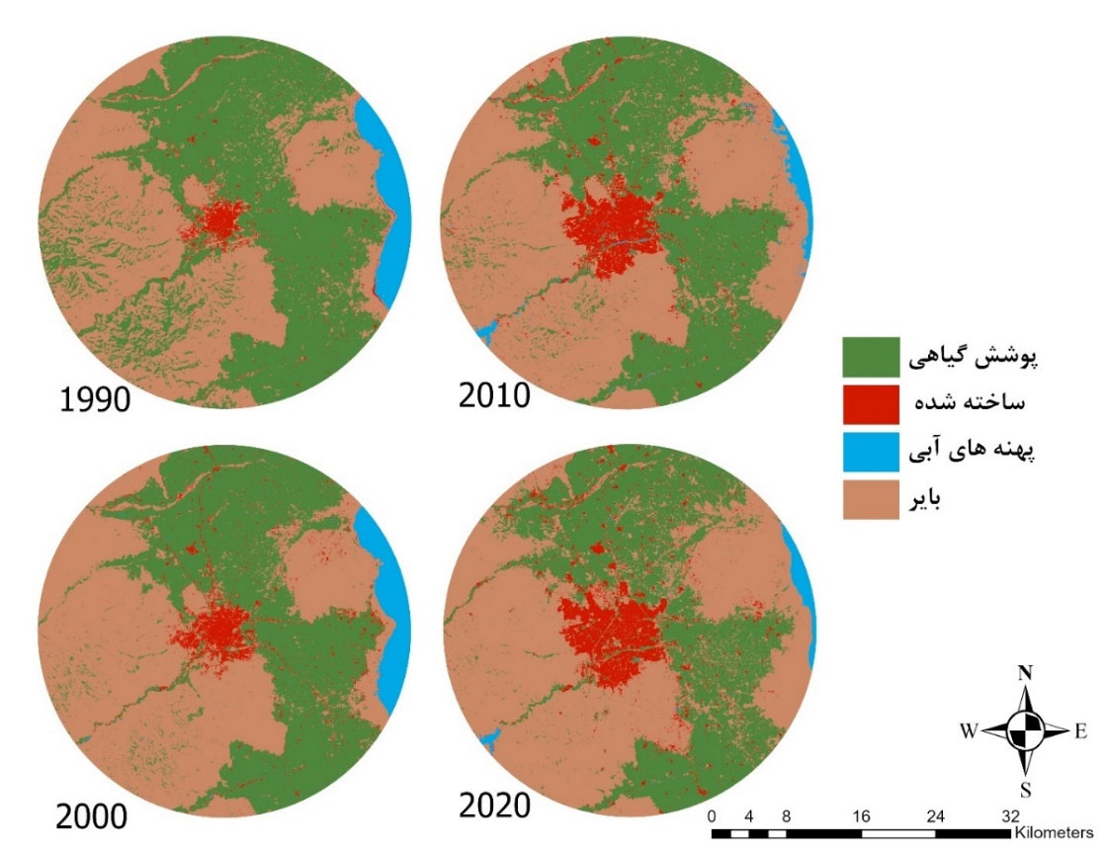
Vegetation
Built up
Water
Barren

Fig 1: Classified images of Urmia urban area 1990-2020
2-3- Gradient Model
When presenting geographical and temporal changes in patterns between urban and rural areas, the gradient model has proven to be a beneficial tool (McDonnell and Pickett, 1990; Zhang et al., 2016; Cheng et al., 2019; Yang et al., 2022). Urban expansion is examined in this study in terms of both space and time. Gradient analysis has been applied for this purpose in conjunction with geographic information systems and remote sensing. In this study, buffer analysis based on geographic information system is applied. It comprises of buffer zones encircling the city centre in a circle. At first, the central business area (CBD) is thought to be the core location and the focal point of the city. The entire area is covered by a buffer zone (20 concentric/buffer zones) with a width of 1 km. This system is intended to monitor Urmia's general process of expansion, encompassing both the city and its suburbs. Next, in eight equal directions (north, northeast, east, southeast, south, southwest, west, and northwest), the final circular region is divided. In order to enable statistical comparison, these many areas are used to extract the built area in various directions.
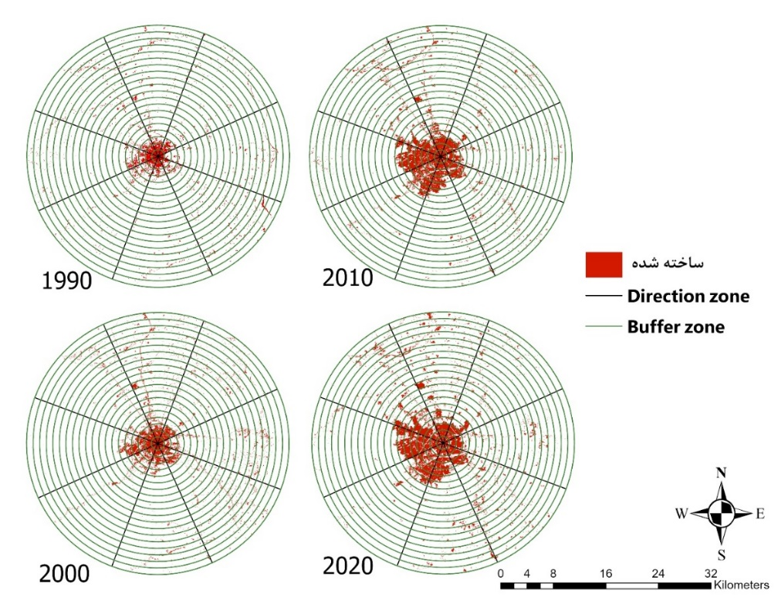
Built up

Fig 2: Built-up lands and zoning of Urmia urban area in the period of 1990-2020

2-4- Urban expansion measurement
The pace, volume, and intensity of urban expansion have all been studied, and growth ratio indicators and geographic information system (GIS) analytical techniques have been used in several of these investigations. Urban expansion intensity index (UEII) (Hu et al., 2007; Herold et al., 2015), landscape expansion index (LEI) (Liu et al., 2009), and urban expansion differentiation index (UEDI) are a few examples of Certain ones have been utilised on a frequent basis. Urban expansion was measured in this study using a mixed method (Heidarinejad, 2017).
The first statistical index to determine the average annual urban growth rate is the Average Annual Urban growth Rate (AUER) (Equation 4). According to Acheampong et al. (2016), this indicator determines the built-up land's average yearly increase during the course of the study period in a case study. Although it can be computed for any duration, AUER is typically computed for yearly intervals. An effective metric for comprehending and controlling urban growth is AUER. It can be used to monitor the rate at which urban areas are growing, pinpoint regions that are seeing fast urbanisation, and evaluate how urban development affects other forms of land cover (Seto et al., 2012; Angel et al., 2007; Zhao et al., 2020).
Equation 4
$${AUER}_{i}=\left[{\left(\frac{{ULA}_{it2}}{{ULA}_{it1}}\right)}^{\frac{1}{∆t}}-1\right]×100$$
where AUERi is the annual urban expansion rate. ULAit2 and ULAit1 are the area of unit i at times t2 and t1, respectively. AUER is not affected by the size of the spatial unit. ∆t is the study period.
Furthermore, this study has employed the Urban Expansion Intensity Index (UEII).
Equation 5 illustrates how the UEII determines a geographical unit's annual average proportion of newly built-up land, standardised by the unit's total area (Manesha et al., 2021). The following is its formula (Li et al., 2015).
Equation 5:
${UEII}_{i}$ $=\frac{\left|{ULA}_{it2}-{ULA}_{it1}\right|}{{TLA}_{i}×∆t}×100$
Unit I's urban expansion intensity index is denoted by UEIIi, whereas ULAit2 and ULAit1 represent the areas within unit I at periods t2 and t1, respectively. The entire area in unit I, t of the research period is denoted by TLAi. Consequently, the computation involves splitting the mean yearly rate of urban growth by the entire area of a certain geographic region. Higher values of the unitless UEII index denote a faster and more intensive rate of urban expansion (MacGregor-Fos et al., 2022; Liu et al., 2021; Zhou et al., 2020).
Changes in the amount of urban area per unit of time can be assessed using the urban growth intensity index. This index is important for assessing the geographical variations of urban growth because it provides a quantitative assessment of the volume and intensity of urban expansion (Heidarinejad, 2017; Medayese et al., 2023). Urban expansion will vary depending on the regulation of urban driving variables and their geographical consequences during the expansion process.
The preference for urban growth is the term used to describe this tendency (Alsharif and Pradhan, 2013; Heidarinejad, 2017). Urban spatial expansion has been quantitatively evaluated and analysed in this study using UEII. Furthermore, the desire for urban expansion during a given time period was identified using UEII. UEII measures the intensity of changes in urban cover over time and represents potentials for urban expansion. The Urban growth Intensity Index (UEII) scores of the 20 concentric regions that comprise the region are divided into five UEII regions (Table 1) to reflect the spatial evolution pattern of urban land growth. (Heidarinejad, 2017; Alsharif et al., 2015).
Table 1: Range of Urban Expansion Intensity Index
Range | Potentials of urban expansions
0 <UEII <0.28 | Slower development
0.28 <UEII <0.59 | Low-speed development
0.59 <UEII <1.05 | Medium-speed development
1.05 <UEII <1.92 | High speed development
UEII <1.92 | Extremely high-speed development
Ref: Acheampong et al., (2016); Heidarinejad, (2017)
Furthermore, the Urban Expansion Differentiation Index (UEDI) determines the proportion of the total altered area to the growth in urban area of one unit (proportionally). In contrast to UEII, UEDI measures the difference in urban land expansion between various spatial units. It so renders the units comparable. (Acheampong et al., 2016; Heidarinejad). The differentiation or diversity in urban growth patterns in a given area is assessed and quantified using the urban expansion differentiation index (UEDI), which is used in land use analysis and urban planning. This index offers insightful information about the nature and spatial distribution of urban growth throughout time(Zhao et al., 2020; Yan et al., 2018). This criterion is useful in evaluating the differentiation of urban land expansion and identifying hot spots of urban expansion. The formula for this case is as follows (Li et al., 2015):
Formula number 6:
${UEDI}_{i}$ $=\frac{\left|{ULA}_{it2}-{ULA}_{it1}\right|×{ULA}_{it1}}{\left|{ULA}_{it2}-{ULA}_{it1}\right|×{ULA}_{it1}}×100$
The entire area of unit i at times t2 and t1, respectively, is represented by ULAit1 and ULAit2, while the differentiation index of urban expansion in unit i is denoted by UEDIi. Generally speaking, UEDI can be divided into three categories: (1) The study region as a whole classifies a region as fast-growing when the differentiation index of the constituent geographical unit, or region, is greater than 1. (3) When the region differentiation index equals 1, the region is compared to the region (2) when the region differentiation index is less than 1, in which case the region is defined as a slow-growth region in respect to the case study, and Table 2 categorises the research area as a medium growth area (Acheampong et al., 2016; Heidarinejad, 2017).
Table 2: Range of the Differentiation Index for Urban Expansion
Range | Urban Expansion Differentiation
UDEI<1 | Fast Growing Area
UDEI=1 | Moderate Growing Area
UDEI<1 | Slow Growing Area
Ref: Acheampong et al., (2016); Heidarinejad (2017)

2-5- Measurement of urban spatial patterns
Quantitative measurements of an object's or feature's spatial distribution are called spatial metrics. By assessing urban land use parameters like the size, form, and connection of various urban elements, they can quantify the urban spatial pattern. According to the study's goals, three dimensions have been determined in order to comprehend the primary patterns of urban expansion, which are the outcome of spatial patterns within the city. Using the Fragstats 4.2 programme, several landscape parameters were computed in order to draw the urban spatial layout. Finding the association between metric and pattern values is challenging, though. Intercorrelation exists between most metrics (McGarigal et al., 2012).
Quantifying the spatial patterns' accumulation level is a crucial step in urban pattern analysis (Hong et al., 2000; Clark & Evans, 1954). He et al. (2001) claim that the aggregation index is a useful tool for managing and understanding spatial patterns in the surrounding environment. The aggregation index (AI) is a spatial statistic that quantifies the degree to which related characteristics are aggregated or clustered together in a landscape or spatial dataset. The aggregation index is the number of adjacencies of a given land cover class divided by the maximum number of adjacencies that may potentially belong to that class. It may be more effective since it allows concentrate on just one class at a time (Alberti, 2008). This index indicates the degree to which the objects in a given region are distributed or grouped. Evaluating the spatial distribution of species or phenomena is helpful in a number of fields, such as ecology, geography, and urban planning. Because this index is class-specific, it is more accurate than other indices that measure landscape aggregation generally. Consequently, AI provides a quantitative basis for linking a class's spatial pattern to a specific process. The map units have no bearing on the computation because the aggregate index is a ratio variable. It may be contrasted with other or comparable picture classes, or even with other similar classes of the same image at various resolutions. (Hong et al., 2000; Heidarinejad, 2017). The specific formula and method for calculating the aggregation index can differ depending on the research question, the type of data, and the software used. These methods consider the spatial arrangement of features and compare them to a random or uniform distribution to determine whether the features are clustered or scattered.
Compaction indices are calculated to determine the urban footprint. The urban footprint is almost a circle. This study uses the mean radius of gyration (MRoG) as a convenient tool to measure the extent of patches and joints, which preserves the actual measurement units (meters). The mean radius of gyration is a spatial metric that measures the dispersion of habitat patches around a central point. Thus, the average gyration index provides insights into how objects are concentrated or dispersed in a region. The average radius of the gyration index is equal to the average distance (m) between each cell in the patch and the center of the patch (Heidarinejad, 2017; Botequilha et al., 2006; Baker et al., 2015; Rocha et al., 2016). As a result, the mean radius of rotation is a useful measure to evaluate the impact of land use change on landscape landscapes (Baker et al., 2015). A smaller mean radius of gyration (MRoG) index indicates compactness, while a larger mean radius of gyration (MRoG) index indicates that objects are more scattered from their center (Wang et al., 2018; Pérez-Hernández et al., 2018). It should be noted that the Mean Radius of Rotation Index (MRoG) is a powerful tool for understanding and managing the terrain. It is a relatively new measure, but it has quickly gained popularity among climate ecologists and researchers from other disciplines (McGarigal et al., 2012; Rocha et al., 2016).
An effective spatial measure for determining the average distance between items or points in a collection is the Euclidean Mean Nearest Neighbor (ENN_MN). In spatial analysis, knowing the general spatial distribution of features or objects is very useful. This measure sheds light on whether items in a study area scatter or cluster. Therefore, a spatial statistic that calculates the average distance between a point and its nearest neighbor in the same class is called the average Euclidean distance of the nearest neighbour. It is computed by dividing the total number of points by the sum of the distances between each point and its closest neighbors within a class. According to the shortest straight-line distance determined from the cell centers, Euclidean Mean Nearest Neighbor (ENN_MN) determines the distance to the closest neighboring patch of the same kind (McGarigal and Marks, 1995; Diggle, 2013; Jin and He, 2012; Liu et al. al., 2019). Euclidean nearest neighbor mean values are never less than zero and never have boundaries. This index gets closer to 0 as the distance from the closest neighbor gets smaller. The cell size, which is equal to twice the cell size when applying the neighboring patch rule, sets a minimum value for this index. The size of the territory, which in this study is the size of the block, sets an upper limit. The average Euclidean nearest neighbor is not defined if the patch has no neighbors, that is, no other patches of the same class (Heidarinejad, 2017; McGarigal, 2012). As a result, the index's value represents the typical separation between an object and its closest neighbors. A smaller value denotes clustering or spatial dependence, meaning that objects are more likely to be found in close proximity to their immediate neighbors. Conversely, a greater value suggests that the items are dispersed more widely or uniformly within the research region (Diggle, 2013; Jin and He, 2012).
2-6- Regression
Variations in the spatial criteria values were employed as dependent variables to comprehend the impact of urban expansion on spatiotemporal patterns. Understanding how urban expansion affects spatial patterns required an understanding of the results of quantifying urban expansion using growth ratio indices (UEII and UEDI) as independent variables. Furthermore, taken into consideration as dependent variables were modifications in the spatial metrics' values (AI, GYRATE_MN, and ENN_MN).
One of the many increasingly popular spatial regression methods is geographically weighted regression (GWR). A spatial statistical method for modelling spatially varied connections between variables in geographic data sets is called geographically weighted regression, or GWR. By fitting a regression equation for each feature in the data set, geographically weighted regression yields a local model of the variable (Heidarinejad, 2017; Fotheringham et al., 2002). Geographically weighted regression generates spatial data that indicate spatial diversity in interactions between variables, in contrast to traditional regression, which generates a single regression equation to summarise the overall correlations between explanatory and dependant variables. These data are used to create maps, which are essential for analysing and understanding spatial relationships. This regression's equation (Equation 7) can be written as follows (Zhou et al., 2020; Fotheringham et al., 2002).
Equation 7:
$$ŷ_{1}=β_{0}\left(u_{i}v_{i}\right)+\sum_{k}{β_{k}\left(u_{i}v_{i}\right)x_{ik}+ε_{i}}$$

Where yî is the estimated value of the dependent variable for observation i, β0 is the cross-sectional variable, βk is the parameter estimate for variable k, xik is the value of the kth variable for i, εi is the error term, and (uivi) takes the coordinate location of i.
It is posited that the influence of nearby observations on each other's parameter estimation is more than that of distant observations. A distance decay function with observation i at its centre determines the weight given to each observation. The distance between polygon centres is used to compute the distance between observations when dealing with regional data. Where the weight distance quickly approaches zero, a bandwidth adjustment modifies the distance decay function, which might take on many shapes. The analyst might choose the bandwidth manually or by optimising it with an algorithm that aims to reduce the cross-validation (CV) score. As an alternative, the Akaike Information Criterion (AIC) score can be minimised to determine the bandwidth. (Equation 8) (Medayese et al., 2023; Heidarinejad, 2017; Nakaya et al., 2005).
Equation 8:
$$AIC_{t}=2n\log_{e}\left(σˆ̂\right)+n\log_{e}\left(2π\right)+n\left\{\frac{n+tr\left(S\right)}{n-2-tr\left(S\right)}\right\}$$

One benefit of using the AIC technique is that it accounts for the possibility of multiple degrees of freedom in models based on different observations. Furthermore, the user can select between a variable bandwidth that grows and decreases in the model over regions with sparse observations, or a set bandwidth that is used for each observation. Regressing regions of dense observations is more crucial for the model with a lower AICt value. For the GWR model, the AICt approach was therefore applied in this investigation (Medayese et al., 2023; Heidarinejad, 2017; Griffith, 2008).
- Results and Discussion
In this research, the appearance of land use changes in a specific area in four different decades (1990, 2000, 2010 and 2020) is very important. These data are obtained from remote sensing images and image processing techniques and make it possible to interpret changes in urban expansion, vegetation, water resources, and land cover status of the region.
Table3. Area and share of Landuse
Year | 1990 |  | 2000 |  | 2010 |  | 2020
Land use | Km² | % | Km² | % | Km² | % | Km² | %
Vegetation | 598.67 | 47.71 | 505.70 | 40.30 | 482.44 | 38.45 | 449.56 | 35.83
Built-Up | 34.43 | 2.74 | 63.13 | 5.03 | 87.33 | 6.96 | 109.64 | 8.74
Water | 56.94 | 4.54 | 56.46 | 4.50 | 24.04 | 1.92 | 17.80 | 1.42
Barren-Land | 564.76 | 45.01 | 629.50 | 50.17 | 660.98 | 52.68 | 677.78 | 54.02

Built up
Water
Vegetation
Barren
Fig 3. Share of land uses 1990-2020

According to the data in Table 3 and Figure 3, in 1990, the total area of the study area was equal to 1254.80 square kilometers. 47.71% (598.67 square kilometers) belonged to vegetation. This percentage gradually decreased in the following years and decreased to 35.83% in 2020. This decrease represents the increase in construction activities and urban development, which, on the one hand, requires urban development and, on the other hand, affects the issues related to the preservation of natural resources and vegetation.
The share of built-up users has also increased greatly in these periods. In 1990, only 2.74% (34.43 km²) of the area was built-up. But, in 2020, this number has increased to 8.74% (109.64 square kilometers). This increase represents comprehensive urban development and changes in the urban structure of the region.
As for surface waters, their area in 1990 was equal to 4.54% (56.94 square kilometers) of the total area and has shown a continuous decrease in the following years. In 2020, only 1.42 percent (17.80 km2) of the area was devoted to water. This decrease represents the lack of water resources and changes in the region. This issue raises the need for proper management of water resources.
Barren lands have also played an important role in these changes. Their area has increased from 45.01 percent (564.76 square kilometers) in 1990 to 54.02 percent (677.78 square kilometers) in 2020. This increase represents the changes in the geological and climatic conditions of the region.
In general, a detailed analysis of these data shows that several factors have influenced land use changes during these four decades. The increase of the built surface and the decrease of plants in cities represent the processes of urbanization and urban development. Instead, the reduction of water resources and the increase of barren lands represent changes in the geological and climatic conditions of the region.

Table 4. Conversion between land uses (KM2)
بازه زمانی
Class | 1990-2000 | 2000-2010 | 2010-2020
1->2 | 21.73 | 10.95 | 16.59
1->3 | 1.39 | 1.59 | 0.29
1->4 | 103.54 | 56.43 | 57.84
مجموع | 126.66 | 68.98 | 74.72
2->1 | 4.00 | 11.73 | 5.65
2->3 | 0.14 | 1.51 | 0.09
2->4 | 8.35 | 8.85 | 14.18
Total | 12.49 | 22.08 | 19.92
3->1 | 0.03 | 1.07 | 2.11
3->2 | 0.20 | 0.62 | 0.48
3->4 | 2.45 | 36.82 | 5.43
Total | 2.68 | 38.52 | 8.03
4->1 | 29.73 | 32.93 | 34.06
4->2 | 19.29 | 34.70 | 25.16
4->3 | 0.68 | 2.93 | 1.39
Total | 49.70 | 70.56 | 60.61
1- Vegetation 2- Built up 3-Water 4- Barren

In Table 4, land use transformations in different time frames for four land classes (vegetation, built-up, water areas, and barren) are given in the study area. This table shows the changes that have occurred in land use during the specified period of time.
From land class 1 (vegetation) to land class 2 (built), 21.73 square kilometers of vegetation land has been converted to built from 1990-2000. This figure will decrease to 10.95 square kilometers in the next decade. But in 2010-2020, there was an increasing trend, and vegetation conversion to built-up area was 16.59 square kilometers. Similar transformations are observed in land class 1 (vegetation) to land class 3 (water areas). These changes show that several vegetation lands have turned into water areas. But these changes have decreased in recent decades compared to previous decades. Also, a similar trend is observed in converting vegetation to barren. So, in 1990-2000, the conversion rate was 103.54 square kilometers. But in the following decades, it has decreased to 56.43 and 57.84 square kilometers. In general, reducing vegetation and converting it to other uses, especially barren and built lands, is evident in all decades. In the last decade, this conversion has increased. Another significant trend related to converting irrigated lands to barren lands, especially in 2000-2010, is that about 36.82 square kilometers of irrigated areas has been turned into barren lands. The conversion of barren land into built-up land is also a good indication of the result of urban expansion in the urban area of Urmia, the highest amount of which was 34.70 square kilometers in the years 2000-2010.
In 1990, the built area was 34.43 square kilometers, which increased over the years and reached 109.64 square kilometers in 2020. Therefore, the share of built area has also increased in these periods. In 1990, the built-up area of the total area was 2.74%, and in 2020 it increased to 8.74%. This increase in the share of the built area shows urban growth and urban development in these periods. Furthermore, the annualized growth rate (AUER) shows that approximately 83.3% of this increase occurred in the initial period. Compared to 25.5% in the last 10-year period, the volume of urban expansion in the first period was the highest(Figure 4).
Overall, the analysis shows that the city expanded continuously during these periods. The built area has increased in proportion to the total area. It may indicate urban expansion and population growth.

Fig 4. Area and share of total built up land

3-1- Evolutionary-temporal features of urban land expansion
Every place and direction may experience urbanisation in a different way. This phenomena is indicative of the urban area's growth. The Urban Expansion Intensity Index (UEII) adjusts the yearly rate of urban growth for every study unit based on its land area. This score was utilised in the current study to determine if urban expansion was preferred over a 30-year period in a case study. The built-up area intensity in various city regions from 1990 to 2020 is contrasted in Figure 4.
Figure 5 shows that the highest values of the urban intensity index are from 1990 to 2000. This issue indicates the major occurrence of urban expansion in this period. Thus, from the city center to a distance of 4 km, it has increased rapidly to a value of 34.88, which indicates the experience of high intensity of urban expansion in this area. But, the highest intensity of urban expansion occurred at a distance of 16 km with a value of 69.66. But in the following decades, the intensity of urban expansion is significant only up to a radius of 7 km, and from a distance of 8 km from the city center, with increasing distance and decreasing the intensity of expansion, it has slowly decreased, and the intensity of expansion has decreased in peripheral areas. The outcome reveals that Urmia City's central regions are home to the region seeing the highest rate of expansion. However, the following decades saw a marked decline in the expansion intensity relative to the previous phase.

Fig 5. Changes in the intensity index of urban expansion (UEII) in the central regions

Fig 6. Urban expansion variations in the intensity index (UEII) in different geographical directions
The expansion intensity index for Urmia during a 30-year period is compared in Figure 6 in various directions within the city. The primary directions of urban expansion throughout the first ten years of the 1990s–2000s were north and east. However, the rate of urban growth has accelerated in the north, west, and southwest in the ensuing decades. The tremendous rate at which the populated areas to the north of Urmia are expanding is astonishing.
The difference index, in contrast to the urban expansion intensity index (UEII), normalises urban expansion (UEDI) to the rate of expansion throughout the metropolis. so strengthening the uniformity between the units of spatial expansion (Achiampong et al., 2016). This indicator is frequently used to assess the trend of urban expansion and identify regions that experience significant variations in urban expansion.
It is evident from Figure 7's fluctuations in UEDI index values over a 30-year period that the model needed to be more reliable. According to the UEDI index, the beginning point in the first period was almost equal to 0 (central areas), and in the subsequent periods, it rose in the peripheral areas. The examination revealed that the case study's original centre has been enlarged in subsequent years. In fact, over the past ten years, nearly all inner-city areas have increased their UEDI scores. In other words, over time, the central areas close to the previous lands are built, and as a result, urban expansion occurs at distances far from the center. Areas located within a radius of 3 to 8 kilometers from the city center have grown significantly from 1990 to 2000. The main reason is the addition of urban areas. However, the areas located in 9 to 13 km have grown less than those in 13 to 16 km, which can be one of the reasons for establishing industries and activities related to agriculture. From 2000 to 2010, however, the largest urban expansion occurred in 6 and 7 kilometers from the city center, and other areas experienced even less growth compared to other decades. From 2010 to 2020, the radius of 8 km from the city center has experienced the greatest expansion of built-up lands. But another important thing that has happened is the significant growth of the radius of 11 to 14 kilometers of built-up land. One of the possible reasons for this is the land use policies and the transfer of some incompatible industries and services outside the city, as well as the growth caused by the addition of rural centers to the city.
Figure 8 shows the difference index values of urban expansion in which directions. Therefore, in the first decade of 1990-2000, the greatest difference and intensity of urban expansion occurred in the direction of east and north. But, in the next decade, the desire to expand the built lands in the southwest, west, and northwest has increased. Finally, in the decades of 2010-2020, the pattern of urban expansion has tended toward the east and northern regions, which is mainly due to the increase in agricultural and industrial activities.

Fig 7. UEDI index values in concentric regions

Fig 8. UEDI index values in geographical directions
In order to better understand and compare the UEDI values, the UEDI pattern in Urmia (hot spot) was examined according to three selected patterns. There are three possible expansion classes based on this index:
High (ie UEDI>1),
Medium (ie UEDI = 1)
and low (ie UEDI<1) (Heidarinejad, 2017).
The top class of UEDI was split into "very high" and "high" subclasses based on the values that were obtained. Likewise, there were two categories for the lower class: "low" and "very low." The Jenks Natural Breaks method in ArcGIS is used to display the five UEDI score classes in concentric zones in Figure 9. The spatial visualisation outcomes for directional zones in this category are also displayed in Figure 10.
The acquired data indicated that during the course of two decades, marginal areas were home to the hotspots of urban expansion. The north and northeast are experiencing extremely fast expansion, whereas the west and south are experiencing the slowest rate of expansion.

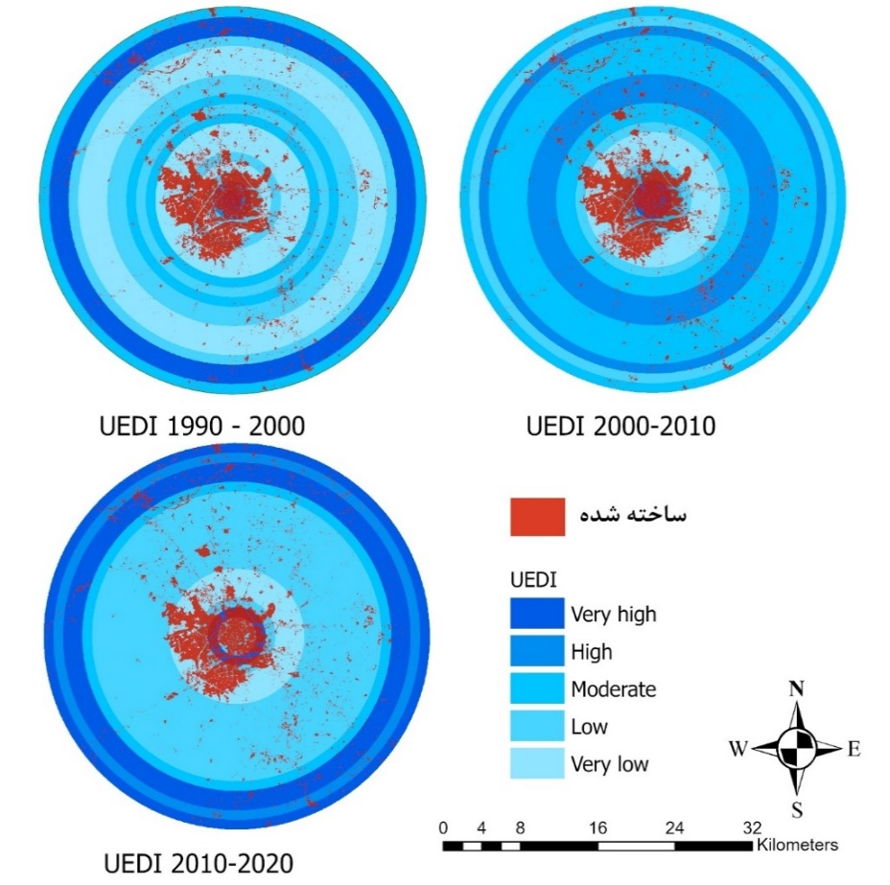
Built up
Fig 9. UEDI index values in concentric regions
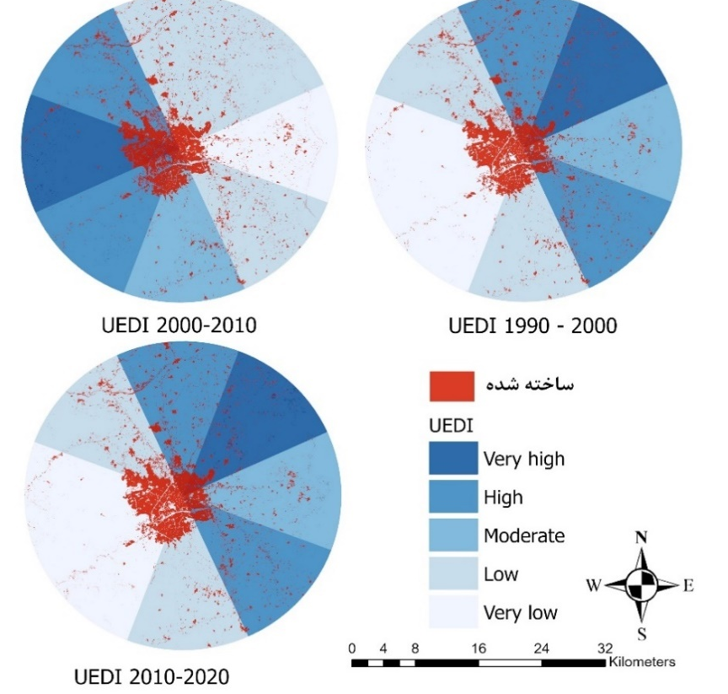
Built up
Fig 10. UEDI index values in geographical directions

3-2- Patterns of landscape in the urban area of Urmia
Three geographic land analysis criteria were applied in order to examine and contrast patterns of urban expansion. At both the micro and macro levels, the three primary features of the urban pattern—aggregation, compactness, and isolation—were explained by these spatial criteria. Spatial requirements were interpreted for the entire Urmia urban region at the macro level. The analysis of spatial micro-patterns in concentric zones and in various orientations has persisted in this work.
Data on changes in land spatial criteria values over time in the Urmia urban area between 1990 and 2020 is shown in Figure 4. The expansion of additional urban patches is typically factored into the distribution of urban areas, as indicated by the rising AI index. The heightened aggregation suggests that there was a tendency for the synthetic stains to develop an aggregation pattern. Furthermore, the rising trend of ENN_MN demonstrated a decline in the isolation process over the course of the investigation. Moreover, compaction in the city showed an increasing trend, according GYRATE_MN. The increase in GYRATION_MN and AI generally indicates the fragmented growth and scattered development of the current metropolis in Urmia.

Fig 11. Temporal changes of land spatial indicators in Urmia urban area
Temporal changes in spatial measures were interpreted in spatial units in order to provide a more comprehensive picture of the pattern of urban expansion in the Urmia urban area. Figure 12 shows the evolution of cumulative index value for 30 years since 1990. This graph shows a similar negative trend in the cumulative index value in 20 concentric regions over 30 years. The value of the AI index decreased sharply with increasing distance from the city center. Urmia's centre sections generally have higher cumulative index values. This could result in the emergence of tiny construction sites in the city's periphery and surrounding areas. This can become a problem if the city grows through dispersed development.
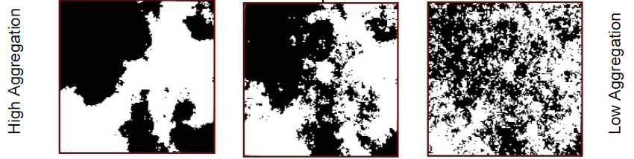

Fig 12. AI index changes based on distance from city center
The next graph (Figure 13) of the AI index in the case study in different directions shows how much the ratio of each spatial unit of the accumulation process was from 1990 to 2020. Overall, according to the graph, a higher value of AI is recorded in the Southeast (SE), South (S), and Southwest (SW) regions. In other words, the patches of land built in these areas have a more cumulative pattern than other areas.

Fig 13. AI index changes based on geographical directions
The Gyration index was used in directed and concentric zones to examine the micro compaction process. The Gyration index value variation in Urmia between 1990 and 2020 is depicted in Figure 14. In general, it is evident that the Gyration Index declined quickly, reaching its minimum value approximately 8 km outside the city centre. Then, on the periphery, there has been a consistent tendency. Research has generally indicated that the densification process has been accelerating in Urmia's periphery.

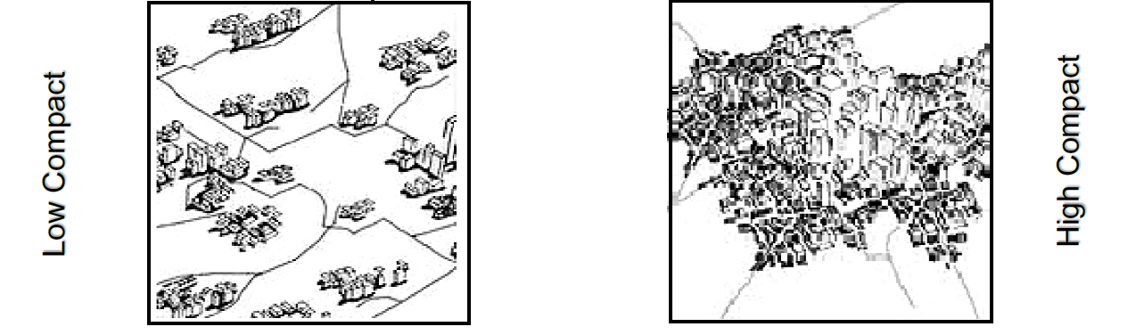
Fig 14. Gyration index changes based on distance from the city center
The diagram below (Figure 15) compares the Gyration index in directional zones. This graph shows that in the 1990s-2000s, the eastern (E) and southern (S) regions recorded high values of the gyration index. This process has been similar in the following decades. But, in the following decades, the western part of the region has also witnessed the growth of this index.

Fig 15. Gyration index changes based on geographical directions
The ENN_MN index, which measures the growth in the distance between areas of the same type of use, was used to examine the next pattern (separation or isolation). The change in ENN_MN in peripheral regions between 1990 and 2020 is depicted in Figure 16's linear diagram. This figure indicates that there is a decrease in the variety of uses as the distance from the city centre grows along with the degree of isolation.

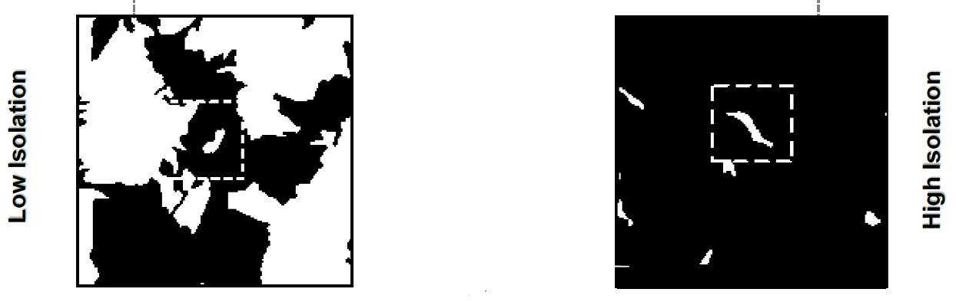
Fig 16. Changes of the ENN_MN index based on the distance from the city center
The directions with the greatest index values during the research period are displayed in the radar diagram (Figure 17). It is evident that the directional and peripheral zones have higher ENN_MN values overall. Furthermore, the index value in the centre regions is significantly lower than in the periphery regions, and it has exhibited a consistent trend over the course of the time. The graphs had identical initial values, but their periphery saw a dramatic increase in value. West (W) and Northeast (NE) have the best separation technique.

Fig 17. ENN_MN index changes based on geographical directions
Two phases can be distinguished when examining Urmia's urbanisation. A decline in the AI index indicates that between 1990 and 2000, the city's core area grew due to the rapid expansion in the city's periphery. Furthermore, fresh growth is seen in regions that are divided from one another by open space. It displays the city's sweeping growth. Between 2000 and 2010, there was a decline in the rate of urban expansion. The accumulation of specks fell significantly during this time, and the city saw a cumulative decline in GYRATION_MN. It might suggest that urban patch development has been the main focus of Urmia's ongoing growth, and that this development has been accompanied by a notable rise in ENN_MN and a cumulative decline in Gyration.
3-3- Urban spatial patterns and the consequences of urban expansion
Two spatial indices (growth ratio indices) for gauging urban expansion are UEII and UEDI, as was previously mentioned. They are regarded as independent factors to look into the connection between spatial patterns and urban growth. Furthermore, the spatial criteria's value is regarded as a dependent variable. The GWR model was selected as a useful model to examine the connection between these two categories of variables. Table 5 displays the corrected R² and AICt values produced by the GWR model for various time periods.
Table 5. The GWR regression measures' outcomes
Period | Spatial metrics | Adjusted R² |  | AICt
Period | Spatial metrics | UEII | UEDI | UEII | UEDI
1990-2000 | AI | 0.4571 | -0.1402 | 174.4822 | 54.6116
1990-2000 | GYRATE_MN | 0.4093 | 0.1429 | 176.7599 | 48.9642
1990-2000 | ENN_MN | 0.2664 | -0.0893 | 178.6680 | 53.5632
2000-2010 | AI | 0.3974 | -0.1134 | 140.6866 | 87.4393
2000-2010 | GYRATE_MN | 0.4646 | -0.0422 | 137.1340 | 85.4452
2000-2010 | ENN_MN | 0.2710 | -0.0941 | 144.4142 | 86.9415
2020-2010 | AI | 0.2347 | -0.0349 | 99.7322 | 73.1597
2020-2010 | GYRATE_MN | 0.2488 | 0.0912 | 97.8137 | 70.7454
2020-2010 | ENN_MN | 0.1265 | 0.1703 | 101.8860 | 74.1855

Overall, Table 5 shows higher values for R² and AICt for UEII than for UEDI. The analysis of two distinct variables reveals that the index of urban development exhibits a more robust correlation with spatial patterns. To put it simply, alterations in spatial arrangements are strongly correlated with the magnitude of urban expansion.
The regression coefficients exhibited substantial variation among urbanised locations. The spatial distribution of the coefficient indicates that the connections between spatial factors and UEII values differ across concentric zones. The coefficients for each spatial pattern exhibited a consistent trend for the first two decades, which remained relatively unchanged in the last decade, as illustrated in the accompanying graphs.
The initial graph (Figure 18) depicts the correlation between UEII and AI as influenced by the proximity to the urban core over a span of two decades. Initially, a notable positive association was identified at a distance of 12 km from the city centre. This suggests that the acceleration of expansion can result in a rise in the agglomeration process. The negative coefficients observed at a distance of 12 km from the city centre indicate that the rapid growth of urbanisation results in a decline in the development of larger urban structures and an increase in the consolidation of land in the peripheral areas of Urmia.

Fig 18. The relationship between UEII and AI based on the distance from the city center
The shift in relationship values between ENN_MN and UEII in the central sections is depicted in the second diagram (Figure 19). Both positive and negative values have been displayed by the separation index. Over the course of the investigation, a negative correlation has been found overall. It demonstrates how the intensification of urban expansion results in a lessening of the separation process as one moves away from the city centre. Conversely, the growth of ENN_MN has been positively impacted by urban expansion. The AI trend line value and the ENN_MN value exhibit a reversing trend when compared.

Fig 19. The Relationship between ENN_MN and UEII based on distance from city center
Figure 20 illustrates how varied oscillations were seen throughout the study period in the effects of expansion on the changes of GYRATION_MN value in various regions. The regions that have suffered the most are 17 km out from the city centre. The intensification of urban expansion in region 17 has resulted in a decline in the index of gyration and the dispersion process, as indicated by the negative link between the intensity of expansion and the index of accumulation (Gyration index). Overall, the GWR analysis demonstrated that Urmia City's spatial arrangement may greatly accelerate urban expansion.

Fig 20. Relationship between GYRATION_MN and UEII based on distance from city center

- Conclusion
The current study examines the urban expansion of medium-sized cities. In this sense, user changes have been addressed first. The results show that during the course of the four decades under investigation, a variety of factors have influenced changes in land usage. Growing built-up areas and dwindling plant life in Urmia are indicators of the city's increasing urbanisation. Rather, the rise in arid areas and the decline in water resources represent changes in the climate and geology of the region. The conversion of desert land into developed land in the Urmia metropolitan area is a good predictor of the effects of urbanisation.
Therefore, in the next step, the urban expansion process of Urmia between 1990 and 2020 will be investigated. In this regard, three indicators and two types of boundaries (directional zones and concentric circles) have been used. The results show that the area of Urmia City during the periods under review has been continuously expanded, and the built area has increased proportionately to the total area. Also, the findings indicate that the middle areas of Urimeh city have expanded with high intensity. Compared to the first period (1990-2000), the intensity of expansion has decreased significantly in the following decades. In the first decade of 1990-2000, the greatest difference and intensity of urban expansion occurred in the direction of the east and north of Urmia city. However, in the next decade, the desire to expand the built lands in the southwest, west, and northwest has increased. Finally, in the decade of 2010-2020, the pattern of urban expansion has tended towards the east and northern regions. The main reason is the increase in agricultural and industrial activities. In the next step, the patterns of the landscape in Urmia city have been examined. In general, the growth of Urmia city has been in the form of scattered and fragmented development. The results show that the density process has been increasing in the marginal areas of Urmia city. As the distance from the city center increases, segregation also increases, which means a decrease in the variety of uses.
Spatial-geographical regression analysis showed that the spatial pattern of Urmia city can significantly intensify urban expansion.
The results of the present study show that the city of Urmia has experienced urban sprawl in different periods. It confirms the study's results by Abedini et al. (2020). In the discussion of the quantification of growth patterns, the results of the present study show the efficiency of using UEDI, UEII, and AUER indices. This issue is consistent with the results of Heidarinejad's research in 2017 and confirms the suitability of his proposed method for studying the patterns of urban expansion in mid-organ cities.
Examining the characteristics of Urmia's urban growth serves as a useful illustration of Iran's medium cities. Evidence from the study suggests that urban sprawl has expanded in Urmia city's periphery due to urban expansion. Compared to a more compact pattern, this urban design may result in greater ecological and environmental issues. The dispersed pattern on the outskirts of the city has resulted in a significant loss of agricultural land, making it imperative to improve the efficiency of land management policies and urban land use planning. The study's conclusions lead to the following recommendations:
Infill development policy: considering that Urmia City has many vacant lands (Abedini & Khalili, 2019). This potential can lead to the optimal use of the existing land and stop the expansion and destruction of the land around the city.
Detailed investigation and monitoring of land use changes: The land use pattern, as one of the most sensitive issues in urban planning, is not only a physical issue but also a social, economic, environmental, and management issue. On the other hand, it should be given sufficient attention in urban development plans, especially the master plan, which is the guiding document for the comprehensive development of the city. For example, the gardens inside Urmia remain neglected for a long time until they turn into barren lands. Finally, these lands will be converted into a built environment. Therefore, it is necessary to control these cases using legal tools such as a comprehensive and detailed city plan. Utilizing green infrastructure, such as including green spaces, parks, and natural corridors in urban plans to improve environmental quality, provide recreational opportunities, and reduce the heat island effect, can be helpful. Creating a green belt can also be useful for curbing urban expansion and protecting agricultural and natural areas.
For future research, it is recommended to consider factors driving urban expansion in different spatial units (directional and concentric zones) according to the spatial extent of the city. Also, the impact of urban expansion on different social groups has shown that urban sprawl has several adverse social effects, such as increasing income inequality, social isolation, and reduced access to public services. However, more research is needed to understand how these effects are distributed across different social groups, such as race, ethnicity, income, and age.

References
Al Rifat, S. A., & Liu, W. (2019). Quantifying spatiotemporal patterns and major explanatory factors of urban expansion in miami metropolitan area during 1992-2016. Remote Sensing, 11(21). https://doi.org/10.3390/rs11212493
Abedini, A., & Khalili, A. (2019). Determining the capacity infill development in growing metropolitans: A case study of Urmia city. Journal of Urban Management, 8(2), 316-327.
Abedini, A., Khalili, A., & Asadi, N. (2020). Urban sprawl evaluation using landscape metrics and black-and-white hypothesis (case study: Urmia City). Journal of the Indian Society of Remote Sensing, 48, 1021-1034.
Assari, A., Birashk, B., Mousavi Nik, M., & Naghdbishi, R. (2016). IJTPE Journal IMPACT OF BUILT ENVIRONMENT ON MENTAL HEALTH: REVIEW OF TEHRAN CITY IN IRAN. International Journal On, 26(1), 81–87.
Acheampong, E., Baffoe, G., & Asamoah, E. (2017). Urban expansion in the Greater Accra Metropolitan Area of Ghana: A spatial and temporal analysis. Land Use Policy, 67, 506-520.
Angel, S., Sheppard, S., Civco, D. L., Buckley, R., Perlin, S., & Herold, M. (2007). The dynamics of global urban expansion. Washington, DC: Transportation Research Board.
Angel, S., Sheppard, S., Civco, D. L., Buckley, R., Perlin, S., & Herold, M. (2007). The dynamics of global urban expansion. Washington, DC: Transportation Research Board.
Alsharif, A.A.; B. Pradhan (2013). Urban sprawl analysis of Tripoli Metropolitan city (Libya) using remote sensing data and multivariate logistic regression model. Journal of the Indian Society of Remote Sensing, pp. 1-15.
Alberti, M. (2008). Advances in Urban Ecology: Integrating Humans and Ecological Processes in Urban Ecosystems. Springer Science+Business Media, Boston, MA. CrossRef.
ALSHARIF, A. A. A., PRADHAN, B., MANSOR, S., & SHAFRI, H. Z. M. (2015). URBAN EXPANSION ASSESSMENT BY USING REMOTELY SENSED DATA AND THE RELATIVE SHANNON ENTROPY MODEL IN GIS: A CASE STUDY OF TRIPOLI, LIBYA. Theoretical and Empirical Researches in Urban Management, 10(1), 55–71. http://www.jstor.org/stable/24873521
Baker, J., Van Der Leeuw, S., & Van Os, B. (2015). Landscape metrics for assessing ecological connectivity and fragmentation. Ecological Indicators, 58, 192-198.
Bouhennache, R.; Bouden, T.; Taleb, A. A.; Chaddad, A. (2015). Extraction of urban land features from TM Landsat image using the land features index and Tasseled cap transformation. Recent Advances on Electro science and Computers.
Botequilha Leitão, A.; Miller, J.; Ahern, J.; McGarigal, K. (2006). Measuring landscapes: A planner's handbook (Washington: Island Press).
Clark, P. J., & Evans, F. C. (1954). Distance to nearest neighbor as a measure of spatial relationships in populations. Ecology, 35(4), 445-453.
Cao, Y., Wang, Y., Li, G., & Fang, X. (2020). Vegetation response to urban landscape spatial pattern change in the Yangtze River Delta, China. Sustainability (Switzerland), 12(1), 1–18. https://doi.org/10.3390/SU12010068
Chakraborti, S., Das, D. N., Mondal, B., Shafizadeh-Moghadam, H., & Feng, Y. (2018). A neural network and landscape metrics to propose a flexible urban growth boundary: A case study. Ecological Indicators, 93(February), 952–965. https://doi.org/10.1016/j.ecolind.2018.05.036
Cheng, J., Zhang, Y., & Li, Z. (2019). A gradient model for land use classification using remote sensing data. Remote Sensing of Environment, 231, 111476.
Diggle, P. J. (2013). Statistical Analysis of Spatial and Spatio-Temporal Point Patterns (3rd Edition). CRC Press.
Feyisa, G. L., Mehari, A. S., & Bewket, W. (2014). Water resources assessment using the modified normalized difference water index (MNDWI) at Hare watershed, eastern Ethiopia. Journal of African Earth Sciences, 95, 106-114.
Fotheringham, A. S., Brunsdon, C., & Charlton, M. (2002). Geographically Weighted Regression: The Analysis of Spatially Varying Relationships. Wiley.
Gao, H., Huete, A. R., Ni, W., & Miura, T. (2009). Optical monitoring of large-area snowpack properties and runoff prediction using the MODIS and AMSR-E products. Remote Sensing of Environment, 113(12), 2990-3001.
Gong, J., Hu, Z., Chen, W., Liu, Y., & Wang, J. (2018). Urban expansion dynamics and modes in metropolitan Guangzhou, China. Land Use Policy, 72(December 2017), 100–109. https://doi.org/10.1016/j.landusepol.2017.12.025
Griffith, D. A. (2008). Geographically weighted regression: A method for exploring spatial nonstationarity. Journal of the Royal Statistical Society: Series B (Statistical Methodology), 70(2), 269-291.
Huang, X., Xia, J., Xiao, R., & He, T. (2019). Urban expansion patterns of 291 Chinese cities, 1990–2015. International Journal of Digital Earth, 12(1), 62–77. https://doi.org/10.1080/17538947.2017.1395090
Huete, A. R. (1988). A soil-adjusted vegetation index (SAVI). Remote Sensing of Environment, 25(3), 295-309.
Huete, A. R., Tucker, C. J., Kimes, D. S., & Van Leeuwen, W. J. D. (1991). Satellite remote sensing of primary production and water cycle in arid and semi-arid regions. Remote Sensing of Environment, 35(3), 217-233.
He, C., Shi, P., Zhao, S., Li, J., Zhang, X., & Liu, Y. (2015). Urban expansion monitoring in China using Landsat time series data. Science of The Total Environment, 502, 533-543.
Huang, B., Zhao, B., Song, Y., Zhang, J., Wang, S., Liu, Z. Z., & Huang, J. (2019). Urban land use mapping using a combination of spectral, spatial and temporal information of Landsat 8 OLI imagery. International Journal of Applied Earth Observation and Geoinformation, 78, 251-264.
Herold, M., Scepan, J., & Clarke, K. C. (2002). The use of remote sensing and landscape metrics to describe structures and changes in urban land uses. Environment and Planning A: Economy and Space, 34(8), 1443-1458.
Heidarinejad, N. (2017). The effects of urban expansion on spatial and socioeconomic patterns of the peri-urban areas: a case study of Isfahan city, Iran.
Hong, Y. Y.; Morris, M.; Chiu, C. Y.; Benet-Martínez, V. (2000). Multicultural minds: A dynamic constructivist approach to culture and cognition. American Psychologist, 55: pp.709-720
Hu, Z.-L., Du, P.-J., & Guo, D.-Z. (2007). Analysis of urban expansion and driving forces in Xuzhou city based on remote sensing. Journal of China University of Mining and Technology, 17(2), 267–271.
Hu, X., Gao, J., & Li, Z. (2006). A modified normalized difference vegetation index to reduce the impact of atmospheric scattering and soil brightness. International Journal of Remote Sensing, 32(18), 5695-5705.
Jensen, J. R. (2016). Remote sensing of the environment: An Earth resource perspective. Pearson Education.
Jin, Y., & He, Y. (2012). Spatio-temporal variability of urban growth patterns in Nanjing, China: A remote sensing-based landscape metrics analysis. Landscape and Urban Planning, 104(2), 209-223.
Karimi, F., Sultana, S., Shirzadi Babakan, A., & Suthaharan, S. (2019). An enhanced support vector machine model for urban expansion prediction. Computers, Environment and Urban Systems, 75(January), 61–75. https://doi.org/10.1016/j.compenvurbsys.2019.01.001
Kawamura, H., Igarashi, T., & Tsuchiya, K. (1992). A new spectral index (UI) to detect urban areas. In Proceedings of the 18th Asian Conference on Remote Sensing (pp. 1199-1206).
Khalili, A. (2016). Optimal Model Presentation for Urban Smart Growth with Emphasis on Infill Development (Case Study: Urmia City) (Doctoral dissertation, University of Urmia).
Li, J., Fang, W., Wang, T., Qureshi, S., Alatalo, J. M., & Bai, Y. (2017). Correlations between socioeconomic drivers and indicators of urban expansion: Evidence from the heavily urbanised Shanghai metropolitan area, China. Sustainability (Switzerland), 9(7). https://doi.org/10.3390/su9071199
Liu, Y., Hu, W., Ye, Y., Li, X., & Zhang, X. (2021). Assessing urban expansion intensity using a modified urban expansion intensity index (UEII). Land Use Policy, 109, 105706.
Liu, X., Li, H., Li, S., & Wang, J. (2019). Landscape pattern analysis of urban green space in Beijing using spatial metrics. Urban Forestry & Urban Greening, 40, 1-10.
Li, Q.; Fang, Ch.; Li, G.; Ren Zh. (2015). Quantitative Measurement of Urban Expansion and Its Driving Factors in Qingdao: An Empirical Analysis Based on County Unit Data. Journal of Resources and Ecology, 6 (3).
Li, P., Xiao, C., & Feng, Z. (2018). Mapping rice planted area using a new normalized EVI and SAVI (NVI) derived from Landsat-8 OLI. IEEE Geoscience and Remote Sensing Letters, 15(12), 1822-1826.
Madanian, M., Soffianian, A. R., Koupai, S. S., Pourmanafi, S., & Momeni, M. (2018). Analyzing the effects of urban expansion on land surface temperature patterns by landscape metrics: a case study of Isfahan city, Iran. Environmental Monitoring and Assessment, 190(4). https://doi.org/10.1007/s10661-018-6564-z
Mondal, B., Dolui, G., Pramanik, M., Maity, S., Biswas, S. S., & Pal, R. (2017). Urban expansion and wetland shrinkage estimation using a GIS-based model in the East Kolkata Wetland, India. Ecological Indicators, 83(July), 62–73. https://doi.org/10.1016/j.ecolind.2017.07.037
MacGregor-Fors, I., Falfán-Herrera, I., García-Arroyo, M., & Lemoine-Rodríguez, R. (2022). A novel approach for the assessment of cities through ecosystem integrity. Urban Ecosystems, 25(11), 2675-2694.
McFeeters, S. K. (1996). The use of the normalized difference water index (NDWI) in the delineation of open water features. International Journal of Remote Sensing, 17(7), 1425-1432.
McGarigal, K., Cushman, S. A., & Ene, E. (2012). FRAGSTATS v4: Spatial pattern analysis program for categorical and continuous maps. University of Massachusetts Amherst.
Medayese, S., Magidimisha-Chipungu, H. H., & Chipungu, L. (2023, May). Spatial Matrices of Urban Expansion in Lafia, North-Central Nigeria. In Forum Geografi (Vol. 37, No. 1).
Manesha, E. P. P., Jayasinghe, A., & Kalpana, H. N. (2021). Measuring urban sprawl of small and medium towns using GIS and remote sensing techniques: A case study of Sri Lanka. The Egyptian Journal of Remote Sensing and Space Science, 24(3), 1051-1060.
McDonnell, M. J., & Pickett, S. T. A. (1990). Ecosystem Structure and Function along Urban-Rural Gradients: An Unexploited Opportunity for Ecology. Ecology, 71(4), 1232–1237. https://doi.org/10.2307/1938259
Nakaya, T.; Fotheringham, A. S.; Brunsdon, C.; Charlton, M. E. (2005). Geographically weighted Poisson regression for disease association mapping, Statistics in Medicine 24: 2695–2717.
Pratibha, P. S.; Priya, M. H.; Duhita, S. D. (2014). Fusion Classification of Multispectral and Panchromatic Image using Improved Decision Tree Algorithm’’, IEEExplore, 978-1-4799-3140-8/14/$31.00 ©2014 IEEE.
Pérez-Hernández, C. G., Zapata-N, M. L., Martínez-López, C. A., & Valdez-Cepeda, R. D. (2018). Evaluating the impact of different climate scenarios on the urban growth and development of the Mexico City Metropolitan Area using SLEUTH model. Urban Climate, 23, 27-47.
Qi, J., Chehbouni, A., Huete, A. R., Kerr, Y. H., & Sorooshian, S. (1994). A modified soil adjusted vegetation index. Remote Sensing of Environment, 48(2), 119-126.
Rocha, J., Nunes, M., Mendes, L., Sousa, J., Sá, S., & Pereira, P. (2016). A modified red-edge greenness index based on red and red-edge bands for monitoring vegetation vigor. International Journal of Remote Sensing, 37(1), 71-89.
Rimal, B., Zhang, L., Keshtkar, H., Wang, N., & Lin, Y. (2017). Monitoring and modeling of spatiotemporal urban expansion and land-use/land-cover change using integrated Markov chain cellular automata model. ISPRS International Journal of Geo-Information, 6(9). https://doi.org/10.3390/ijgi6090288
Seto, K. C., Güneralp, B., & Hutyra, L. R. (2012). Global forecasts of urban expansion to 2030. Science, 333(6044), 1286-1291.
Tucker, C. J., Justice, C. O., Prince, S. D., Kerr, Y. H., & Paltridge, G. W. (1985). Monitoring global land cover from satellite data: A review. International Journal of Remote Sensing, 6(10-11), 1397-1416.
Terfa, B. K., Chen, N., Zhang, X., & Niyogi, D. (2020). Urbanization in small cities and their significant implications on landscape structures: The case in Ethiopia. Sustainability (Switzerland), 12(3), 1–19. https://doi.org/10.3390/su12031235
Wu, Y., Li, S., & Yu, S. (2016). Monitoring urban expansion and its effects on land use and land cover changes in Guangzhou city, China. Environmental Monitoring and Assessment, 188(1), 1–15. https://doi.org/10.1007/s10661-015-5069-2
Wu, Y., Zhao, Z., Zhu, S., Xiang, L., & Liu, Y. (2021). Spatiotemporal analysis of urban expansion and its influencing factors in the Guangzhou-Foshan metropolitan region of China from 2000 to 2018. Land Use Policy, 110, 105745.
Wang, D., Li, X., Chen, Y., Li, Y., & Zhao, J. (2018). Spatiotemporal Variations in Urban Expansion and their Influencing Factors in China. Sustainability, 10(12), 4721.
Xu, H. Q. (2006). Modification of normalised difference water index (NDWI) to enhance open water features in remotely sensed imagery. International Journal of Remote Sensing, 27(14), 3025-3033.
You, H., & Yang, X. (2017). Urban expansion in 30 megacities of China: categorizing the driving force profiles to inform the urbanization policy. Land Use Policy, 68(18), 531–551. https://doi.org/10.1016/j.landusepol.2017.06.020
Yan, X., Liu, Y., Wang, X., & Li, X. (2018). Spatiotemporal analysis of urban expansion and its influencing factors in the Beijing-Tianjin-Hebei metropolitan region of China from 1990 to 2015. Land, 7(9), 118.
Yang, Z., Zhang, X., Wu, Y., Li, X., & Jiang, J. (2022). Spatiotemporal analysis of urban expansion intensity and its driving factors in the Pearl River Delta region of China from 1990 to 2020. Land Use Policy, 113, 105916.
Zhang, Z., Li, N., Wang, X., Liu, F., & Yang, L. (2016). A comparative study of urban expansion in Beijing, Tianjin and Tangshan from the 1970s to 2013. Remote Sensing, 8(6). https://doi.org/10.3390/rs8060496
Zhao, J., Yang, W., Peng, J., Li, C., Li, Z., & Liu, X. (2019). Analyzing and modeling the spatiotemporal dynamics of urban expansion: A case study of Hangzhou city, China. Journal of Environmental Engineering and Landscape Management, 27(4), 228–241. https://doi.org/10.3846/jeelm.2019.11561
Zhao, H., Li, P., Zhang, X., Wang, S., & Wang, J. (2020). Urban expansion simulation based on average annual urban expansion rate and multi-criteria evaluation. Land, 9(10), 372.
Zhao, H., Li, P., Zhang, X., Wang, S., & Wang, J. (2020). Urban expansion simulation based on average annual urban expansion rate and multi-criteria evaluation. Land, 9(10), 372.
Zhou, Y., Ma, W., & Liu, W. (2020). Urban expansion intensity and its relationship with land use policy in China. Habitat International, 100, 102083.
Zhang, X., Friedl, M. A., Schaaf, C. B., Strahler, A. H., Hodges, J. C. F., Gao, F., ... & Crews, J. (2003). Monitoring vegetation phenology using MODIS. Remote Sensing of Environment, 84(3), 471-475.
Zhang, H., Zhang, Y., Wang, C., & Liu, Y. (2018). Monitoring drought dynamics with the modified normalized difference water index (MNDWI) in a changing climate. Water Resources Management, 32(13), 4427-4442.
Zhang, Z., Tu, Y. J., & Li, X. (2016). Quantifying the spatiotemporal patterns of urbanization along urban-rural gradient with a roadscape transect approach: A case study in Shanghai, China. Sustainability, 8(9), 862.

