****-* (Don’t Edit)

1. A Preparation of Two Page, Two-Column Manuscript for CCFA9 (Bolded, Font18, Times New Roman) {Style: Article Title}
   1. 1Atefeh Fattahi, 2,*Mahmood M. Shokrieh, and 3Siavash Kazemirad **(Font11, Times New Roman) (Name, Family name) {Style: Article Title}**
      1. 1M.Sc. Student, 2Professor, 3Assistant Professor
      2. 1,2Composites Research Laboratory, Center of Excellence in Experimental Solid Mechanics and Dynamics, School of Mechanical Engineering, Iran University of Science and Technology, Tehran, 16846-13114, Iran
      3. 3School of Mechanical Engineering, Iran University of Science and Technology, Tehran, 16846-13114, Iran**{Style: Author(s) Affiliation}**
         1. *(Corresponding Author: Shokrieh@iust.ac.ir) **{Style: Corresponding Author}**
            1. {Style: Headers Author}

Abstract is also a concise summary of the study and the second mostly read portion of a paper. The summary of your work for CCFA 9 should not exceed two hundred and fifty words. It should be a single paragraph. This template provides a quick guide for preparing the article structure using the **style** features of Microsoft Word. The formatting method, article sections, font types, and sizes are fully set in the styles, and authors only need to paste their text into the respective sections and select the appropriate style. Authors should note that the journal **cannot accept articles that are not prepared using this template.** Please use this file and the "**Styles**" toolbar to format your article correctly. **{Style: Text}** {**Maximum 250 words**}

About four keywords or phrases, separated by commas. (eg: FMLs, Delamination, Guided Lamb wave) **{Style: keyword}**

1. Introduction { style: Header 1}

Introduction is the starting part of your paper and is also important. However, your introduction part should not exceed half a page. The first paragraph should start with a broad statement and then narrow down to the research topic on the rest of the paragraphs. Please use this template for preparing your article. The page layout and margins have already been set in this template. Authors only need to save a copy of this file to a location on their computer. Then, by copying and pasting their text into this file, they can select the appropriate style. Additionally, after pasting the text into each section, you can directly apply the corresponding style using the following path: Paste option -> Match with Destination Format **{style: text}**

1. Helpful Hints
   1. Subhead level 1 {style: Header 2}

Title is the most important part of a paper. It gets read first by the CCFA 9 editors, reviewers, and later by the participants of the conference and the readers all over the world. The title of a paper is a concise summary of the main points of your paper. It should contain all the key elements of your study.



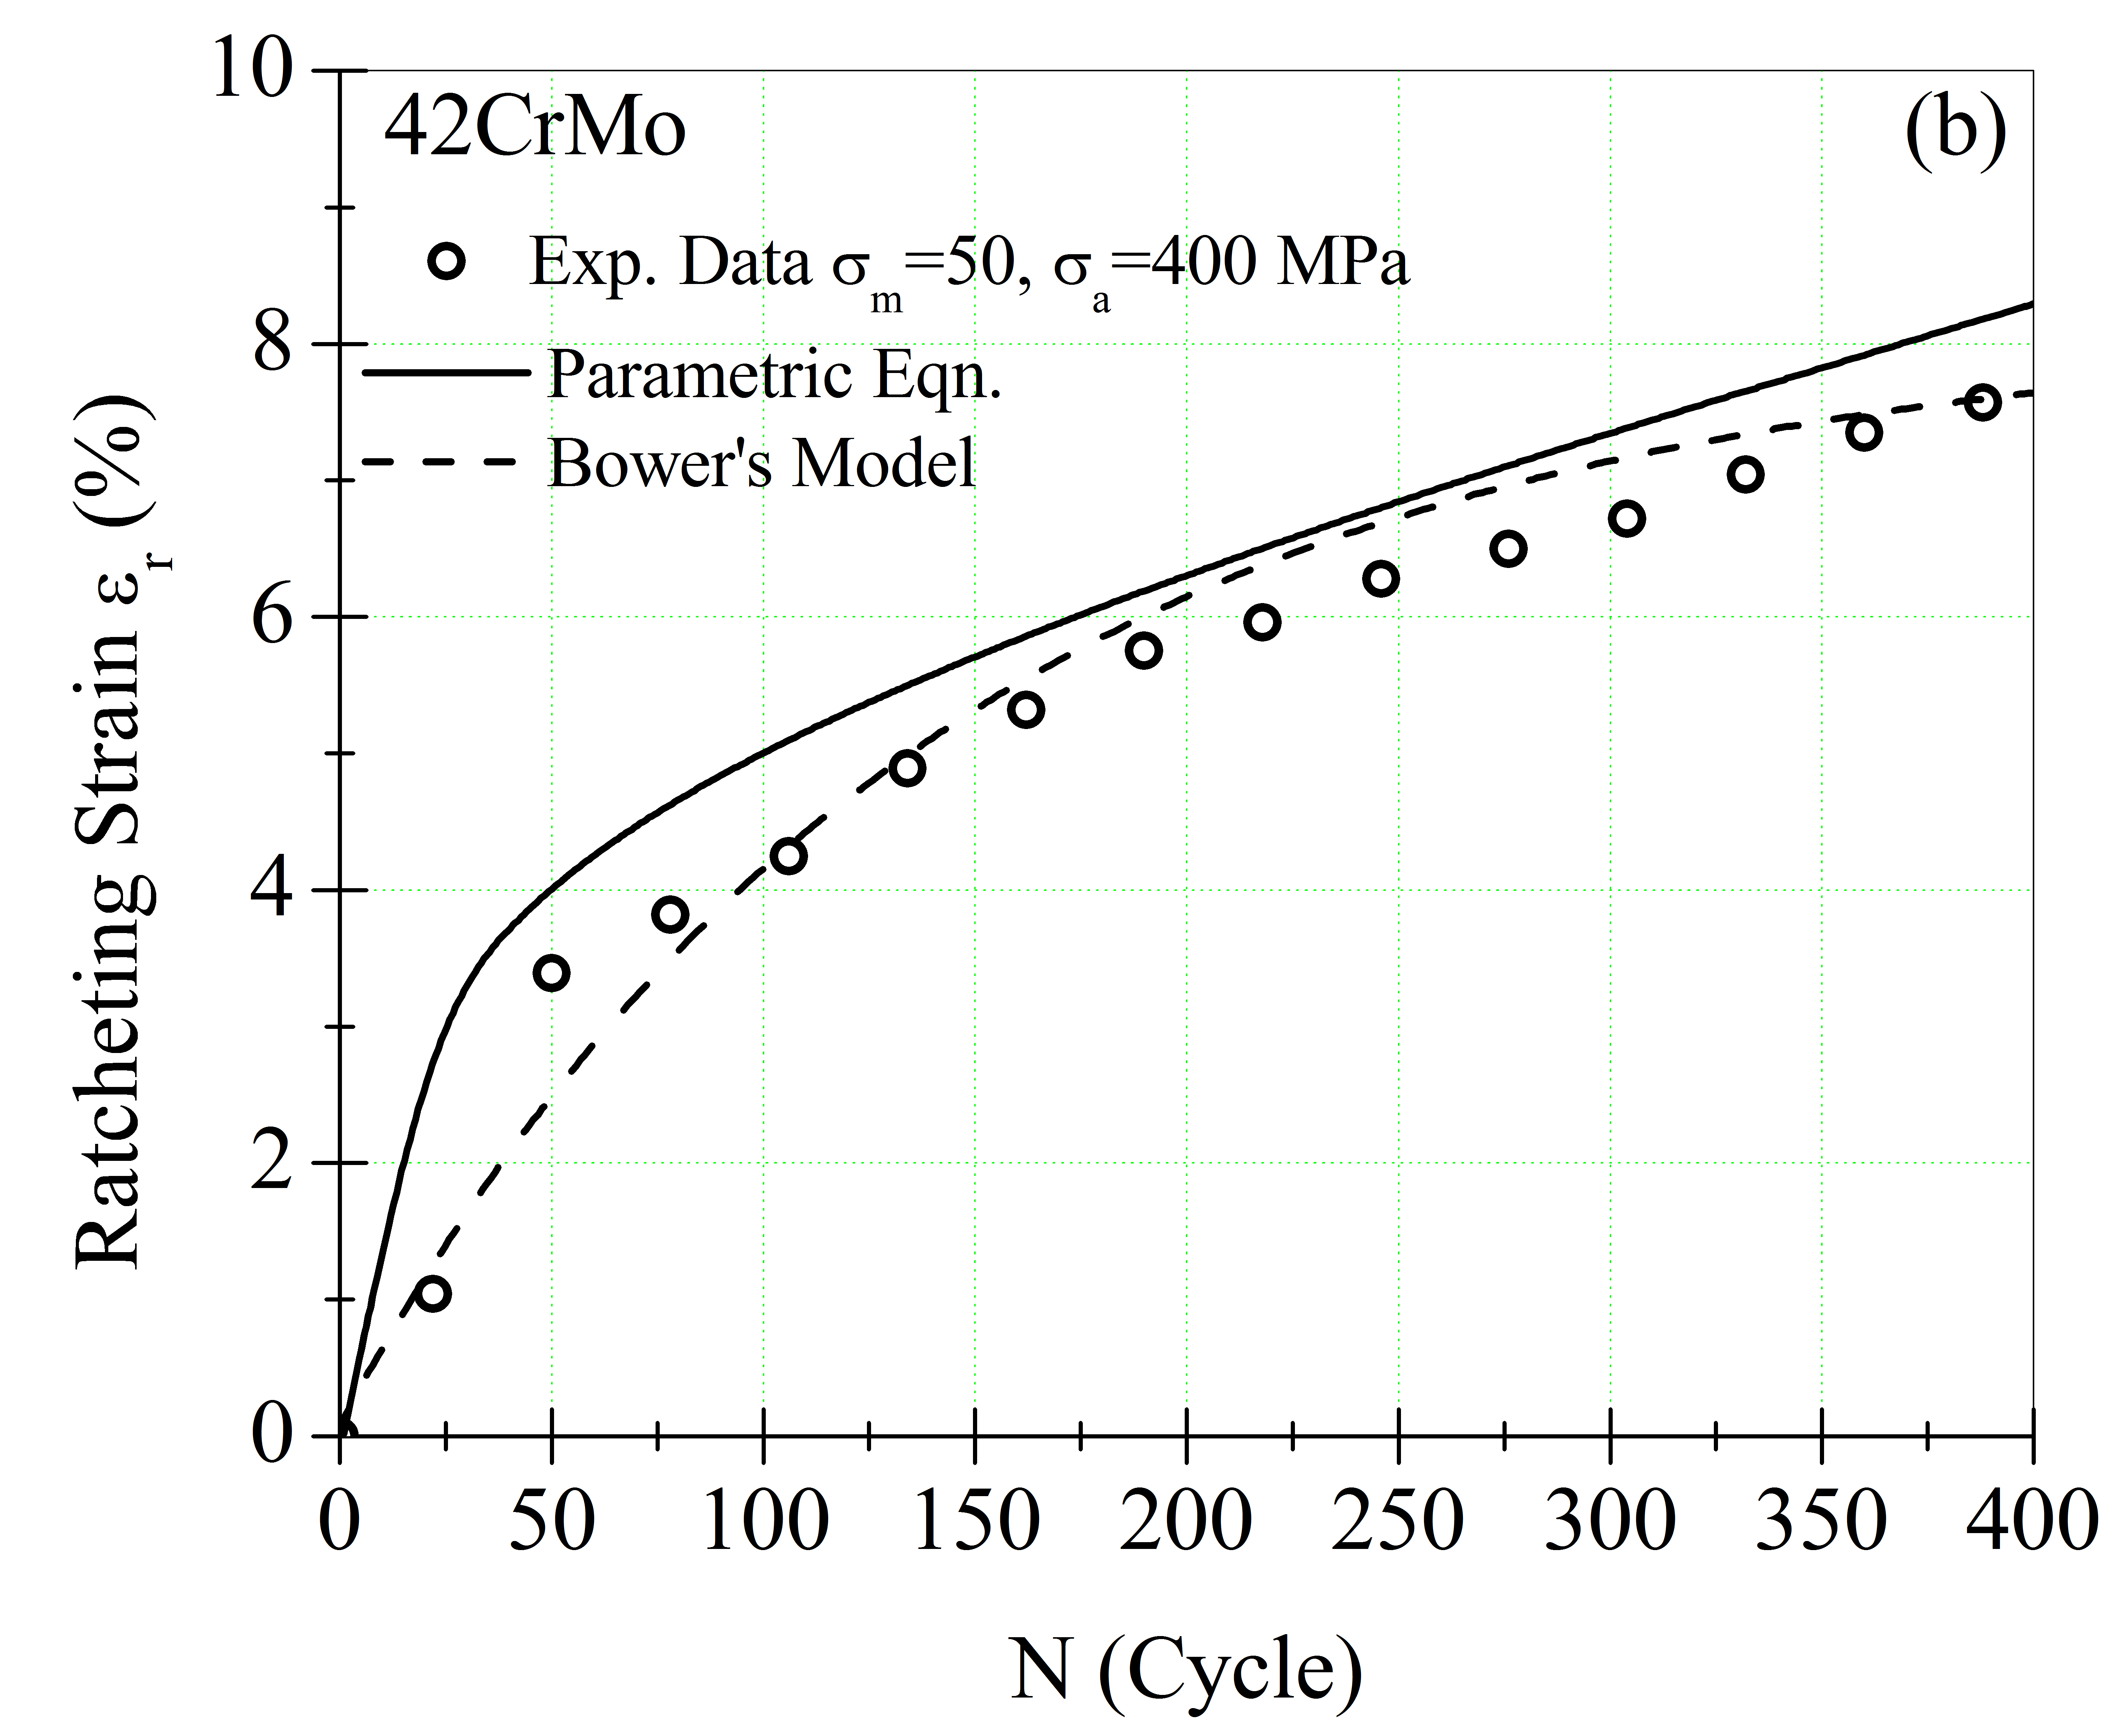

* + 1. (a) Please see the symbols in the figure use common symbols and those of widely used. (b) Provide references if data has been extracted from literature. (Font 8 for Captions) **{style: Figure title}**

Subhead level2 **{style: Header 3}**

Note that the entire manuscript, text is single space, and only Time New Roman must be used. Prepare your manuscript in full-size format on A4 paper. Please use this A4 template. Follow the type sizes specified in Table I. Times New Roman is the preferred font.

The column width is 88mm (3.46 in). The space between the two columns is 4mm (0.16 in). Paragraph indentation is 3.5 mm (0.14 in). Left and right justify your columns. Use automatic hyphenation and check spelling. Digitize or paste down figures.

* + - 1. Mechanical Properties **{style: Table Heading}**

|  |  |  |
| --- | --- | --- |
| Material | E (GPa) | σy (MPa) |
| 304 steel [3] | 190 | 209 |
| 42CrMo [7] | 190.5 | 310 |
| 316L steel [9] | 190 | 285 |
| Copper [10] | 129 | 60 |

(One space)

Position figures and tables at the tops and bottoms of columns. Avoid placing them in the middle of columns. Large figures and tables may span across both columns. Figure captions should be centered below the figures; table captions should be centered above. Avoid placing figures and tables before their first mention in the text. Use the abbreviation “Fig. 1,” even at the beginning of a sentence.

(One space)

* 1. References

Number the citations consecutively in square brackets [1]. Punctuation follows the bracket [2, 3]. Give all authors’ names if there are two; use “et al.” if there are three authors or more. Papers that have been submitted or under review should not be cited. Papers that have been accepted for publication should be cited as “in-press”. No paper title is required.

(One space)

* 1. Abbreviations and Acronyms

Define abbreviations and acronyms the first time they are used in the text, even if they have been defined in the abstract. Do not use abbreviations in the title unless they are unavoidable.

(One space)

* 1. Equations

Number equations consecutively with equation numbers in parentheses with the right margin. Italicize Roman symbols for quantities and variables, but not Greek symbols. Use parentheses to avoid ambiguities in denominators. Punctuate equations with commas or periods when they are part of a sentence:

*a* + *b* = *c*. (1)

(One space)

Symbols in your equation should be defined before the equation appears or immediately following. Use “Eqn. (1)” not “equation (1),” except at the beginning of a sentence: “Equation (1) is …”

(One space)

* 1. Other Recommendations

Use a zero before decimal points: “0.25,” not “.25.” Use “cm3,” not “cc.” Do not mix complete spellings and abbreviations of units: “Wb/m2” or “Webers per square meter,” not “Webers/m2. Try to get your manuscript proofread by a colleague before your final submission. Do not add page numbers.

1. Units

Use either SI units as primary units. An exception would be the use of English units as identifiers in trade, such as “3.5-inch disk drive”.

1. Some Common Mistakes

The word “data” is plural, not singular. The word alternatively is preferred to the word “alternately” (unless you mean something that alternates). Be aware of the different meanings of the homophone's “affect” and “effect,” “complement” and “compliment,” “discreet” and “discrete,” “principal” and “principle.” Do not confuse “imply” and “infer.” The prefix “non” is not a word; it should be joined to the word it modifies, usually without a hyphen. There is no period after the “et” in the Latin abbreviation “et al.” The abbreviation “i.e.” means “that is,” and the abbreviation “e.g.” means “for example”.

1. Conclusion

In recent years, research papers must end with conclusion. This can be well understood. It is expected authors to very briefly highlight concluding points of the manuscript.

Acknowledgment

Acknowledgments are made briefly to those contributing to the research in a sentence or two.

References {style: references}

1. Murzynski, J. and Degelman, D., Journal of Applied Mechanics 26, pp. 1617-1626, 1996.
2. Srisatkunarajah, S. and Jeyakumar, V., Multiaxial Fatigue, F. Tinakoe and M. Lukus (Editors), Prentice Hall, 1985, pp. 240-252.
3. Wei, L., Sushi, T. and Chen, H., In Proceedings of the 2nd International Conference on Ccomposites (CCFA-2), pp.1 85-190, 2010.