Preparation of Your Submission for the Proceedings of 2INZC Conference
1.5 inch top margin
* should be deleted before submission

(12 Bold)

F. First Author’s Surnameª, A. Presenterof the Paperª, C. CorrespondingAuthor^{b}*(10 regular)
ªDepartmentof …, University, City, Postal code, Country(10 regular)
^{b}Department of ..., University, City, Postal code, Country (10 regular)
*e-mail@corresponding author’s address.ir

Abstract (11 Bold):This instruction provides guidelines for preparing submissions tothe 2nd Iran National Zeolite Conference (2INZC). The length of the manuscript should not be exceeded 2 pages. It should be submitted in pdfformat for reviewing process. The paper size is A4 (210 x 297 mm), leaving 0.8inchesfor left and right margins, 1.5 inches for top margin and 1 inch for bottommarginfor all pages. All pages should have the header of the conference. The main text font must be Times New Roman 10. Please underline the name of author who will present the article in the conference and also indicate the corresponding (contact) author with “*” and give his/her e-mail address as above. You can use this file as a template for your manuscript, but you should remove notes on the margins (4 gray notes on the sides of this page).The maximum length of the abstract (this section) is 200 words. The abstract should contain the aim and significant findings of the research.
0.8 inch left margin
* should be deleted before submission

0.8 inch right margin
* should be deleted before submission

Keywords (11 Bold): Max. 5 Keywords, 10 regular and separated with “;”

Introduction (11 bold)
The main body of the paper should be typed single spaced(10 regular), two columns (spacing 0.2 inches), fully justified, and divided into sections including Introduction, Materials and method, Results and Discussion, Conclusions, and References. Heading of each section should be typed using 11 bold fonts and aligned left, separated by an Enter from the following text. Do not insert page numbers.

The full length of the paper should be fitted to 2 pages. It’s appreciated if you tune last page in 2 equal columns. For this, you can insert a “Continuous Break” at the end of the document. For inserting this character, use the “Breaks” menu from “Page Layout” tab of MS Word.

Please do not end a page with a heading or subheading.Do not end a page with one or more blank lines, except to avoid ‘widow’ headings and to end your paper.

Materials and method
Authors should present materials, methods, instrumentations, software, and experimental procedures briefly. Please identify the suppliers’completename(companies) which provided the materials and equipment.

Results and Discussion

All illustrations, formulas, figures and tables should be numbered throughout the text orderly.Do not assemble figures at the end of your paper, but place them as close as possible after they are mentioned in the main text.
1 inch bottom margin
* should be deleted before submission
1 inch bottom margin
* should be deleted before submission

Color illustrations are acceptable, but they should remain clear when printed in monochrome. All figures and diagrams should have readable scale-bars or legends. Please do not supply figures that are too low in resolution. Figure and Table legends should be typed in single-spaced, size 8 regular, Times New Roman. Captions for tables go above of each table. Captions for figures should be given below of each figure.Use the abbreviation “Fig. fig-number” to refer a figure.

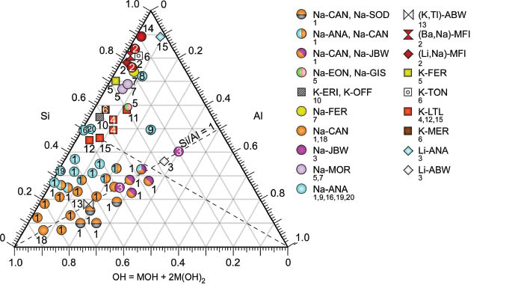

Fig.1: Example of a figure caption. The Caption must be Times New Roman, 9 regular, and centred.
If you need to present graphics, we suggest that you use a text box to insert graphics.

This method is somewhat more stable than directly inserting a picture (collection of relevant pictures).

Please use non-visible rules on your frame.

Table1: Table type style, example of table headnote.
Column title | Column title
copy | copy

Number all the equations with equation numbers in parentheses and use the abbreviation “Eq. (equation-number)” through the text. Please use Equation Editor to create displayed equations. Below is an example:

$n_{t}=\int_{E_{f,0}}^{E_{f,n}}{g\left(x\right)dx}$ (1)

where,
$g\left(x\right)=Σ^{n} f\left(y_{n}\right).$ (2)

Even through the text use Equation Editor for mathematical parameters. There is difference between character “a” and parameter$a$.

Only SI units should be used. For unites use regular Times New Roman fonts, for example,$x=10 nm$, and not$x=10 nm$.

Abbreviations should be explained when they appear in the text for the first time.

References should be numbered serially in a single sequence and identified in the text by enclosing in squared brackets, e.g. [1, 3], [5-8]. They should be set out in a list numbered according to their appearance in the text. Give title and all authors’ names and do not use “et al.” unless there are six authors or more. Capitalize only the first word in a paper title, except for proper nouns and element symbols.

Use the style given here for bibliography (i.e. [1] for Journal articles, [2] for Books and [3] for Conference papers). Papers that have not been published, even if they have been submitted for publication, should be cited as “unpublished” [4]. Papers that have been accepted for publication should be cited as “in press” [5]. For papers published in translation journals, please give the English citation first, followed by the original foreign-language citation” [6].

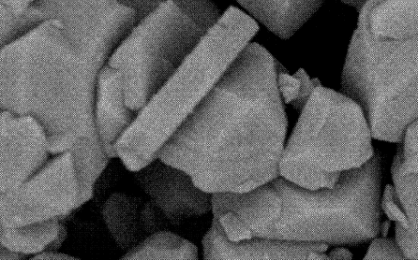
Fig.2: Example of a figure caption for images.

Conclusions
The importance of the work and the significance of the achievements should be highlighted in conclusion part. Avoid repeating the abstract as the conclusion.

Acknowledgment (Optional)
In this section you may want to acknowledge providers of financial supports, facilities, contributors (who their contribution is not enough to be named as a co-author) and etc.

References
[1] B. Surname1, F. Surname2, “Conversion of xylose to levulinic acid over modified acid functions of alkaline-treated zeolite Y in hot-compressed water”, Chemical Engineering Journal, 2011, 113-120.
[2] A. Surname1, D. Surname2, “Zeolites in Industry”, 2004, John Wiley and Sons, p. 456.
[3] B. Surname1, F. Surname2, “Applications of Zeolite X”, Proc. of the 3rd International Conference on Zeolite, Arak University, Iran, 2012, 189-200.
[4] B. Surname1, F. Surname2, “Title of paper if known,” unpublished.
[5] B. Surname1, F. Surname2, “Title of paper with only first word capitalized,” J. Name Stand. Abbrev., in press.
[6]B. Rep, S. Bali, “Transformation and morphology of zeolite Z-254 with acidic media in Na₂O–Al₂O₃–SiO₂–H₂O system”, Mesoporous Materials, vol. 205, 1, 298-303, March 2014 [Digests 3rdInternational Conf. Zeolite, p. 251, 2013].

